MacOS 9

Conexant provides the following files as part of the package

USB ADSL Install/Install - Install script
USB ADSL Install/Uninstall - Uninstall script
USB ADSL Install/Components/cnxtadsl - Driver
USB ADSL Install/Components/cnxe2fw.bin – firmware binary file
Install.scr - source of installation script

Uninstall.scr - sources of Uninstall script

End user should only receive “USB ADSL Install” folder, Install.scr and Uninstall.scr are provided for customization/localization purposes only.

Driver customization

To modify driver’s property you will need to use Apple’s resource editor application – ResEdit. It is freely available from various Apple-software web-sites, for example http://www.versiontracker.com/moreinfo.fcgi?id=417&db=mac.

To modify driver:

- Start ResEdit application
- Open “cnxtadsl” driver ( this two steps can be combined if you just drag cnxtadsl file on ResEdit icon)

- Select “ADSL” resource type
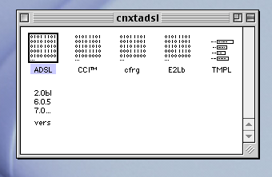

- Select resource with id 0
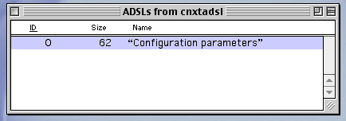

- The following dialog will appear:
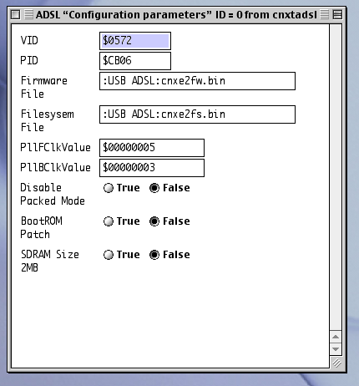

All the fields have same meaning as in Windows Inf file.

For example, here is what should be put into these fields for some devices (the ones I know about):

 | USBNET (Hasbani) | E2-P52 | E2-Rushmore
VID | $572 | $572 | $572
PID | $CB01 | $CB05 | $CB06
Firmware File | <should be empty> | :USB ADSL:cnxe2fw.bin | :USB ADSL:cnxe2fw.bin
Filesystem File | <should be empty> | :USB ADSL:cnxe2fw.bin | :USB ADSL:cnxe2fw.bin
PllFClkValue | -1 ( or $FFFFFFFF ) | $2D874DF | 5
PLLBClkValue | -1 ( or $FFFFFFFF) | $196A51A | 3
Disable Packed Mode | False | False | False
BootROM Patch | False | True | False
SDRAM Size 2MB | False | False | False

Install/Uninstall scripts customization

MacOS 9 driver installation is done by simple AppleScript-based application.
Conexant provides English version of scripts. Customers may localize these scripts and/or add extra messages.

- Open script file. Double-click on the script file. AppleScript application should start and open this file automatically.
- Edit this file as necessary.
- Save this file as an application. Select File/Save As Run-Only menu. In the dialog box select path and script name. In Format drop box select Application. Make sure that Stay Open option is unchecked, Never Show Startup Screen is checked.

There is a document describing AppleScript language at http://developer.apple.com/techpubs/macosx/Carbon/interapplicationcomm/AppleScript/AppleScriptLangGuide/index.html

Usually it is not necessary to edit the script, just modify (localize) dialog strings.
Here are strings defined for Install script:

For successful installation dialog box
msgDone - Displayed message. Currently "Installation of USB ADSL is completed. To complete installation you need to restart your computer now."
butRestart - name of the button to restart computer. “Restart”
butLater - name of the button to quit installer without restarting. “I will restart later”

Dialog box which displays when there is something wrong with installation (missing file).
msgError – message. “Incorrect installation package”
butOK – button. “OK”
The following strings are defined in Uninstall.scr:

Dialog box which displays before uninstall to make sure that user actually wants to uninstall driver:
msgAsk – message. “Are you sure you want to remove USB ADSL driver”
butYes – button “Yes”
butNo – button “No”

Dialog box displayed after uninstall is done.
msgDone – message “USB ADSL driver was successfully removed”
butOK – button “OK”

Web pages/firmware customization

USB ADSL Install/Components/cnxe2fw.bin is a firmware file which contains Conexant’s default Web-pages. Customers may replace this file by customized firmware file. This file is the same as in PC-Windows driver.

MacOS X

Conexant provides the following files as part of the MacOS X package

ConexantADSL.kext - Driver ( in fact this is not a file, this is folder)
makepackage - Script to create installation package from the driver
Uninstall - Uninstall script
Uninstall.scr - Sources of Uninstall script

End user should receive Install_USB_ADSL.pkg (which is generated by makepackage script) and Uninstall script.

Driver customization

Modification of driver’s VID/PID requires editing of ConexantADSL.kext/Contents/Info.plist file.

You may use any text editor to modify this file, for example TextEditor (located in Applcations folder).
To see Info.plist file in Finder – select ConexantADSL.kext, Ctrl-Click ( click mouse while pushing Ctrl key ). Select “Show Package Contents” in context menu, go to Contents folder, drag and drop Info.plist file into TextEdit application.

Find idProduct and idVendor keys, and put proper values (note that these values should be decimal, not hexadecimal). Save the file

To change firmware file, copy prope cnxe2fw.bin file into ConexantADSL.kext/Contents/Resources/

Generating installation package

Installation package can be created using makepackage. In terminal application – start makepackage script as root:

cd ~Desktop/OSXPackage
sudo ./makepackage

The script will generate Install_USB_ADSL.pkg.

