

This product can be set up using any current web browser, i.e., Internet Explorer 6 or Netscape Navigator 6.2.3.

DSL-502T

D-LinK

ADSL Router

Before You Begin
Make sure you have all the necessary information and equipment on hand before beginning the installation.

Check Your Package Contents

DSL-502T ADSL Router

CD-ROM (containing Manual and Warranty)

Ethernet (CAT5 UTP) Cable

Power Adapter

USB Cable

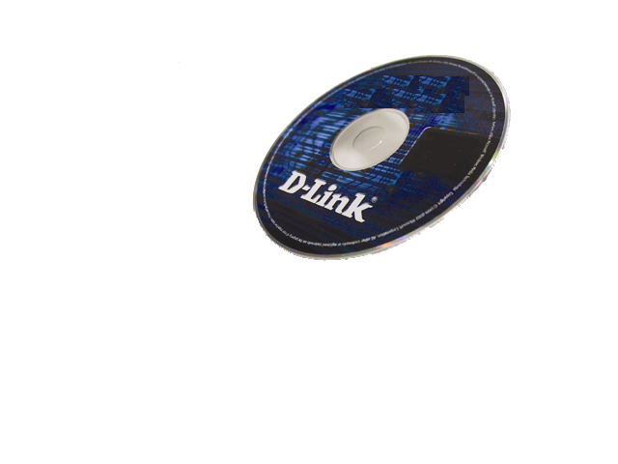


Using a power supply
with a different voltage rating will damage and void the warranty for this product.

If any of the above items are missing, please contact your reseller.

©2003 D-Link Systems, Inc. All rights reserved. Trademarks or registered trademarks are the property of their respective holders. Software and specifications subject to change without notice. DWL-2100AP. 11122003


Connecting the Router to Your Computer

- First, connect the power adapter to the receptor at the back panel of the
DSL-502T and then plug the other end of the power adapter to a wall outlet or
power strip. The Power LED will turn ON to indicate proper operation.
- Insert one end of the cable into the Ethernet port on the back panel of the
DSL-502T and the other end of the cable to an Ethernet Adapter or available Ethernet port on your computer.

Ethernet port, connect Ethernet cable here
Factory Reset button

ADSL port, connect ADSL cable here
Power cord connects here

USB port, connect USB cable here and install USB driver
Please read the User’s Manual for instructions on how to use the USB port.



Configuring the Router

To use your Web browser to access the web pages used to setup the Router, your computer must be configured to “Obtain an IP address automatically”, that is, you must change the IP network settings of your computer so that it is a DHCP Client. If you are using Windows XP and do not know how to change your network settings, skip ahead to Appendix A and read the instructions provided. You may also read the User Manual for instructions on changing IP settings for computers running Windows operating systems.

Open your Web browser and type “http://192.168.1.1” into the URL address box. Then press the Enter or Return key.
The Login page appears.

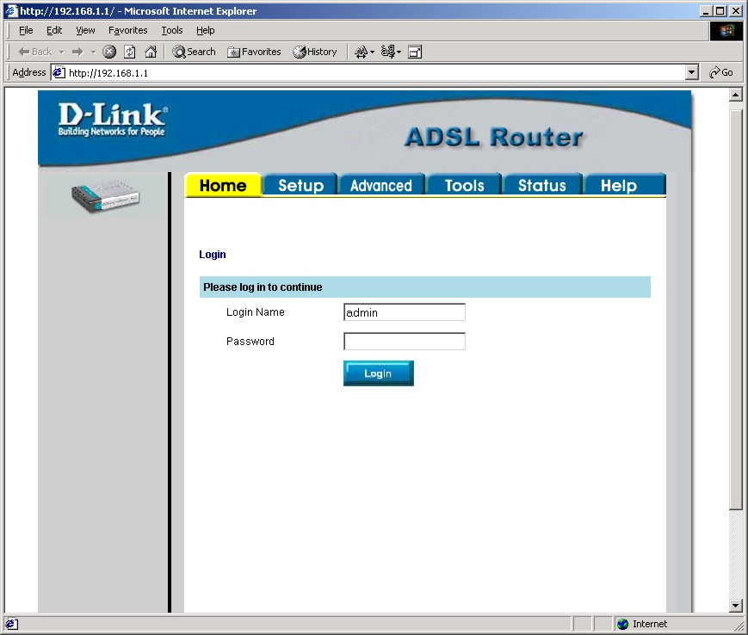
Type “admin” for the Login Name and “admin” in the Password field.

Click Login

Configuring the Router (continued)

Once you have logged in, the Home screen will appear. Click the Setup tab to go to the Setup menu and configure the Router.
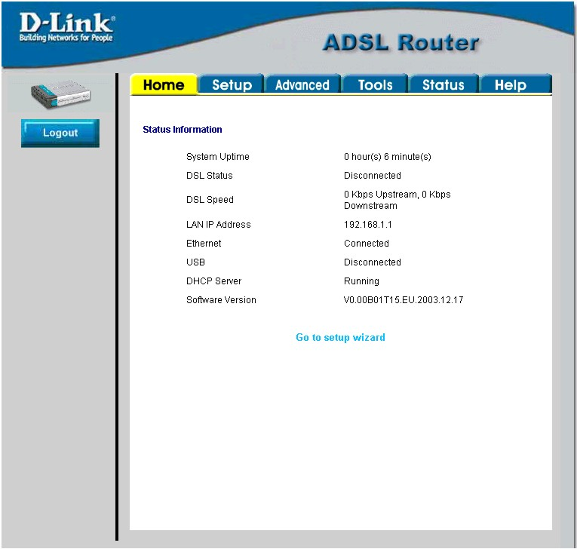
Click Setup

Configuring the Router (continued)

In the Setup menu, click the Connection 1 button to go to the configuration menu for the Internet connection.
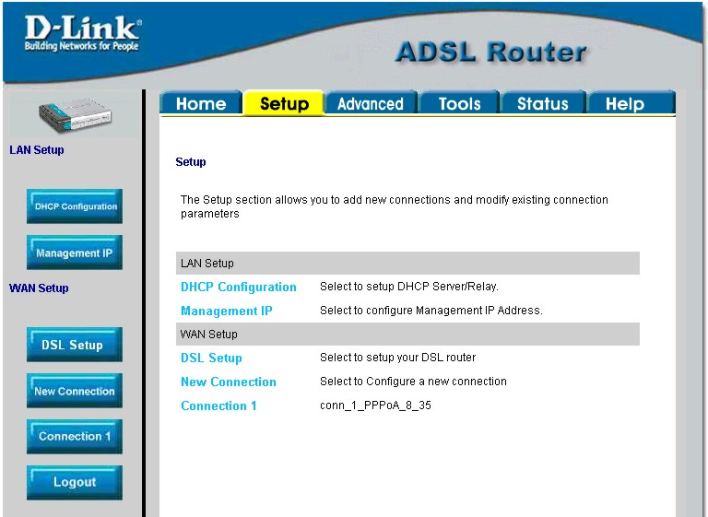

Click Connection 1

Configuring the Router (continued)

In the Connection 1 menu, type the Username and Password used to verify the identity of your ISP account. Click the Apply button when you have entered all the information. To save the changes made to Connection 1, click the Tools tab and follow the instructions on the next page.
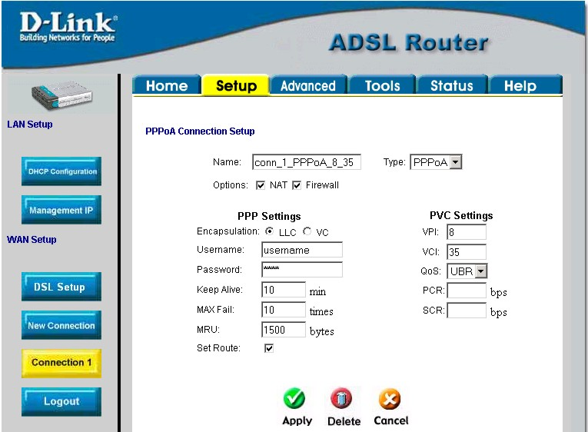
Type the Username and Password used for your account.

Click the Apply button after you have entered the account information.
Click Tools when you have applied the new settings.

Appendix
For additional settings or information, refer to the Advanced, Tools, or Status tabs on the web-management interface; or to the manual located on the CD-ROM.

Configuring IP Settings in Windows XP
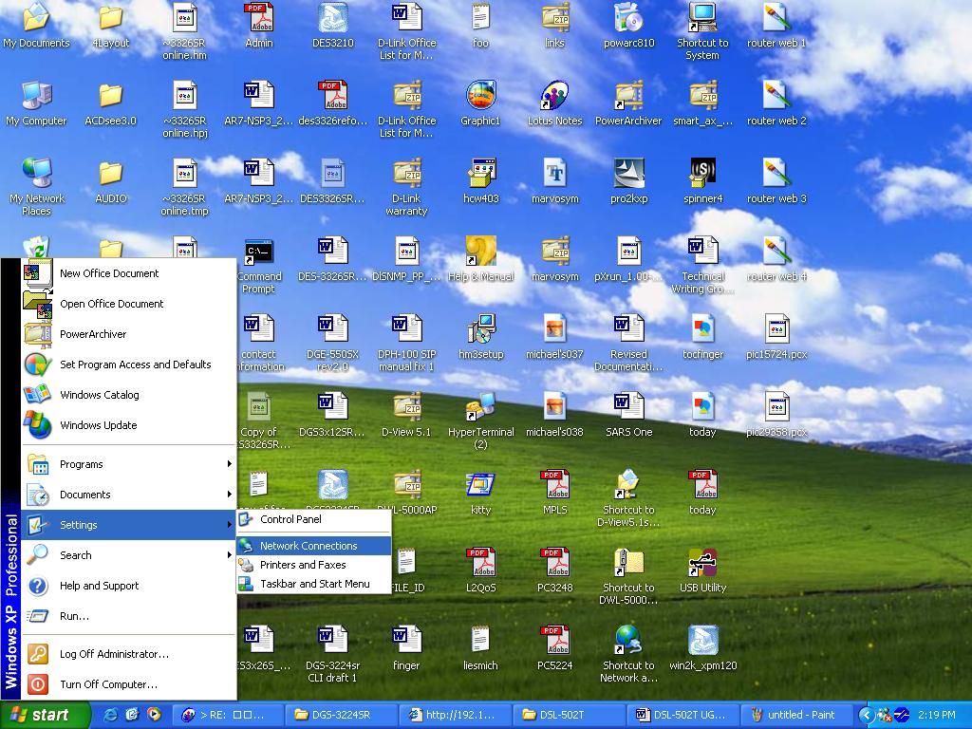
Use the following steps to configure a computer running Windows XP to be a DHCP client.
- From the Start menu on your desktop, go to Settings, then click on Network Connections.
- In the Network Connections window, right-click on LAN (Local Area Connection), then click Properties.
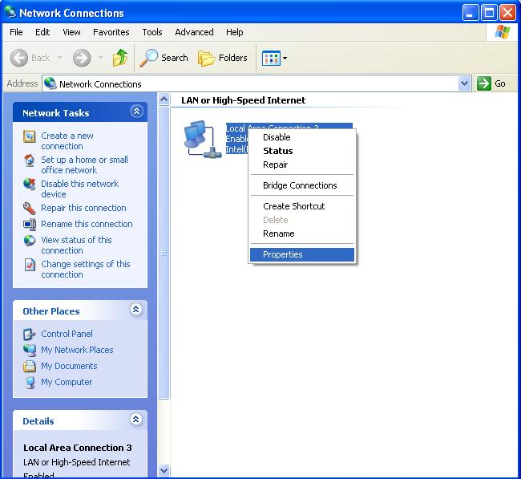
Right-click on the Local Area Connection icon and Select the Properties option from the pull-down menu.
- In the General tab of the Local Area Connection Properties menu, highlight Internet Protocol (TCP/IP) under “This connection uses the following items:” by clicking on it once. Click on the Properties button.
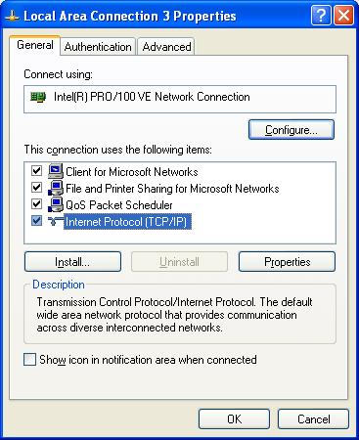
Click Properties

- Select “Obtain an IP address automatically” by clicking once in the circle. Click the OK button.
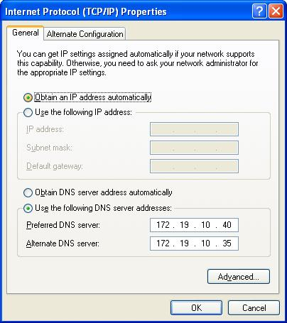
Select Obtain an IP address automatically in the Internet Protocol (TCP/IP) Properties window
Your computer is now ready to use the Router’s DHCP server.

Technical Support
You can find software updates and user documentation on the D-Link website.

D-Link provides free technical support for customers within the United States and within Canada for the duration of the warranty period on this product.

U.S. and Canadian customers can contact D-Link technical support through our website, or by phone.
Tech Support for customers within the United States:
D-Link Technical Support over the Telephone:
(877) 453-5465
24 hours a day, seven days a week.
D-Link Technical Support over the Internet:
http://support.dlink.com
email:support@dlink.com
Tech Support for customers within Canada:
D-Link Technical Support over the Telephone:
(800) 361-5265
Monday to Friday 8:30am to 9:00pm EST
D-Link Technical Support over the Internet:
http://support.dlink.ca
email:support@dlink.ca



