DSL-504G Quick Installation Guide
Use this Quick Installation Guide to quickly establish your ADSL connection and access the Internet.

Overview
The following steps summarize the procedure used to install the Router:
- Preparation - Gather information and equipment needed to install the device.
- Connect the Router - Connect the cables to the device and to the telephone wall socket, then connect the power adapter and turn on the power.
- Change IP Settings - Change the IP settings on your computer so you can access the web-based software built into the Router.
- Configuration - Use the web-based management software to configure the Router.
- Connect to Internet – Establish the the ADSL connection to the WAN (Wide Area Network), and ultimately to the Internet.

Preparation
If you are using a bridged connection you may need to install additional software on your computer. Some ADSL connections use a connection method known as a bridged connection (RFC 1483 Bridge) to connect to their ISP. In this case, software must be installed on the computer that enables it to connect to the ISP’s network.

Low Pass Filters
You may need to use a filter on your telephone line to prevent interference problems. Ask your ISP for more information. Appendix B of the User’s Guide illustrates two common types of filters used with ADSL devices.

Web Browser
Configuration of the Router is done using a web browser. Any common web browser can be used to configure the Router with the web configuration management software. The program is designed to work best with more recently released browsers such as Microsoft Internet Explorer® version 5.0, Netscape Navigator® version 4.7, or later versions.

Ethernet Port (NIC Adapter)
Your computer connects to the Router through the Ethernet port on the Router, therefore your system must be equipped with a working Ethernet port. If your computer does not have an Ethernet port, you must install an Ethernet (NIC) adapter before you can use the Router. If you must install an adapter, follow the installation instructions that come with the Ethernet NIC adapter. Be sure to enable the TCP/IP protocol for your operating system. Instructions for enabling TCP/IP in Windows operating systems are included in this guide.

User Name and Password
Most users will need to supply a user name and password used to access the service provider’s network. This information is stored in the Router’s memory for PPP connections or in computer memory for bridged connections.
ACCOUNT INFORMATION
User Name:
Password:

IP Settings
To access the Router’s management software that uses a web-based (HTML) interface for configuration, you will need to change the LAN IP settings of your computer. The web browser uses these LAN IP settings to enable communication with the Router.

Connect the Cables
Place the Router in a safe and accessible location where you can easily view the LED indicators on the front of the device.
Connect the power adapter

Connect the Router to your computer

Connect the ADSL cable

Factory reset button

You are now ready to connect the Router. Follow these steps:

- Connect the ADSL line - Use the twisted-pair ADSL cable (standard telephone cable) included with the Router to connect it to the telephone wall socket. Plug one end of the cable into the ADSL port on the rear panel of the Router and insert the other end into the wall socket. If you need to install a low pass filter, follow the instructions of your ISP.
- Connect the Router to your computer - Connect the Modem directly to a 10/100BASE-TX Ethernet adapter card (NIC) or the factory installed Ethernet port on your PC or notebook computer. Use the Ethernet cable provided.
- Connect the power adapter - Insert the AC Power Adapter cord into the power receptacle labeled 9V AC 1A located on the back of the Router and plug the adapter into a suitable power source. You should see the Power LED indicator light up and remain lit. After a few seconds, the Status LED indicator will start to blink green; this indicates the Router is functioning. Look at the Ethernet Link/Act indicator and make sure it lights or blinks green; this indicates the connection to your computer is OK. Use these LED indicators to monitor the Router for normal function.
- Factory reset button–The Router may be reset to the original factory default settings by depressing the reset button three times while the device is powered on. Use a ballpoint or paperclip to push down the reset button. Remember that this will wipe out any settings stored in flash memory including IP settings. The factory default IP address of the Router is 10.1.1.1 and the subnet mask is 255.0.0.0.

Configure IP Settings
In order to configure your system to receive IP settings from the Router it must first have the TCP/IP protocol installed. If you have an Ethernet port on your computer, it probably already has TCP/IP protocol installed. If you are using Windows XP the TCP/IP is enabled by default for standard installations. Below is an illustrated example of how to configure a Windows XP system to automatically obtain IP settings from the Router. Following this example is a step-by-step description of the procedures used on the other Windows operating systems to first check if the TCP/IP protocol has been installed, if it is not instruction are provided for installing it. Once the protocol has been installed you can configure the system to receive IP settings from the Router.
For computers running non-Windows operating systems, follow the instructions for your OS that configure the system to receive an IP address from the Router, that is, configure the system to be a DHCP client.

Note | If you are using this Router to provide Internet access for more than one computer, you can use these instructions later to change the IP settings for the other computers. However you cannot use the same IP address since every computer must have its own IP address that is unique on the local network.

Configure Windows XP for DHCP
Use the following steps to configure a computer running Windows XP to be a DHCP client.
- From the Start menu on your desktop, go to click on Control Panel.
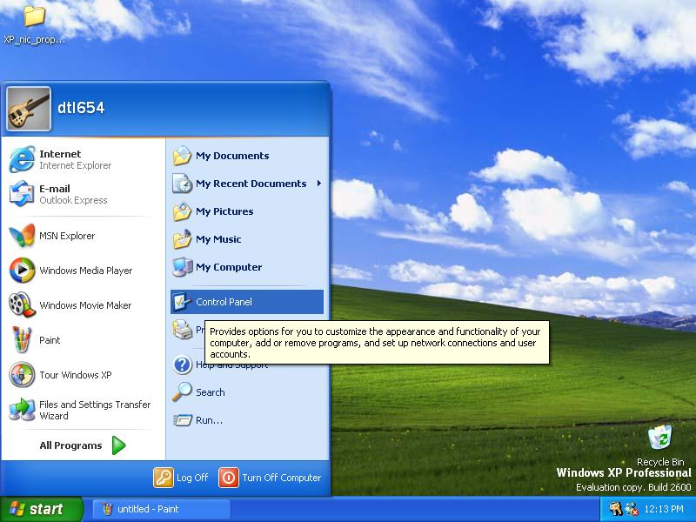
- In the Control Panel folder, click on Network and Internet Connections.
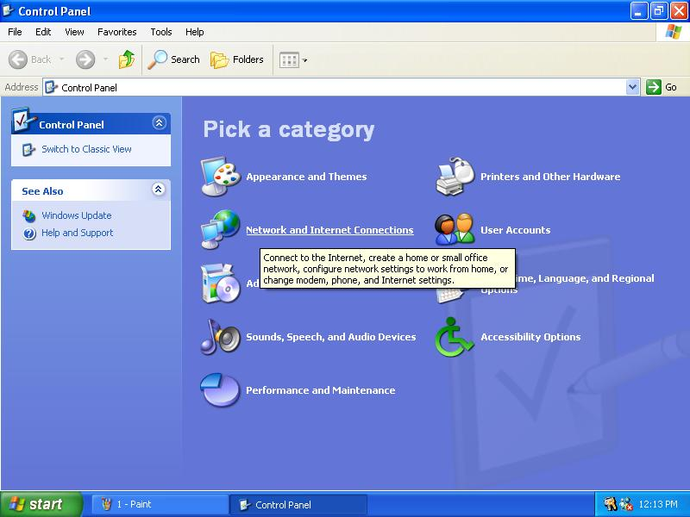
- In the Network and Internet Connections folder, click on Network Connections.
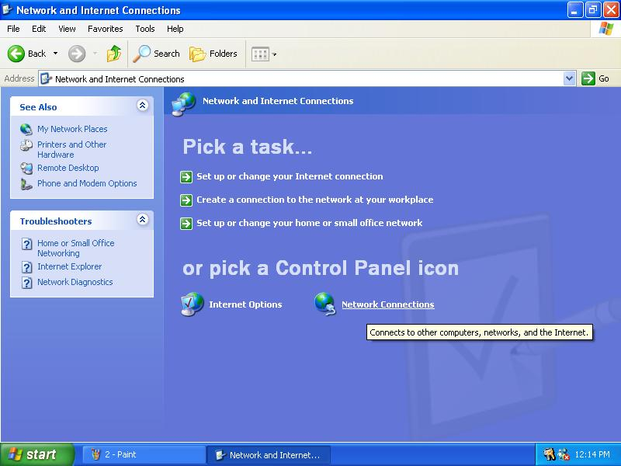
- In the Network Connections folder, highlight the Local Area Connection icon by clicking on it once. A new option is revealed under Network Tabs in the left side panel.
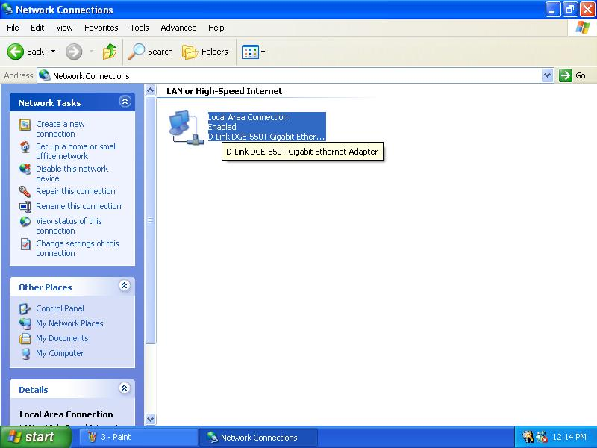
- Click on Change settings of the connection under Network Tabs.
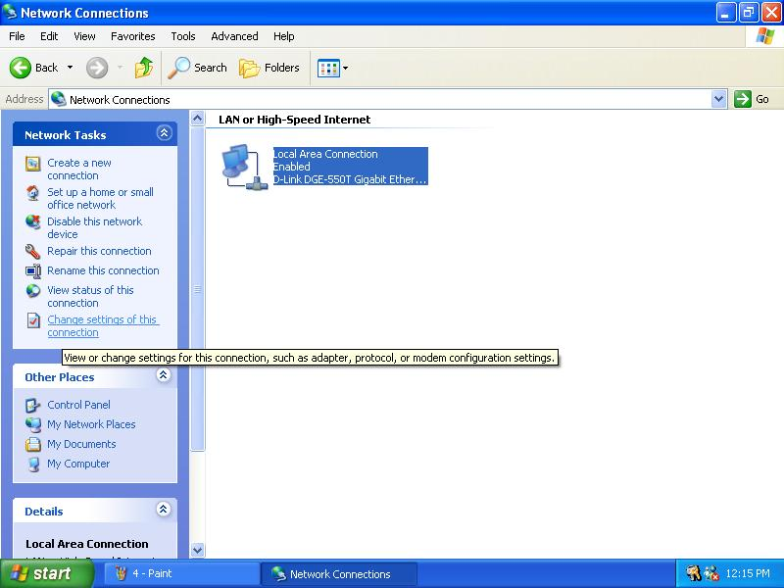

- In the General Tab of the Local Area Connection Properties menu, highlight Internet Protocol (TCP/IP) under “This connection uses the following items:” by clicking on it once. Click on the Properties button.
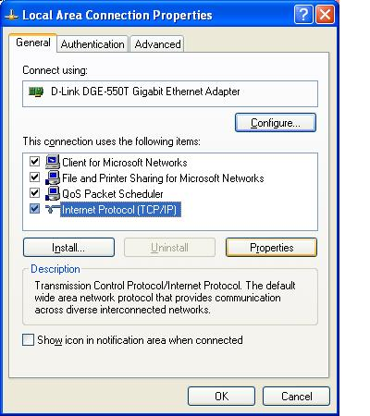
- Select “Obtain an IP address automatically” by clicking once in the circle. Click the OK button.
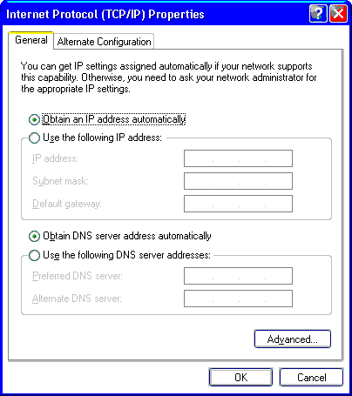
Your computer is now ready to use the Router’s DHCP server.

Windows 2000
First, check for the IP protocol and, if necessary, install it:
- In the Windows task bar, click the Start button, point to Settings, and then click Control Panel.
- Double-click the Network and Dial-up Connections icon.
- In the Network and Dial-up Connections window, right-click the Local Area Connection icon, and then select Properties.
- The Local Area Connection Properties dialog box displays with a list of currently installed network components. If the list includes Internet Protocol (TCP/IP), then the protocol has already been enabled, skip ahead to Configure Windows 2000 for DHCP.
- If Internet Protocol (TCP/IP) does not display as an installed component, click Install.
- In the Select Network Component Type dialog box, select Protocol, and then click Add.
- Select Internet Protocol (TCP/IP) in the Network Protocols list, and then click OK.
- You may be prompted to install files from your Windows 2000 installation CD or other media. Follow the instructions to install the files.
- If prompted, click OK to restart your computer with the new settings.

Configure Windows 2000 for DHCP
- In the Control Panel, double-click the Network and Dial-up Connections icon.
- In Network and Dial-up Connections window, right-click the Local Area Connection icon, and then select Properties.
- In the Local Area Connection Properties dialog box, select Internet Protocol (TCP/IP), and then click Properties.
- In the Internet Protocol (TCP/IP) Properties dialog box, click the button labeled Obtain an IP address automatically.
- Double-click OK to confirm and save your changes, and then close the Control Panel.
Your computer is now ready to use the Router’s DHCP server.

Windows ME
First, check for the IP protocol and, if necessary, install it:
- In the Windows task bar, click the Start button, point to Settings, and then click Control Panel.
- Double-click the Network and Dial-up Connections icon.
- In the Network and Dial-up Connections window, right-click the Network icon, and then select Properties.
- The Network Properties dialog box displays with a list of currently installed network components. If the list includes Internet Protocol (TCP/IP), then the protocol has already been enabled. Skip ahead to Configure Windows ME for DHCP.
- If Internet Protocol (TCP/IP) does not display as an installed component, click Add.
- In the Select Network Component Type dialog box, select Protocol, and then click Add.
- Select Microsoft in the Manufacturers box.
- Select Internet Protocol (TCP/IP) in the Network Protocols list, and then click OK.
- You may be prompted to install files from your Windows Me installation CD or other media. Follow the instructions to install the files.
- If prompted, click OK to restart your computer with the new settings.

Configure Windows ME for DHCP
- In the Control Panel, double-click the Network and Dial-up Connections icon.
- In Network and Dial-up Connections window, right-click the Network icon, and then select Properties.
- In the Network Properties dialog box, select TCP/IP, and then click Properties.
- In the TCP/IP Settings dialog box, click the Obtain and IP address automatically option.
- Double-click OK twice to confirm and save your changes, and then close the Control Panel.
Your computer is now ready to use the Router’s DHCP server.

Windows 95, 98
First, check for the IP protocol and, if necessary, install it:
- In the Windows task bar, click the Start button, point to Settings, and then click Control Panel. Double-click the Network icon.
- The Network dialog box displays with a list of currently installed network components. If the list includes TCP/IP, and then the protocol has already been enabled, skip to Configure IP Information Windows 95, 98.
- If TCP/IP does not display as an installed component, click Add. The Select Network Component Type dialog box displays.
- Select Protocol, and then click Add. The Select Network Protocol dialog box displays.
- Click on Microsoft in the Manufacturers list box, and then click TCP/IP in the Network Protocols list box.
- Click OK to return to the Network dialog box, and then click OK again. You may be prompted to install files from your Windows 95/98 installation CD. Follow the instructions to install the files.
- Click OK to restart the PC and complete the TCP/IP installation.

Configure Windows 95, 98 for DHCP
- Open the Control Panel window, and then click the Network icon.
- Select the network component labeled TCP/IP, and then click Properties.
- If you have multiple TCP/IP listings, select the listing associated with your network card or adapter.
- In the TCP/IP Properties dialog box, click the IP Address tab.
- Click the Obtain an IP address automatically option.
- Double-click OK to confirm and save your changes. You will be prompted to restart Windows.
- Click Yes.
When it has restarted your computer is ready to use the Router’s DHCP server.

Windows NT 4.0 workstations:
First, check for the IP protocol and, if necessary, install it:
- In the Windows NT task bar, click the Start button, point to Settings, and then click Control Panel.
- In the Control Panel window, double click the Network icon.
- In the Network dialog box, click the Protocols tab.
- The Protocols tab displays a list of currently installed network protocols. If the list includes TCP/IP, then the protocol has already been enabled. Skip to “Configure IP Information”
- If TCP/IP does not display as an installed component, click Add.
- In the Select Network Protocol dialog box, select TCP/IP, and then click OK. You may be prompted to install files from your Windows NT installation CD or other media. Follow the instructions to install the files.
- After all files are installed, a window displays to inform you that a TCP/IP service called DHCP can be set up to dynamically assign IP information.
- Click Yes to continue, and then click OK if prompted to restart your computer.

Configure Windows NT 4.0 for DHCP
- Open the Control Panel window, and then double-click the Network icon.
- In the Network dialog box, click the Protocols tab.
- In the Protocols tab, select TCP/IP, and then click Properties.
- In the Microsoft TCP/IP Properties dialog box, click the Obtain an IP address automatically option.
- Click OK twice to confirm and save your changes, and then close the Control Panel.
- Your computer is now ready to use the Router’s DHCP server.

Access the Web Configuration Manager
Once the computer has IP settings that allow it to access the web-based configuration software, you can change the settings to enable the Router to connect to the Internet.
If the browser software on the computer you are using is configured to use a proxy server for Internet access, it is necessary to first disable the proxy connection.
Check for Proxy service in Windows Internet Explorer:
In Windows Internet Explorer, you can check if a proxy server is enabled using the following procedure:
- In Windows, click on the START button, go to Settings and choose Control Panel.
- In the Control Panel window, double-click on the Internet Options icon.
- Click the Connections tab and click on the LAN Settings button.
- Verify that the “Use proxy server” option is NOT checked. If it is checked, click in the checked box to deselect the option and click OK.
To use the web-based management software, launch your web browser software and use the LAN IP address of the Router to access the management software. The default LAN IP address of the Router is used in the Address bar of your web browser window. Type in http:// followed by the default IP address, 10.1.1.1 in the address bar of the browser. The URL in the address bar should read: http://10.1.1.1
A new window appears prompting you for a user name and password needed to gain access the web configuration manager.

Configure the Router
Now that your IP settings have been changed, you can access the configuration software using your computer’s web browser. If the browser software on the computer you are using is configured to use a proxy server for Internet access, it is necessary to first disable the proxy connection. Computers used on corporate networks or computers that use special Internet security and other software are sometimes set up to use a proxy server for the web browser.

Check for Proxy
In Windows Internet Explorer, you can check if a proxy server is enabled using the following procedure:
- In Windows, click on the START button, go to Settings and choose Control Panel.
- In the Control Panel window, double-click on the Internet Options icon.
- Click the Connections tab and click on the LAN Settings button.
- Verify that the “Use proxy server” option is NOT checked. If it is checked, click in the checked box to deselect the option and click OK.
To use the web-based management software, launch your web browser software and use the LAN IP address of the Router to access the management software. The default LAN IP address of the Router is used in the Address bar of your web browser window. Type in http:// followed by the default IP address, 10.1.1.1 in the address bar of the browser. The URL in the address bar should read: http://10.1.1.1
A new window appears prompting you for a user name and password needed to gain access the web configuration manager.
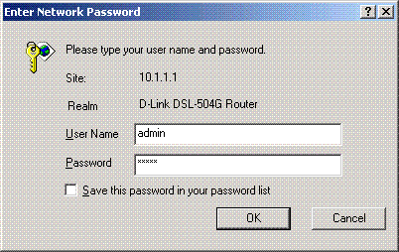
Use the default user name: admin and password: admin for first time set up.
The first web page you will see when you successfully login is the System View page. This page can be used later, once you have a connection established. The menu you need to establish the ADSL connection is the Quick Configuration menu. This menu is located in the Home folder located on the left hand side of your browser window. Open this folder by clicking on it twice.
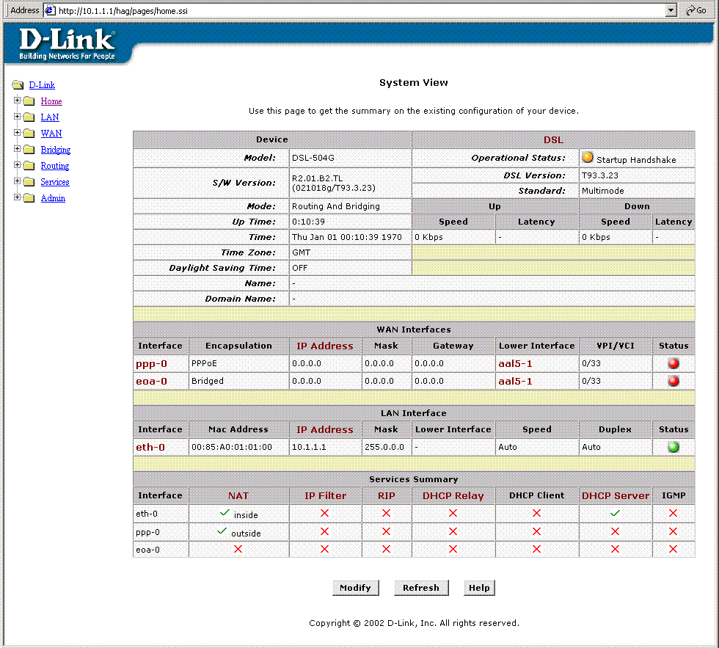
Web-based Manager Main Menu – First Time Log On
In the Home folder you will see two hyperlinks (see below). You need to access the Quick Configuration menu; double-click on the hyperlink for this menu. Once you have accessed the menu you can change the Router’s configuration settings as instructed by your ISP. You will then need to save or “Submit” the settings to the flash memory of the Router. Finally you will use another menu to commit the new settings so the Router can use them, and restart the device. This last step is done in the Commit & Reboot menu. If you have been given special connection software to install on your computer, you can install it while the Router is rebooting.

Configure WAN Connection (ADSL Service Connection)
Click on the Quick Configuration hyperlink to access the configuration settings you need to establish the ADSL connection.
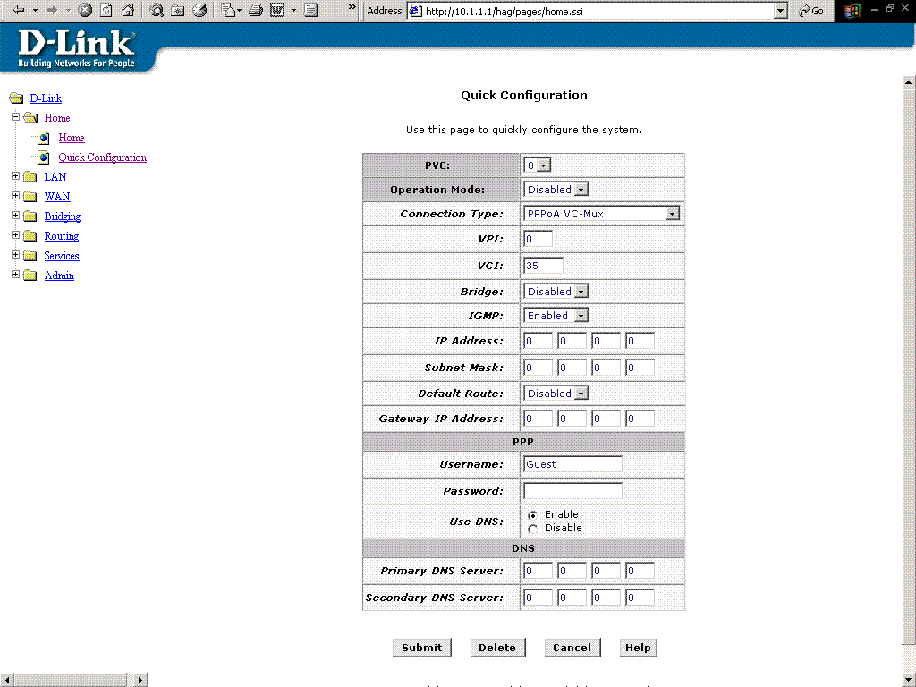
Quick Configuration Menu
When setting up the Router for the first time, use the Quick Configuration window and follow the steps below to change settings as instructed by your ISP. Some of the settings can be left at their default value depending on the requirements of the connection.
In the Quick Configuration menu make sure the Operation Mode: drop-down menu displays Yes and follow these steps to configure the Router:
- PVC: Leave this set at the default value 0 the first time the Router is set up. For more information on this option see Multiple PVC Operation in the User’s Guide.
- Operation Mode: This also should be left at the default setting Enabled. This enables the PVC used for the initial connection.
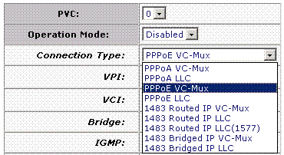
- Connection Type: Change connection method and packet encapsulation technique as instructed by your ISP. The available connection types are PPPoA VC-Mux, PPPoA LLC, PPPoE VC-Mux, PPPoE LLC, 1483 Routed IP VC-Mux, 1483 Routed IP LLC, 1483 Routed IP LLC(1577), 1483 Bridged IP VC-Mux, 1483 Bridged IP LLC from the pull-down menu. Default Connection Type = PPPoE VC-Mux.

- VPI: If instructed to change this, type in the VPI value for the initial connection (using PVC 0). Default = 0.
- VCI: If instructed to change this, type in the VCI value for the initial connection (using PVC 0). Default = 33.
- Bridge: This may be left t the default setting Disabled. Some users may opt to enable this now by selecting Enabled from the drop-down menu.
- IGMP: Leave this set to Disabled.
- IP Address: & Subnet Mask: Some users may be required to configure the IP settings for the WAN connection. If you are using IPoA or a Bridged IP connection, you may be instructed by your ISP to enter your global IP settings. If you are told to enter an IP Address and Subnet Mask, enter them here.
- DNS Some users will be required to enter an IP address used for DNS services. If you are given a DNS server IP address enter that here along with a secondary or back-up DNS server IP address if you were given one.
- For PPP connections (PPPoE or PPPoA), you must supply a User Name and Password used to verify the identity of your account.
- If you entered a DNS server IP address (Step 9) leave this set to Enable. If you are not using DNS, select the Disable option.
When you have defined the Quick Configuration settings, click the Submit button to save the settings in temporary memory. These settings and all other configuration changes made to the Router must be Committed (to non-volatile memory) and the Router must be rebooted for the changes to go into effect. The Router will negotiate the ADSL connection automatically upon rebooting. Continue to the Commit & Reboot procedure.

Commit & Reboot
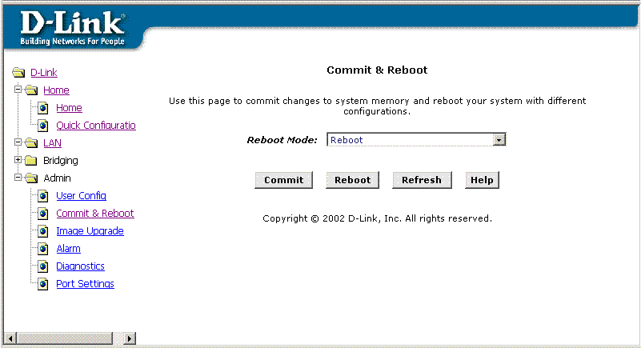
Commit and Reboot Menu
To save current configuration settings as they have been submitted click the Commit button. A message informs you when the settings have been successfully committed to memory. You must now reboot the device to put the settings into effect. Make sure Reboot is selected in the Reboot Mode: pull-down menu and click .
After the Router has rebooted it will begin to negotiate the ADSL connection for your account. This will normally take a few seconds. When the ADSL connection has been successfully established, the ADSL Link LED indicator will light steady green. If the ADSL Link indicator does not light after a minute or so access the web configuration manager an double check the settings.
Note | Bridged connections often use PPP connection software to establish the connection and verify the identity of the user. If you have been given a CD with connection software for your computer, install this now following the instructions of your ISP. After the Router has rebooted it will negotiate the ADSL connection.

Connect to the Internet
Upon restart, the Router is ready to use. You can check the status of the ADSL connection by reconnecting to the Router’s management software with your browser. Access the Router again using the same procedure described earlier. You can see the status of the ADSL connection listed under DSL in the System View menu. This is the first menu that appears when you access the configuration software. Look at the Operational Status: indicator. This will tell you that the Router is connecting or has already connected to your ISP’s network. When this indicator is Green, you may use your browser to surf the Internet or continue to configure the Router.

