DFE-520TX

Date: March 15, 2005

Product name: | DFE-520TX
Product Group & Type:
Revision: | A1
Available:
Picture: | 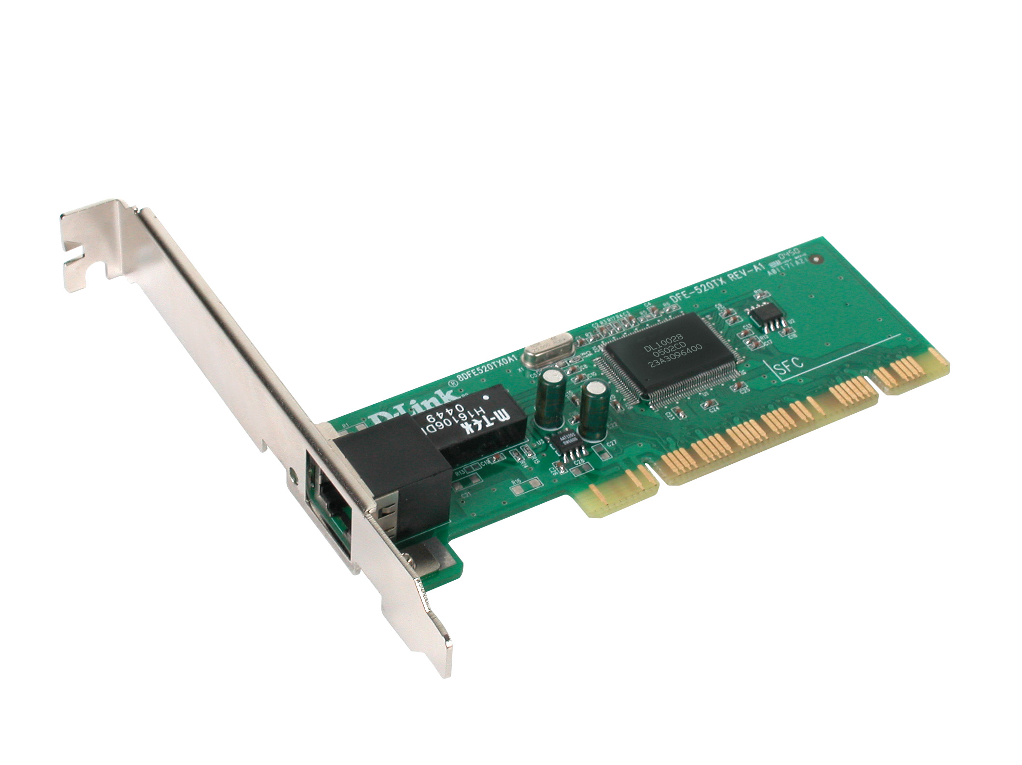
Why Sell This Product: | - This network card is the lowest cost network card offered by D-Link. It provides the basic functions for desktop Ethernet connection (no WOL, no boot ROM). It’s target at users needing just the basic Ethernet connection.  Selling Points  - Extremely low price.  - Single-chip solution for high hardware reliance.  - Small size, light weight.
Key Features: | - 802.3 10BASE-T/802.3u 100Base-TX standard  - Auto-detection of 10Mbps and 100Mbps network speeds  - Supports 802.1x function (MD5 only)  - 32-bit PCI Local Bus Master high-speed operation  - Full/half duplex operation  - Complies with Advanced Configuration and Power Interface specification v.1.0  - Complies with PCI Power Management v.1.1  - Supports 802.3x Flow Control  - Supports PCI clock speed up to 33Mhz independent of network clock  - On-board FIFO buffer, no external memory on host required  - Low Ethernet command processing overhead
Technical Details: | General  Standards  - IEEE 802.3 10BASE-T Ethernet  - IEEE 802.3u 100BASE-TX Fast Ethernet  - IEEE 802.3 NWay auto-negotiation  - IEEE 802.3x Flow Control  - PCI local bus 2.2 specification  Topology  Star  Protocol  CSMA/CD  Network Data Transfer Rates  - 10BASE-T:  10Mbps (half-duplex)  20Mbps (full-duplex)  - 100BASE-TX:  100Mbps (half-duplex)  200Mbps (full-duplex)  Network Cables  - 10BASE-T:  UTP Cat.3, 4, 5 (100 m max.)  EIA/TIA-568 STP (100 m max.)  - 100BASE-TX:  UTP Cat. 5 (100 m max.)  EIA/TIA-568 STP (100 m max.)  Diagnostic LED Report  - Link  - Activity  Physical & Environmental  Power Consumption  0.4 watts max.  Dimensions  120 x 20 mm  Weight  106 grams  Operating Temperature  0 to 40 ℃  Storage Temperature  -10 to 70 ℃  Operating Humidity  10% to 90% RH  Storage Humidity  5% to 90% RH  Emission  - FCC Class B  - CE Class B  - C-Tick  O.S. Driver Support  Microsoft Windows 98 SE, 2000, ME, XP
EMI/EMC Report | ☑FCC No. ☑ CE No. ◻ VCCI No.  ◻ CTR-21 No. ☑ C-Tick No. ◻ A-Tick No.  ◻ FDA No. ◻ R&TTE No. ◻ BSMI No.  ◻ Others
Safety | ◻ TUV No. □ CUL No. ◻ CSA No.  ◻ Others
Packaging Style | ☑ Clamshell ◻ White Box◻ Gift Box ◻ Bulk □ White Box with D-Link Logo  ◻ Others
Packaging Contents: | - DFE-520TX NIC card  - One CD Rom for Manual/QIG/Driver  - One hard copy QIG
UPC Code:
  EFE520TX..A1 | 790069275562
  IFE520TX..A1 | 790069275579
  TFE520TX..A1 | 790069275586
  NFE520TX..A1 | 790069275593
  BFE520TX..A1 | 790069275609
Units Per Carton: | 60
Cartons Per Pallet: | For USA Air:12, Sea: 14 | For WW Air:16, Sea: 16
Dimensions and Weight: | Box:  mm,Others 160mm x 182mm x 20mm, 0.106 kg  Carton: 590x457x480 mm, 10.01 kg  Pallet: (by Air) 1220x1020x1453 mm, 136.2 kg (for USA)  1200x1100x2055 mm, 178.66 kg (for WW)  (by Sea) 1220x1020x2050 mm, 176.16 kg (for USA)  1200x1100x2055 mm, 178.66 kg (for WW)  INTRASTAT weight: 0.058 kg (Box)  Packing material weight (Box):  - Paper: 0.022 kg  - Plastic: 0.017 kg  - Mixed: 0.019 kg

PMA
Product Class
Item Group
Sub Group
Intelligence
Tech.(Features)
Layer
Application
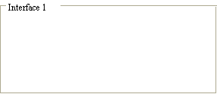
Q'ty

Interface
Net Interface
Port NO.

