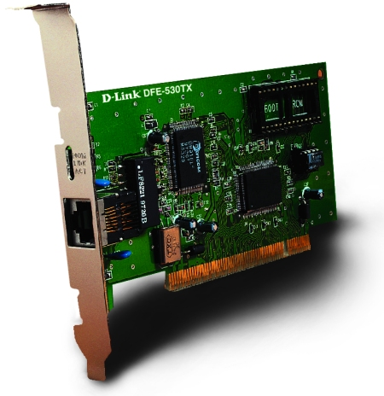

DFE-530TX
The adapter's single RJ-45 connector senses the network speed and automatically adjusts itself to the connected network type.
Plug and Play Installation
As a PCI v.2 1 local bus-compliant adapter, the DFE-530TX features plug and play installation.
High Performance
The DFE-530TX uses the bus master burst mode to directly transfer network data between the card and the host's memory, bypassing the host's CPU to offload the host's work load. This PCI adapter removes network bottlenecks and is ideal for high-power servers and videographic or multimedia stations.
Features
- Single RJ-45 connector
- Auto detection of 10Mbps Ethernet and 100Mbps Fast Ethernet.
- Windows 95 certified for Plug-n-Play functionality.
- 32-bit Bus Mastering with Burst Mode and Independent FIFO buffers.
- ISO 9001 Certified Manufacturing Facility.
- Uses D-Link Ethernet Controller.
- Can plug into Pentium / 486 machine's PCI Bus Master slot, independent of the CPU speed.
- Complies with the Ethernet/IEEE 802.3 100Base-TX and 10Base-T industry standard for easy migration.
- Support half and full duplex operation.
- Supports PCI clock speed up to 33Mhz, independent of network clock.
- Built-in FIFO buffers to eliminate external memory.
- Multi-thread operation.
- Low Ethernet Command Processing Overhead.
- 32-bit Memory addressing (4GB) over the PCI bus.
- Extensive use of VLSI components to provide high hardware reliability, small power consumption and reduced network interface card size.
- 3 LED indicators (Link/Act, 100M, Full Duplex).
Drivers Supported
- Novell
- ODI
- NDIS
- SCO Unix
- LAN Manager
- Windows for Workgroups
- Windows NT
- Windows 95
- Windows 98
- NetBIOS

