
Please note that you will need Cat5, RJ-45 cable to complete your network installation. Please see Appendix B for more information regarding cables.

Inserting the DFE-690TXD Cardbus PC Card into your laptop
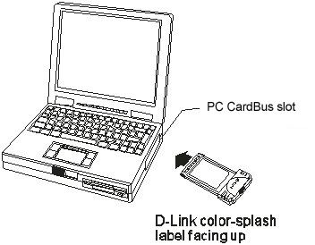
With the laptop turned ON,
insert the DFE-690TXD
Cardbus PC Card
into your laptop.
Gently insert the front end of the DFE-690TXD (with the yellow “arrow”
on the card pointing toward
the computer) into the Cardbus PC
slot on your laptop,
until it is firmly seated.


Running the “Found New Hardware Wizard”

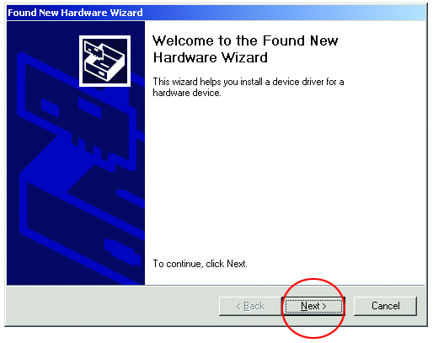
This “Welcome” screen will appear.

Click Next
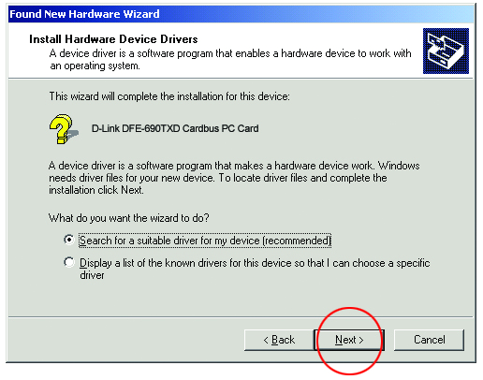
Running the “Found
New Hardware
Wizard”
continued

Select “Search for a suitable
driver for my device.”

Click Next

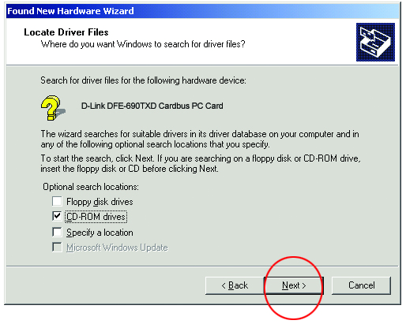
At this screen,
select “CD-ROM drives.”
Insert the CD that is included with the DFE-690TXD.

Click Next
Windows will copy the files to the hard drive.

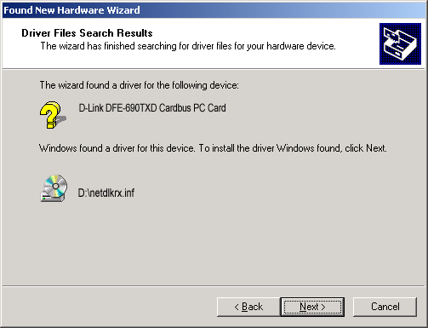
The “Found New Hardware Wizard” will find
the driver.

Click Next

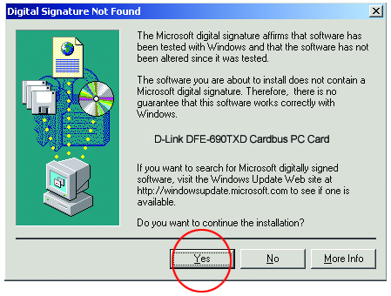

Click Yes

Running the “Found New Hardware Wizard”
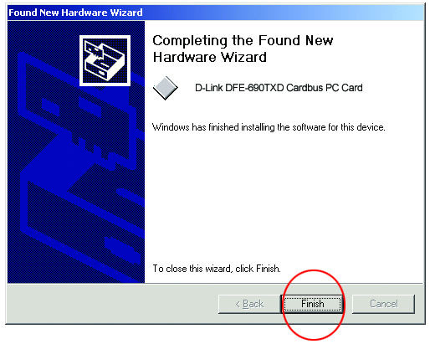
continued

The “Found New Hardware Wizard” has completed the installation.

Click Finish

Please see Appendix A to check the installation.

Connecting to your network
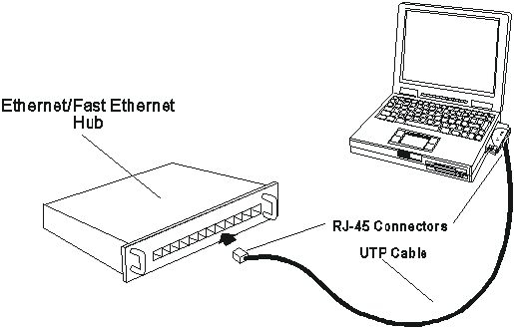

After the Hardware Wizard” has completed the installation of the DFE-690TXD,
you can make your network connection.
Please insert one end of the RJ-45 cable into the built-in connector of the DFE-690TXD CardBus PC Card, and then insert the other end of the RJ-45 cable into
your networking hub or switch.
Please see Appendix A to check the installation.
You are now networked! Please see Appendix B for information on cables.

For more information, please see your User’s Manual

Appendix A
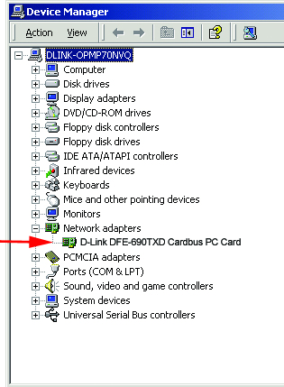
To check the installation
of your DFE-690TXD,
please go to:
START > SETTINGS >
CONTROL PANEL.
Double click on the “System” icon.

At the “System Properties”
window, click on the
“Device Manager” tab.
Your DFE-690TXD will appear
under “Network Adapters,”
as shown.

Appendix B

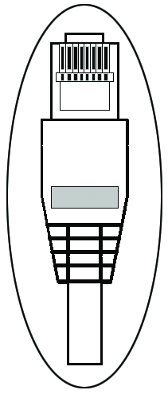
Connecting Your Network Cable
Category 5 UTP cable can be used for both Fast Ethernet cabling and for traditional Ethernet cabling.

Connecting for Fast Ethernet cabling
Cat5 cable is required for Fast Ethernet operation. The maximum cable length between the DFE-690TXD and the supporting hub is 300 ft. The cable must be “straight” (not a “crossover” cable), with an RJ-45 plug at each end.

Connecting for traditional (10Mbps) Ethernet cabling
Category 3, Category 4, and Category 5 UTP cable, as well as EIA/TIA-568 100-ohm STP cable, all qualify under traditional Ethernet cabling rules. The maximum cable run between the DFE-690TXD and the supporting hub is 300 ft.
The cable must be “straight” (not a “crossover” cable) with a
RJ-45 plug at each end. 6012+9600067

