

Please note that you will need Cat5, RJ-45 cable to complete your network installation. Please see Appendix B for more information regarding cables.

Inserting the DFE-690TXD Cardbus PC Card into your laptop
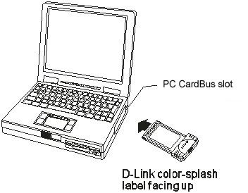
With the laptop turned ON,
Insert the DFE-690TXD
Cardbus PC Card
into your laptop.
Gently insert the front end of the Cardbus PC Card
(with the yellow “arrow”
on the card pointing toward
the computer) all the way into the Cardbus PC slot on your laptop,
until it is firmly seated.


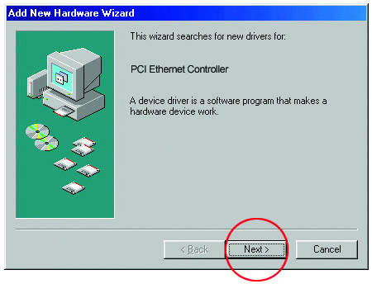
Running the “Add New Hardware Wizard”

Windows will automatically detect new hardware and begin
searching for drivers.

Click Next

Running the “Add New Hardware Wizard”
continued
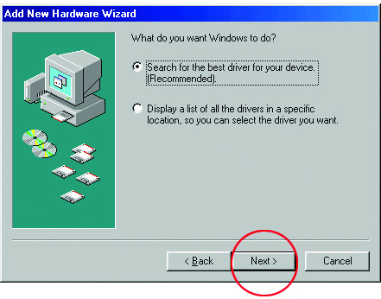

At the next screen, select “Search for
the best driver for your device.”

Click Next to continue the installation.
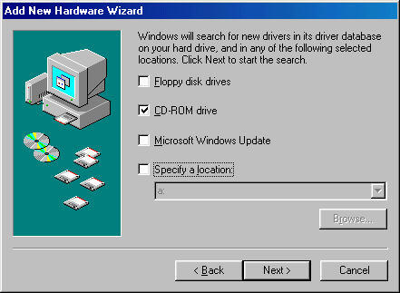
At the following screen, select “
CD-ROM Drive”

Insert the CD that is included with the
DFE-690TXD

Click NEXT.

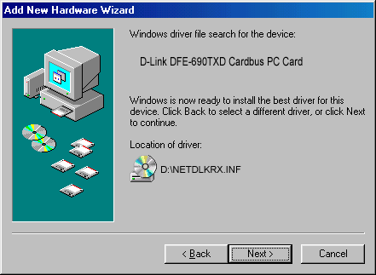
The “Hardware Wizard” will
find the driver for your Cardbus
PC Card.

Click Next, to continue.

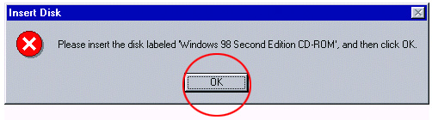
If prompted for the Windows 98 CD,
insert the Windows 98 CD into the
CD-ROM drive.

Click OK

Running the “Add New Hardware Wizard”
continued
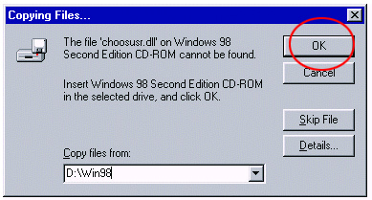

Specify the correct location in the “Copy files from:” box. If the CD-ROM drive is the D: drive, then type D:\Win98 in the box. (Some computers will have the Windows98 files available in the C:\Windows\options\cabs directory.)
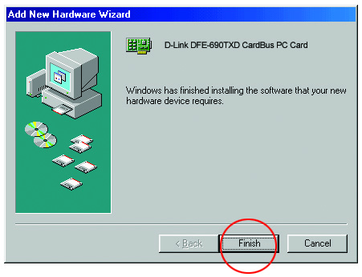
After typing in the location,
Click OK
Windows will copy the necessary files.

To complete the installation,

Click Finish
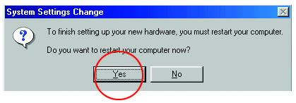
At this screen,

Click Yes to restart the computer.


Connecting to your network

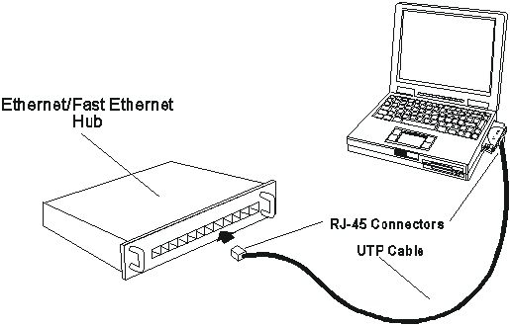
After the “Hardware Wizard” has completed the installation of the DFE-690TXD, you can make your network connection.
Please insert one end of the RJ-45 cable into the built-in connector of the DFE-690TXD CardBus PC Card, and then insert the other end of the RJ-45 cable into your networking hub or switch. Please see Appendix A to check the installation.
You are now networked! Please see Appendix B for information on cables.

For more information, please see your User’s Manual

Appendix A
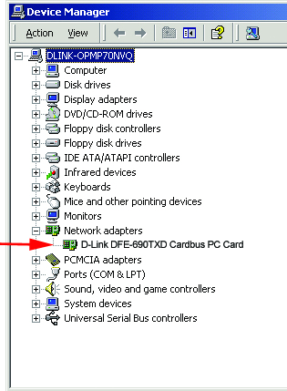
To check for proper installation
of your DFE-690TXD,
please go to
START > SETTINGS >
CONTROL PANEL.
Double click on the “System” icon.

At the “System Properties”
window, click on the
“Device Manager” tab.
Your DFE-690TXD will appear
under “Network Adapters,”
as shown.

Appendix B

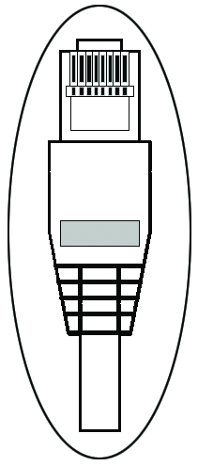
Connecting Your Network Cable
Category 5 UTP cable can be used for both Fast Ethernet cabling and for traditional Ethernet cabling.

Connecting for Fast Ethernet cabling
Cat5 cable is required for Fast Ethernet operation. The maximum cable length between the DFE-690TXD and the supporting hub is 300 ft. The cable must be “straight” (not a “crossover” cable), with an RJ-45 plug at each end.

Connecting for traditional (10Mbps) Ethernet cabling
Category 3, Category 4, and Category 5 UTP cable, as well as EIA/TIA-568 100-ohm STP cable, all qualify under traditional Ethernet cabling rules. The maximum cable run between the DFE-690TXD and the supporting hub is 300 ft. The cable must be “straight” (not a “crossover” cable) with RJ-45 plug at each end.

