
Please note that you will need Cat5, RJ-45 cable to complete your network installation. Please see Appendix B for more information regarding cables.

Inserting the DFE-690TXD Cardbus PC Card into your laptop
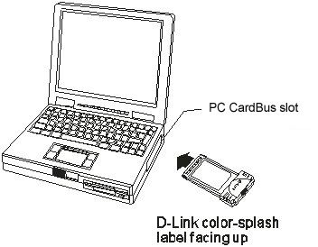
With the laptop turned ON,
insert the DFE-690TXD

Cardbus PC Card
into your laptop.
Gently insert the front end of the Cardbus PC Card
(with the yellow “arrow”
on the card pointing toward
the computer) all the way into the Cardbus PC slot on your laptop,
until it is firmly seated.


Running the “Add New Hardware Wizard”
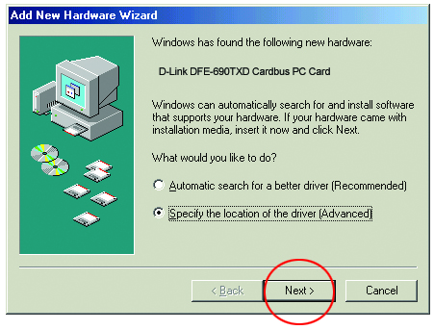

Windows will automatically detect new hardware and begin searching for drivers.
Insert the CD that is included with your purchase of the DFE-690TXD.
Select “Specify the location of the driver.”

Click Next
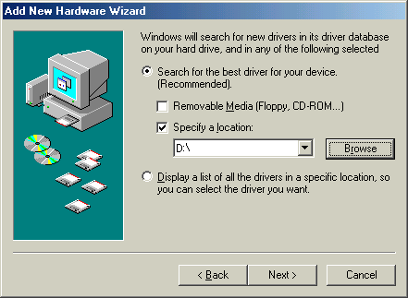
Running the
“Add New Hardware Wizard”

At this screen, select “Search for the best driver for your device.”
Choose “Specify a location.”
Type the drive letter for the CD-ROM into the box or choose “Browse” to highlight the CD-ROM drive. Click Next

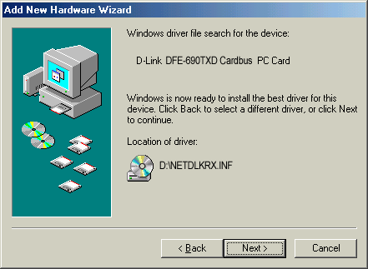
The Wizard has located the driver on the CD-ROM drive.

Click Next
Windows will copy the files to the hard drive.
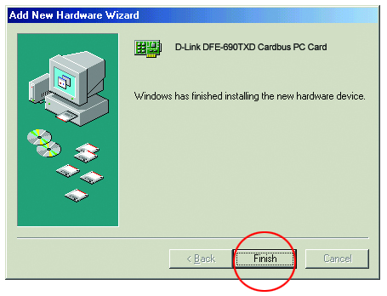
Windows has finished installing the DFE-690TXD.

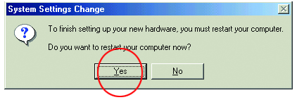
Click Finish

Select “Yes” to restart the computer.


Connecting to your network

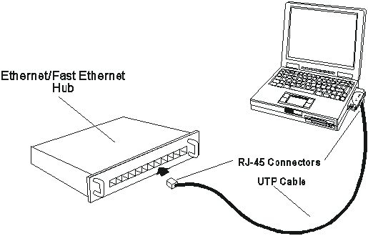

After the “Hardware Wizard” has completed the installation of the DFE-690TXD, you can make your network connection.
Please insert one end of the RJ-45 cable into the built-in connector of the DFE-690TXD Cardbus PC Card, and then insert the other end of the RJ-45 cable into your networking hub or switch.
Please see Appendix A to check the installation.
You are now networked! Please see Appendix B for information on cables.


For more information, please see your User’s Manual

Appendix A
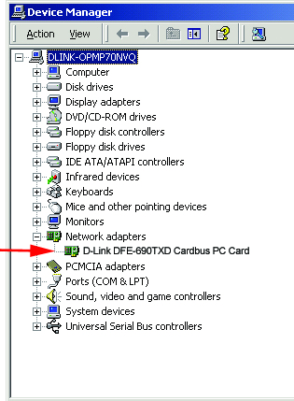
To check the installation
of your DFE-690TXD,
please go to:
START > SETTINGS >
CONTROL PANEL.
Double click on the “System” icon.

At the “System Properties”
window, click on the
“Device Manager” tab.
Your DFE-690TXD will appear
under “Network Adapters,”
as shown.

Appendix B

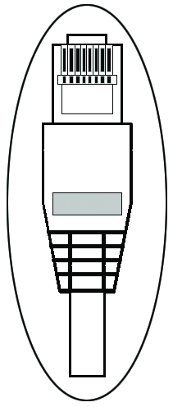
Connecting Your Network Cable
Category 5 UTP cable can be used for both Fast Ethernet cabling and for traditional Ethernet cabling.

Connecting for Fast Ethernet cabling
Cat5 cable is required for Fast Ethernet operation. The maximum cable length between the DFE-690TXD and the supporting hub is 300 ft. The cable must be “straight” (not a “crossover” cable), with an RJ-45 plug at each end.

Connecting for traditional (10Mbps) Ethernet cabling
Category 3, Category 4, and Category 5 UTP cable, as well as EIA/TIA-568 100-ohm STP cable, all qualify under traditional Ethernet cabling rules. The maximum cable run between the DFE-690TXD and the supporting hub is 300 ft.
The cable must be “straight” (not a “crossover” cable) with RJ-45 plug at each end.

