

Contents of Package
Make sure the package contains the following items. If any items are missing, contact the reseller.
- DFE-690TXD Cardbus (10/100Mbps Ethernet) PC Card for Macintosh
- Quick Install Guide
- CD-ROM, which includes driver software

Before you begin, make sure that you have the following:
- A PowerPC-based Macintosh Powerbook or iMAC laptop computer with a 32-bit Cardbus PCMCIA slot. (The DFE-690TXD is not compatible with Macintosh 16-bit Card Services PCMCIA slots.)
- Macintosh Operating System 8.0 or higher

When you have completed the installation, your network may look similar to this:
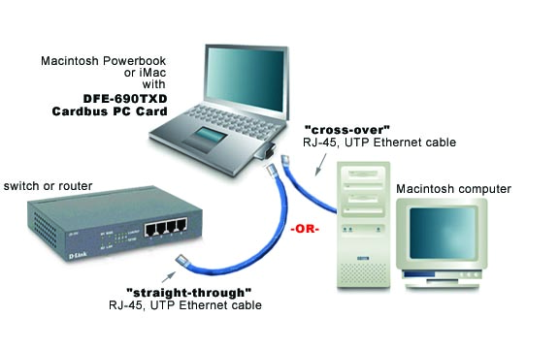

Inserting the DFE-690TXD into your laptop
With the laptop turned “OFF,” insert the DFE-690TXD Cardbus PC Card into an available PCMCIA slot. Turn “ON” the computer.
(Note: There may be a warning screen, indicating that the appropriate software is not available for the new device. Ignore this message and click “Cancel” to continue the installation.)


Installing the driver
Insert the DFE-690TXD CD-ROM into Macintosh’s CD-ROM drive.
When the CD-ROM icon appears on the Desktop, double-click to open it.
The window below will appear. Double-click the Macintosh folder.

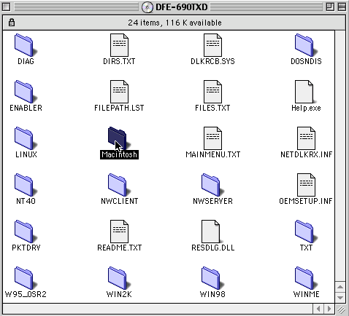

-2-
Click on the “DFE-690TXD Driver for Mac OS” folder and drag it to your desktop. Double-click on the folder to open it.
Installing the driver (continued)
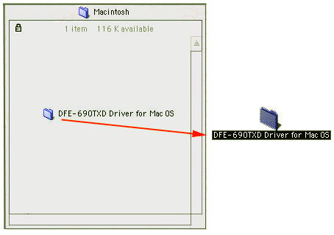

Double-click on the “Installer” icon to begin the installation.
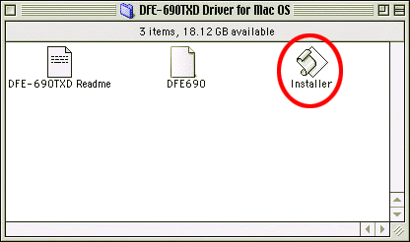

-3-
Installing the driver (continued)

Click “Install”
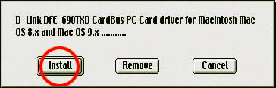

Click “OK” to restart your computer.

-4-

Verifying the Installation of the DFE-690TXD

After the Macintosh restarts, the driver will be installed. To check on the driver, open the Apple Menu and choose “Extensions Manager.” When it opens, you will see a “Controls Panels” heading and an “Extensions Manager” heading. Scroll down to the “Extensions” heading and look for an Extension labeled “DFE-690.”
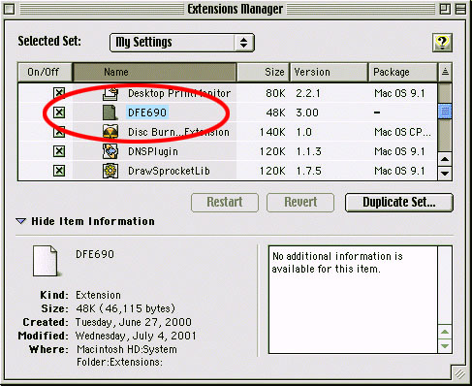
Make sure that the box to the left of “DFE-690” is checked to ensure that the driver is enabled.

-5-


Configuring Network Services

From the Desktop, open the Apple menu > choose Control Panels >

click TCP/IP.

- Click the “Connect via” list box arrow and select “Ethernet slot D-Link.”

Do not choose “DFE-690 Ethernet.”

- Next, click on the “Configure” list box. Choose “Manual” (For Static Addressing) or “Using DHCP Server” (for Dynamic Addressing.) Choose “Quit” from the File Menu. When prompted to save the new settings, Click “Save.”

- Restart the computer one more time. Your adapter is now ready to network with other computers.
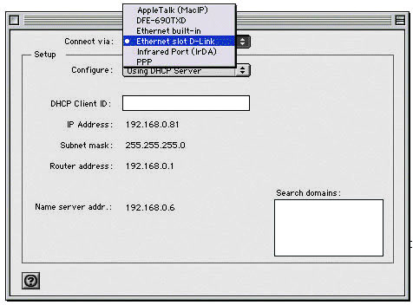

-6-
Connecting to Your Network
After the installation of the DFE-690TXD, you can make your network connection. Please insert one end of the RJ-45 “straight-through” cable into the built-in connector of the DFE-690TXD Cardbus PC Card, and insert the other end of the RJ-45 cable into your networking router or switch.
To connect your laptop directly to another Macintosh computer, please insert one end of a RJ-45 “crossover” cable into the built-in connector of the DFE-690TXD Cardbus PC Card, and insert the other end of the “cross-over” cable into the Ethernet port on your Macintosh computer.

You are now networked!

Technical Support

You can find the most recent software and user documentation
on the D-Link website.
D-Link provides free technical support for customers within the United States for the duration of the warranty period on this product.
U.S. customers can contact D-Link technical support through our web site, by e-mail, or by phone.
United States technical support, by phone, is available Monday through Friday from 6:00 a.m. to 10:00 p.m. (PST.)

Web:
http://www.dlink.com

Phone:
1-800-758-5489

If you are a customer residing outside of the United States, please refer to the list of D-Link locations that is included in the User’s manual.

DIGITAL HOME SOLUTIONS
6012+9600108
Printed in China

