DFL-M510

Date: July 12,2005

Product Description: | Information Security Gateway
Revision: | A1
Availability: | E/Jun , 2005
Picture: | 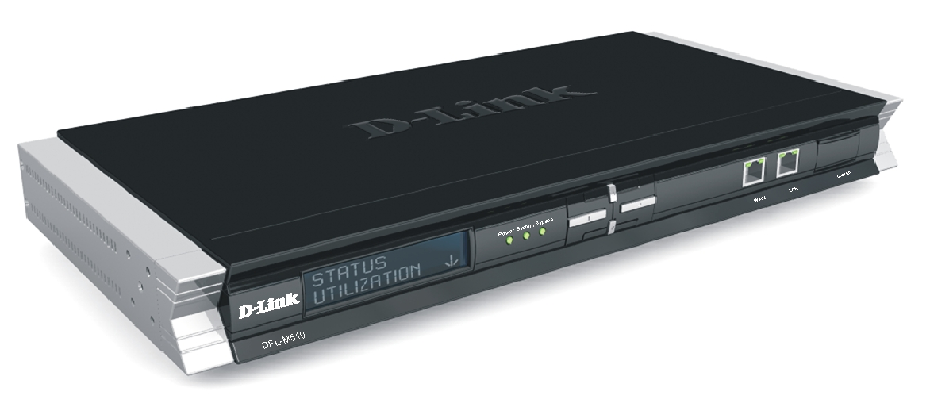
Why Sell This Product: | D-Link’s DFL-M510 Information Security Gateway is an entirely new type of security product for medium-sized and large business. Other vendors also have similar products but call them by different names. The primary purpose is to counter security threats caused by a surge in Internet messenger (IM) and peer-to-peer (P2P) applications in enterprises in recent years. We expect this product to become a major security product in the very near future, and it should be an ideal supplement to our NetDefend firewall product line.  Selling Points  - Complete IM and P2P application control  - Complete network security protection  - Complete web application control  - Complete streaming media/mail transfer support  - Real-time monitoring/complete log & report  - Better price/function ratio compared with similar product from other vendors  We’re attaching a Comparison Chart that compares the DFL-510 with other similar competitor products for your reference.
Key Features: | IM/P2P Application Management  - Supports Most IM/P2P Applications  - Blocks Viruses over IM/SPIM  - Prevents Misuse of IM/P2P Applications  Bandwidth Management  - Controls File Transfer/Streaming Media Over HTTP  - Controls Personal Mail  - Controls Web Usage  - QoS Bandwidth Management  Malicious Traffic Prevention  - Blocks Spyware, Network Worms, Trojan, Softether,  - Illegal Agents  - Identifies Victims  - Protects Against DOS/DDOS  - Zone-Defense Mechanism*  Traffic Monitoring/Report  - Monitors Traffic Real Time  - Provides Multi-layer TOP N Reports  Hardware  - Hardware-Based Layer 7 Payload Inspection  - Hardware Bypass to Maximize Network Uptime  - 1 Ethernet WAN Port, 1 Ethernet LAN Port  - Front Panel LCD/Key Pad to Display Status/Monitoring Information  * Available in future firmware upgrade
Technical Details: | Functions & Benefits  Real Transparent Mode Implementation  - Easy installation with no change to existing network architecture  - Interoperability with third-party network devices  Hardware-Based Layer 7 Payload Inspection  - High-performance processing via ASIC Content Processing Chip  Granular Management by Hosts, IPs, Groups, Subnets  - Transparent control of IM, P2P, file transfers, streaming media, personal mail  - Discreet control of Internet activities through application of policy-based actions on hosts, groups, IPs, subnets  Transparent Blocking of Trojan, Spyware, Illegal Agents (Softether), Network Worms  - Prevention of malicious traffic spreading on the network  Victim Identification  - Isolation of trouble spots for troubleshooting  Hardware Bypass  - No single points of failure, maximized network connection in case of a hardware crash  Log/Analysis Report  - Easily readable reports printable in html formats  DOS/DDOS Protection, Stealth Mode  - Protection from various kinds of DOS/DDOS attacks  - No response to ICMP packets in Stealth mode  Summary of Main Functions  IM/P2P Management  - Control/management of IM applications  - Control/management of P2P applications  - Policy setting by IP, host name, group or subnet  Layer 7 Applications Management  - Control/management of file transfers  - Control/management of streaming media  - Control/management of web applications  - Control/management of email for personal use  - User-defined application control  Health Checking  - Detection/blocking of malicious programs such as Spyware, Softether, Network Worms  - Victim identification in Intranet  - D-Link Zone Defense mechanism* to prevent malicious programs from spreading on network  Real-Time Monitor and Report  - Real-time traffic monitoring  - Multi-layer TOP N reports  Installation/Setup  - Plug-and-play installation with no change to existing network  - Transparent in-line mode, seamless integration with other network devices  - Java web-based setup Wizard  - Hardware bypass mechanism to maximize network connectivity  - Stealth mode for interfaces  Physical & Environmental  Ower Input  - Internal Universal Power Supply  Dimensions  - 440 x 250 x 44 mm 19-inch Standard Rack-Mount Width, 1U Height  Operating Temperature  - 0 to 60 ℃o  Storage Temperature  - -20 to 70 ℃  Operating Humidity  - 5% to 95% non-condensing  EMI  - FCC Class A  - CE Class A  - C-Tick  Safety  - TUV  - UL(EN60950)
EMI/EMC Report | ☑FCC No. ☑ CE No. ◻ VCCI No.  ◻ CTR-21 No. ☑ C-Tick No. ◻ A-Tick No.  ◻ FDA No. ◻ R&TTE No. ◻ BSMI No.  ◻ IC No. ◻ Others
Safety | ◻ TUV No. ☑ UL No. ◻ CSA No.  ☑ CB No. ◻ Others
Packaging Style | ◻ Clamshell ◻ White Box ◻ Gift Box ◻ Bulk ☑ Brown Box ◻ Others
Packaging Contents: | - DFL-M510 x 1  - CAT5 Ethernet cable x 1  - Master CD x 1  - Power cord x 1  - Console cable x 1  - Rack mount brackets x 2
UPC Code:
  UPC code |  | Part Number
  790069 | 276682 | IFLM510B..A1
  790069 | 282485 | EFLM510BE.A1
  790069 | 275777 | EFLM510B..A1
  790069 | 275784 | EFLM510E..A1
  790069 | 275791 | IFLM510A..A1
  790069 | 275807 | IFLM510E..A1
  790069 | 275814 | IFLM510N..A1
  790069 | 282454 | TFLM510A..A1
  790069 | 282461 | NFLM510C..A1
  790069 | 282478 | BFLM510A..A1
Units Per Carton: | For USA | For EU | For WW
Units Per Carton: | 4 | 4 | 4
Cartons Per Pallet: | For USA | For EU | For WW
Cartons Per Pallet: | Air: 12 , Sea: 16 | Air: 16, Sea: 16 | Air:12 , Sea: 16
Dimensions and Weight: | Box:  ◻ 237x168x36mm (Type A) ◻ 225x150x75mm (Type B)  ◻ 269x162x65mm (Type C) ◻ 274x208x68mm (Type D)  ◻ 274x208x118mm (Type D1) ◻ 274x208x138mm (Type D2)  ◻ 288x245x66mm (Type E)  Others 544x385x109 mm, 4 kg  Carton: 563x448x419 mm, 17.6 kg  Pallet: (by Air) 1220x1020x1540 mm, 226 kg (for USA)  1200x1100x1965 mm, 297 kg (for EU)  1200x1100x1560 mm, 226 kg (for WW)  (by Sea) 1220x1020x1960 mm, 297 kg (for USA)  1200x1100x1965 mm, 297 kg (for EU)  1200x1100x1960 mm, 297 kg (for WW)  INTRASTAT weight: 2.91 kg (Box)  Packing material weight (Box):  - Paper: 0.56 kg  - Plastic: 0.18 kg  - Mixed: 0.35 kg

PMA
Product Class
Item Group
Sub Group
Intelligence
Tech.(Features)
Layer
Application
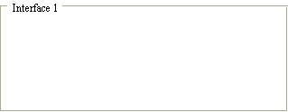
Q'ty

Interface
Net Interface
Port NO.
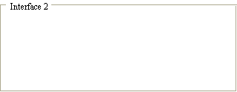
Interface
Net Interface
Port NO.

