

ENGLISH

DSA-5100
Wireless Service Gateway Balancer
This product can be set up using any current web browser, i.e., Internet Explorer 6 or Netscape Navigator 6.2.3.
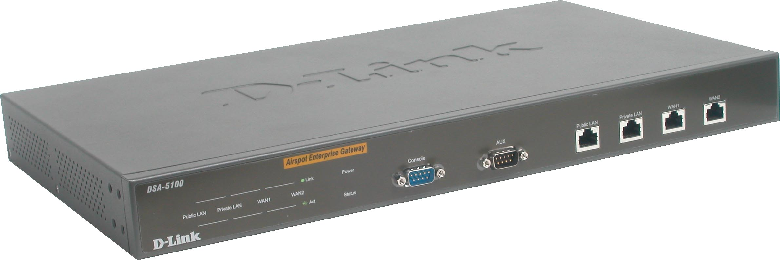

Before You Begin
This Quick Installation Guide (QIG) provides instruction for installing the DSA-5100 and Ethernet configuration for other PCs. The former part is going to show how to connect DSA-5100 with other Network equipments and Network configuration of DSA-5100. The latter part is a description for configuring Network setting of other PCs on Ethernet to make sure the normal function of whole Network.

Check Your Package Contents CCCCONCContents

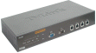
- DSA-5100 Wireless Service Gateway Balancer

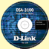
- CD-ROM (Containing Manual and Warranty)

- 4 Ethernet cable
- CAT5 UTP(Straight-through, white) ,
1 CAT5 UTP Crossover cable (blue)
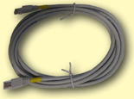


- RS232 Console Cable



Using a power cord
with a different voltage
rating will damage and void the
warranty of this product.
- Power Cord

If any of the above items are missing, please contact your reseller.

©2003 D-Link System, Inc. All rights reserved. Trademarks or registered trademarks are the property of their respective holders. Software and specifications subject to change without notice. DSA-5100. 05192003
Part No. IG-BDSA-5100
Product overview (Front)
POWER LED - Solid light: Power is on

light indicates a proper
connection to the power
supply.
WAN LED – a solid light
indicates connection on the
WAN port. The LED below
a connection from the Local
Network port for a Private
Network. The LED below blinks

WAN1 port - can be connected to the Internet or Intranet by Switch.
CONSOLE Port – For resetting to
factory defaults, or reconfiguring the device. For Advanced users only!

WAN2 port - can be connected to the Internet or Intranet by Switch.

Link LEDs – stands for being connected to RJ45 connectors

light indicates a proper
connection to the power
supply.
WAN LED – a solid light
indicates connection on the
WAN port. The LED below
a connection from the Local
Network port for a Private
Network. The LED below blinks

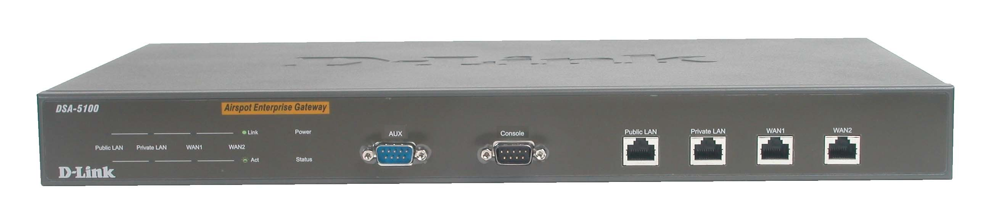
Public LAN port - can be connected to the open network environment managed by the system or WLAN , and requires authentication before logging on to the Internet.
ACT LEDs – stands for transmitting data.
AUX Port – Reserved for future usage

Private LAN port – can be connected to the trustful Intranet environment by Switch or Ethernet without authentication for logging on to the Internet.

Status LED – After boot up: Black: run BIOS.
Blink: run OS.
Solid light: System ready.

light indicates a proper
connection to the power
supply.
WAN LED – a solid light
indicates connection on the
WAN port. The LED below
a connection from the Local
Network port for a Private
Network. The LED below blinks

Product overview (Back)
Power Socket:
Power Cord Plug

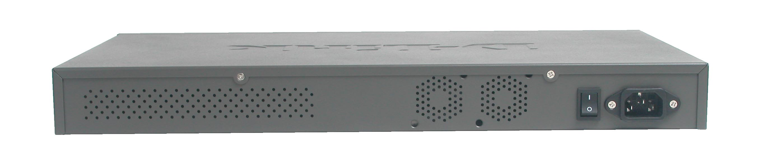


Connecting the DSA-5100 to Your Network

C
CCCONCContents

A. Ensure that the DSA-5100 is powered ON.

B. Public LAN Port Connection.
Please use a Straight-through Ethernet cable to connect the DSA-5100 to a switch
or a wireless access point to provide public access to your broadband
connection. The Link LED light will illuminate to indicate a proper
connection. If the Link LED does not illuminate, please check the
device’s physical connections.

C. Insert an Ethernet cable to the Private LAN Port on the front
panel of the DSA-5100. Connect the other end of the Ethernet cable to a switch.
If the Link LED illuminates, it means you have a proper connection.

D. Insert an Ethernet cable into the WAN1 port on the front panel of the DSA-5100.
Connect the other end to a router or directly to a high speed cable or DSL
modem. If the connection is live, then the Link LED will illuminate.

E. ( Optional ) Insert an Ethernet cable into the WAN2 port on the front panel of the DSA-5100. Connect the other end to a router or directly to a high speed cable. If the connection is live, then the Link LED will illuminate.


Using The Setup Wizard

C
CCCONCContents

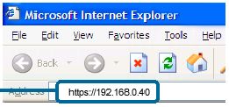
Open your Web browser and
type “https://192.168.0.40” into
the URL address box. Then press the Enter or Return key.

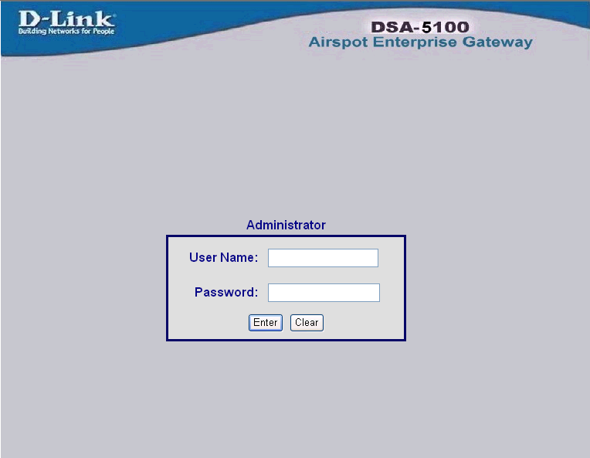
Type “admin” for both the username and the password
Click Enter
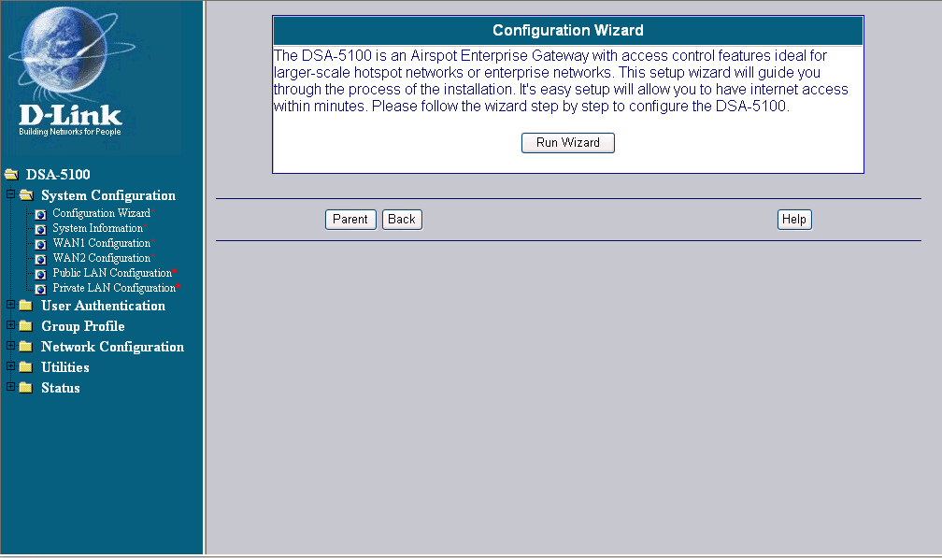
Click Run Wizard
Once you have logged in, the Home screen will appear.

2 . The setup Wizard (Continued)
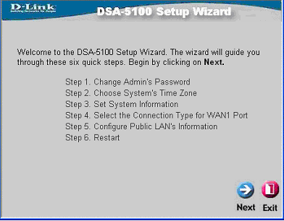
Click next
You will see the following screen
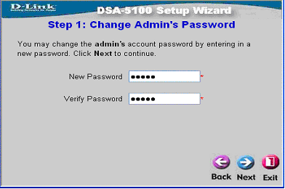
Click next
Set up your new password.
You have the option to establish a password.

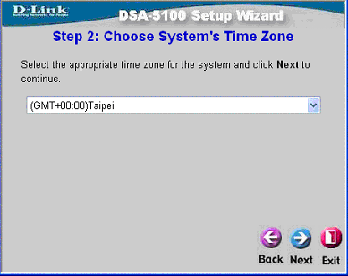
Click next
Select the appropriate time zone for your location
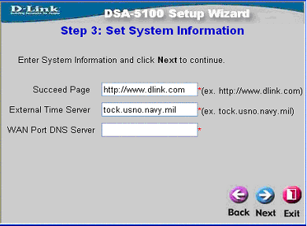
Click next
Set System Information in the
fields provided to you. The
Succeed Page is the URL that
you are directed to when you
have been successfully
Authenticated. The Time
Server and Domain Name
Server (DNS) must be required.

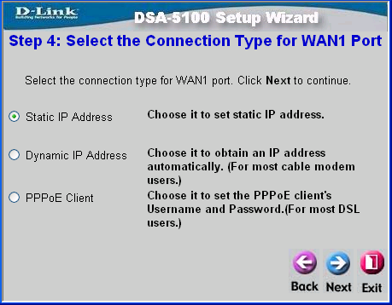
Click next
Select an Option
At this point, the setup wizard
will ask you for your Internet
connection type. If you have a Dynamic or PPPoE connection,you will be brought to the corresponding page.

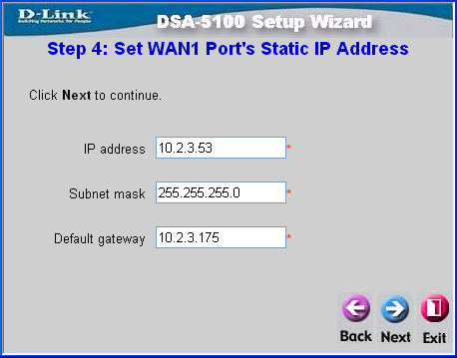
Click next
For Static IP Address :
Please enter the IP ,Netmask, and Gateway of WAN1 Port. After this setup is completed, click “Next” to continue or “Exit” to exit.

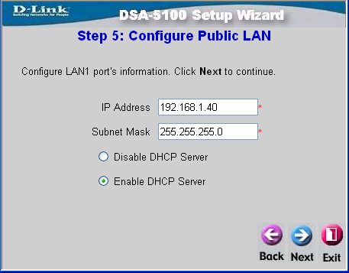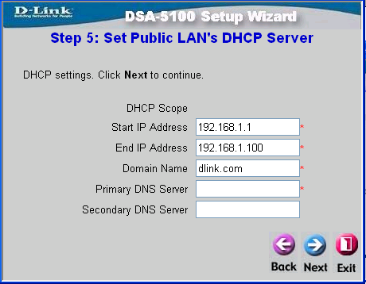
Click next
Click next
Configure Public LAN. You will be prompted to enter the settings for the Managed “Public” Network. You may also switch the DHCP Server ON or OFF.

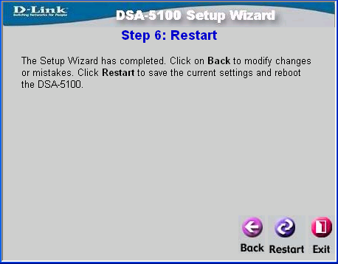
Click Restart
If you selected Enable DHCP Server, this screen will
appear:

Enter the settings in the fields provided to setup the distribution
of IP Addresses to clients on your network.

After Restarting the DSA-5100,
the basic setup for the unit is
complete. Please refer to the
User Manual for other advanced settings.

Verify if local user could pass the authentication, and then use the online Network:

- To add a local user account, please refer to manual for instructions.
2. After register a user account, please enter username and password in the User Login Page.

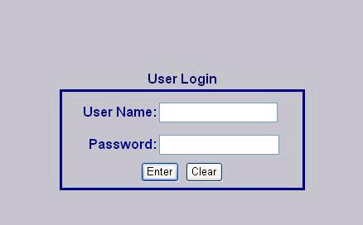
Example: Suppose a local user account has both username and password as “test”, then type “test” in respective field, then click “Enter”.

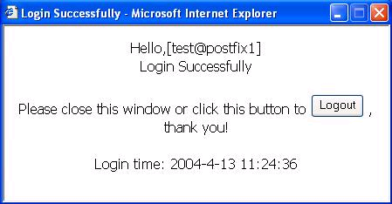
Check login status.

Technical Support
You can find software updates and user documentation on the D-Link website.
D-Link provides free technical support for customers within the United States and within Canada for the duration of the warranty period on this product.
U.S. and Canadian customers can contact D-Link technical support through our website, or by phone.

Tech Support for customers within the United States:
D-Link Technical Support over the Telephone:
(877) 453-5465
24 hours a day, seven days a week

D-Link Technical Support over the Internet:
http://support.dlink.com
email: support@dlink.com

Tech Support for customers within the Canada:
D-Link Technical Support over the Telephone:
(800) 361-5265
Monday to Friday 8:30am to 9:00pm EST

D-Link Technical Support over the Internet:
http://support.dlink.ca
email: support@dlink.ca

