CardBus 10M HomePNA Network Card

User’s Manual
REGULATORY STATEMENTS

Part15, Class B

This device complies with Part 15 of FCC rules. Operation is subject to the following two conditions:

- This device may not cause harmful interface, and
- This device must accept any interface received, including interface that may cause undesired operation. This equipment has been tested and found to comply with the limits for a Class B digital device, pursuant to Part 15 of the FCC Rules. These limits are designed to provide reasonable protection against harmful interference in a residential installation. This equipment generates, uses and can radiate radio frequency energy, and if not installed and used in accordance with the instructions, may cause harmful interference to radio communications. However, there is no guarantee that interference will not occur in a particular installation. If this equipment does cause harmful interference to radio or television reception, which can be determined by turning off and on, the user is encouraged to try to correct the interference by one or more of the following measures:
- Reorient or relocate the receiving antenna.
- Increase the distance between the equipment and receiver.
- Connect the equipment into an outlet on a circuit different from that to which the receiver is connected.

 Changes or modifications not expressly approved by party responsible for compliance could void the user authority to operate the equipment.
FCC Part 68 Registration
This equipment complies with Part 68 of the FCC Rules. On the bottom of this equipment is label that contains, among other information, the FCC registration Number and Ringer equipment Number (REN) for the equipment. If requested, this information must be given to the Telephone Company.
The REN is useful to determine the quantity of devices you may connect to your telephone line and still have all of those devices ring when your telephone number is called. In most, but not all areas, the sum of the REN’s of all devices connected to one line should not exceed five (5.0). To be certain of the number of devices you’re local telephone company to determine the maximum REN for you’re calling area. If your telephone equipment cause harm to the telephone network, the Telephone Company may discontinue your service temporarily. If possible, they will notify you in advance. But if advance notice isn’t practical, you will be informed of your right to file a complaint with the FCC.

Your telephone company may changes in its facilities, equipment, operations or procedures that could affect the proper functioning of your equipment. If they do, you will be notified in advance to given you and opportunity to maintain uninterrupted telephone service. If you experience trouble with this telephone equipment, please contact the following address and phone number for information on obtaining service or repairs. The telephone company may ask that your disconnect this equipment from the network until the problem has been corrected or until you are sure that the equipment is not malfunctioning. This equipment may not be used on coin service provide by the telephone company. Connection to party lines is subject to state tariffs.

Table of Contents
Introduction 1
Introduction to Cardbus 1
The CardBus HPNA 2.0 32bit PC Card 3
Features 3
System Requirements 4
Package Contents 4
Getting to Know Your Network Device 5
The Device’s Ports 5
The Device’s LEDs 6
Hardware Installation 7
Overview 7
Installing the CardBus Network Device & Cabling 8
Software Installation 9
Windows 98 Installation 9
Diagnostics & Statistics 13
Network Component Configuration 15
Using File And Printer Sharing 17
Enabling File Sharing 18
Enabling Printers Sharing 20
Windows 2000 Installation 21
Network Component Configuration 25
Windows ME Installation 29
Appendix 33
Specification 33

Introduction

Introduction to Cardbus
Cardbus is the next generation 32-bit version issued by PCMCIA PC Card standard. In addition to support a wider bus (32 bits instead of 16 bits), CardBus also supports bus mastering and operation speeds up to 33 MHz. The 132MBytes bus transfer rate (compares with legacy 16-bit I/0 PC Card, 20MByte) provides the mobile user to enjoy the high-bandwidth network connection.

A mobile computer, which equipped with CardBus and properly configured is the fundamental requirement to use the CardBus HPNA 2.0 32bit PC Card. To make sure about this point, please follow the guideline listed below:
- Cardbus is designed to support both 16-bit and Cardbus Card. But the legacy 16-bit PC Card slot couldn't accept the CardBus PC Card. In order to prevent the wrong operation, CardBus is thus developed with particular mechanical consideration to prevent it fit into the legacy 16-bit PC Card Slot. If you can't insert the CardBus HPNA 2.0 32bit PC Card into the slot firmly reaching the bottom, your notebook probably hasn’t the capability to support CardBus technology. Please check your notebook manual for detail information.
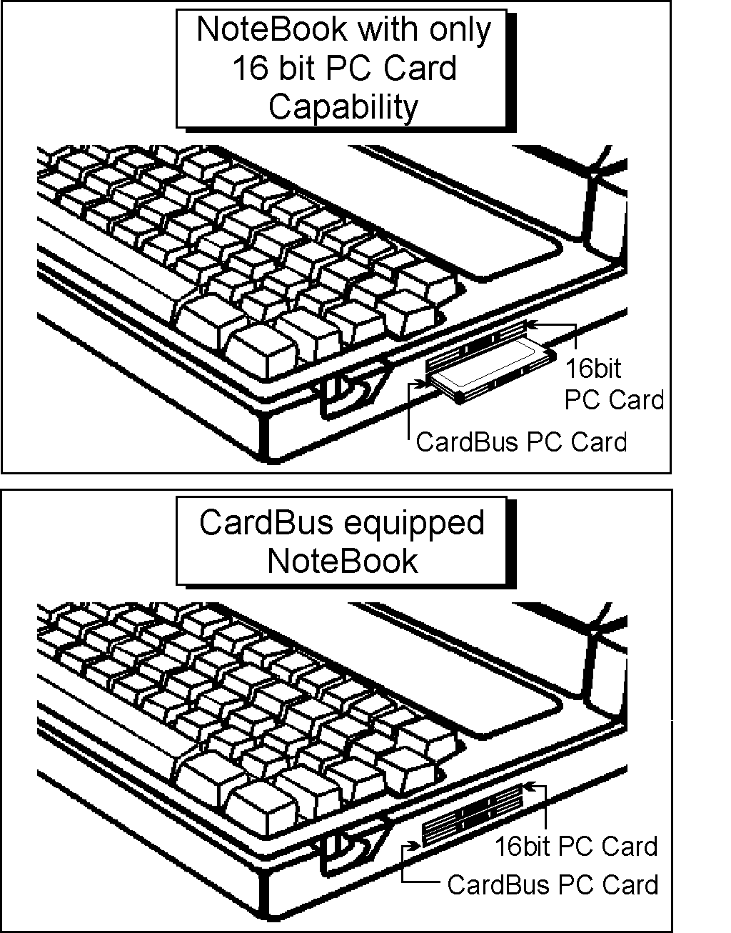
- Due to variant design of notebook computers, some models implement a setting in the Computer’s BIOS to switch between Cardbus and 16-bit PC Card modes. You could consult the User’s Guide of your notebook and properly set on the CardBus or Auto_Detect mode.

The CardBus HPNA 2.0 32bit PC Card
The CardBus HPNA 2.0 32bit PC Card is a device designed with HomePNA 2.0 specification. You can simply plug the cord into a standard phone jack and enjoy faster, less expensive Internet access. It is the ideal solution for the entire family and the rising number of households with more than one PC. With the device, you can go to the Internet and talk on the telephone simultaneously.

Like the first-generation HomePNA products, it uses your existing phone lines, but it can operate at speeds up to 10 Mbps. Unlike Ethernet, HomePNA doesn’t require a hub; each PC simply connects to the nearest telephone jack. It is easy to install, work well, and cost less. Furthermore, it is interoperable and backward-compatible with the older 1-Mbps solutions.

Features
- Builds a network using your existing telephone line -- no additional hubs or network cables needed
- Most convenient way to share the internet connection, file, printer and peripherals in Home
- Up to 10Mbps transfer rate over telephone lines
- Backward compatible with 1Mbps HomePNA 1.1 specification
- PC Card CardBus standard with high performance 32-bit PCI-like bus master architecture
- Hot Swap-- Insert or remove from PC without powering off
- Works with any CardBus-equipped PC
- Supports Microsoft Windows 98/2000/ME
- Supports two RJ-11 modular telephone ports
- 3 easy-to-read LED status indicators
- Connects up to 30 computers together on your Phonewire Network up to 1000 feet

System Requirements
- An IBM compatible notebook computer with CardBus supported socket
- Drivers and utilities provided with this product
- Windows 98/2000/ME preinstalled

Package Contents
- One CardBus 10M HomePNA Network Card
- One Driver Compact Disc
- One User’s Manual

Getting to Know Your Network Device

The Device’s Ports
- PHONE: connects to a telephone
set using a RJ-11 cable
- HOMELINK: connects to the phone
jack on the wall using a RJ-11 cable
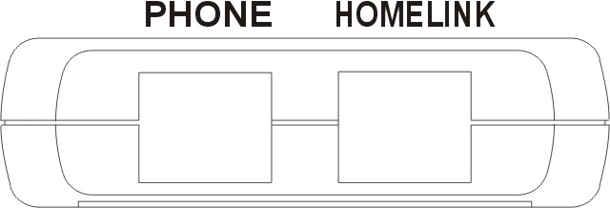

The Device’s LEDs
- Rx: blinks green when receiving data
- Tx: blinks green when transmitting data
- Link: lights green when well connected to
a phoneline network
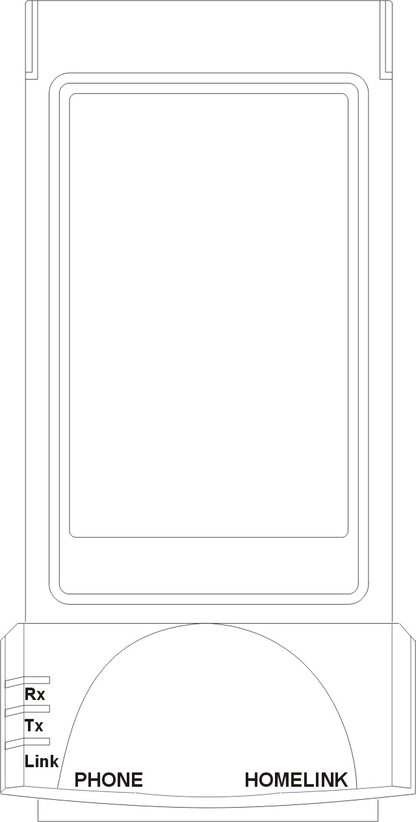

Hardware Installation

Overview
The following instructions show you how to install your CardBus 10M HomePNA Network Card. After you install the device, you must install the device’s driver on your PC and configure your PC to access your HomeLink phoneline network.

Driver installation and PC configuration instructions follow these hardware installation instructions.

Installing the CardBus Network Device & Cabling
- Insert CardBus 10M HomePNA Network Card into the CardBus slot of your system.
- Connect one end of the telephone cable to the HOMELINK port and the other end to the phone jack on the wall.
- Connect one of the telephone cable to the PHONE port and the other end to a telephone set.
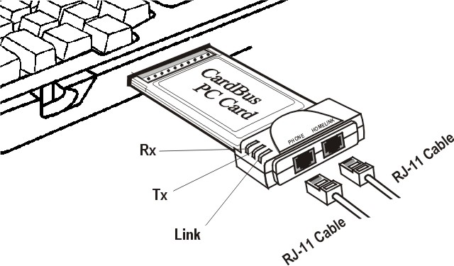

Software Installation

Windows 98 Installation
- Insert the network device into the CardBus slot of your system. Windows 98 will automatically detect the device and prompt you the following message. Click Next.
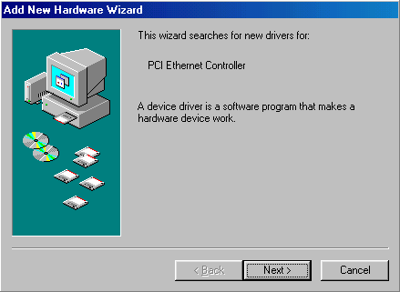
- Select Search for the best driver for your device (Recommended) and click Next.
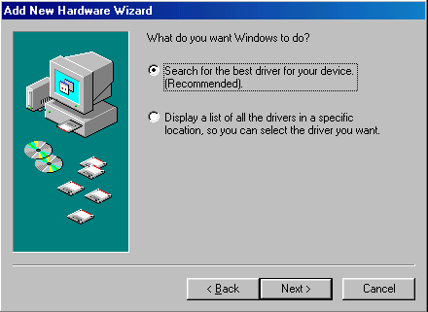
- Load the device driver compact disc into your CD-ROM drive, select CD-ROM drive and click Next. Windows 98 will start searching for the suitable driver for the device.
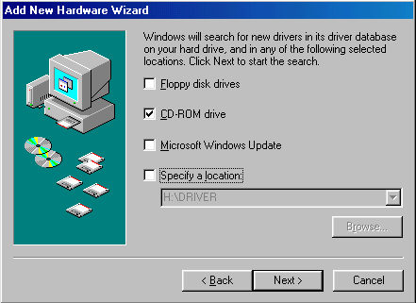
- Click Next. Windows 98 will copy necessary files onto your system. When asked to supply the original Windows 98 installation CD-ROM, you’ll need to place it into the CD-ROM drive for the software installation need.
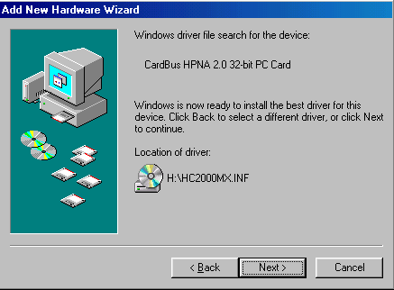
- Click Finish to complete software installation.
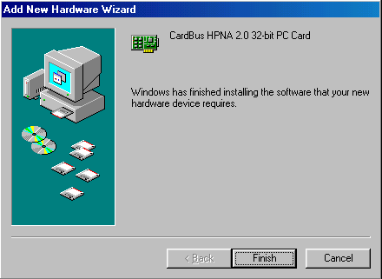
- When asked to restart your computer, click Yes to activate the device.
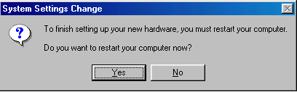
- To verify if the device exists in your computer and is enabled, go to Start→Settings→Control Panel→System. Click the Device Manager tab. If the CardBus HPNA 2.0 32bit PC Card is found, it means that your device is well installed and enabled. If not, consult your computer dealer for technical support.
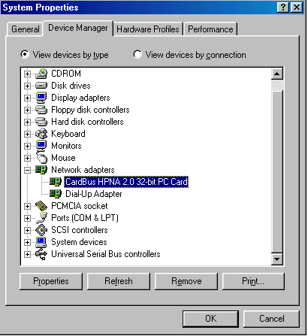

Diagnostics & Statistics
- When the device and software driver are well installed in your computer, you will see DHN-690 icon automatically displaying in the Control Panel. Double-click the DHN-690 icon, the following figure will appear on the screen.
- The General tab displays the information about the PC Card.
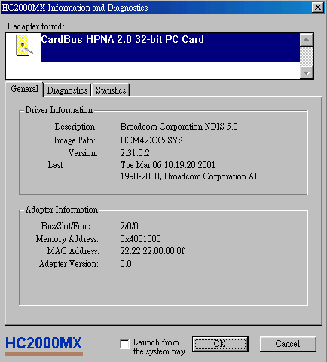
- The Diagnostics tab allows you to do the hardware self-testing for the PC Card. Click the Test Chip button to start. If for some reason, the bar appears red, it means the PC Card is defective. Consult your distributor for technical support.
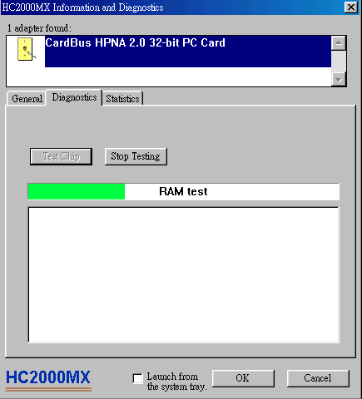
- The Statistics tab displays the network statistics information. If the Launch from the system tray is checked, the DHN-690 icon will appear on the Status Area on the right bottom of the Desktop. It is more convenient for you to use the application directly.
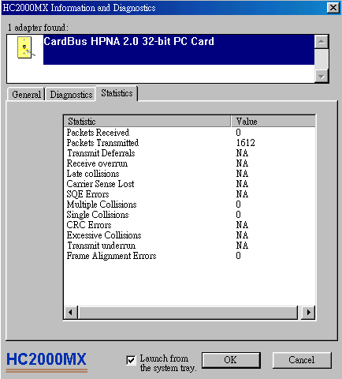

Network Component Configuration
- Once the driver has been installed, you must make some changes on your network settings. Click Start→Settings→Control Panel→Network and make sure that you have all the following components installed.
- Client for Microsoft Networks
- CardBus HPNA 2.0 32bit PC Card
- NetBEUI
- TCP/IP
If any components are missing, click the Add button to add them in. All the protocols and clients required and listed above are provided by Microsoft. After you click Add, highlight the component you need, click Add, highlight Microsoft, then double-click on the item you want to add.
- If you are using Windows 95 or Windows 98 network, enable the File and Printer Sharing to make your computer visible on the network.
- Click the Identification tab. Type the name of your computer in the computer name box. Make up a name that is unique among the computers names on your network.
- Type the name of your workgroup in the workgroup box. The name you type should be the same workgroup name in use by all of the other PCs on the network.
- Click the Access Control tab. Make sure that Shared-level access control is selected. If connecting to a NetWare server, share level can be set to User-level access control.
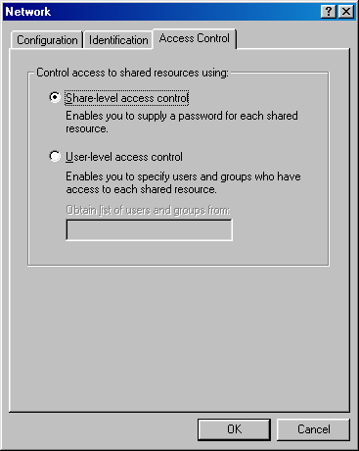
- When finished, remove all disks from your computer and restart your computer to activate the new device.
- Once the computer has restarted and Windows 98 has booted up, a Logon window will appear requiring you to enter a username and password. Make up a username and password, enter them, and click OK. Do not click the Cancel button, or you won’t be able to log onto the network.
- When you are at the Windows 98 desktop, double-click the Network Neighborhood icon. You should see the names of the other PCs on the network that have enabled file and printer sharing.

Using File And Printer Sharing
- Click Start→Settings→Control Panel. Double-click Network.
- Click the Configuration tab, followed by the File and Printer Sharing button. The File and Printer Sharing window will appear.
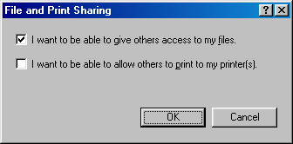
- If you'd like others to be able to access the files on your computer’s hard drive, select I want to be able to give others access to my files.
- If you'd like to share your printer with other users on the network, select I want to be able to allow others to print to my printer.
- Click OK. File and Printer Sharing for Microsoft Networks should now appear on the list of installed components. Click OK. When asked to restart your computer, choose to do so.

Enabling File Sharing
- Double-click My Computer. A window of available disk drives will appear.
- Right-click once the drive or folder that you want to make available to other users.
- Click Sharing, followed by the Sharing tab. Click Share As. In the Share Name box, enter a name for the drive or folder you are sharing, (eg: C-Drive, CD-ROM, Leela, etc.).
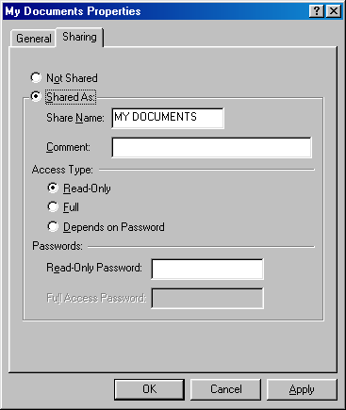
Next, decide on the access type that you want to give other users.
- Read-Only access lets other users view the files on your PC.
- Full access lets users create, change, or delete files on your PC.
- Depends on Password lets users have Read-Only and/or Full access, depending on the password that you decide to give them.
Use your mouse to select the access type that you want other users to have. If you want to assign access password(s), type them into the Password box (es).
If you are sharing a cable modem or DSL broadband connection that you will be using to access the Internet, you should protect all of your shared drives and printers with private passwords.
When finished, click Apply, followed by OK.

Enabling Printers Sharing
- Click Start→Settings→ Printers. A window of available printers will appear.
- Right-click the printer that you want to share with other users. Click Sharing, followed by the Sharing tab. Click Share As. In the Share Name box, give a name to the printer you're about to share (Jack's HP4, for example). If you want to assign a password to the printer so only certain users can access it, type a password in the Password box. When you're done, click Apply, followed by OK. Your printer(s) are now shared.

Windows 2000 Installation
- Insert the network device into the CardBus slot of your system. Windows 2000 will automatically detect the device and prompt you the following message. Click Next.
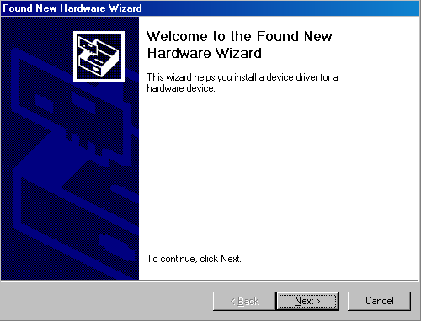
- Select Search for a suitable driver for my device (Recommended) and click Next.
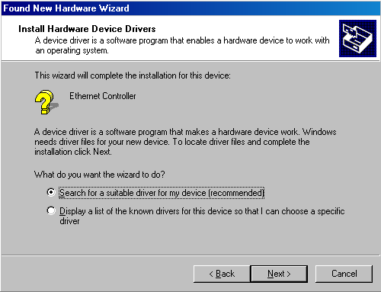
- Load the device driver compact disc into your CD-ROM drive, select CD-ROM drives and click Next. Windows 2000 will start searching for the suitable driver for the device.
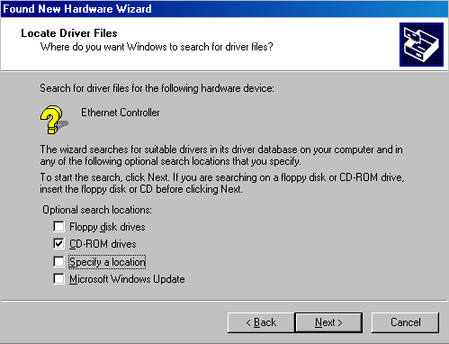
- Click Next. Windows 2000 will copy necessary files onto your system.
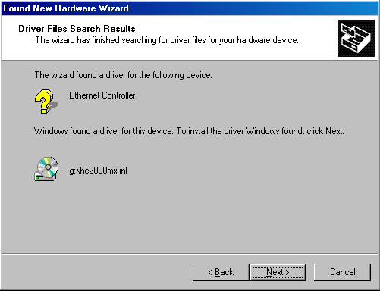
- Click Yes to continue.
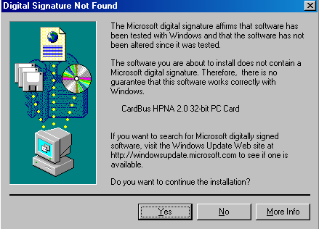
- Click Finish to complete software installation.
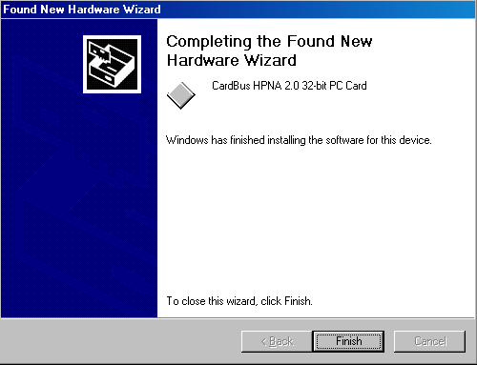
- To verify if the device exists in your computer and is enabled, go to Start→Settings→Control Panel→System→Hardware. Click the Device Manager button. If the CardBus HPNA 2.0 32bit PC Card is found, it means that your device is well installed and enabled. If not, consult your computer dealer for technical support.
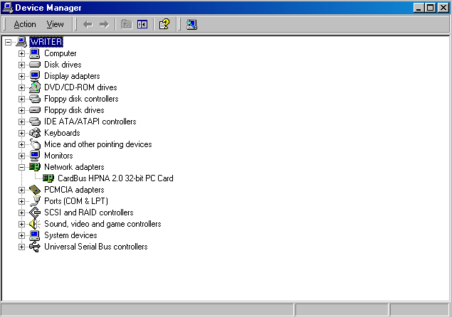
Note: For Diagnostics and Statistics about the PC Card, refer to the corresponding section in Windows 98 for more details.

Network Component Configuration
- Go to
Start→Settings→Control Panel→Network and Dial-up Connections.
- Double-click the Local Area Connection icon, the following figure will appear.
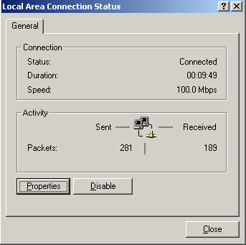
- Click the Properties button. Make sure the following components are installed.
- Client for Microsoft Networks
- File and Printer Sharing for Microsoft Networks
- NetBEUI Protocol
- Internet Protocol (TCP/IP)
If any components listed above are missing, click the Install button to add them in manually. Click Close to exit.
- Go to
Start→Settings→Control Panel→System.
Open the Network Identification tab and click the Properties button.
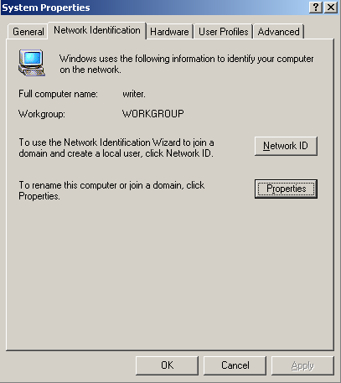
- Type the name of your computer in the computer name box. Make up a name that is unique among the computers names on your network.
- Type the name of your workgroup in the workgroup box. The name you type should be the same workgroup name in use by all of the other PCs on the network.
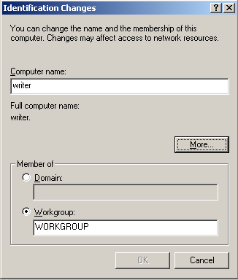
- When finished, remove all disks from your computer and restart your computer to activate the new device.
- Once the computer has restarted and Windows 2000 has booted up, a Logon window will appear requiring you to enter a username and password. Make up a username and password, enter them, and click OK. Do not click the Cancel button, or you won’t be able to log onto the network.
- When you are at the Windows 2000 desktop, double-click
My Network Places→Computers Near Me. You should see the names of the other PCs on the network that have enabled file and printer sharing.

Note: For the way of Using File And Printer Sharing, please refer to the related sections in Windows 98 for more details.

Windows ME Installation
- Insert the network device into the CardBus slot of your system. Windows ME will automatically detect the device and prompt you the following message. Select Specify the location of the driver (Advanced) and click Next.
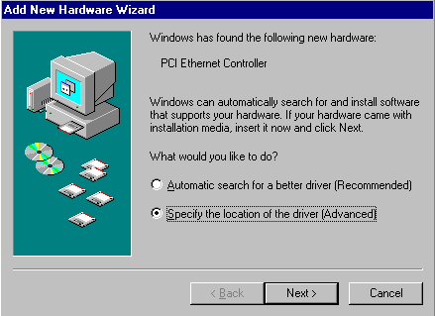
- Highlight the drive where the device driver is (in this case is H:) and click OK.
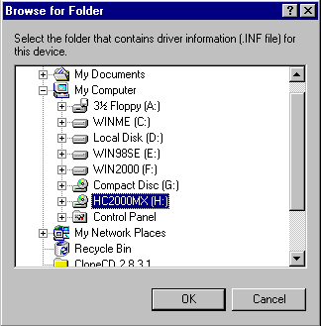
- Select Search for the best driver for your device (Recommended), check Specify a location. Press the Browse button to select drive H: and click Next.
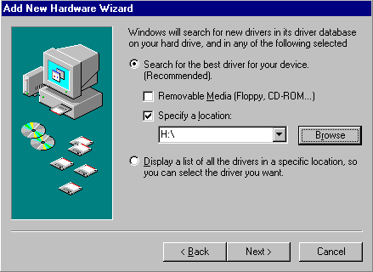
- Click Next. Windows ME will copy necessary files onto your system.
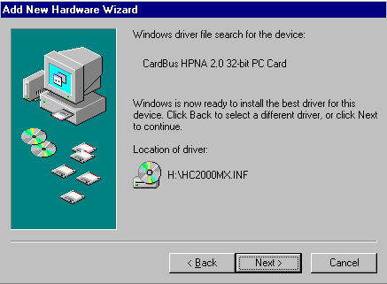
- Click Finish to complete software installation.
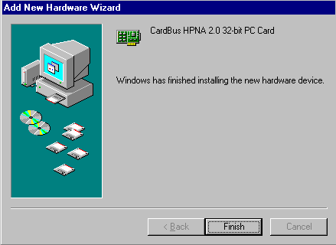
- When asked to restart your computer, click Yes to activate the device.
- To verify if the device exists in your computer and is enabled, go to Start→Settings→Control Panel→System. Click the Device Manager tab. If the CardBus HPNA 2.0 32bit PC Card is found, it means that your device is well installed and enabled. If not, consult your computer dealer for technical support.
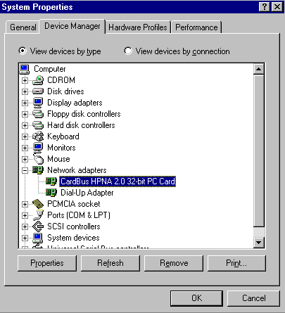
Note: For Diagnostics and Statistics & Network Component Configuration, refer to the corresponding sections in Windows 98 for more details.

Appendix

Specification
- Standards:
HomePNA v1.0, 1.1 and 2.0 compatible
PCMCIA CardBus PC Card standard
- Protocol:

CSMA/CD
- Ports:

2 x RJ-11 standard modular telephone ports
- Cabling type:

Standard copper telephone cable
- Speed:
1Mbps for HomePNA 1.0, 1.1 compliant devcies
4Mbps to 10Mbps for HomePNA 2.0 compliant devices
- LEDs: Rx, Tx, Link

