

Firmware Version: | v1.04_4026
Prom Code Version:
Published Date: | 2014/8/14

Content:
Upgrading Instructions: 2
New Features: 2
Problems Fixed: 2
Known Issues: 3
Related Documentation: 3

Revision History and System Requirement:
Firmware Version | Date | Model | Hardware Version
v1.04_4026 | 2014/8/14 | DCS-825L | A1
v1.03_3725 | 2014/4/14 | DCS-825L | A1
V1.02_3427 | 2014/1/13 | DCS-825L | A1
V1.01_3327 | 2013/11/29 | DCS-825L | A1
V1.00 | 2013/10 | DCS-825L | A1

New Features:
Fireware Version | New Features
v1.04_4026 | - Support EN300 328 v1.8.1.  - Upgrade mydlink agent to v2.0.17-B81.
v1.03_3725 | - Correct the daylight saving time rule for (GMT+12:00) Fiji.  - Fix the HTTPS authentication issue for mydlink.  - Fix the incorrect field spelling issue of CGI /config/portal_info.cgi for mydlink.  - Fix the unsuitable copyright issue.  - Fix the incorrect SD card status issue after re-plugin SD card.  - Support full-duplex dgtalkie.  - Support command fw_upgrade for mydlink.  - Support Group Gets /config/portal_info.cgi for mydlink portal.
V1.02_3427 | - Improve boot-up speed.  - Support high/low temperature events for mydlink.  - Turn up the volume of boot up music.  - Upgrade mydlink agent to v2.0.17-b49.
V1.01_3327 | - Support Windows format size SD card.  - Support SD card with multi-partitions.  - Support following two behaviors while rebooting.  - Light on the thermal LED in Blue/Green/Red colors for 0.5 seconds, respectively.  - Play the boot up music if it’s enabled.  - Support display following items on Device Info web-page.  - MAC address both for AP router and AP client.  - Current wireless channel both for AP router and AP client.  - Speed up following processes. (work with v1.02 App)  - Boot up process for setup wizard  - Change user password  - Set date and time  - Set wireless configuration  - Enable NTP sync function with server “ntp1.dlink.com” as default.  - Upgrade mydlink agent to v2.0.17-b43.

Problems Fixed:
Firmware Version | Problems Fixed
v1.04_4026 | Fix HTTP/HTTPS authentication issue for specific symbol password by upgrading lighttpd server.

Known Issues:
Firmware Version | Known Issues

Related Documentation:
N/A

Upgrading Instructions:
Follow the steps below to upgrade the firmware:
1. Download the latest firmware file from the D-Link website. The file is in .bin file format.

For Windows:

Step 1
In the Control Panel, click Network and Internet.

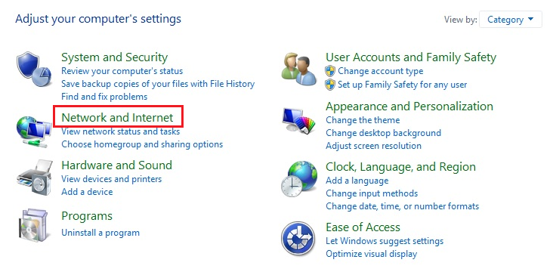
Step 2
Click View network computers and devices.

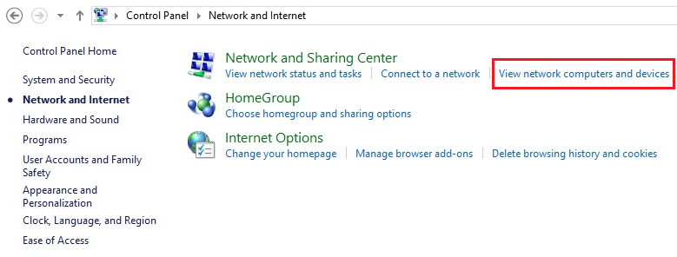

Step 3
Make a note of the camera’s IP address.

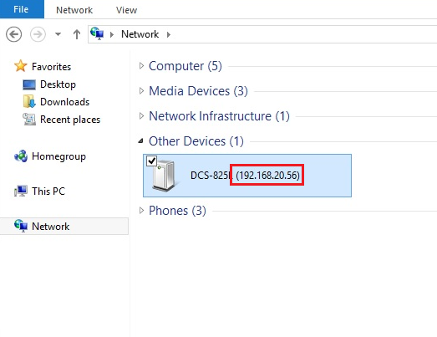

Step 4
Open a web browser and enter “http://IP_Address/eng/admin/tools_firmware.cgi” in the address bar (where IP_Address is the IP address you made a note of in Step 3).

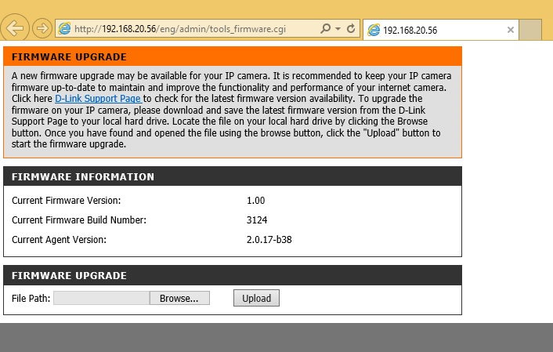

Step 5
If you do not already have the firmware file to use, follow the instructions on this page to download the latest file from the D-Link Support Page. Then click Browse… and locate the file. Finally, click the Upload button.

For Mac:

Step 1
Open Safari, and click Bonjour.

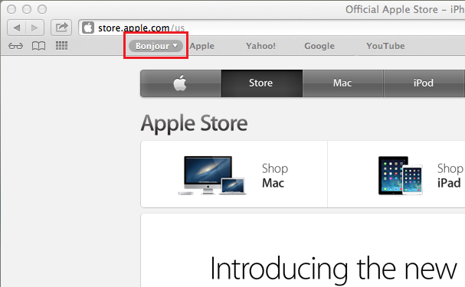

Step 2
Select the device you want to perform the firmware upgrade on.

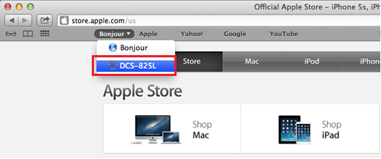

Step 3
Add “/eng/admin/tools_firmware.cgi” to the address currently in the address bar and press Enter.

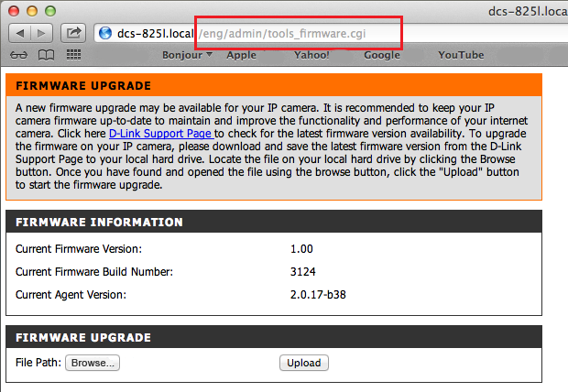

Step 4
If you do not already have the firmware file to use, follow the instructions on this page to download the latest file from the D-Link Support Page. Then click Browse… and locate the file. Finally, click the Upload button.

