

Software Version: | V1.05.06
Agent Version: | V2.0.19-b89
Published Date: | 2016/03/08

Content:
Revision History: 2
New Features: 2
Problems Fixed: 3
Known Issues: 3
Related Documentation: 4

Revision History:
Software Version | Date | Model | Hardware Version
V1.05.06 | 2016/03/08 | DNR-312L | A1

System Requirement (minimum HW requirement)

System Minimum Requirements
Hardware Requirements | One 3.5” SATA hard disk drive
Network Requirements | Broadband Internet connection (for remote access)  Network camera(s) (refer to the D-Link website for a list of supported cameras)  10/100/1000 Mbit Ethernet switch or router
Web-based Configuration Utility  Requirements/Remote PC  Minimum Requirements | Computer with the following:  Computer with Microsoft Windows 7, 8, Vista, or XP (with Service Pack 3);  Mac OS X (10.7 or above)  PC with Pentium 4 – 2.4 GHz or above; at least 512MB RAM  Internet Explorer 7, Firefox 12, Safari 4 or higher.  Existing 10/100/1000 Ethernet-based network

New Features:
Software Version | New Features
V1.02.03 | - Upgrade the mydlink agent 2.0.18-b45  - ONVIF support (Profile S V14.06)  - Support Device Pack update function  - Add Recycle setting for keeping x days video  - Support D-Link Discovery Protocol (DDP)  - Ability to turn on/off camera motion detection and adjust sensitivity and percentage through DNR-312L local & remote GUI  - Support 720P TV/Monitor  - Support snapshot in playback  - Remove SSL 3.0  - Support Cameras: DCS-930LB1 / DCS-932LB1 / DCS-942LB1 / DCS-3714 /DCS-5615 / DCS-6004L /DCS-6005L / DCS-6112B1 / DCS-6113B1 / DCS-6115 / DCS-6314 / DCS-6315 / DCS-7000L / DCS-7110B1 / DCS-7413B1/ DCS-2210L / DCS-2230L
V1.03.02 | - Support Cameras: DCS-935L / DCS-1201 / DCS-4201 / DCS-4602EV / DCS-4701E / DCS-5029L / DCS-6212L  - Support mydlink auto FW upgrade function.  - IP filter exclude IP camera list.  - Fixed the security bugs CTTI-VUZ-103-36001  - Fixed the security bugs CTTI-VUZ-103-36002  - Fixed the security bugs CTTI-VU-103-36010  - Fixed the security bugs CTTI-VUZ-103-36008
V1.05.06 | - Support Multi profile function on IE.  - Support PIR/ Sound Dection Event.  - Support IP Cameras: DCS-934L / 5009L / DCS-4802E  - Support Two-way audio function on IE.  - Fixed the security bugs CTTI-VUZ-103-36007  - Fixed the security bugs OnSec-VU-104-25001  - Fixed the security bugs OnSec-VUZ-104-25002  - Fixed the security bugs OnSec-VUZ-104-25003  - Fixed the security bugs OnSec-VUZ-104-25004  - Fixed the security bugs OnSec-VUZ-104-25005  - Fixed the security bugs OnSec-VUZ-104-25014  - Fixed the security bugs OnSec-VUZ-104-25015  - Fixed the security bugs OnSec-VUZ-104-25007  - Fixed the security bugs OnSec-VUZ-104-25008  - Fixed the security bugs OnSec-VUZ-104-25013

Problems Fixed:
Software Version | Problems Fixed
V1.02.03 | - Fixed DLAB DBG14040657: After DUT optimized cameras, DCS-7110 video settings wouldn’t be changed.  - Fixed DLAB DBG14080392: A non-admin account couldn’t browse the Playback page.  - Fixed DLAB DBG14080396: Display and Language page would be disappeared after log-in by a non-admin account.
V1.03.02 | - Fixed Keep Day(s) Video function.  - Fixed Camera verification wrong message.
V1.04.03 | - Fixed Digital signature invalid
V1.05.06 | - Fixed D-track : HQ20151001000016: The motion detection settings are not properly synchronized from and to between DNR-312L and DCS-6004L  - Fixed D-track: HQ20151117000015: Camera offten disconnects.

Known Issues:
Firmware Version | Known Issues
V1.05.06 | - Video Clip can’t export on browser of the MAC O.S.  Root cause: MAC O.S. don’t have Microsoft AVI library, so it can’t export AVI in MAC O.S.

Related Documentation:
N/A

Known Issue – Video export issue of DNR-312L NVR

Model: DNR-312L
HW Ver.: A1
FW Ver.: V1.00.45

Issue Description:
Video clips will be flip when user export recorded video from browser and DNR-312L NVR.

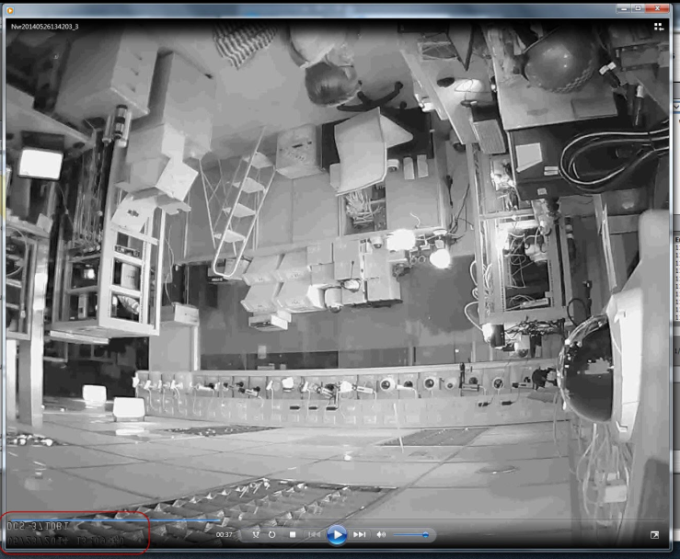

Root cause:

This issue is only happened in browser and DNR-312L NVR when user export recorded video. Local UI of DNR-312L NVR and Playback manager application will not to happen this problem.
The root cause is DNR-312L NVR needs to Support OSD (On Screen Display) characters on the video clip, but some of video clips will be flip if user’s PC memory has problem during swap video clip from memory to hard disk.
To avoid this problem happen, suggest users to use Local UI of DNR-312L NVR or Playback manager application to do video exxport when user’s PC cause this issue.

Improvement:
Alert users this issue to be a known issue with FW V1.00.45. Vendor will improvement memory swap
mechanism in the next FW version to avoid this issue happen again.

