DAS-3248/DAS-3248F

Date: Nov. 30th, 2004

Product name: | 48-port ADSL/ADSL2+ IP DSLAM
Revision: | A1
Available: | E/ Nov. 2005
Picture: | DAS-3248  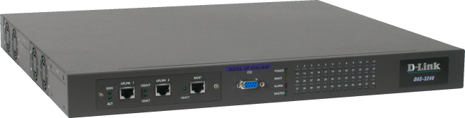
Picture: | DAS-3248F  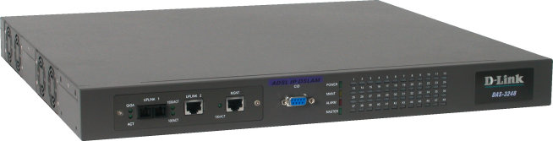
Why Sell This Product: | By Marketing
Key Features: | By Marketing
Technical Details: | By Marketing
EMI/EMC Report | ☑FCC No. 後補 ☑ CE No. 後補 ◻VCCI No.  ◻ CTR-21 No. ◻ C-Tick No. ◻ A-Tick No.  ◻ FDA No. ◻ R&TTE No. ◻ BSMI No.  ◻ Others
Safety | ☑ TUV No. 後補 ◻ UL No. ◻ CSA No.  ◻ Others
Packaging Style | ◻ Clamshell ◻ White Box ◻ Gift Box ◻ Bulk ☑White Box with D-Link Logo  ◻ Others
Packaging Contents: | - DAS-3248 X 1  - Power cord X 1  - CD X 1  - Quick Installation Guide x 1  - CAT5 Ethernet cable x 3  - RS-232 cable x 1  - Rackmount kit
UPC Code:
  BDAS3248F.A1 | 790069 271496
  DAS3248A..A1 | 790069 271502
  DAS3248B..A1 | 790069 271519
  DAS3248E..A1 | 790069 271526
  DAS3248N..A1 | 790069 271533
  DAS3248U..A1 | 790069 271540
  BDAS3248..A1 | 790069 271557
  DAS3248FA.A1 | 790069 271441
  DAS3248FB.A1 | 790069 271458
  DAS3248FE.A1 | 790069 271465
  DAS3248FN.A1 | 790069 271472
  DAS3248FU.A1 | 790069 271489
Units Per Carton: | 3
Cartons Per Pallet: | For USA Air: 12, Sea: 20 | For WW Air: 16, Sea: 20
Dimensions and Weight: | Box:  ,Others , 8.6 kg  Carton: 555x534x358 mm, 27.6 kg  Pallet: (by Air) 1200 x 1100 x 1455 mm, 453.4 kg (for WW/USA)  (by Sea) 1200 x 1100 x 1830 mm, 563 kg (for WW/USA)  INTRASTAT weight: 7.05 kg (Box)  Packing material weight (Box):  - Paper: 1.22 kg  - Plastic: 0.04 kg  - Mixed: 0.03 kg

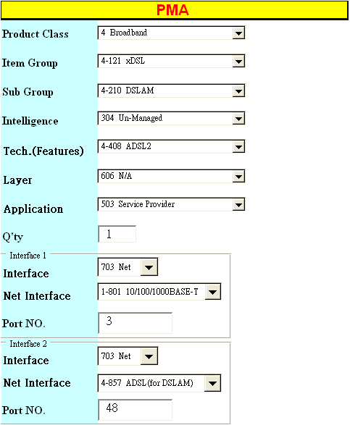
Approved | Checked | PM
Akira Huang | Joe Chou | Ming Wei

