

Product Announcement

Date: 2004/12/23
To: WW/USA

Subject: New Product Release for IP DSLAM of DAS-3248

D-Link is pleased to make this formal announcement for the following new product.
Please start to promote for this new product and advise if we can be helpful in any aspects.

Model Name: DAS-3248

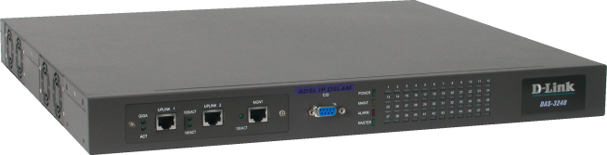

Model Name: DAS-3248F
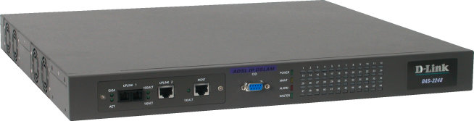

About DAS-3248

Due to the soaring needs for bandwidth consuming from various applications, bandwidth and performance management are decisive factors for ISP’s surviving in the market. D-Link now is developing the best cost-effective solution, Standalone Smart IP DSALM to meet ISP’s demand. The scalable design of DAS-3248 consists of two network modules; each network module provides eight ADSL ports with built-in POTS splitters. It provides broadband data service over existing copper wires without affecting the conventional voice service.

Product Feature

- Support up to 64*128 MAC address & 2K Multicast MAC address per DAS-3248 system
- Support 802.1q VLAN and Port-based VLAN
- Security : VLAN filtering, MAC Filtering, IP Filtering, Access Control List by MAC and IP address
- Traffic prioritization (802.1p)
- Rate limiting by MAC and IP address
- plink Aggregation (802.3ad)
- BRAS support 802.1x, DHCP Server & Relay, PPPoE, MPLS

Technical Specifications

Specification
System Architecture | ADSL/ADSL2/ADSL2+ Interface
- 48 (DAS-3248) ports ADSL/ADSL2/ADS2+ subscriber interface with built-in POTS Splitter  - One 1000BaseT MGNT+ Two 1000BaseT or one Giga LX Uplink/Subtend Interface (module selectable)  - Subtending capability allows up to 8 units to be cascaded and managed as one unit  - Telco-50 pin Centronic connector for ADSL+POTS IN and POTS OUT | - Downstream DMT data rate from 32 kb/s up to 25 Mb/s; Upstream DMT data rate from 32 kb/s to 1 Mb/s  - Comply with ITU G.992.1 (G.DMT),; G.DMT.bis; ITU G.992.2 (G.Lite); ANSI T1.413 issue 2; ITU G.994.1 (G.handshake) for ADSL, G.992.3 for ADSL2, and G.992.5 for ADSL2+  - Extended power management capabilities to optimize power consumption for each application  - Maximum reach exceeding 20Kft(6.1Km)
- Protocol Handling Capability | - Management
- 8 VCs per xDSL ports  - 128 MAC address per xDSL ports  - 64*128 MAC address  - 2K Multicast MAC address  - 512 VLAN(any value in 4096) support  - Configurable packet size (64 to 1542) | - Microsoft NT/SNMP-based GUI EMS  - Local RS-232 CLI, and Ethernet SNMP/TELNET management  - Remote in-band SNMP/TELNET management  - Firmware upload/download via FTP or TFTP  - SNMP v1, v2c, v3
- LAN Side (Uplink or Extension Side)
- 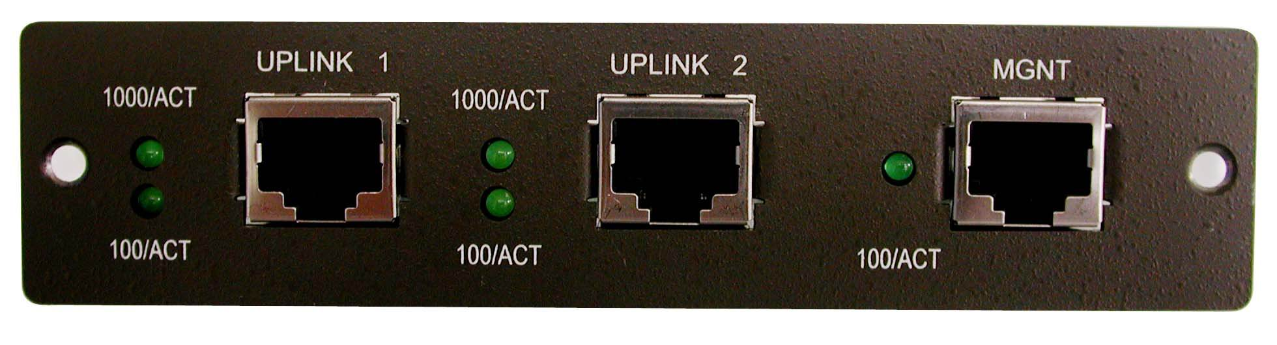 | - 1* 1000BaseT-MGNT + 2*1000BaseT
- 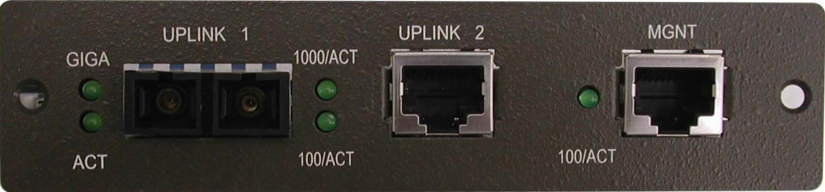 | - 1*1000BaseT-MGNT+1*1000BaseT+  - 1*1000Fx(SX/LX/LH/ZX)
- ATM MIBs | - Private MIBs
- RFC 1514, 2515 Definitions of Managed Objects for ATM Management | - Any specific private Traps
- Physical condition | - Protocol
- Dimension: 400mm(D)x440mm(W)x44mm(H)  - Weight: 6.8kg | - STP; IGMP snooping; GMRP; GVRP; LACP; LACP marker; SNMP/UDP/IP/MAC/Ethernet
- Power | - Operating Environment
- AC Power: auto ranging 90~240 VAC, 50-60 Hz, IEC connector  - Power Consumption: 150 watts | - Operating Temperature: 0°~50 °C, 32°~122 °F  - Storage Temperature: -30c°~70 °C, -22°~158 °F  - Humidity: 5% to 90% RH non-condensing

Packaging Content

- DAS-3248 X 1
- Power cord X 1
- CD X 1
- Quick Installation Guide x 1
- CAT5 Ethernet cable x 3
- RS-232 cable x 1
- Rack mount kit

Ordering Information(Part no. & Packing Description)
P/N | Description
DAS3248FA.A1 | 48-port ADSL2/2+ IP DSLAM with fiber module, US power
DAS3248FB.A1 | 48-port ADSL2/2+ IP DSLAM with fiber module, UK power
DAS3248FE.A1 | 48-port ADSL2/2+ IP DSLAM with fiber module, EU power
DAS3248FN.A1 | 48-port ADSL2/2+ IP DSLAM with fiber module, AU power
BDSA3248F.A1 | 48-port ADSL2/2+ IP DSLAM with fiber module, US power
DAS3248A.A1 | 48-port ADSL2/2+ IP DSLAM with Copper Giga module, US power
DAS3248B.A1 | 48-port ADSL2/2+ IP DSLAM with Copper Giga module, US power
DAS3248E.A1 | 48-port ADSL2/2+ IP DSLAM with Copper Giga module, EU power
DAS3248N.A1 | 48-port ADSL2/2+ IP DSLAM with Copper Giga module, AU power
BDSA324F.A1 | 48-port ADSL2/2+ IP DSLAM with Copper Giga module, US power

Ordering Price

Please refer to “Price Book”

Lead Time:

6 weeks Per Order with forecast.

