
Product Announcement

Date: June, 12, 2003
To: All Locations

Subject: New Product Release for DKVM-2KU; 2-PORT MINI KVM SWITCH KIT WITH USB 2.0 SHARING

D-Link is pleased to make this formal announcement for following new product. Please start to promote for this new product and advise if we can be helpful in any aspects.

MODEL NO.: DKVM-2KU Rev.A1
PART NO.:

- DKVM2KU…A1 (for Worldwide)

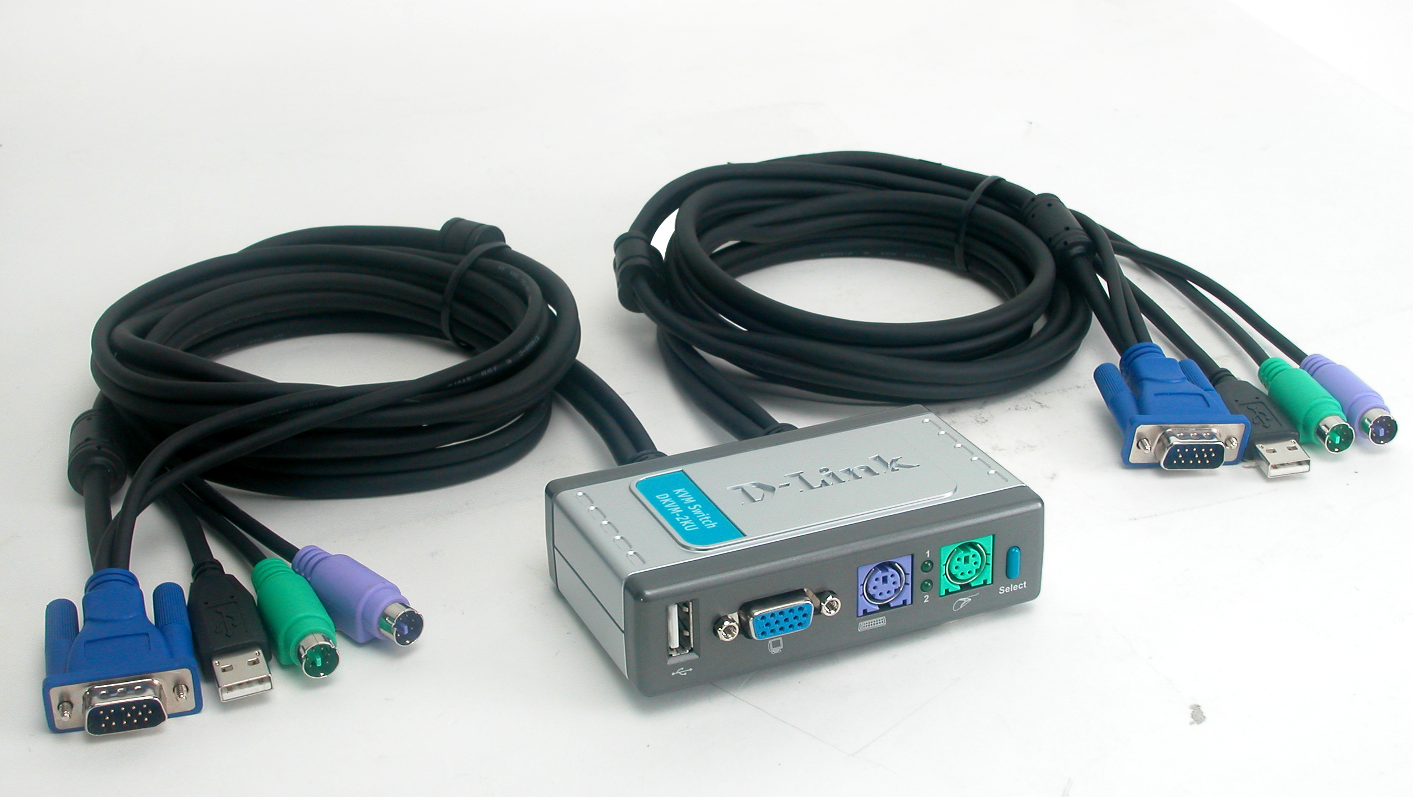

About DKVM-2KU

The D-Link DKVM-2KU is a 2 port MINI KVM switch Kit with USB 2.0 sharing that allows you the ultimate in control of 2 PCs from one set of keyboard , mouse , and VGA monitor.
The D-Link DKVM-2KU KVM Switch is capable of supporting the most demanding resolutions up to 2048×1536 at 72 Hz refresh rate without any noticeable degradation in image quality. D-Link DKVM-2KU KVM Switch has designed an easy-to-use front panel push button or by keyboard Hot Key command that makes switching computers easier.

Functions and Features

Access TWO computers with one set of Keyboard, Monitor and Mouse.

Save space while being cost effective.

Audible feedback when switching

Front panel LEDs indicate the selected PCs.
- Select PCs using the front panel SELECT button or Hot Key command
- Support SVGA, VGA, and multi-sync monitors, resolutions up to 2048×1536.
- Non-powered.
- Switch computer and devices simultaneously by SELECT button or Hot Key command.
- Under Auto Scan mode, USB device switching will come with the computer
scan sequence.

Technical Specifications

- Console Connectors:
Keyboard connector: MINI DIN-6 PIN Female.
Mouse connector: MINI DIN-6 PIN Female.
Monitor connector: HD 15 PIN Female.
USB connector : USB A Type Female
- KVM Cables for connecting computers (Length: 6ft.)
Keyboard connector: MINI DIN-6 PIN Male.
Mouse connector: MINI DIN-6 PIN Male.
Monitor connector: HD 15 PIN Male.
USB connector : USB A Type Male

- Port LEDs : 2 pcs color: green
- Manual selection : Push Button
- Hot Key : Yes
- Switching Confirmation : Buzzer
- Dimension (LxWxH cm) : 10.4*6.2*2.8
- Weight(with cable) : 570g

Product Application

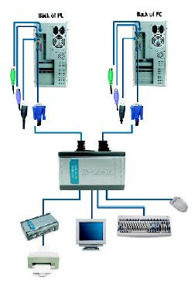
Box Included
- DKVM-2KU 2 Port KVM Switch Kit with built-in 2sets of KVM cables( 6ft in length)
- QIG x 1

Ordering Information
DKVM-2K ( 2 Port MINI KVM SWITCH KIT )

- DKVM-2KU(for worldwide)

Ordering Price
Please refer to the Price Book from BBD.

Lead Time:
About 3-4 weeks per order

