DCS-3220

Date: September 13, 2004

Product name: | 2-Way Audio Internet Camera
Product Group & Type:
Revision: | A1
Available:
Picture: | 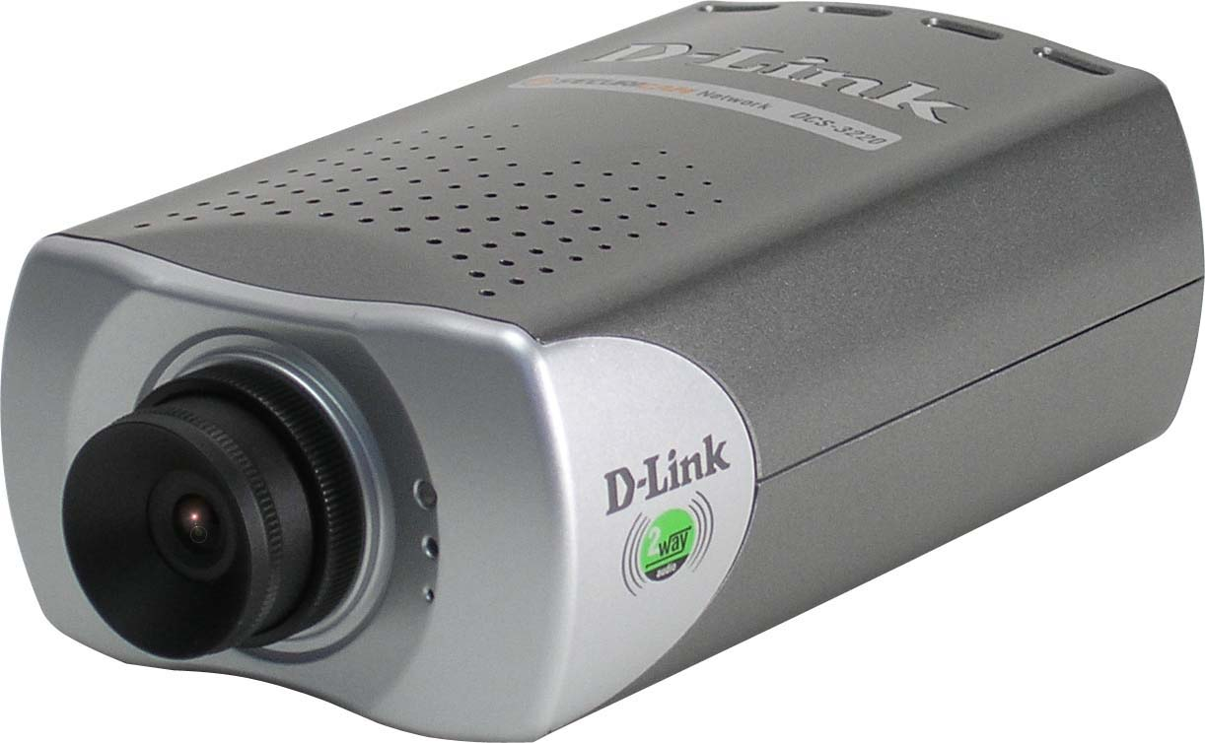
Why Sell This Product: | - Target users: business, factories, shop owners and wealthy residents needing surveillance systems.  - The DCS-3220 is positioned as a mid-range model in your Internet camera line, supplementing the current DCS-2000 series. It is priced higher, but has more advanced functions like sharp video/image quality and digital zoom.  - The DCS-3220 and DCS-2000 can be concurrently sold to different users with different technical requirements and budgets.  Selling Points  - All the functions that the DCS-2000 series offers, plus: 2-way audio acting like an intercom with video, CCD sensor/sharper image and 4x digital zoom.  - Strong software with Motion Detection Recording, smart playback, event-trigger e-mail notification, etc. (same as the DCS-2000).  - Can be installed along with the DCS-2000 series cameras in the same surveillance site. Users may try to experiment with a single DCS-3220 added to their existing security system. Once satisfied with the additional merits of the new camera, they may want to install more units.
Key Features: | - Stand-alone Internet camera with CPU & RAM, no need to attach to PC  - Local access through Ethernet, remote access through Internet  - 4x digital zoom for close-up viewing *  - Listen and talk with 2-way audio **  - Surveillance software to control up to 16 cameras  - Motion detection triggered recording or scheduled recording  - Smart playback  - High compression ratio recording  - Connects to external devices for alarm-based event recording when trigger is activated  - Implemented for intruder detection with still image capture & email notification  - Powerful software for image capture & video recording  - Easy deployment with UPnP & DNS support, web-based configuration  * 4x digital zoom enlarges an image by magnifying the pixels in a selected portion of the image by 4 times.  ** 2-way audio requires a powered speaker to be connected to the camera (not included).
Technical Details: | Camera  Sensor  - Built-in 1/4-inch CCD sensor  - Resolution: 380 TV lines  - Automatic Gain control (AGC): 24dB  - Automatic Exposure (AE)  - Automatic White Balance  - Electronic shutter: 1/60 or 1/50 to 1/10000 sec.  - Minimum Illumination: 1.0 ux @ f2.0  Lens  - CS mount type  - Fixed focal, (6mm, f1.8) with fine tuning  LED indicator  1 bi-color LED indicator for status indication (POST, connection,  heartbeat)  Reset button  Push button to reset to factory default settings  Extended I/O  - 1 relay alarm output (max. 24V DC 1A, 125V AC 0.5A  - 1 Optic-isolated sensor input (max.12V DC 50mA)  Memory  - SDRAM: 16Mbytes  - Flash ROM: 4Mbytes  Video  Resolution  - Up to 30fps at 176 x 120 (NTSC)  - Up to 30fps at 352 x 240 (NTSC)  - Up to 10fps at 704 x 480 (NTSC)  Modulation  NTSC and PAL (different CCD sensors supporting NTSC or PAL in  different camera models)  Format  - MPEG4 simple profile compression for streaming video  - JPEG compression for still image  - Compression ratio: 5 levels  - Max. image frame rate: 30fps (NTSC), 25fps (PAL)  - Adjustable image size, quality and bit-rate  - Time stamp and text overlay  Compression Options  Medium, standard, good, detailed, excellent (user-selectable)  Video Sizes  QSIF/QCIF, SIF/CIF, 4SIF/4CIF (user-selectable)  Information Display  Image can be overlaid with text, timestamp and motion detection window  Color Modes  Color mode, monochrome mode (user-selectable)  Position  Flip and mirror can adjust image position  Image Settings  Brightness, contrast, hue, saturation (user-adjustable)  Zoom-In  Seamless digital zoom function with up to 4x magnification  Audio  Audio Input  Built-in omni-directional microphone with S/N more than 60dB  Audio Output  Microphone socket for line-out unbalanced 0.05 to 1.0 Vpp  Format  - Proprietary, 8Kbps audio codec  - 2-way audio, mono, supporting simplex, half-duplex, full-duplex modes  Function  - Can be muted at server side by administrator (camera microphone on/off)  - Can be muted at client side (PC speaker on/off)  - Adjustable audio volume (PC microphone on/off)  Network  Network Interface  802.3/3u 10/100Mbps Ethernet  IP Installation  IP address is installed at system reboot unless an option is set to fix it.  Protocols and Applications  - DDNS support with several famous DDNS servers  - UPnP support  - NTP client  - SMTP client  - FTP client  - FTP server  - FTP supports passive mode  - HTTP server: max. 10 users to view at the same time  - Adjustable server port  Optional  - IP filtering  - SMTP Authentication  Motion Detection  Configuration  - 3 motion-detection windows  - 2 adjustable parameters: sensitivity and percentage  Indicator  When motion is detected, users can be informed from the image  Extended I/O  Digital Input  - Status checking of high, low, rising, falling  - DI triggered or motion triggered alert and notified via FTP or e-mail  Digital Output  On/Off  Management & Viewing  Remote Management  Configuration can be accessed via Web browser  Security  - Administrator and user group protected  - Password authentication  Viewing System Requirements  - Protocol: ActiveX  - Operating System: Microsoft Windows XP, 2000, ME  - Browser: Internet Explorer v.6  Physical & Environmental  Power Input  12VDC, 1.5A  Power Supply  Through external AC switching power adapter  Power Consumption  4.8 watts  Dimensions  135 (L) x 89 (W) x 57 (H) mm (6.25 x 3.25 x 2.12 inches) (camera only)  Weight  240 grams (8.5 oz.) (camera only)  Operation Temperature  0 to 60 ℃  Storage Temperature  -30 to 75 ℃  Humidity  5% to 95% non-condensing  Emission (EMI)  - FCC Class B  - CE Class B  Safety  LVD (EN60950)  Package Includes  - DCS-3220 Internet Camera  - 12V/1.5A external power adapter  - Cat. 5 Ethernet cable  - Quick Installation Guide  - Master CD  - Camera stand bracket
EMI/EMC Report | ☑FCC No. ☑ CE No. ◻ VCCI No.  ◻ CTR-21 No. ☑ C-Tick No. ◻ A-Tick No.  ◻ FDA No. ◻ R&TTE No. ◻ BSMI No.  ◻ Others
Safety | ◻ TUV No. ◻ UL No. ◻ CSA No.  ◻ Others
Packaging Style | ◻ Clamshell ◻ White Box ☑ Gift Box ◻ Bulk ◻ Others
Packaging Contents: | - DCS-3220 device  - CAT5 Ethernet cable  - CD-ROM  - Stand/ Mounting Bracket  - AC power adapter  - QIG
UPC Code:
  BCS3220A..A1 | 790069269516
  TCS3220A..A1 | 790069270895
  ECS3220E..A1 | 790069270901
  ICS3220A..A1 | 790069270918
  ICS3220E..A1 | 790069270925
  NCS3220CP.A1 | 790069270932
  ECS3220BP.A1 | 790069270949
  ECS3220EP.A1 | 790069270956
  ICS3220AP.A1 | 790069270963
  ICS3220EP.A1 | 790069270970
  ICS3220NP.A1 | 790069270987
Units Per Carton: | 10
Cartons Per Pallet: | Air: 20 for WW, 21 for USA  Sea: 24 for WW, 21 for USA
Dimensions and Weight: | Box: 286 x 247 x 84 mm, 1.2 kg  Carton: 510 x 440 x 320 mm, 13 kg  Pallet: (by Air) 1220 x 1020 x 1460 mm, 293 kg (for USA)  1200 x 1100 x 1700 mm, 280 kg (for WW)  (by Sea) 1220 x 1020 x 1460 mm, 293 kg (for USA)  1200 x 1100 x 2140 mm, 332 kg (for WW)  INTRASTAT weight: kg (Box)  Packing material weight (Box):  - Paper: 0.60 kg  - Plastic: 0.20 kg  - Mixed: 0.35 kg

