

Firmware Version: | 1.00.3430
Prom Code Version:
Published Date: | 2009/9/30

Content:
Revision History and System Requirement: 2
Upgrading Instructions: 2
Upgrading by using CLI (serial port) 2
Upgrading by using Web-UI 2
New Features: 2
Changes of MIB & D-View Module: 2
Changes of Command Line Interface: 2
Problems Fixed: 2
Known Issues: 3
Related Documentation: 3

Revision History and System Requirement:
Firmware Version | Date | Model | Hardware Version
1.00.3430 | 2009/9/30 | DCS-7510 | A1

Upgrading Instructions:

Upgrading by using CLI (serial port) (Optional Item)

Upgrading by using Web-UI

New Features:
Fireware Version | New Features
1.00.3430 | First release

Changes of MIB & D-View Module:

Changes of Command Line Interface: (Optional Item)

Problems Fixed:
Firmware Version | Problems Fixed
1.00.3430 | First release

Known Issues:
Fireware Version | Known Issues
1.00.3430 | While execute Java-Based browser to launch the DCS-7510's Web UI, the screen will pop-up the attached message. But you will find the name will display "speaker". This is the Java Applet class name; the name can't be changed by our firmware.  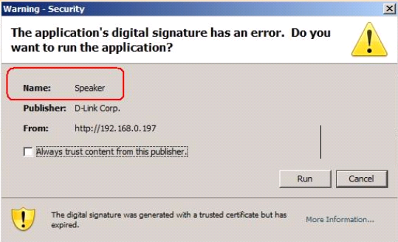

Related Documentation:
- User Manual
- White Paper/Technical Brief (Optional Item)
- Configuration Guide (Optional Item)
- …etc

