Internet Camera

Affordable Surveillance for Home/SOHO
Remote Video Surveillance
Take Snapshots/Record to Hard Drive
Motion-Detection Triggered Recording/E-mail Alerts
With or Without 802.11g Wireless Connection

 The D-Link DCS-900/DCS-G900 Internet camera is an affordable full-featured surveillance
FEATURES

Video Recording MJPEG Compression Mode Motion-Detection Recording
Quality Video Monitoring
640 x 480 Video Resolution
Up to 30 Frames Per Second Video
Security
Motion-Detection Alarms
Email Notification
WEP Data Encryption/Wi-Fi Protected Access
(WPA) Security *
Multiple Connectivity Options
10/100Mbps Ethernet for LAN or Internet
Connection
802.11g Wireless LAN (Up to 54Mbps Speed) *

* For DCS-G900 camera only

system designed for home and the small office. It connects to the broadband Internet or a
local network to provide remote high-quality video monitoring. You can access and control the camera using an Internet browser. Video captured by the camera can be recorded to a
computer hard drive. With motion detected image recording and powerful software for multi- camera monitoring and management, this camera provides a comprehensive system for convenient surveillance from both a local site or remotely from anywhere in the world.

By signing up with one of the many free Dynamic DNS services available on the Web, you can assign an easy-to-remember name and domain to the camera (such as www.mycamera.myddns.com). This allows you to remotely access your camera without having to remember the IP address, even if your Internet Service Provider has changed it.

Motion Detected Recording. Instead of recording 24 hours a day, 7 days a week, images can be recorded when motions are detected. This saves disk space and eliminates the time
wasted to view unnecessary images. Playback consumes little time with triggered event browsing and fast database searching.

Multiple Camera Monitoring. You can remotely monitor your camera using a web-based interface or the bundled advanced software. Up to 10 users can simultaneously view the live feed from the camera. Using the centralized surveillance software supplied with this camera, you can monitor and manage multiple cameras, set recording schedules, configure motion detection settings, and change settings to multiple cameras.

With or Without Wireless Connection. Two camera models are available for selection: the DCS-900 with an Ethernet port, and the DCS-G900 wireless camera with both the Ethernet and the 802.11g WLAN interface. The wireless model offers installation flexibility and freedom of wireless connectivity at difficult locations without the hassle of running Ethernet cables. This wireless camera supports WPA-PSK, TKIP, and WEP for establishing secure connections to your wireless network.


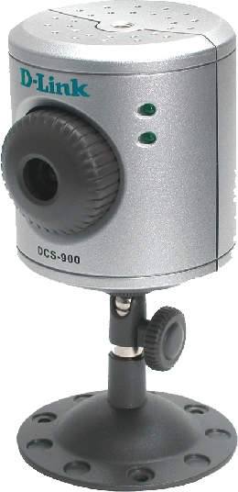
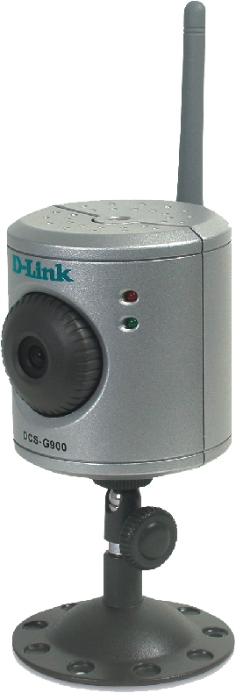

1 DCS-900/DCS-G900




Specification Chart
DCS-900 1
DCS-G900

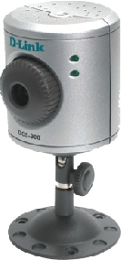

Hardware & System

Network Connection
RAM Flash
O. S. Support
Browser Support

Ethernet Wireless LAN Standard
8MB 8MB
2MB 2MB
Windows 98SE, ME, 2000, XP Windows 98SE, ME, 2000, XP
Internet Explorer v.6 & Above, Nescape Navigator v.7 Internet Explorer v.6 & Above, Nescape Navigator v.7

10/100BASE-TX Port 10/100BASE-TX Port
-
- 802.11g

Data Rates
Antennas
Transmitter Output Power

Communication Protocols
Universal Plug and Play (UPnP) Dynamic DNS Services (DDNS)
Time Synchronisation With NTP Server
Text, Date & Time Overlay
- Up to 54Mbps
- 2dBi Gain Detachable Diversity Antenna (RP-SMA Connector)
- 15 dBm +/- 2 dB
TCP/IP, UDP, HTTP, SMTP, NTP, DNS, DHCP, ARP, ICMP, BOOTP

Software Functions
Playback Schemes View Snapshots Save Snapshots
Motion Detection Alarm
Email Notification
Date, Time Interval, Event Triggering Date, Time Interval, Event Triggering

Management & Firmware Updates

Management Site
Using Web Browser
Max. Cameras on Single Screen 2
Reset Button

Max. Users Accessing Camera Simultaneously

Local & Remote

16

10

Local & Remote

16

10

Camera Specifications
Lens (Focal Length, Aperture)
Sensor Resolution Image Sensor Lens Type Illumination
Automatic Gain Control (AGC) Automatic White Balance (AWB) Automatic Exposure (AE)
Back Light Compensation (BLC) Electronic Shutter
Shutter Speed
6.0mm, f1.8
640 x 480
1/4-imch Color CMOS Sensor, Progressive Scan Mode
Fixed Lens
Min. 2.5 lux
24dB

1/60 to 1/15,000 sec.
6.0mm, f1.8
640 x 480
1/4-imch Color CMOS Sensor, Progressive Scan Mode
Fixed Lens
Min. 2.5 lux
24dB

1/60 to 1/15,000 sec.

Color Selection
Image Frame Rate Image Compression Compression Ratios
Color
Up to 30fps
MJPEG
5 Levels
Color
Up to 30fps
MJPEG
5 Levels

Video
Resolution
160 x 120 @ 30fps, 320 x 240 @ 25fps, 640 x 480 @ 10fps 160 x 120 @ 30fps, 320 x 240 @ 25fps, 640 x 480 @ 10fps

Viewing System Required Protocol
Scheduled Recording Brightness Control Contrast Control Saturation
ActiveX & Java
ActiveX & Java

1. Specifications applied to DCS-900 hardware version B1 only.
2. Up to 4 cameras using IPView SE surveillance/management software, up to 16 cameras using D-ViewCam surveillance/management software.

2 DCS-900/DCS-G900




DCS-G900
Wireleess
Wireless
Internet Camera
Cable/DSLModem

Router

DCS-900
10/100 Fast Ethernet
Wireless
Internet Camera

10/100 Fast Ethernet
Internet Camera
Monitoring
Computer

Physical & Environmental

Diagnostic LEDs Dimensions Humididy
Power 66mm (diameter) x 73mm (height) (camera only) Max. 95% RH, non-condensing
Activity 66mm (diameter) x 135mm (height) (including camera stand)
EMC
Input Power Weight FCC Class B
5VDC, 2.5A | 110 grams (DCS-900) | CE
Through external power adapter | 130 grams (DCS-G900) | C-Tick

Power Consumption Operating Temperature
5 watts (max.) 0o to 50oC

Storage Temperature
  -25o to 60oC

D-Link Worldwide Offices
IC

Safety
LVD (En60950)

U.S.A. Canada
Europe (U. K.) Germany France Netherlands Belgium
Italy Sweden Denmark Norway Finland Spain Portugal
Czech Republic Switzerland Greece

TEL: 1-800-326-1688
TEL: 1-905-8295033
TEL: 44-20-8731-5555
TEL: 49-6196-77990
TEL: 33-1-30238688
TEL: 31-10-282-1445
TEL: 32(0)2-517-7111
TEL: 39-02-2900-0676
TEL: 46-(0)8564-61900
TEL: 45-43-969040
TEL: 47-99-300-100
TEL: 358-9-2707 5080
TEL: 34-93-4090770
TEL: 351-21-8688493
TEL: 420-(603)-276-589
TEL: 41-(0)-1-832-11-00
TEL: 30-210-9914 512

FAX: 1-866-743-4905
FAX: 1-905-8295223
FAX: 44-20-8731-5511
FAX: 49-6196-7799300
FAX: 33-1-30238689
FAX: 31-10-282-1331
FAX: 32(0)2-517-6500
FAX: 39-02-2900-1723
FAX: 46-(0)8564-61901
FAX: 45-43-424347
FAX: 47-22-309580
FAX: 358-9-2707-5081
FAX: 34-93-4910795

FAX: 41(0)-1-832-11-01
FAX: 30-210-9916902

Luxemburg Poland Hungary Singapore Australia India
Middle East (Dubai) Turkey
Egypt

Israel LatinAmerica Brazil
South Africa
Russia China Taiwan
Headquarters

TEL: 32-(0)2-517-7111
TEL: 48-(0)-22-583-92-75
TEL: 36-(0)-1-461-30-00
TEL: 65-6774-6233
TEL: 61-2-8899-1800
TEL: 91-022-26526696
TEL: 971-4-3916480
TEL: 90-212-289-56-59
TEL: 202-414-4295
TEL: 972-9-9715700
TEL: 56-2-232-3185
TEL: 55-11-218-59300
TEL: 27-12-665-2165
TEL: 7-095-744-0099
TEL: 86-10-58635800
TEL: 886-2-6600-0123
TEL: 886-2-6600-0123

FAX: 32-(0)2-517-6500
FAX: 48-(0)-22-583-92-76
FAX: 36-(0)-1-461-30-09
FAX: 65-6774-6322
FAX: 61-2-8899-1868
FAX: 91-022-26528914
FAX: 971-4-3908881
FAX: 90-212-289-76-06
FAX: 202-415-6704
FAX: 972-9-9715601
FAX: 56-2-232-0923
FAX: 55-11-218-59322
FAX: 27-12-665-2186
FAX: 7-095-744-0099 #350
FAX: 86-10-58635799
FAX: 886-2-6600-8168
FAX: 886-2-6600-9898

Rev. 01 (Dec. 2005)
Specifications subject to change without prior notice.

DCS-900/DCS-G900

3
D-Link is a registered trademark and SecuriCam is a trademarks of D-Link Corporation/D-Link System Inc. All other trademarks belong to their proprietors.

