D-Link Corporation

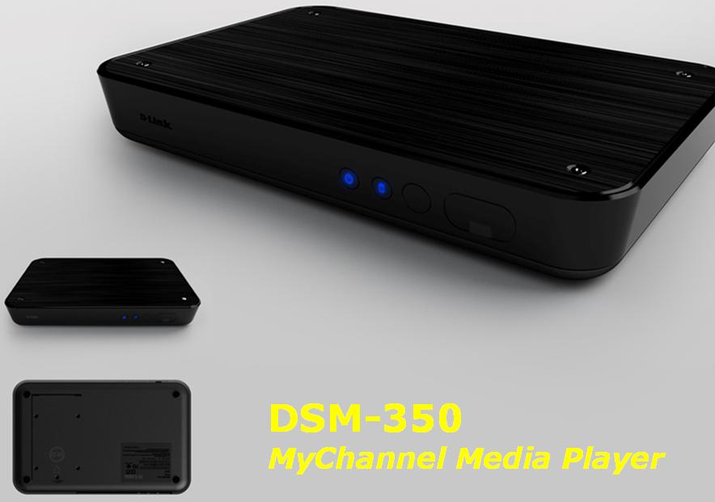

ver. A1.0
Date: 2009/04/02

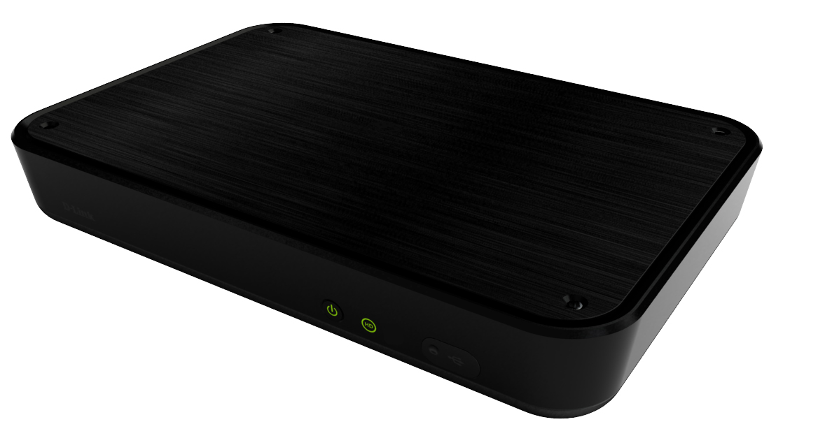
Revision History
Version | Revised Date | Person Name | Content Revised
0.1 | 2009/02/26 | Miles Lee | First Edition
0.2 | 2009/03/02 | Miles Lee | Update the size of DDR2
0.3 | 2009/03/04 | Miles Lee | Update Power LED behavior
01.0 | 2009/04/02 | Miles Lee | - Update the CC1100 specification.  - Update the LED behavior.  - Update the packaging content.
Table of Contents
1 Introduction 4
2 Application 4
3 Product Features 4
3.1 H/W Features 4
3.2 LED Indicators 5
3.3 Firmware Features 6
3.4 Support Media Format 7
3.4.1 Video File Formats 7
3.4.2 Video Decoder 8
3.4.3 Audio Decoder 9
3.4.4 Pictures 10
3.5 Device Portal Features 10
3.6 User Portal Features for DSM-350 11
3.7 TV UI Features 12
3.8 Remote Controller 13
3.8.1 Appearance 13
3.8.2 Key Definitions 14
3.9 OS Support 15
3.9.1 Device Portal (mydlink) 15
3.9.2 User Portal 15
4 Housing Design 15
5 Physical & Environment 16
5.1 Operation 16
5.2 Storage 16
6 Emission (EMI), Safety & Other Certifications: 16
7 Package Contents 16

Introduction

The DSM-350 is a media adapter, which supports plenty of video formats and supports up to 720p HD video resolution. It provides HDMI out to allow connecting the TV via HDMI interface and provides an USB host in front panel to allow connecting to a USB device. With a 2.5-inch HDD inside, the DSM-350 can be a network storage device so the user doesn’t need extra storage to access the files.
Different from other vender’s media player, the DSM-350 can also help users to channelize their media contents from anywhere, anytime over the Internet. After doing so, users just need to turn on the device, and then they can watch the contents by pressing arrow keys on the remote controller. The behavior is like you turn on the TV to watch the program.
The DSM-350 also builds in a BT downloader allowing downloading the media contests from the Internet via P2P technology.

Application
The application of DSM-350 is shown in below diagram.
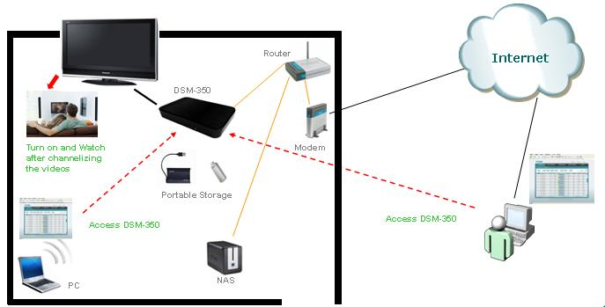

Product Features

H/W Features
Key Components / Performance
CPU & Codec | C2 CC1100
Flash Memory | 32MB
DDR2 SDRAM | 256MB
HDMI controller | ANALOGIX ANX9030
Ethernet controller | RTL8103-EL
Audio DAC | WM8521
Port Functions
LAN | 10/100BaseT ports x1  Compliant to following standards:  IEEE 802.3 compliance  IEEE 802.3u compliance  Support Full-Duplex operations  MDI/MDIX auto-negotiation  802.3x Flow Control support for Full-Duplex mode
IR Receiver | IP Remote sensor ; NEC protocol;
USB Host | USB type A X1; support up to 1A output
USB client | Mini - B receptacle X1; connect to PC
SATA connector | 2.5” HD connection; inside the housing.
HDMI (Video Out) | HDMI A type X 1; support video resolution up to 720p
S/PDIF | Digital audio signal output; fiber optical type.
Composite (Video Out) | RCA plug X1 (yellow)
Analogue Audio | Analogue audio output; RCA plugs X2 (red for right channel, white for left channel)
DC Jack | Connect to an external power adapter.
Power Consumption | Max 24W; support power saving mode
Power Adaptor | Input: 110-240VAC, 50/60Hz  Output: 12VDC/2A

LED Indicators
Location | LED Indicative | Color | Status | Description
Device | HDD | Blue | On | HDD is connected
Device | HDD | Blue | Off | HDD is not connected
Device | HDD | Red | Blinking | HDD space is full or malfunction
Device | Power | Blue | On | Power on the system
Device | Power | Red | On | Power is connected; TV output is off
Device | Power | Red | Off | Power off the system
Device | LAN | Orange | Blinking | Transmitting or receiving data
Device | LAN | Orange | Off | No transmitting or receiving data
Device | LAN | Green | Off | LAN is connected in 10Mbps
Device | LAN | Green | On | LAN is connected in 100Mbps

Firmware Features
Feature Item | Feature | Detailed Description
Networking | Protocol | - IPV4, ARP, TCP, UDP, ICMP  - DHCP Client  - DNS Client  - DDNS Client  - FTP Client/server (phase II)  - HTTP Server  - Samba Client /Server  - PPPoE  - UPnP Port Forwarding
Networking | Ethernet | 10/100M BaseT Fast Ethernet auto negotiation
Video system | NTSC/PAL
Settings & Maintenance | PPPoE | For dial-up connection
Settings & Maintenance | Static IP | for static IP connection
Settings & Maintenance | DHCP | Factory default
Settings & Maintenance | Password change
Settings & Maintenance | wireless | optional
Settings & Maintenance | FW download | Click a button to check and download the latest FW
Device IP | Auto IP
Security | Login authentication | ID: admin /PWD: admin
Firmware | Upgrade failure protection | Backup boot loader code
File System | HDD connection | NTFS file system & Unicode file name

Support Media Format

Video File Formats
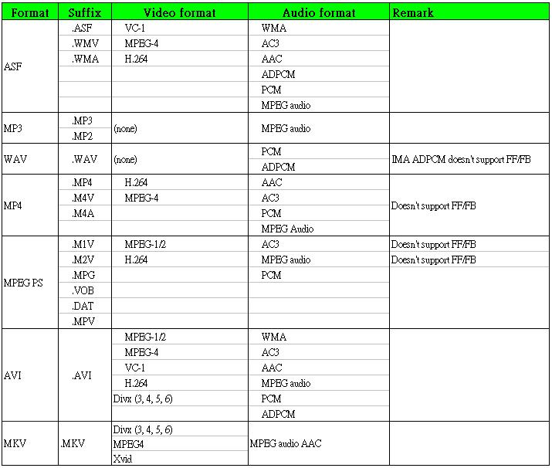

Video Decoder
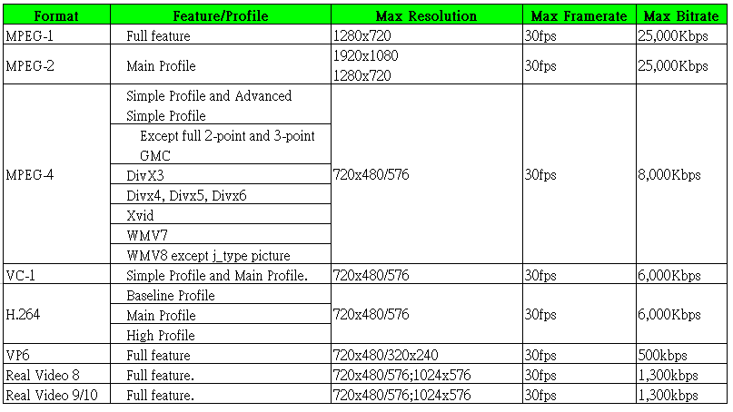

Audio Decoder
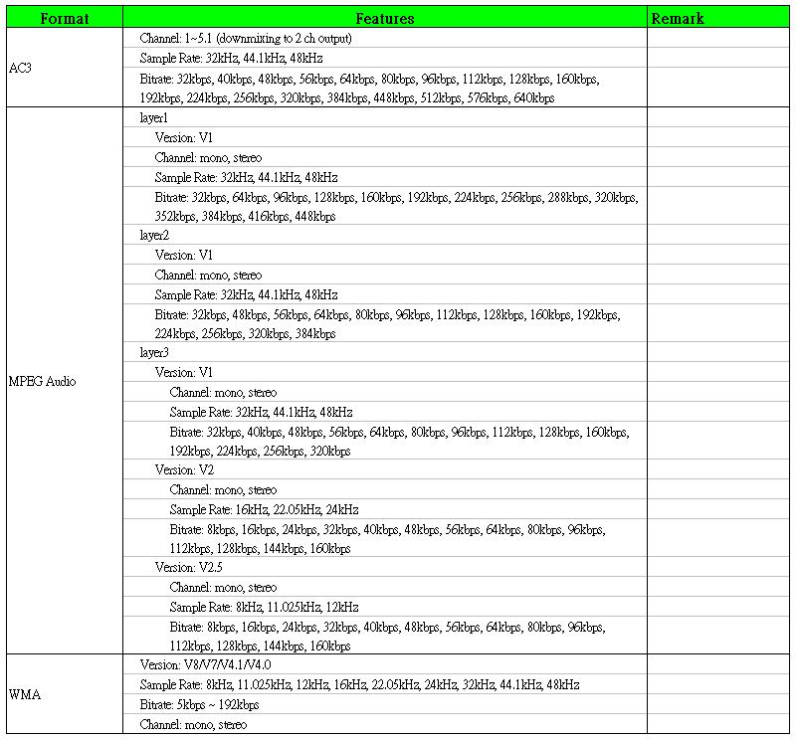
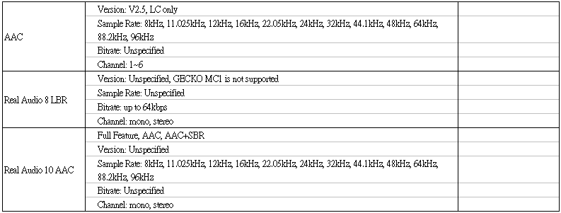
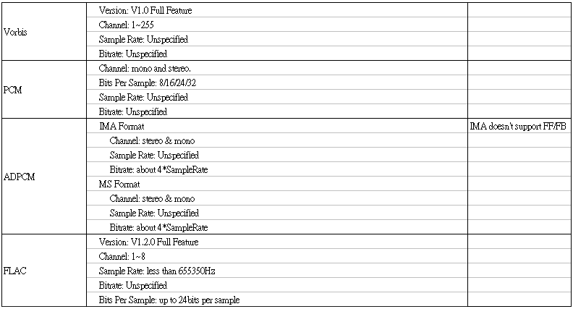

Pictures
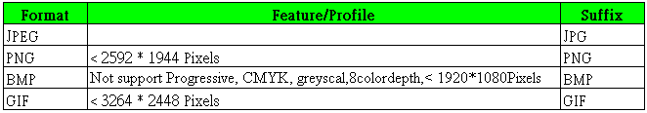

Device Portal Features
Item | Feature | Description
Language | Multiple | Supports Simple Chinese, Traditional Chinese, French, German, Spanish, Italian, Russian, and English.
Torrent | URL download | Get Torrent from URL
Torrent | PC download | Get Torrent form PC
Torrent | Sharing Pool download | Get Torrent from sharing pool.
Torrent | Select channel | Allow creating a new channel or selecting an old channel; One channel is pre-defined in factory default.
Torrent | Download Status | - Display Torrent download status, such as priority, name, size, progress, status, up/down speed, left time, seed, and peers, etc.  - Support the following buttons:  - Stop  - Start  - Remove  - Pause  - Priority move up  - Priority move down  - Click to view the download event in details  - Share to your friend (phase II)
Channel | Management | - Add CH  - Del CH  - Edit CH  - Program priority move up  - Program priority move down
Sharing (Phase II) | Torrent sharing | - Shared torrent list.  - Shared device list.
File | Management | - Media file search  - Media file from/ to directory selections  - Display the directory the file is located  - Move media files  - Delete media files  - Backup media files to NAS or USB stick (phase II)
Settings | Network & Function Settings | - Network Settings:  - PPPoE  - Static IP  - DHCP  - password change  - FW upgrade  - Format HDD  - Function Settings:  - Upstream BW limitation  - Downstream BW limitation  - Torrent download limitation  - Reset above Items’ value to factory default  - Display device information such as model name, IP, and MAC address, storage capacity

User Portal Features for DSM-350
Item | Feature | Description
Language | Multiple | Current only support English
Device Settings | Setting the devices | Click Go To My Device button to login in the web page of the device.
Device Info | Display information of device | Display device information, such as device name, IP, and MAC address, etc.
Note: other portions please refer to the specifications of mydlink portal.

TV UI Features
Mode | Feature | Description
TV | Video | - Delay time (minute :second : mini second) (move to TV)  - Text position  - Text color (black/white/green) (default: white)
TV | Information | - Channel No.  - Channel Name  - Program name  - Progress for both channel and program  - Audio information  - Subtitle  - Playback status  - Audio volume  - Message  - Smart preview  - Network status when it is error
Settings | System Settings | - System reset (back to default settings)  - HDD format  - Language selection (Simple Chinese, Traditional Chinese, French, German, Spanish, Italian, Russian, or English.) (Default: depends on the SKU.)  - FW check/update  - Device information: name/mac/network information (IP/connection type/Internet status)  - Storage space indication
Settings | Video Settings | - Aspect ratio: 4:3/16:9/auto (default: auto)  - Video output: HDMI/Composite (default: composite)  - Display resolution:480i/480p (default: 480p)  - Video system: NTSC/PAL (default: depends on the SKU)
Settings | Playback Settings | - Audio track (left/Right/Both or Chinese/English…) (default: Both)  - Smart preview: on/off (default: on)  - Digital/Stereo: stereo/Digital (default: stereo)  - Font size: small/medium/large (default: medium)  - Subtitle: on/off (default: on)  - Channel No. Display: on/on+title/off (default: on+title)
Friends | Friend List | - Add/Accept/Reject/Delete the list
Download | Torrent Download Status | - Status: Downloading  - Status: Pause  - Status: Stop  - Status: Complete  - Status: Queue (waiting)  - Function: Share the torrent
Download | Shared Torrent List | - Display shared torrent list with program name and file name  - Add shared torrent to the download list  - Delete shared torrent
EPG | Channel List | - Display all channel (channel number/name/time)  - Display new channel (channel number/name/time)  - Display new program  - Program List  - Display program list in a channel (sequence/snapshot/file name/program title/time/)

Remote Controller

Appearance
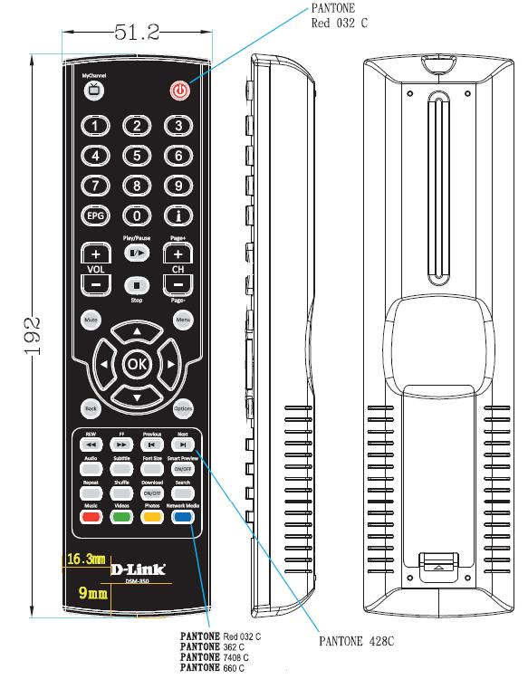
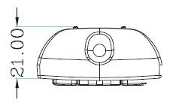

Key Definitions
Mode | Key | Description
TV | MyChannel | Press to jump into TV channel
TV | Mute | Press to turn on/off the audio of video
TV | Information | Press to display/non display the program information
TV | Smart Preview | Press for smart preview on/off.
TV | Font Size | Press to select the font size.
TV | Subtitle | Press to select the subtitle.
TV | Audio | Press to select audio track, such as stereo, left mono, right mono
TV | VOL + | Press to increase the volume of audio.
TV | VOL - | Press to decrease the volume of audio.
TV | CH/ Page + | Press to jump to next channel.
TV | CH /Page - | Press to jump to previous channel.
TV | Play/Pause | Press to play/pause the video.
TV | Previous | Press to jump to the previous segment of the video.
TV | Next | Press to jump to the next segment of the video.
TV | Stop | Press to stop the video.
TV | Options | Option function
TV | Backward | Press to reverse the video. 1X/2X/4X cyclically.
TV | Forward | Press to forward the video. 1X/2X/4X cyclically.
TV | 10 Number Keys | 0,1,2,3,4,5,6,7,8,9
TV | Power | Press to turn device on/standby
Media | Menu | Display main menu
Media | Search | Search media
Media | Repeat | For music repeat
Media | Shuffle | Random play for music
Media | Videos | Go to video mode
Media | Music | Go to Music mode
Media | Photos | Go to Photo mode
Media | Network Media | Go to Network Media mode
Download | Download On/Off | Press to Start/Stop all download events.
EPG | EPG | Press to jump into EPG mode
EPG | Left | Press to go left or change to previous program
EPG | Right | Press to go right or change to next program
EPG | Up | Press to go up or channel up
EPG | Down | Press to go down or channel down
EPG | OK | Press to execute “Enter” command or play media
EPG | Back | Press to return to previous page

OS Support

Device Portal (mydlink)
Windows XP / Vista

User Portal
Windows XP / Vista

Housing Design

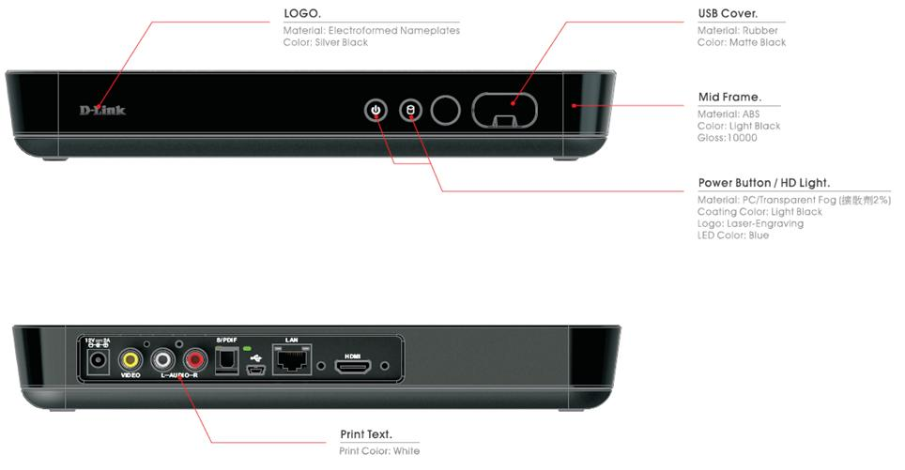

Physical & Environment

Operation
- Operation Temperature: 0-40°C
- Humidity: 20%-80% RH non-condensing

Storage
- Storage Temperature: -15-60°C
- Humidity: 0%-90% RH non-condensing

Emission (EMI), Safety & Other Certifications:
- FCC
- CE
- C-Tick
- BSMI
- CCC (waiting for request)
- Compliant to RoHS & WEEE

Package Contents
  - Media Player x 1
  - 12V2A External Power Adapter x 1
  - Remote controller including a separated battery set x 1
  - CAT5 Ethernet cable (1.5M) x 1
  - AV cable (1.5M) x 1
  - Quick Installation Guide + System & Remote control user manual x 1
  - CDROM including a wizard and user’s manual
  - Warranty card x 1
  - GNU GPL insert page x 1
  - HDD Kit

