DCS-100 D-ViewCam Firmware Release Note
Firmware Version: 3.01-0310
Date: 2010/03/24

Notes for Using D-ViewCam 3.01 Application
- When accessing cameras, the system only supports the account “admin” in cameras.
- The system will not disable PTZ panel/ focus icon in UI when connecting cameras which don’t support those functions. (However, the functions are invalid.)

Problem Solved:
- DCS-5220Ax/Bx model name inconsistent.
- "Manual Recording" function didn't display in the "on screen menu".
- When DVC V3.0 is running, it will display "System, encounter a problem".
- When installing DVC V3.0 software, it will display "System, encounter a problem".
- "Digital PTZ" function didn't display in the "on screen menu".
- It will display "parameter incorrect" warning message when search IP camera devices.
- The Remote Live Viewer & Remote Playback icons are incorrect in web view.

Enhancements:
- DVC V3.0 support FW versions are inconsistent with latest FW version.

Known Issues:
- Does not support AAC audio codec.
- Because some FW change version and this D-ViewCam 3.01 version early integrate latest FW of IP cameras. It will happen below issues when users use this D-ViewCam 3.01 version with older FW version.
    - DCS-3411/3430 /HW:A1 /FW:v1.01_3512
      - It couldn't detect DCS-3411/3430 model name automatically when click “Auto Detect” button in D-ViewCam V3.01.
    - DCS-3710 /HW:A1 /FW:v1.00.21
      - Bitrate value shows incorrect in live view screen of D-ViewCam.
    - DCS-5605/5635 /HW:A1 /FW:v1.01_4105
      - It couldn't detect DCS-5605/5635 model name automatically when click “Auto Detect” button in D-ViewCam V3.01.
    - DVS-210-1 /HW:A1 /FW:v1.00
      - It couldn't detect DVS-210-1 model name automatically when click “Auto Detect” button in D-ViewCam V3.01.

Device limitations:
- DCS-2120
    - Mirror and flip function is not integrated into Main console.
    - B/W mode is not integrated into Main console.
    - Variable bitrate is not integrated into Main console.
- DCS-6615/6815
    - Home function of PTZ is not integrated into Main console.

HW Support List:
Camera Firmware tested
Model | 2102 | 2120 | 2120tw | 2121 | 3110 | 3410 | 3415 | 3420 | 5220Ax | 5220Bx | 5220tw | 5610 | 6110
Firmware | 1.04 | 1.04eu | 0201tw | 1.04 | 1.02 | 1.01 | 1.00 | 1.03 | 1.05 | 2.00 | 2.00tw | 1.01 | 1.00
Model | 6111 | 6620 | 6620G | 910 | 920 | 3411 | 1100 | 1130 | 6410 | 3430 | 7510 | 5230 | 7410
Firmware | 1.00 | 1.06 | 1.05 | 1.04 | 1.04 | 1.01 | 1.02 | 1.02 | 1.00 | 1.01 | 1.00 | 1.01 | 1.00
Model | 3710 | 5300 | 5300G | 210-1 | 5605 | 5635 | 6615 | 6815
Firmware | 1.00 | 1.06 | 2.05 | 1.5.9 | 1.01 | 1.01 | 1.01 | 1.01

Compatibility:
  - Windows
 | Windows 2000 | Windows XP | Windows Vista | Server 2003 | Server 2008 | Windows 7
3.0.1.1 | N/A | Supported | Supported | Supported | N/A | N/A

  - Windows Internet Explorer Browser
 | IE 6 | IE 7 | IE 8
3.0.1.1 Remote Application | Supported | Supported | Supported*
* Refer to Appendix A for more details..

Appendix A – Windows Internet Explorer 8

In order to access the system with Windows Internet Explorer 8, we need to setup following settings to install ActiveX control.
Generally, there are two settings to make it work.

Note: Please make sure user has already installed vcredist_x86.exe

- Add the Server IP into Trusted Web Site.
  - Click Tools on IE toolbar, and then select Internet Options to start setting.
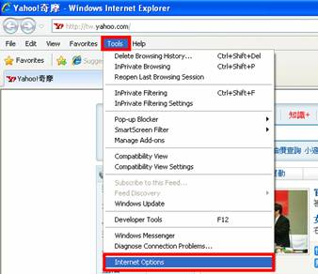
  - Switch to Security tab, select Trusted sites, and then click Sites to add server. 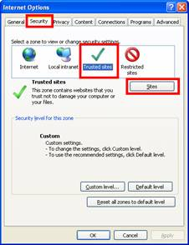
  - Enter IP address of the system and click on Add, then, the IP address will be listed on trust websites.
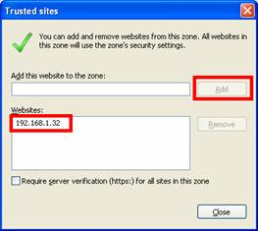
  - Back to Security tab of Internet Options window, click on Custom level… button to setup Security Settings.
Note: Please make sure that you have focus on Trusted sites section.
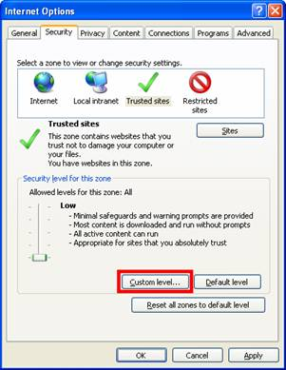
  - Select Low and click Reset… button to setup custom settings to Low. And then click OK to finish configuration.
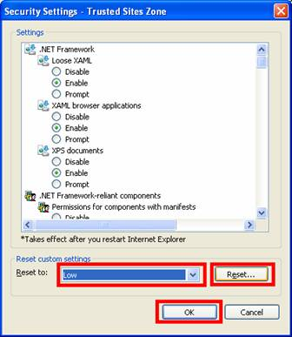

- Add the Server IP Compatibility View Setting
- Click Tools on IE toolbar, and then select Compatibility View Settings to start setting.
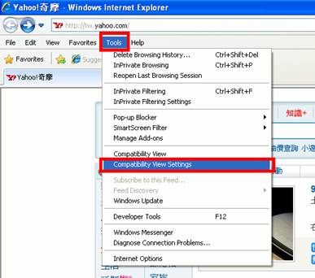
- Enter IP address of the system and click Add, then, the IP address will be set as compatibility views.
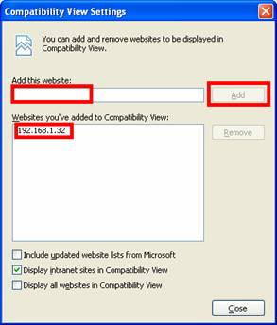
- After setting, the compatibility button will show on browser when connecting to the system.
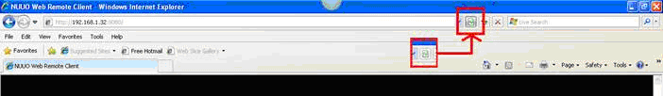

- If it still cannot work, try to use this step.
- Click Tools on IE toolbar, and then select Internet Options to start setting.
- Switch to Advanced tab, disable the Enable memory protection to help mitigate online attacks option of Security setting.
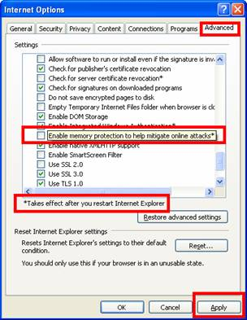
- Restart Internet Explorer after apply the new setting.

Appendix B – Minimum System Hardware Requirement

To ensure D-ViewCam system can maintain high video monitoring and recording performance, need to refer to the following table when establishing the system hardware.

Minimum Hardware Requirement

S of All Cameras | 1200~600 | 600~480 | 480~240 | 240~120 | 120~
CPU | Intel Core 2 Quad  Q6600 | Intel Core 2 Duo  E6400 | Intel Core 2 Duo  E5200 | Intel Core 2 Duo  E5200 | Intel Core 2 Duo  E5200
RAM | 2 GB | 1 GB | 1 GB | 512 MB | 512 MB
Motherboard | Intel G31 or above, MB vendor Asus,  Gigabyte or MSI with Intel Chipset recommended
Display | ATi Radeon 9200 , nVIDIA GeForce FX-5200 , Intel  945G/965G or above (ATi recommended)
Ethernet | 100 baseT or above, Gigabit LAN recommended
Hard Disk | 80 GB or above
OS | MS Windows XP pro sp2 / 2003 / Vista

For example, if users apply Intel Core 2 Quad CPU with D-ViewCam software, according to the table, the total recording and live view ability of this 32 channels system will be 1200 FPS with CIF resolution. Refer to the following section for different video resolution combinations.

M: parameter of resolution of camera.
1 Mega-pixel : M=10
VGA or D1 resolution : M=5
CIF resolution : M=1
N: FPS of Camera

Users can calculate the S value to evaluate hardware requirement by the formula :
S = M * N, it means S value = M (depend on video resolution) * N (FPS of Camera)

Or users can calculate the N value to evaluate FPS for 32 channels by the formula :
N = S ÷ M, it means N (FPS of Camera) = S value ÷ M (depend on video resolution)

For example:

If users apply Intel Core 2 Quad CPU with D-ViewCam software and they want to calculate the FPS per channel, then it could be:

N (FPS per Channel)= S ÷ M ÷ 32

1. FPS for CIF resolution with 32 channels = 1200 ÷ 32 ÷ 1 = 37.5 FPS/Ch
It means D-ViewCam software can record 30 FPS per channel, and it can also display 30 FPS for each channel with CIF resolution.

2. FPS for VGA or D1 resolution with 32 channels = 1200 ÷ 32 ÷ 5 = 7.5 FPS/Ch
It means D-ViewCam software can record at least 7.5 FPS per channel and display at least 7.5 FPS for each channel with VGA or D1 resolution.

3. FPS for Mega-pixel resolution with 32 channels = 1200 ÷ 32 ÷ 10 = 3.75 FPS/Ch
It means D-ViewCam software can record at least 3.75 FPS per channel and display at least 3.75 FPS for each channel with Mega-pixel resolution.

