DNS-120

Date: March 11, 2005

Product name: | Network Storage Adapter
Revision: | A2
Available: | 2005/02/25
Picture: | 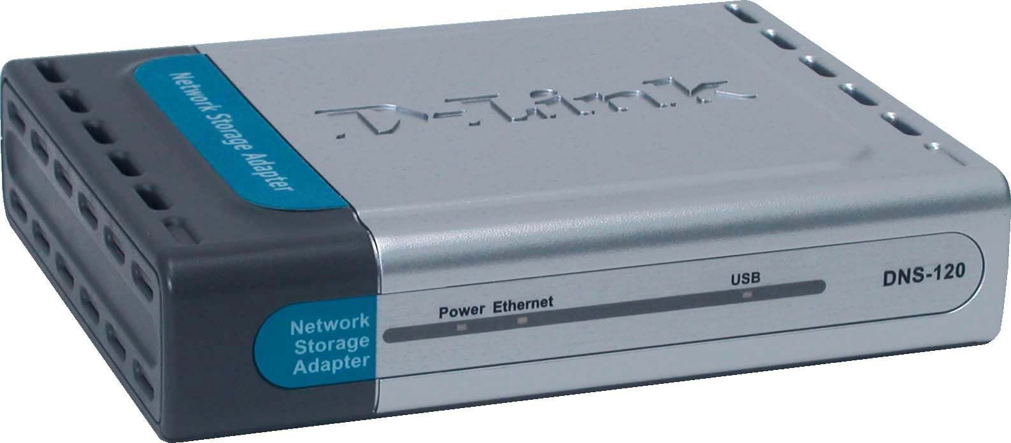
Why Sell This Product: | - We have released a storage product line, which included the flash drives and the network storage devices (with or without hard drives installed inside). Now, we’re adding to this product line a network storage adapter with only USB ports so users can plug in their flash drives and hard drive for network sharing. It’s cheap, and is a compact box for users who already have flash drives and external hard disks.  - This device is targeted at home consumers and SOHO users.  Selling Points  - Very simple setup, no software installation required.  - Small, inexpensive device but includes the useful features like built-in FTP server to access files over Internet, search utility for quick discovery of drives on the network, access security and schedule file backup.
Key Features: | - Allows 2 USB hard drive or flash drive connections  - 10/100 Ethernet LAN port with auto-MDI/MDIX  - Built-in FTP server to access files over Internet  - Easy search utility for quick discovery and mapping drives DHCP compatible  - No software installation necessary  - Web configuration utility  - User management  - Folder management  - USB drive to drive backup  - Local PC to USB drive backup  - Recurring and incremental backup  - Firmware upgrade utility  *Unless additional precautions are taken, use of an FTP Server to access files over the Internet does not provide for secure or encrypted transmissions. It is recommended that the end-user utilize a Virtual Private  Network (VPN) to establish a secure FTP session. Failure to properly disconnect USB drive may result in data loss and/or damage to the device.
Technical Details: | Standard  - IEEE 802.3/802.3u Ethernet  - USB 1.1, 2.0  - Samba 2.2.8a  Device Interfaces  - 1 10/100BASE-TX Ethernet with auto MDI-X support  - 2 USB 2.0 ports  Buttons  - Disconnect button  - Reset button  DHCP Client  Get IP address from DHCP server, Auto-IP  Device Management  - Windows-based utility with firmware download feature  - Network settings  - Auto IP capability  - User account management  - Folder and drive management  - FTP server  - Schedule download  - Backup function  Security Features  - Folder permissions  - Account-based access to FTP  - Account-based access to scheduled downloads  Security Methods  - IP address filtering for Ethernet access with either Deny or Allow setting  - In account mode, via username/password to access the assigned directory  System Monitoring  System log  File System Type  FAT 16/FAT 32  LED Indicators  - Power  - Ethernet  - USB  Diagnostics Capability  - Power-on self test of flash memory, DRAM, Ethernet and USB ports  - Syslog: 256 items  Firmware Download  Via Ethernet (error recovery mechanism must be in place)  Physical & Environmental  Power Requirement  5V DC, 2.5 A  Power Supply  Through external power adapter  Dimensions  141 x 108 x 30 mm  Weight  194 grams  Operating Temperature  5 to 50 ℃  Storage Temperature  -20 to 50 ℃  Operating Humidity  10% to 90%, non-condensing  Storage Humidity  5% to 95%, non-condensing  EMI  - FCC Class B  - CE  - C-Tick  Box Includes  - DNS-120 Network Storage Adapter  - Cat. 5 Ethernet cable  - External power adapter  - CD-ROM containing software and User s Manual  - Quick Installation Guide
EMI/EMC Report | ☑FCC No. ☑ CE No. ◻ VCCI No.  ◻ CTR-21 No. ☑ C-Tick No. ◻ A-Tick No.  ◻ FDA No. ◻ R&TTE No. ◻ BSMI No.  ◻ Others
Safety | ◻ TUV No. ◻ UL No. ◻ CSA No.  ◻ Others
Packaging Style | ◻ Clamshell ◻ White Box ☑ Gift Box ◻ Bulk ◻ White Box with D-Link Logo  ◻ Others
Packaging Contents: | - DNS-120 Network Storage Adapter  - CAT5 Ethernet Cable  - Power Adapter ( 5V, 2.5A )  - CD-ROM with Software and Manual  - Quick Installation Guide
UPC Code:
  BNS120A…A2 | 790069 270666
  ENS120B…A2 | 790069 271366
  ENS120E…A2 | 790069 271373
  INS120A…A2 | 790069 271380
  INS120E…A2 | 790069 271397
  INS120N…A2 | 790069 271403
  CNS120A…A2 | 790069 274244
  NNS120C...A2 | 790069 276644
Units Per Carton: | 10
Cartons Per Pallet: | For USA Air:27, Sea: 36 | For WW Air:27, Sea: 36
Dimensions and Weight: | Box:  ,Others , 0.86 kg  Carton: 380 x 315 x 465 mm, 8.6 kg  Pallet: (by Air) 1220 x 1020 x 1620 mm, 260 kg (for USA)  1200 x 1100 x 1620 mm, 260 kg (for WW)  (by Sea) 1220 x 1020 x 1990 mm, 340 kg (for USA)  1200 x 1100 x 1990 mm, 232.2 kg (for WW)  INTRASTAT weight: 0.86 kg (Box)  Packing material weight (Box):  - Paper: 0.632 kg  - Plastic: 0.18 kg  - Mixed: 0.07 kg

