Amazon S3
Amazon S3 (Simple Storage Service) is an online storage service offered by AWS (Amazon Web Services), providing a simple web services interface that can be used to store and retrieve any amount of data, at any time, from anywhere on the web. With Amazon S3 support, you can easily upload and download data to and from your ShareCenter to Amazon S3.

This Amazon S3 How-To Guide will show you how to:
- Create your AWS Account to access the Amazon S3 services.
- Create a bucket on the Amazon S3 Server where you can upload and download your ShareCenter data to and from.
- Create an Amazon S3 Scheduled Backup on your ShareCenter to automatically upload any ShareCenter Network Share to the Amazon S3 service.

Creating an Amazon S3 Account
To use Amazon S3, you will need an AWS account if you don’t already have one, you will be prompted to create one when you sign up for Amazon S3.
In a web browser, open the following URL:
http://aws.amazon.com/s3
Click on ‘Sign-up for Amazon S3 service’ and follow the on-screen instructions. When you have completed registering, you should get an e-mail from AWS stating that can begin using your account.

Make sure to remember the access key and secret access key which allows your ShareCenter to access the AWS services.
For example the access key might be: WKEAIBWLXWBDNBGTVX9C
and the secret access key might be: CbnCDVM+CggC5w7CqXLOaO5LYI0svc1Yrqwe9jkj
Creating an Amazon S3 Bucket
Once you have logged into Amazon AWS, click the ‘create bucket’ button and in the dialog window type in a bucket name to identify your data and select the region server best suited for your location (to minimize transfer delay). The ShareCenter does not support underscore characters (_) in the bucket name.
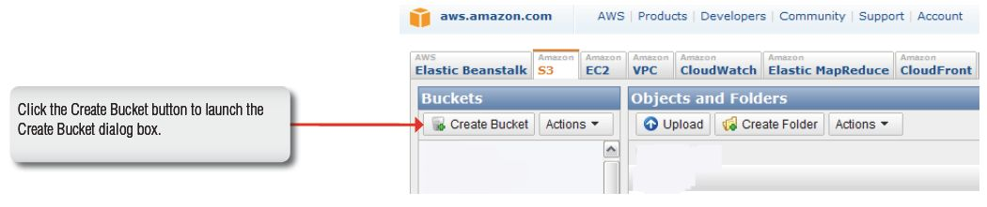
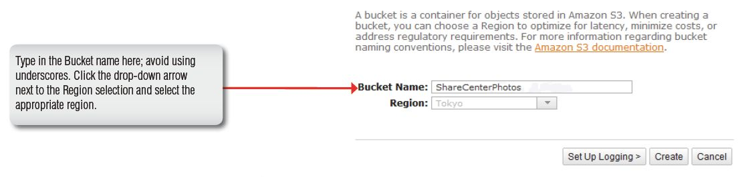

Once the bucket is created you will see it in the Buckets column on the left of the Amazon S3 page. Click it to see the contents of the bucket. It should be empty until your next ShareCenter Amazon S3 backup.

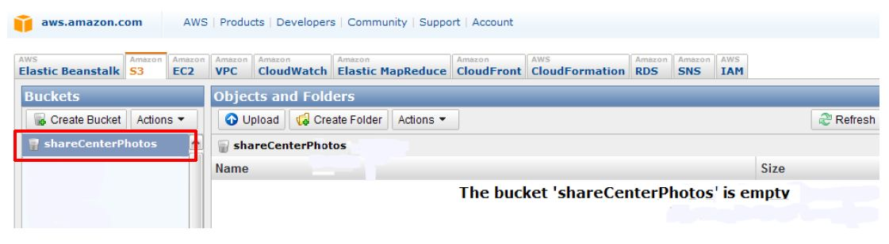

Creating an Amazon S3 Scheduled Backup on the ShareCenter
Click on the ShareCenter’sApplications tab and then click the Amazon S3 icon to launch the Amazon S3 configuration window.

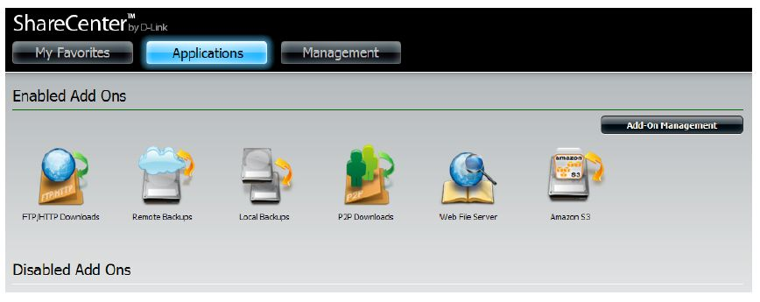

To create a scheduled backup from the ShareCenter to the Amazon S3 bucket, click on the Create button to launch the step by step
configuration wizard.

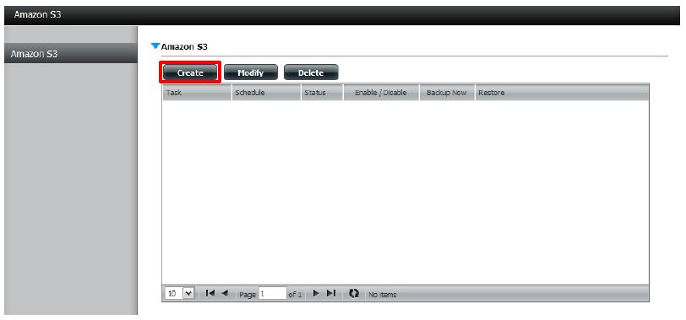

There are 6 steps in creating the Amazon S3 Backup:
- Define name
Set a user defined name for the backup job.
- Configuring Amazon S3
Enter your Amazon S3 credentials and configure the bucket name and regional Amazon server.
- Backup type and direction
Set the type and direction of the backup.
- Configure local network share
Configure the local network share from where data will be backed-up to or from.
- Schedule Backup
Set when the backup will be performed.
- Review all your settings.

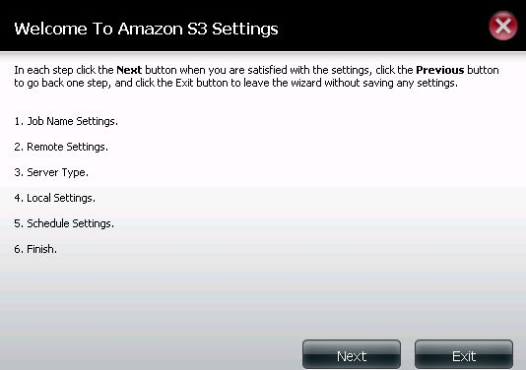
This first window of the configuration shows an overview of the 6 steps. In each window click the Nextbutton to proceed to the next window if you are satisfied with your settings. Click the Previousbutton if you want to go back to check your settings in prior windows, and finally if you want to exit the wizard without making changes click the Exitbutton.

Input a Job Name for this backup. Make sure to name the backup in a way that you can identify it in case you decide to create multiple backups on your ShareCenter.

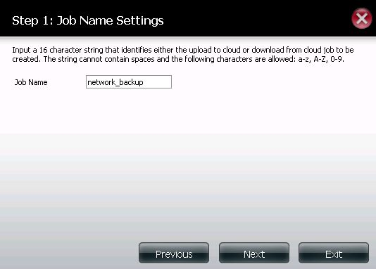

You should have received an Access Key and Secret Access Key in the e-mail from Amazon AWS services when you first registered for your account. Input the two keys along with the name of the bucket (Remote Path) and Region server. Click Next to proceed.

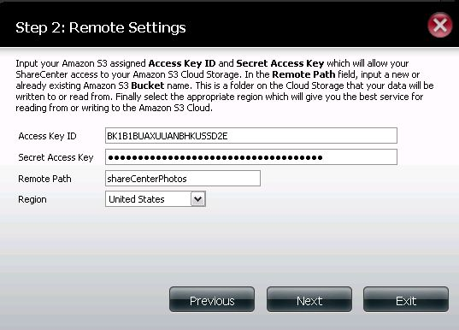

In Step 3 of the wizard, set the direction of the backup using the Typeparameter. You can select Upload to backup from the ShareCenter network share to the Amazon S3 bucket or Download to backup from the Amazon S3 bucket to the ShareCenter network share.

Set the Backup Typeparameter to set the Backup job to:
• Overwrite Existing Filesto write over any files in the target folder with the source files that have identical names.
• Full Backupto create a separate folder containing the entire backup data for each time the job is executed.
• Incremental Backupto write over files with source files that are newer than the target folder files

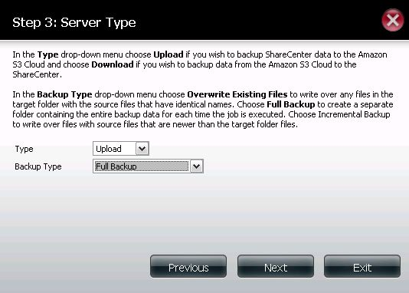
In Step 4 of the wizard, you can set the local path. Click on the Browser button to browse to the network share of the ShareCenter where the data will be backed up to or from.

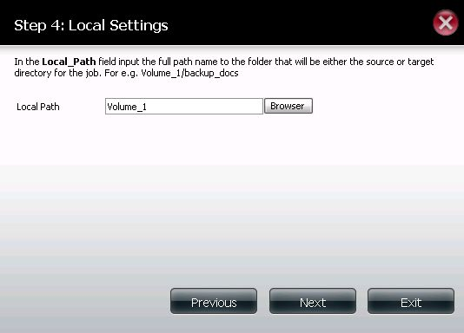

In Step 5, select one of the Schedule Modeoptions to set when to perform the backup. Click on Manualto start the backup later using a button that must be manually clicked on. Click on Once to schedulea date and time to run the job one time only. Click on Schedule to set a daily time when the job is to be run.

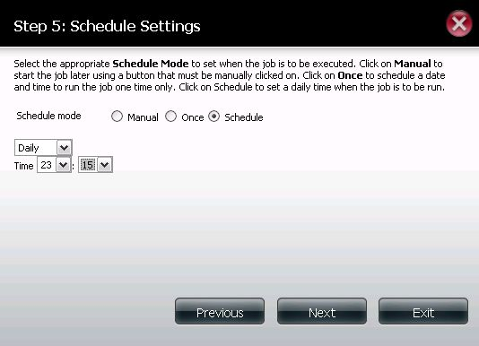

In Step 6 review all your settings and click Previous to go back to make any changes. Click Exit to exit the wizard without saving the job. Click Finish to save the job and exit the wizard.

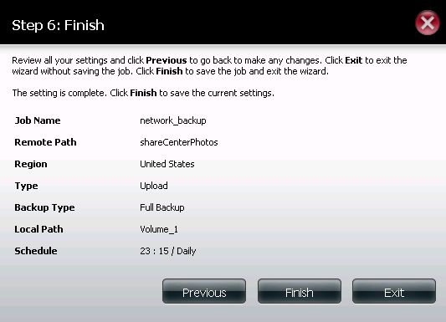

Now that you have created an Amazon S3 Task, you can either wait for the Task to begin as scheduled or click the Backup Now icon to begin the process immediately. A dialog box will ask you to confirm the backup as shown below.

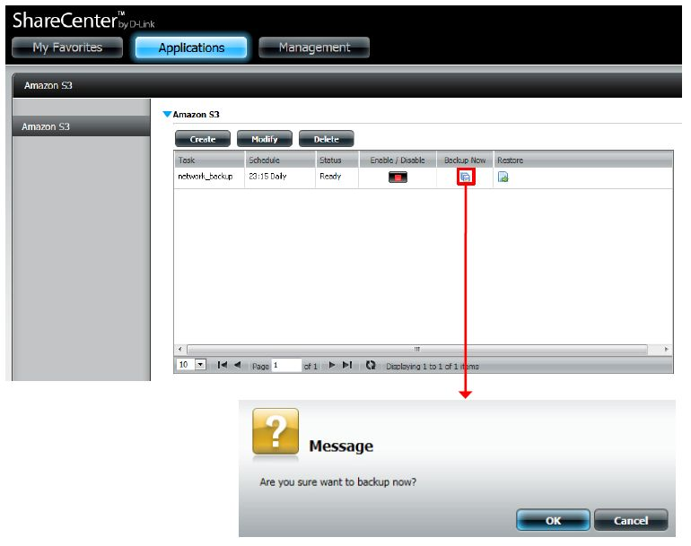
When the backup is underway, the Status field should sayRunning.

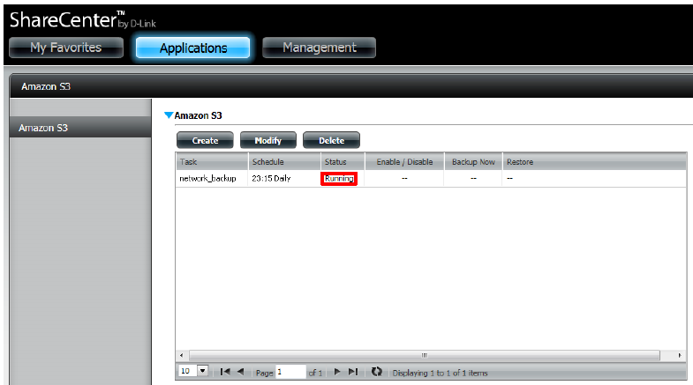

When the backup is complete, the Status field will display Finish. If your sourcefiles ever go missing or become damaged, you can click the Restore icon in the Amazon S3 Task table to restore your files. When you click the restore button in the table, a dialog window will ask you to choose whichBackup date you wish to restore to(see the next page).

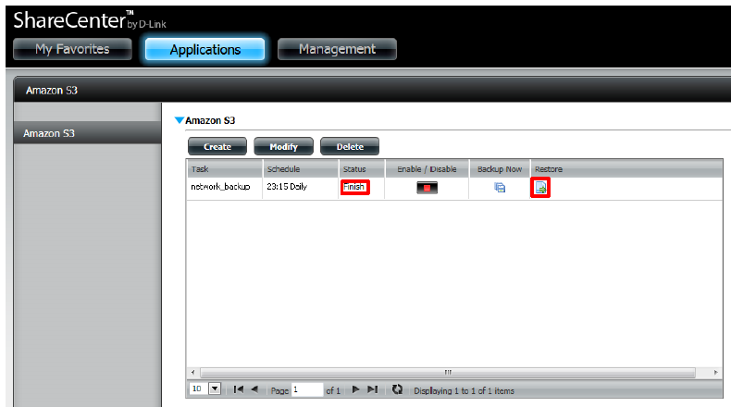
After clicking the Restore icon in the Amazon S3 Tasks table,the Restore window below will appear. Click the Applybutton next to the backup date that you wish to use in restoring your data from.

