File eXchange Protocol (FXP)
File eXchange Protocol (FXP) allows your ShareCenter to transfer data using FTP to a remote FTP server without routing data through a client connection.

Usually, FTP sessions are only between a FTP server and FTP client where data can only be transmitted between the two. The FXP client protocol supports FTP sessions between two FTP servers where one of them can connect to the other to transmit data, without having to go through a client.

This How-to guide will show you how to setup your ShareCenter’s FTP server so that you can transfer data directly to a Remote FTP server. The steps include:
1. Setting up an FTP Network Share on your ShareCenter
2. Enabling and configuring the FTP Server function on your ShareCenter.
3. Verifying that the Remote FTP Server supports FXP.
4. Using a FXP enabled FTP Client to connect to both the ShareCenter FTP server and Remote FTP server to transfer files using FXP.

Note: If you are going to backup from this NAS as the source content of the backup setting, then make sure that the Remote Backup Server is checked and set with a password. If the ShareCenter is connected to a router, you will need to configure the router to forward any available port other than the default port 21 to the IP address of this ShareCenter.

FTP Network Share Setup
In the Management tab of the ShareCenter, click on the Account Management icon to verify or configure a Network Share that supports FTP protocol.

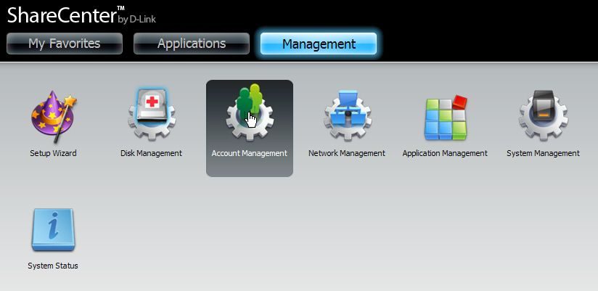

Click on the Network Shares menu selection in the column on the left and verify or configure that the Network Share that will be used for the FXP transfer has FTP protocol enabled. The Network Share will have the SEARCH icon in the FTP column if it supports FTP protocol. You may need to check that the read/write permissions are set appropriately by clicking on SEARCH. If you need to edit the permissions, click on the Modify button to open the configuration wizard for the Network Share.

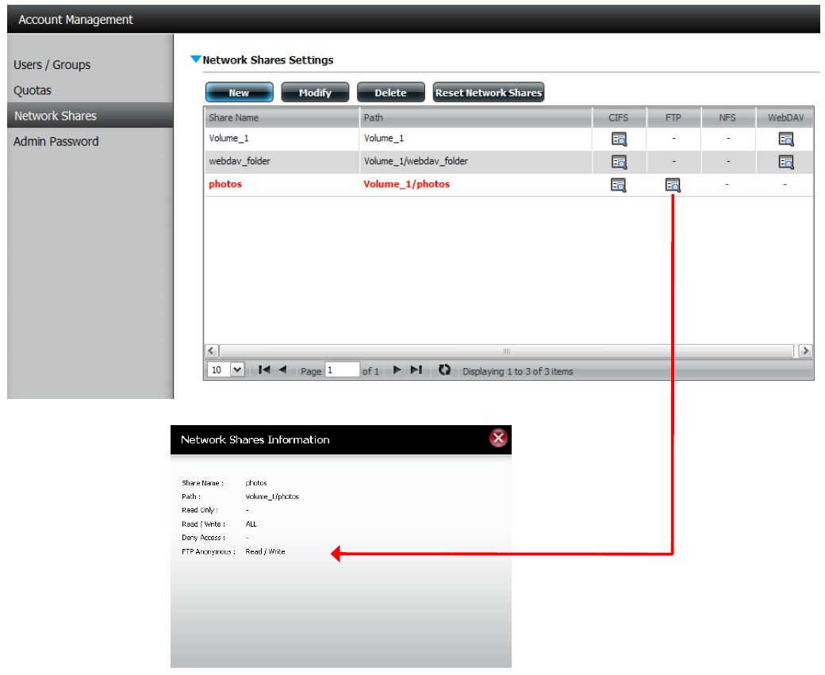

Configure and Enable the ShareCenter’s FTP Server
Once the Network Share is correctly configured with the appropriate FTP protocol, the next step is to configure the FTP Server function on your ShareCenter. The FTP server function needs to have FXP protocol enabled and the TCP port set to a suitable port number other than 21 (standard FTP port).
In the Management tab select the Application Management icon.

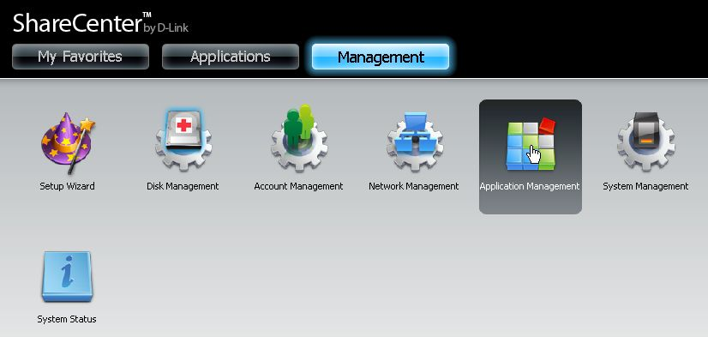

Click on the FTP Server selection in the left column if it is not already selected. The Port configuration should already be set to 21. You can use any available ports as listed to the right of the Port configuration box. Check the FXP Enable radio button to allow your ShareCenter FTP server to support File eXchange Protocol. When you are finished click on the Save Settings button.

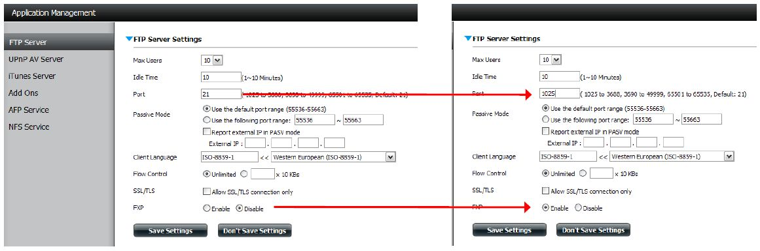

Click on the Blue triangle to the left of the FTP Server Headings title of the page to close the FTP Server configuration window. Click on the FTP server status and double check that the FTP Server settings are:

• Status: Started
• Port: 1025 (or the port you selected in the previous configuration window)

When you are finished, check to make sure the Remote FTP server’s FXP protocol is configured.

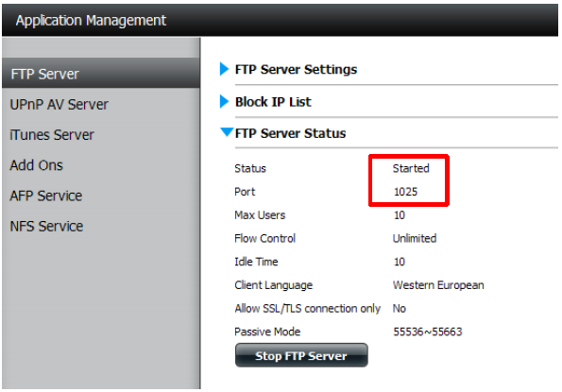

In order to initiate FXP file transfer from one FTP server to another you must use an FTP enabled client as shown in this example using the Software FlashFXP©. This client supports concurrently logging into 2 FTP servers such that you can FXP transfer files from one server to the other without the client in the path. In the FlashXP example below, the left window shows the login to the a Remote FTP server (another ShareCenter) and the right window is logged into the local ShareCenter.
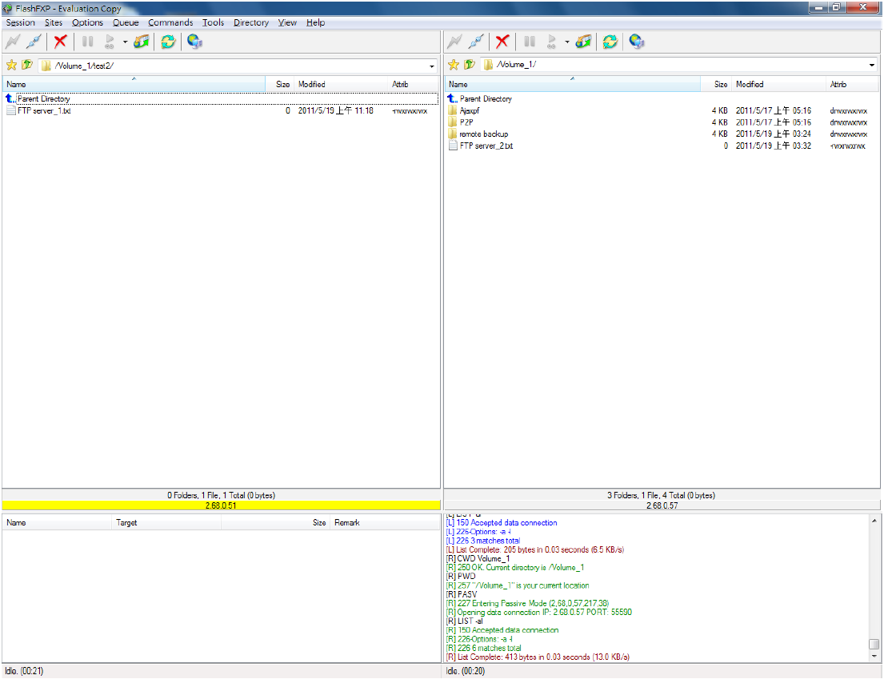

Within FlashFXP© right click on a file to select the Transfer menu option.

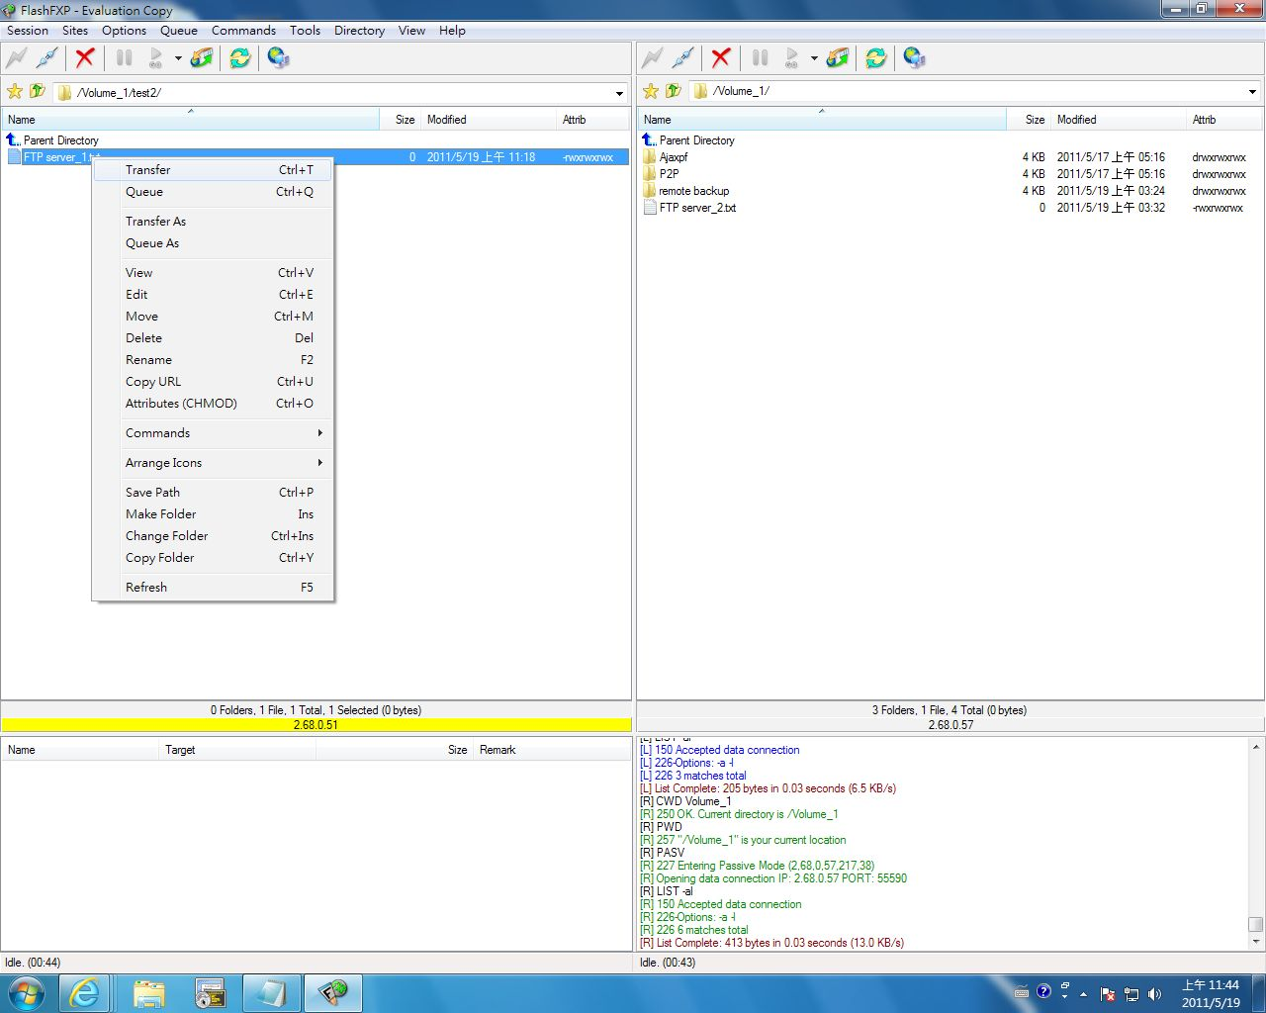
After clicking on Transfer, the Client instructs the FTP servers to transfer the file between each other over a direct link and not in the path of the client’s data path.
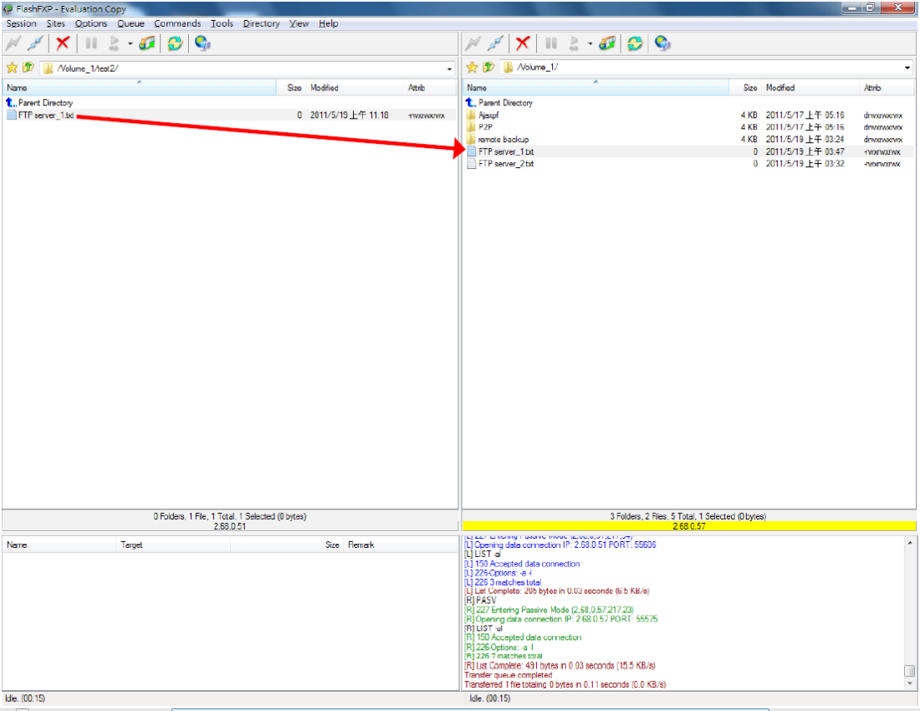

If the FTP Server permissions are set correctly, then you can begintransfering files in both directions using FlashFXP or any other suitable FXP enabled FTP client. In the example below the local ShareCenter file is selected to transfer to the Remote FTP server.

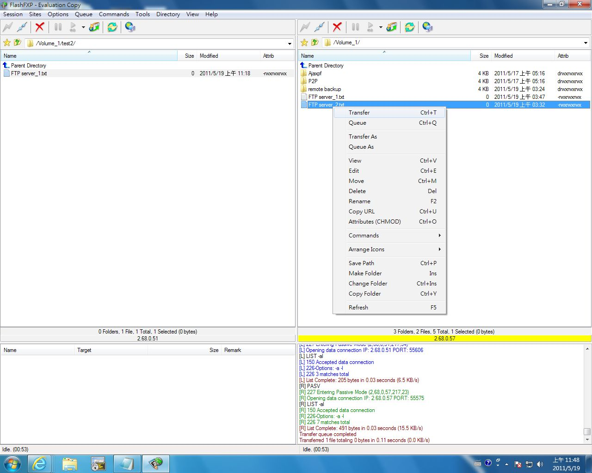
In this screenshot, the file from the local ShareCenter has been transferred using FXP to the remote FTP server directly.
