WebDAV Setting Guide
Connecting from Windows XP
You can connect to your ShareCenter using the Web-based Distributed Authoring and Versioning (WebDAV) protocol from Windows XP using the following procedure.
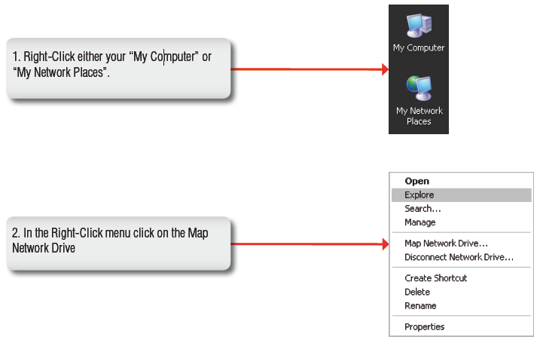
Note: Make sure that the ShareCenter’s Network Share and User that you wish to utilize for the connection have the WebDAV protocol enabled. If you need to turn on the WebDAV protocol, access your ShareCenter’s WebUI as administrator and modify the User in the Management Tab - Account Management Icon - Users/Groups Menu - User Settings. You can modify the Network Share to turn on the WebDAV protocol in the -Management Tab - Account Management Icon - Network Shares Menu - Network Shares - Settings. Refer to the ShareCenter User Manual for details on configuring these settings.

Note: If you are going to backup from this NAS as the source content of the backup setting, then make sure that the Remote Backup Server is checked and set with a password. If the ShareCenter is connected to a router, you will need to configure the router to forward port 80 to the IP address of this ShareCenter.
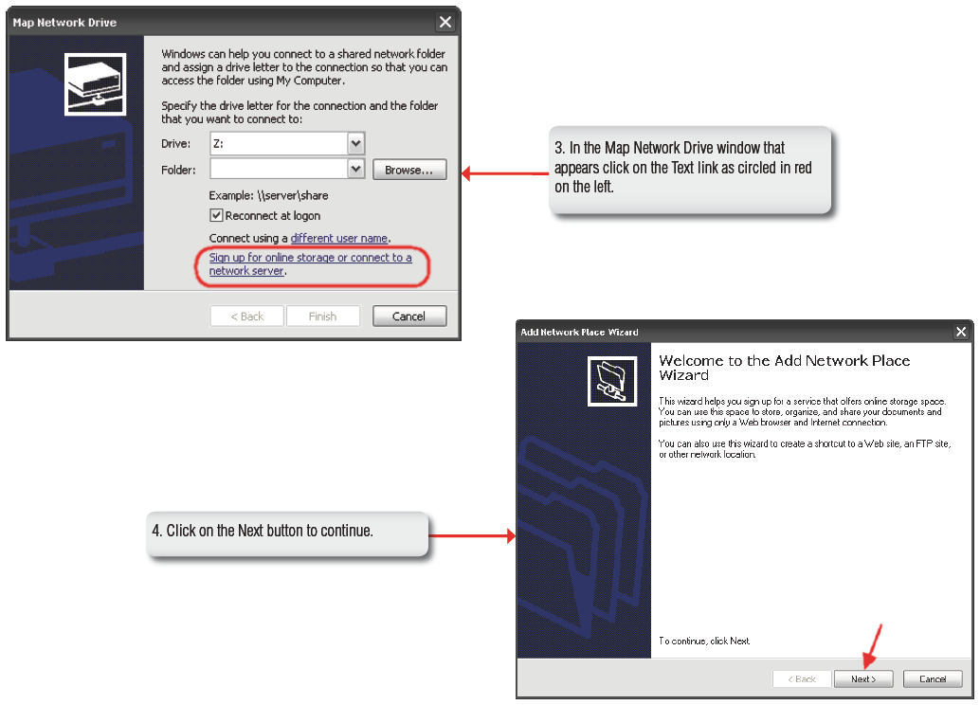
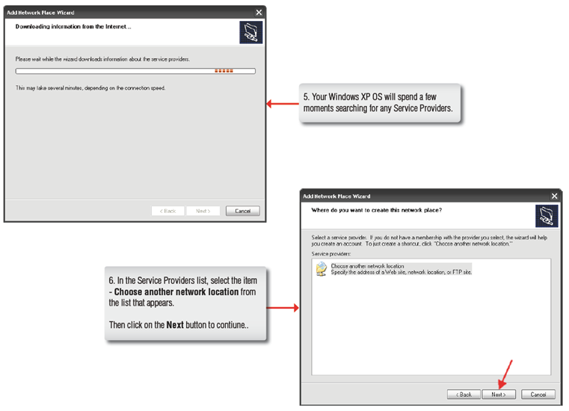
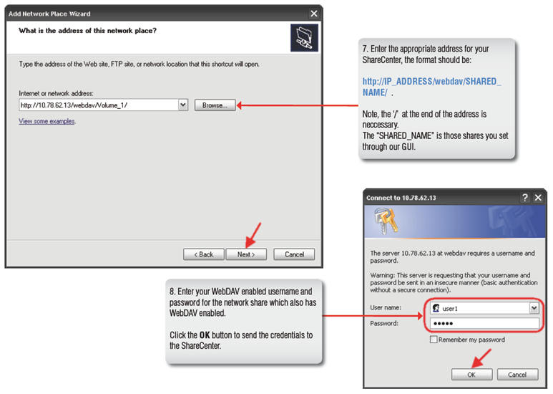
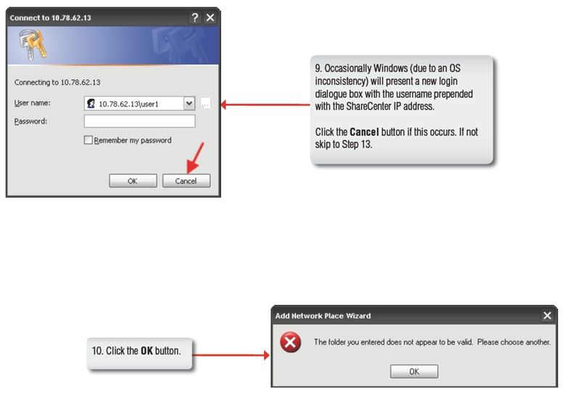
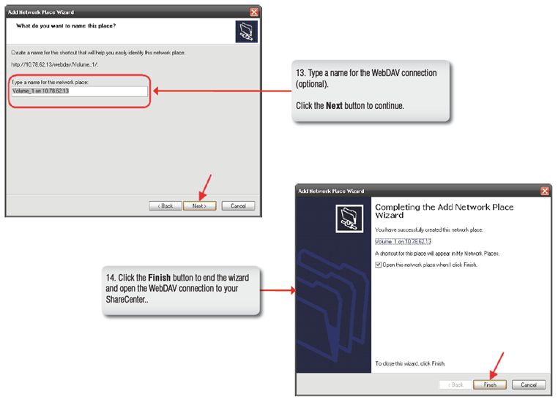

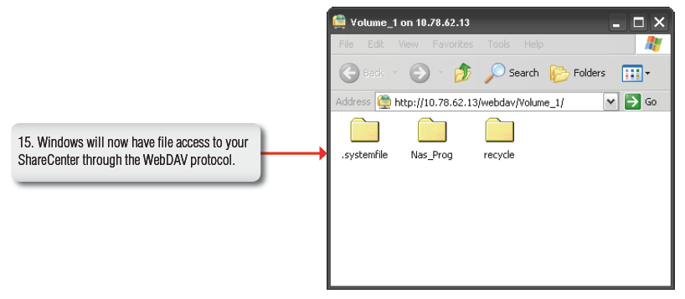

Connecting from Windows Vista
You can connect to your ShareCenter using Web-based Distributed Authoring and Versioning (WebDAV) protocol from Windows Vista using the following procedure.
Note 1: Before following this procedure make sure that your Vista installation is updated with Service Pack 2 and the Windows Vista software update KB907306.
Note 2: Make sure that the ShareCenter’s Network Share and User that you wish to utilize for the connection have the WebDAV protocol enabled. If you need to turn on the WebDAV protocol, access your ShareCenter’s WebUI as administrator and modify the User in the Management Tab - Account Management Icon - Users/Groups Menu - User Settings. You can modify the Network Share to turn on the WebDAV protocol in the -Management Tab - Account Management Icon - Network Shares Menu - Network Shares - Settings. Refer to the ShareCenter User Manual for details on configuring these settings.
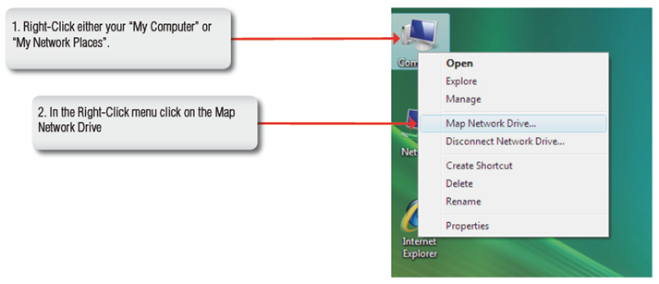
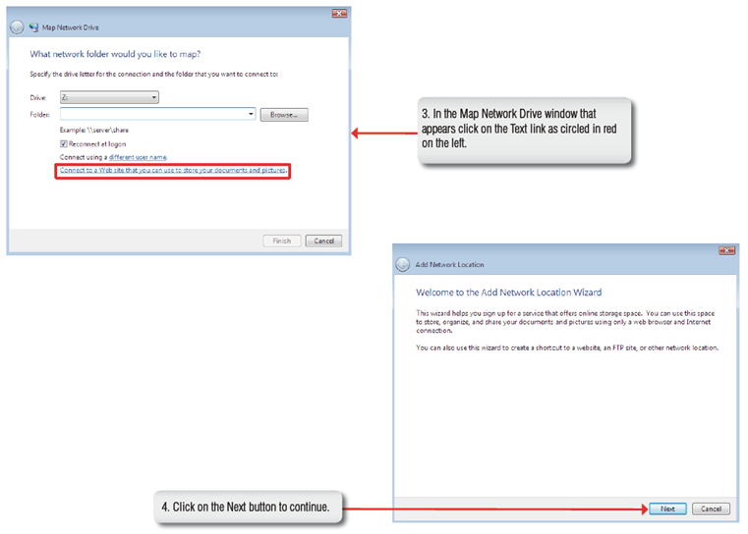
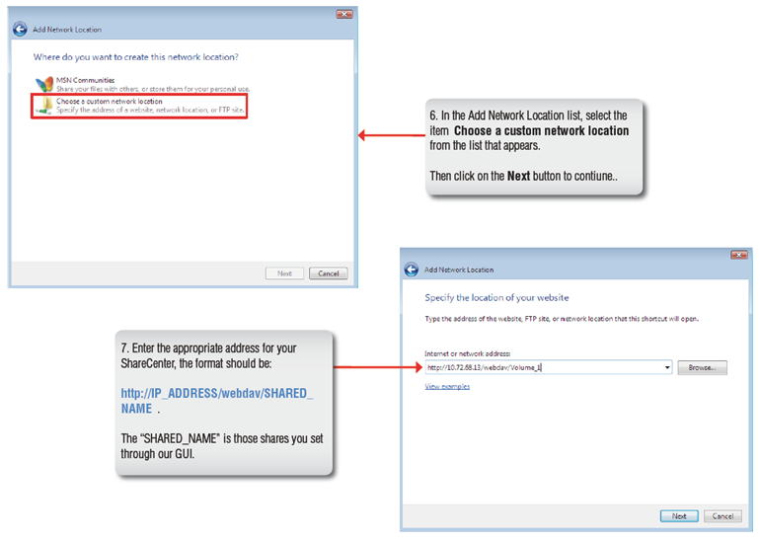
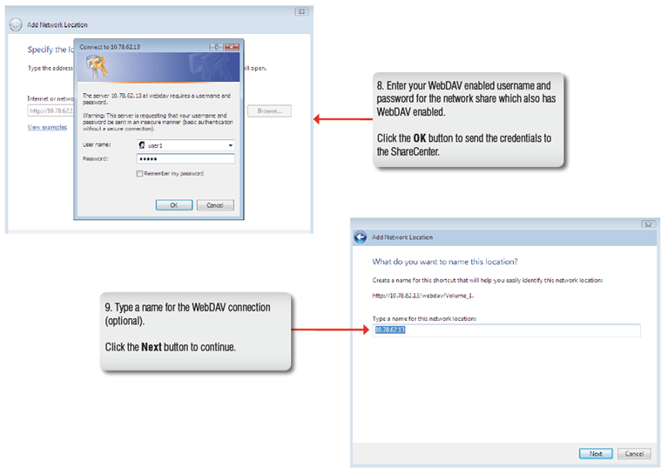
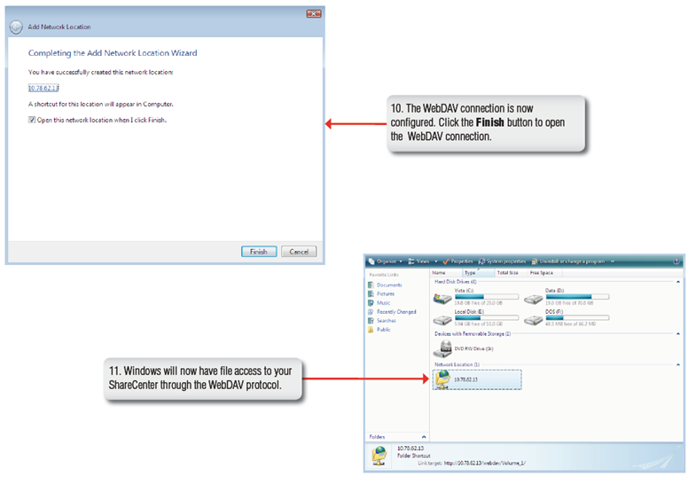
Connecting from Windows 7
You can connect to your ShareCenter using Web-based Distributed Authoring and Versioning (WebDAV) protocol from Windows 7 using the following procedure which utilizes the BitKinex client to connect to your ShareCenter over WebDAV.

Note 1: Windows 7 irregularities make it necessary to install a 3rd Party file sharing client for the WebDAV Protocol. The following is an example of a 3rd Party tool.
Note 2: Make sure that the ShareCenter’s Network Share and User that you wish to utilize for the connection have the WebDAV protocol enabled. If you need to turn on WebDAV protocol access your ShareCenter’s WebUI as administrator and modify the User in the Management Tab - Account Management Icon - Users/Groups Menu - User Settings. You can modify the Network Share to turn on the WebDAV protocol in the -Management Tab - Account Management Icon - Network Shares Menu - Network Shares - Settings. Refer to the ShareCenter User Manual for details on configuring these settings.
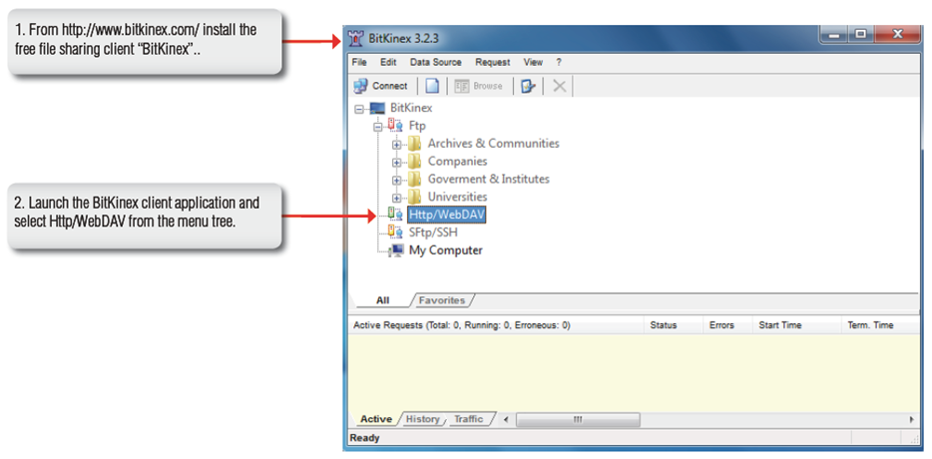
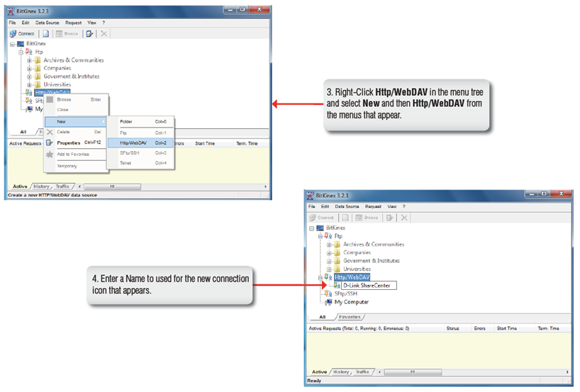
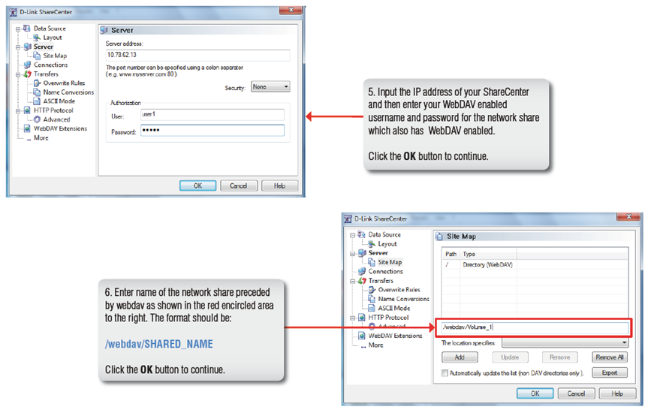
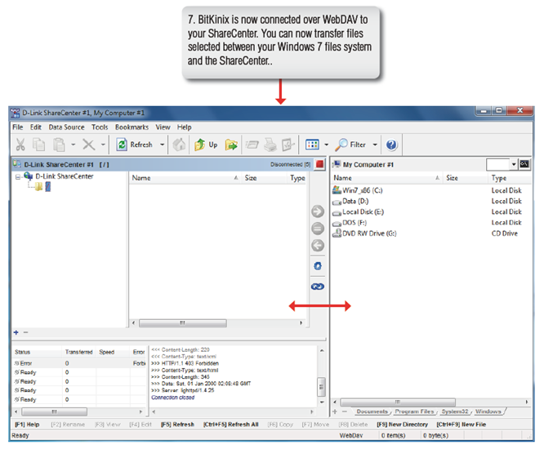
Connecting from MAC OS
You can connect to your ShareCenter using Web-based Distributed Authoring and Versioning (WebDAV) protocol from MAC OS using the following procedure.
Note: Make sure that the ShareCenter’s Network Share and User that you wish to utilize for the connection have the WebDAV protocol enabled. If you need to turn on the WebDAV protocol, access your ShareCenter’s WebUI as administrator and modify the User in the Management Tab - Account Management Icon - Users/Groups Menu - User Settings. You can modify the Network Share to turn on the WebDAV protocol in the -Management Tab - Account Management Icon - Network Shares Menu - Network Shares - Settings. Refer to the ShareCenter User Manual for details on configuring these settings.
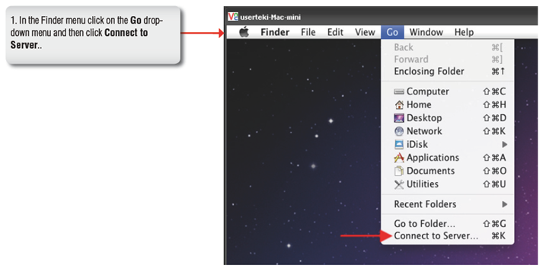
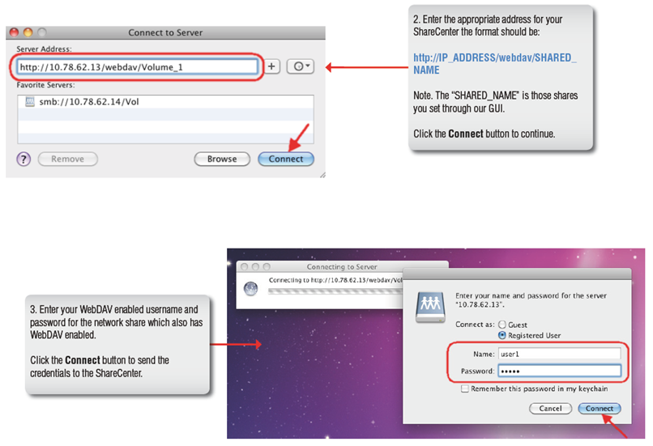
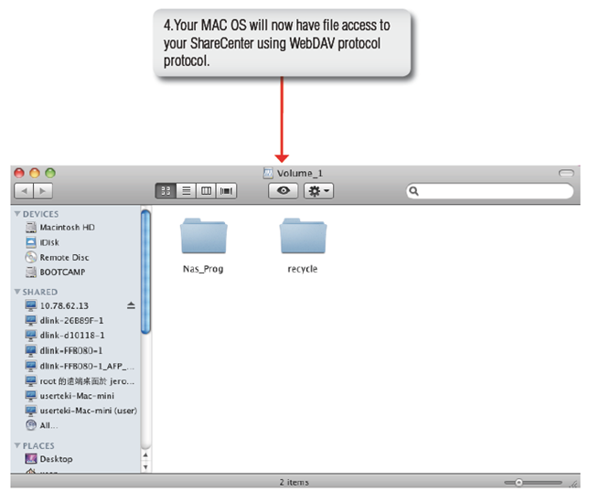
Connecting from LINUX
You can connect to your ShareCenter using Web-based Distributed Authoring and Versioning (WebDAV) protocol from LINUX OS using the following procedure.
Note: Make sure that the ShareCenter’s Network Share and User that you wish to utilize for the connection have the WebDAV protocol enabled. If you need to turn on the WebDAV protocol, access your ShareCenter’s WebUI as administrator and modify the User in the Management Tab - Account Management Icon - Users/Groups Menu - User Settings. You can modify the Network Share to turn on the WebDAV protocol in the -Management Tab - Account Management Icon - Network Shares Menu - Network Shares - Settings. Refer to the ShareCenter User Manual for details on configuring these settings.
