DNS-G120

Date: August 2, 2005

Product Description: | Wireless Network Storage Adapter
Revision: | A1
Availability: | Now
Picture: | 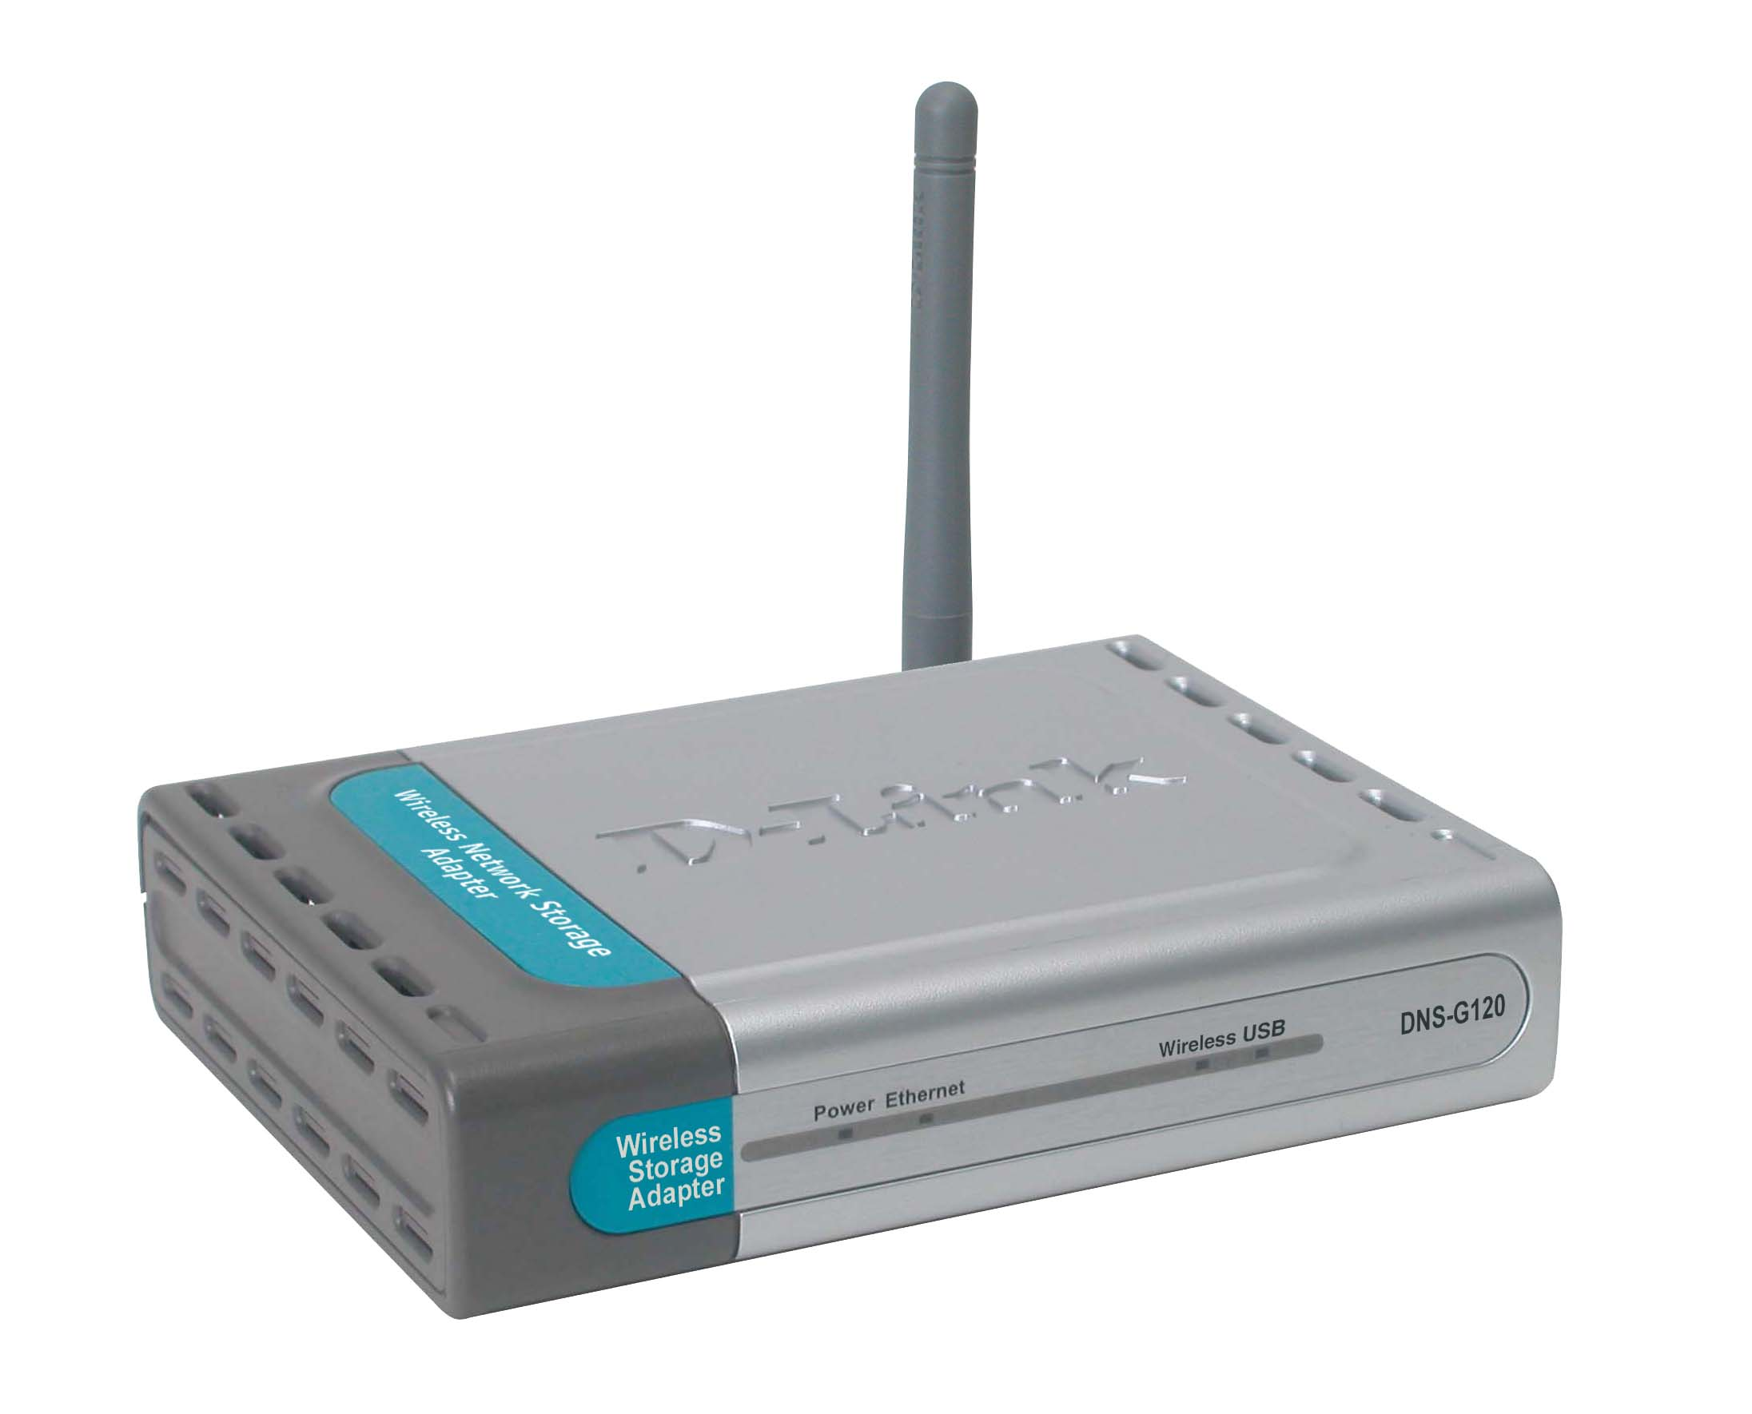
Why Sell This Product: | We have released a storage product line, which included, among other products, the DNS-120 network storage adapter. Now, we’re adding a wireless LAN interface to the previously released network storage adapter to give users a choice of sharing external USB hard drives/flash drives on a wired or wireless network. This new wireless device is targeted at home consumers and SOHO users.  Selling Points  - Simple setup, through an easy search utility.  - Small, inexpensive device but includes the useful features like built-in FTP server to access files over Internet, search utility for quick discovery of drives on the network, access security and schedule file backup.  - Additional 802.11g wireless LAN interface.
Key Features: | Share Hard Drive/Flash Drives  - 2 USB 2.0 Ports for Hard Drives/Flash Drive Connection  - 10/100BASE-TX Port for Ethernet Network Connection  - 802.11g WLAN (Up to 54Mbps Speed) for Wireless Network Access  File Access  - Built-in FTP Server for File Access Over Internet *  - Search Utility for Quick Discovery/Drive Mapping  - DHCP Compatible  - User Management  - Folder Management  Setup/Drive Backup  - Through an easy search utility.  - Web Configuration Utility  - USB Drive-to-Drive Backup  - Local PC-to-USB Drive Backup  - Recurring and Incremental Backup  - Firmware Upgrade through web.  * Unless additional precautions are taken, use of an FTP server to access files over the Internet does not provide for secure or encrypted transmissions. It is recommended that the end-user utilize a Virtual Private Network (VPN) to establish a secure FTP session. Failure to properly disconnect USB drive may result in data loss and/or damage to the device.
Technical Details: | Technical Specifications  Standards  - IEEE 802.3/802.3u Ethernet  - IEEE 802.11b/g wireless LAN  - USB 1.1, 2.0  - Samba 2.2.8a  Device Interfaces  - 10/100BASE-TX Ethernet port  - 802.11g wireless LAN supporting up to 54Mbps speed)  - 2 USB 2.0 ports  Buttons  - Disconnect button  - Reset button  DHCP Client  Get IP address from DHCP server, Auto-IP  Device Management  - Windows-based utility  - Network settings  - Auto IP capability  - User account management  - Folder and drive management  - FTP server  - Schedule download  - Backup function  Security Features  - Folder permissions  - Account-based access to FTP  - Account-based access to scheduled downloads  Security Methods  - IP address filtering for Ethernet access with either Deny or Allow setting  - In account mode, via username/password to access the assigned directory  System Monitoring  System log  File System Type  FAT 16/FAT 32  LED Indicators  - Power  - E thernet  - WLAN  - USB  Diagnostics Capability  - Power-on self test of flash memory, DRAM, Ethernet and USB ports  - Syslog: 256 items  Firmware Download  Through Ethernet (error recovery mechanism must be in place)  Physical & Environmental  Power Requirement  5V DC, 2.5 A  Power Supply  Through external power adapter  Dimensions  141 x 108 x 30 mm  Weight  194 grams  Operating Temperature 0  5 to 50 C  Storage Temperature 0  -20 to 50 C  Operating Humidity  10% to 90%, non-condensing  Storage Humidity  5% to 95%, non-condensing  EMI  - FCC Class B  - CE  - C-Tick  Box Includes  - DNS-G120 wireless network storage adapter  - Cat. 5 Ethernet cable  - External power adapter  - CD-ROM containing software and User's Manual  - Quick Installation Guide  - Detachable antenna  - 4 rubber feet
EMI/EMC Report | ☑FCC No. ☑ CE No. ◻ VCCI No.  ◻ CTR-21 No. ☑ C-Tick No. ◻ A-Tick No.  ◻ FDA No. ◻ R&TTE No. ◻ BSMI No.  ☑ IC No. ◻ Others
Safety | ◻ TUV No. ◻ UL No. ◻ CSA No.  ◻ CB No. ◻ Others
Packaging Style | ◻ Clamshell ◻ White Box ☑ Gift Box ◻ Bulk ◻ Brown Box ◻ Others
Packaging Contents: | - DNS-G120 Wireless Network Storage Adapter  - CAT5 Ethernet Cable  - Power Adapter ( 5V, 2.5A )  - Rubber feet  - Antenna x1  - CD-ROM with Software and Manual  - Quick Installation Guide
UPC Code:
  UPC code |  | Part Number
  790069 | 281815 | BNSG120ANAA1
  790069 | 285516 | INSG120ANAA1
  790069 | 285523 | INSG120BEUA1
  790069 | 285530 | INSG120EEUA1
  790069 | 285547 | INSG120NEUA1
  790069 | 285554 | INSG120ENAA1
Units Per Carton: | For USA | For WW
Units Per Carton: | 10 | 10
Cartons Per Pallet: | For USA | For WW
Cartons Per Pallet: | Air:27, Sea: 36 | Air:27, Sea: 36
Dimensions and Weight: | Box:  ◻ 237x168x36mm (Type A) ◻ 225x150x75mm (Type B)  ◻ 269x162x65mm (Type C) ☑ 274x208x68mm (Type D)  ◻ 274x208x118mm (Type D1) ◻ 274x208x138mm (Type D2)  ◻ 288x245x66mm (Type E)  , Others __________, 0.81 kg  Carton: 380 x 315 x 465 mm, 8.7 kg  Pallet: (by Air) 1220 x 1020 x 1620 mm, 260 kg (for USA)  1200 x 1100 x 1620 mm, 260 kg (for WW)  (by Sea) 1220 x 1020 x 1990 mm, 340 kg (for USA)  1200 x 1100 x 1990 mm, 232.2 kg (for WW)  INTRASTAT weight: 0.34 kg (Box)  Packing material weight (Box):  - Paper: 0.3 kg  - Plastic: 0.1 kg  - Mixed: 0.07 kg

