Before You Begin
You must have at least the following:
An Ethernet-enabled device, such as a laptop or desktop computer that will connect to the DHP-200.
Note: You will need at least two DHP-200 devices in order to create a powerline network.
Safety Instructions
- Do Not operate this product near water
- Do Not locate this product where people may walk on the Ethernet cable.
- The AC coupler should be plugged directly into a 110 VAC wall outlet.
Do Not use an extension cord between the adaptor and AC power source.
- Disconnect this product from wall outlet during a lightning or thunder storm.
- Unplug from the wall outlet before cleaning. Use a damp cloth for cleaning.
Do Not use liquid cleaners or aerosol cleaners.

Check Your Package Contents
These are the items included with your DHP-200 purchase:

DHP-200 PowerLine
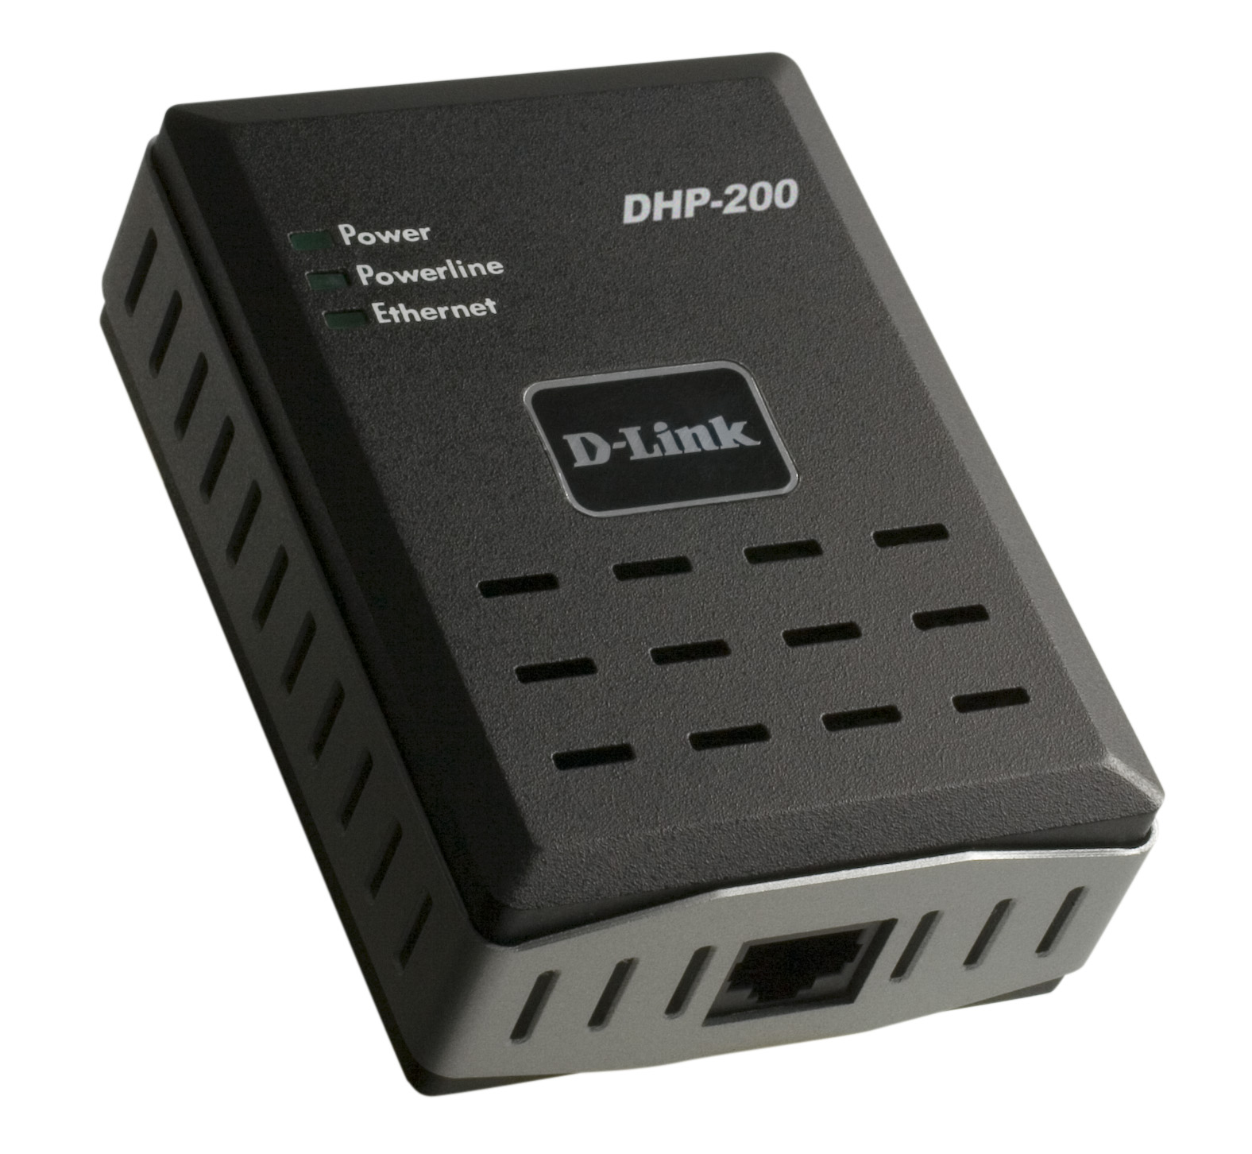

CD-ROM (containing Manual and Warranty)
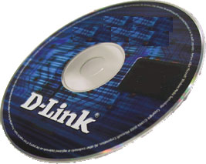

Ethernet (CAT5 UTP/Straight-Through) Cable
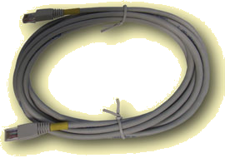

If any of the above items are missing, please contact your reseller.
Connecting DHP-200 To Your Network

The DHP-200 is an excellent solution that can be used to extend your wireless network. In the home or small office building, use a pair of DHP-200 Powerline adapters to link two wireless remote locations without the need to run Ethernet cables. Combined with a broadband Cable/DSL connection, every room with electrical outlets will have easy access to the high-speed Internet connection.
Product LED description

Power This LED will light solid when the Powerline network is functioning properly.
Powerline This LED will blink when there is Powerline activity.
Ethernet This LED will light solid when the DHP-200 has a good link on the Ethernet port, and will blink when there is Ethernet activity.

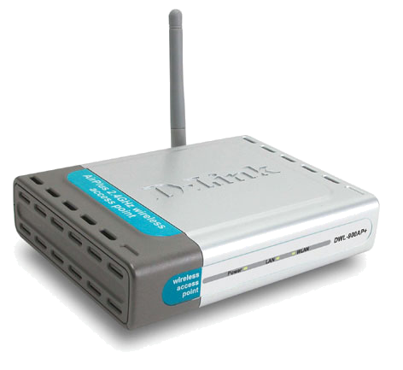
You can connect the DHP-200 directly to PC’s network adapter, switch, or any other Ethernet enabled device. (Note: The Ethernet Port on the DHP-200 is Auto-MDI/MDIX. Meaning you can use a straight-through or a crossover Ethernet (CAT 5) cable when connecting to another Ethernet enabled device.)
OR
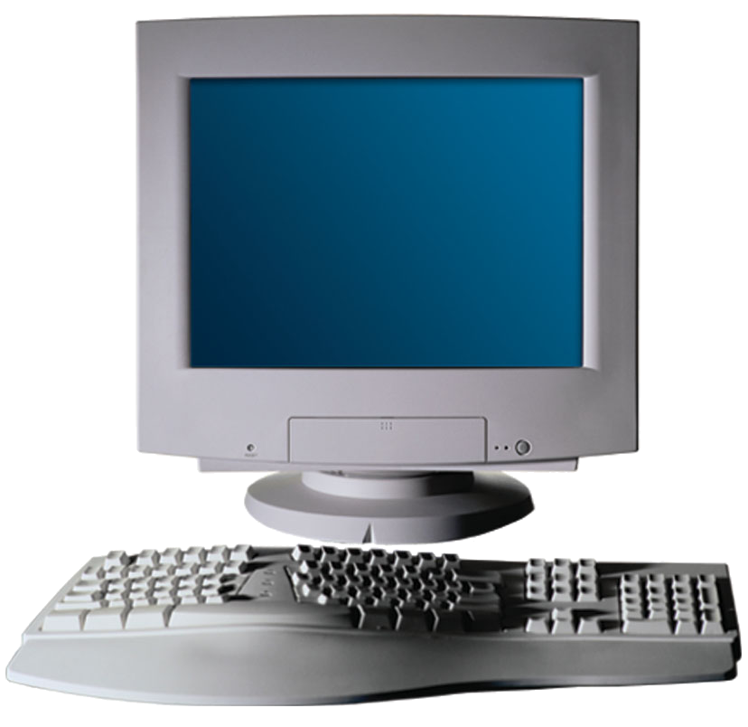

For the D-Link Configuration Utility, connect the DHP-200 directly to a PC.

Configuration Utility
The D-Link Configuration Utility for Windows OS enables the users to identify HomePlug devices on the powerline network, measures data rate performance, ensures privacy and performs diagnostics by setting user defined secure powerline networks.

Installing the D-Link Configuration Utility

To use the Configuration Utility you will need a laptop or desktop computer running Microsoft Windows Operating System.

Insert the Master CD into your CD-ROM drive and the Auto-run program will appear. Alternatively this can also be done manually by double clicking the setup.exe file on the CD.
A Picture of auto run screen

Click Install D-Link PLC Utility

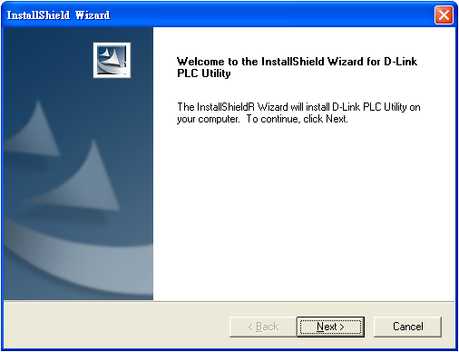

The InstallShield Wizard will begin the DHP-200 software installation. Click Next.

Click Next.

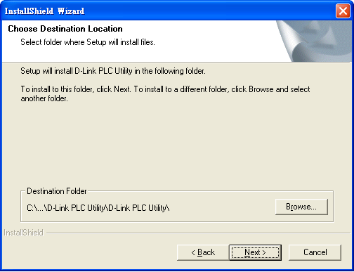

Click Next.

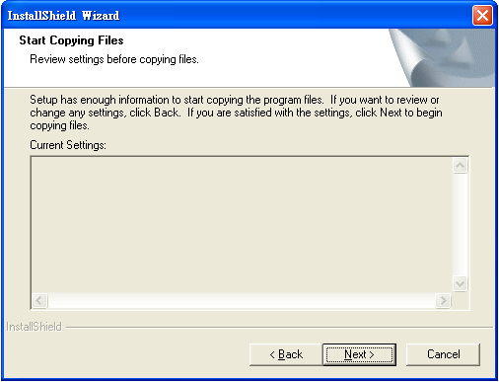

Click Next.

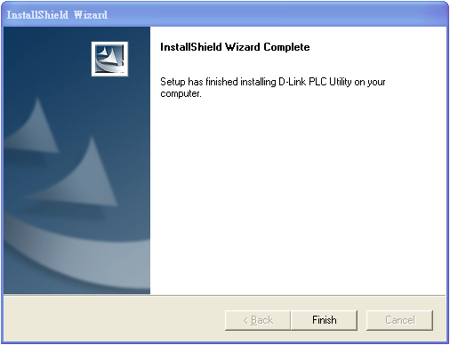

The D-Link PLC Utility installation is now complete.

Click Finish.

Using the D-Link PLC Utility

In order to start the utility, double-click the utility icon.

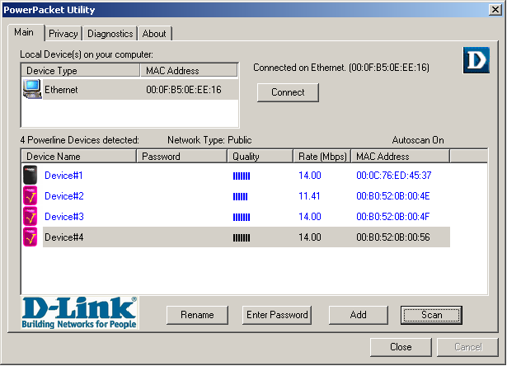

Figure 1 shows the main screen of the configuration utility. The top panel of the screen shot shows a HomePlug device connected locally to the host computer. The bottom panel shows four devices connected remotely to the computer running the utility.

Figure 1: Main Screen
Connection

User Interface
Main Tab
The Main screen provides a list of all powerline devices logically connected to the computer when the utility is running.

The top panel shows all local HomePlug connected to the computer’s NIC (Network Interface Card). In most cases, only one device will be seen. In situations where there are more than one local device being connected, such as a USB or an Ethernet adapter, the user can select the local device by clicking on it and then click the Connect button to its right. The status area above the button indicates that your PC is connected to that same device. Once connected to the local device, the utility will automatically scan the power line periodically for any other HomePlug devices. If no local HomePlug devices are discovered, the status area above the connect button will indicate with a message ‘NO HOMEPLUG ADAPTERS DETECTED’.
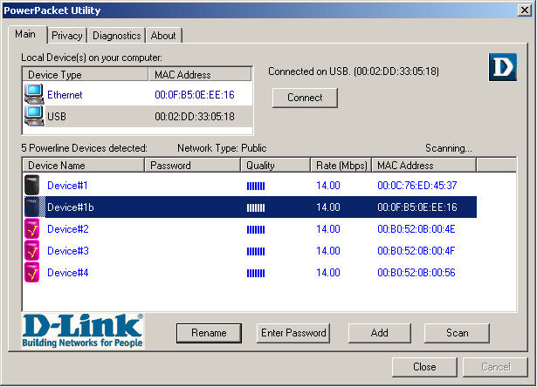

Figure 2 illustrates the presence of two local HomePlug devices connected locally to the computer.

The lower panel displays all the HomePlug remote devices, discovered on the current logical network. The total number of remote devices connected on the same network can be found on top of the remote device panel. The Network type (Public or Private) is also displayed based on the network status of the local device. The scan status option is displayed on the top right corner above the Remote devices panel showing whether the auto scan functionality is turned ON or OFF. The following information is displayed for all devices that appear in the lower panel.
Figure 2: Multiple Local Device Connection

Device Name column shows the default device name, which may be user re-defined. A user can change the name by either using the rename button or by clicking on the name and editing in-place.

MAC Address column shows the Remote device’s MAC address.

Password column by default is blank and ‘Enter Password’ button can be used to enter it.
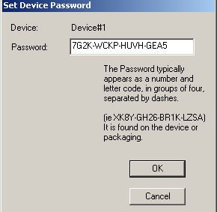
To set the Password of the device (required when creating a private network). First select the device by clicking on its name in the lower panel and then click on the Enter Password button. A dialog box will appear as shown in Figure 3 to type the password. The selected device name is shown above the password field and the password can be verified by hitting the OK button. The Password field accepts the Device password in any case formats, with or without dashed between them.
Figure 3: Set Device Password

A confirmation box will appear if the password was entered correctly. If a device was not found, the user will be notified along with the suggestions to resolve common problems. This process might take a few seconds to get completed.
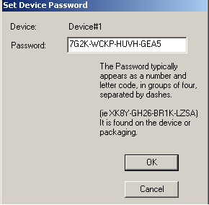
The Add button is used to add a remote device to the existing network by entering the device password of the device. A dialog box will appear as shown below in Figure 4. The dialog box allows the user to enter both a device name and the password.

A confirmation box will appear if the password was entered correctly and if the device was found in the powerline network. If a device was not found, the user will be notified and suggestions to resolve common problems will be presented.
Figure 4: Add Remote Device

Note: The device must be present on the power line (plugged in) in order for the password to be confirmed and added to the network. If the device could not be located, a warning message will be shown.

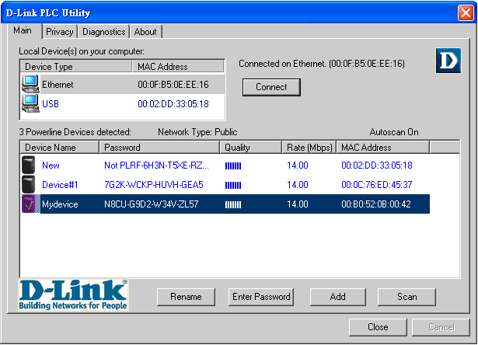
The Scan button is used to perform an immediate search of the HomePlug devices connected to the Powerline network. By default, the utility automatically scans every few seconds and updates the display screen.

A typical screen after naming and supplying passwords might appear as in Figure 5.
Figure 5: Main Screen of the Configuration Utility

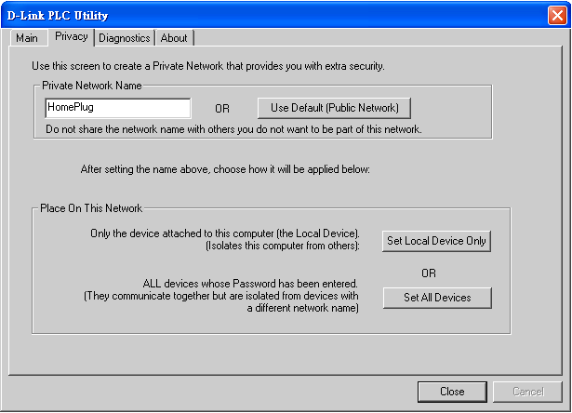
Privacy Tab
The Privacy screen provides the user with an option to maintain security for their logical network and also to select the devices that has to be included in the network. The appearance is shown in Figure 6.

All HomePlug devices are shipped using a default logical network (network name), which is normally “HomePlug”. The Privacy dialog screen allows user to change to a private network by changing the network name (network password) of devices.
Figure 6: Privacy Screen

The user can always reset to the HomePlug network (Public) by entering “HomePlug” as the network name or by clicking on the Use Default button.

Note: Changing the network name to anything other than HomePlug will show the network type on the main screen as Private.

The Set Local Device Only button can be used to change the network name (network password) of the local device. If a new network password is entered, all the devices seen on the Main panel prior to this will be no longer present in the new network, effectively making the local devices not to communicate to the devices who were in the old logical network. Devices previously set up with the same logical network (same network name) will appear in the device list afterward selecting this option.

The Set All Devices button is used to change the logical network of all devices that appear on the Main panel whose Device’s Password had been entered for the same logical network. A dialog window will appear to report the success of this operation. For devices whose device passwords were not entered, this operation will fail and will report a failure message.
Diagnostics Tab
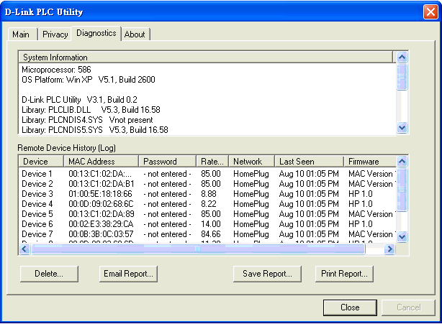
The Diagnostics screen shows System information and a history of all remote devices seen over a period of time. The appearance is shown in Figure 7.

The Upper panel shows technical data concerning software and hardware present on the host computer which were used to communicate over HomePlug on the Powerline network. It shall include the following:
Figure 7: Diagnostics Screen

- Operating System Platform/Version
- Host Network Name
- User Name
- MAC Address of all NICs (Network interface card) connected to the host
- Identify versions of all Driver DLLs and Libraries used (NDIS) and optionally
- HomePlug chipset manufacturer name (Turbo Only devices)
- MAC Firmware Version (Turbo Only devices)
- MAC addresses of all devices connected locally to the host
- Version of the Configuration Utility
- Vendor name

The Lower panel contains a history of all remote devices seen on the computer over a certain period of time. All devices that were on the powerline network are listed here along with a few other parameters. Devices that are active on the current logical network will show a transfer rate in the Rate column; devices on other networks, or devices that may no longer exist are shown with a “?” in the Rate column. The following remote device information is available from the diagnostics screen:
- Device Alias Name
- Device MAC Address
- Device Password
- Device Last known rate
- Device Last Known Network name
- HomePlug chipset manufacturer name
- Date device last seen on the network
- MAC Firmware Version. (Turbo Only)

The diagnostics information displayed may be saved to a text file for later use, or can be printed for reference for a technical support call. Devices, which are not part of the network anymore, can be deleted using the delete button. A dialog window pops up with a confirmation message if we try to delete a device whose password has been entered.

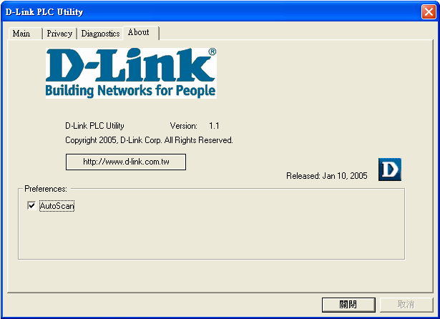
About Tab
The About screen shows the software version and provides a html link to the D-Link website. Clicking on the web address field will open a web browser and take the user directly to the web site.

All of the above changes can be made without requiring a recompile.

Figure 8: About dialog screen

Preferences
The lower part of the panel may display options for user customizations or preferences (such as turning the auto-scan feature on or off) as shown Figure 8.

You have now completed the installation for you DHP-200. Please be sure to configure all other PowerLine devices on your network to use the same password, in order for them to communicate with each other.

Specifications
Standards  - IEEE 802.3 Ethernet/802.3u Fast Ethernet  - Homeplug 1.0  Dimensions  105 x 73 x 37mm  Device Ports  - Ethernet: RJ-45 10/100BASE-TX Ethernet port with auto MDI/MDIX  - Powerline: Power Prongs  Weight  - 283.5 grams (10 oz.)  Frequency Band  4.0 to 21 MHz  Diagnostic LEDs  - Power Indication  - Powerline Link/Activity Indication  - Ethernet Link/Activity Indication  Modulation Scheme  - OFDM (QAM 256/64/16, DBPSK, DQPSK)  Emission  - FCC Class B  - CE Class B  Safety  - UL | Data Rate  - Ethernet: 10/100 Mbps  - Homeplug: Up to 85Mbps  Operating Temperature  - 0°C to 40°C (32°F to 104°F)  Storage Temperature  - -20°C to 70°C (-4°F to 158°F)  Operating Humidity  - 10% to 90% non-condensing  Storage Humidity  - 5% to 95% non-condensing  Encryption  - 56-bit Data Encryption with Key Management  - Software works on Windows  Access Methods  - CSMA/CA  Power Source  - 110 or 220 or 240 VAC, 50/60Hz  QoS  4 priority queues

