DI-524

Date: July14, 2005

Product name: | 802.11g 54Mbps Wireless Cable/DSL Internet Gateway w/USB Printer Port
Product Group & Type: | SOHO Router
Revision: | B1
Availability: | B/Feb, 2005
Picture: | 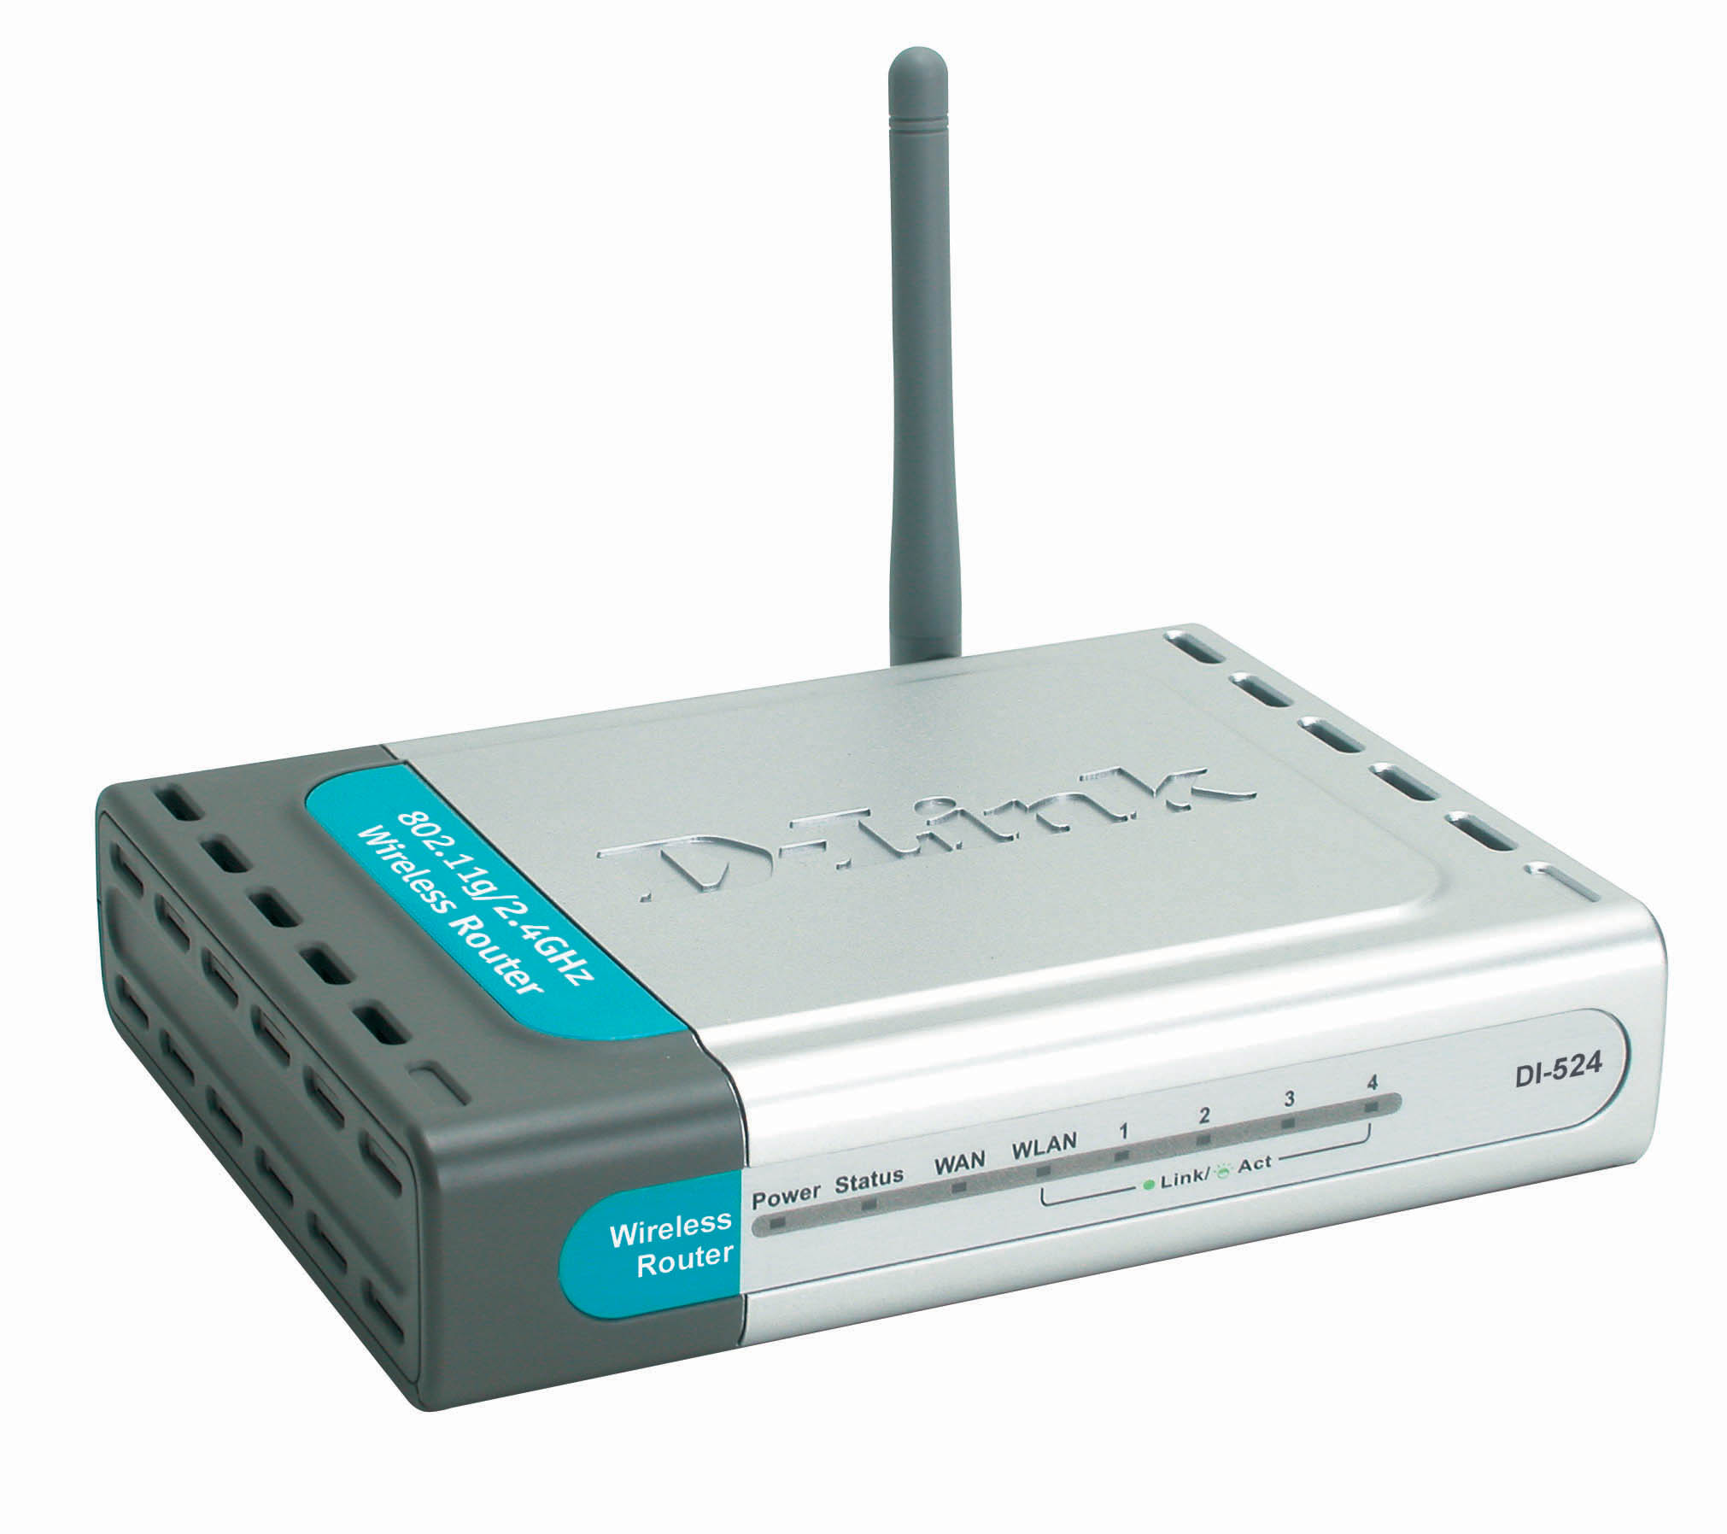
Why Sell This Product: | Last year we introduced the widely sold DI-514 as a low-cost wireless router to supplement your 802.11b product line. Now, we’re repeating this success by introducing the DI-524 to supplement your low cost 802.11g product line. This wireless router targets home/SOHO users upgrading to higher-speed wireless LAN. This router is ISP independent, it can connect to any external DSL or cable modem.  Selling Points  - Low cost, entry-level router, but has many software features normally available in more expensive routers.  - Setup wizard for quick installation should help entry level users.  - Additional hardware benefits like 4 built-in switch ports.
Key Features: | - Remote router with 802.11g wireless LAN interface  - Cable/DSL modem Internet sharing  - Wireless LAN speed up to 54Mbps  - 10/100BASE-TX port for DSL/cable modem connection  - WAN port supports PPPoE for Internet dial-up mode  - 4 built-in 10/100BASE-TX switch ports with auto MDI/MDIX support  - Firewall features include NAT with VPN pass-through, MAC/IP/URL filtering, domain blocking and scheduling  - Web-based configuration with setup wizard for quick installation
Technical Details: | Standards  - IEEE 802.11g  - IEEE 802.11b  - IEEE 802.3  - IEEE 802.3u  Wireless Modulation Technology  Orthogonal Frequency Division Multiplexing (OFDM)  Wireless Frequency Range  2.4GHz to 2.462GHz  Wireless Signal Rates  (With automatic fallback)  54Mbps, 48Mbps, 36Mbps, 24Mbps, 18Mbps, 12Mbps, 11Mbps,  9Mbps, 6Mbps, 5, 5Mbps, 2Mbps, 1Mbps  Wireless Receiver Sensitivity  - 54Mbps OFDM, 10% PER, -68dBm  - 48Mbps OFDM, 10% PER, -68dBm  - 36Mbps OFDM, 10% PER, -75dBm  - 24Mbps OFDM, 10% PER, -79dBm  - 18Mbps OFDM, 10% PER, -82dBm  - 12Mbps OFDM, 10% PER, -84dBm  - 11Mbps CCK, 8% PER, -82dBm  - 9Mbps OFDM, 10% PER, -87dBm  - 6Mbps OFDM, 10% PER, -88dBm  - 5.5Mbps CCK, 8% PER, -85dBm  - 2Mbps QPSK, 8% PER, -86dBm  - 1Mbps BPSK, 8% PER, -89dBm  Wireless Transmit Output Power  15dBm +/- 2dBm  External Antenna Type  Single detachable reverse SMA  Wireless Operating Range  - Indoors: up to 100 m  - Outdoors: up to 300 m  * Environmental factors may adversely affect operating range  Security  - 802.1x user authentication support  - 64-, 128-WEP wireless data encryption  - WPA Wi-Fi Protected Access (WEP with TKIP, MIC,  IV Expansion, Shared Key Authentication)  Firewall Features  - NAT (Network Address Translation) with VPN pass-through  - MAC address filtering  - IP address filtering  - URL filtering  - Domain blocking  - Scheduling  VPN Pass-Through/Multi-Sessions  - PPTP  - L2TP  - IPSec  Device Management  - Web-based Internet Explorer v.6 or Netscape Navigator v6 or  other Java-enabled browsers  - DHCP Server and Client  Diagnostic LEDs  - Power  - Status  - WAN  - LAN (10/100Mbps)  - WLAN  Physical & Environmental  Power Input  Through external power adapter  Dimensions  273 (L) x 205 (W) x 66 (H) mm  Weight  1.32 kg  Operating Temperature  0 to 40 ℃  Humidity  90% maximum (non-condensing)  Safety and Emissions  - FCC  - CE  - C-Tick
EMI/EMC Report | ☑FCC No. ☑ CE No. ◻ VCCI No.  ◻ CTR-21 No. ☑ C-Tick No. ◻ A-Tick No.  ◻ FDA No. ◻ R&TTE No. ◻ BSMI No.  ◻ Others
Safety | ◻ TUV No. ◻ UL No. ◻ CSA No.  ◻ Others
Packaging Style | ◻ Clamshell ◻ Brown Box ☑ Gift Box ◻ Bulk ◻ Others
Packaging Contents: | DI-524 Wireless Router  CD-ROM with Manual  - Quick Installation Guide  - Ethernet Cable  - AC Power Adapter
UPC Code:
  Part Number | UPC code
  II524BEU..B1 | 790069 | 274572
  II524EIS..B1 | 790069 | 273056
  II524EEU..B1 | 790069 | 273063
  II524ENA..B1 | 790069 | 273070
  II524ANA..B1 | 790069 | 273087
  II524NEU..B1 | 790069 | 273094
  TI524ANA..B1 | 790069 | 273100
  NI524CEU..B1 | 790069 | 273117
  EI524BEU..B1 | 790069 | 282539
  EI524EEU..B1 | 790069 | 282546
Units Per Carton: | 5
Cartons Per Pallet: | For WW by Air: 72 Sea: 72 | For UK by Air: 72 Sea: 72
Dimensions and Weight: | Box:  , Others mm, 1.28 kg  Carton: 370*290*230 mm, 7 kg  Pallet: (by Air) 110*120*205 cm, 525 kg (for WW&UK)  (by Sea) 110*120*205 cm, 525 kg (for WW&UK)  INTRASTAT weight: 824g (Box)  Packing material weight (Box):  - Paper: 437g  - Plastic: 15.5g  - Mixed: 3.64g

