DI-624S

Date: June 28, 2005

Product name: | DI-624S 108G Wireless Storage Router
Revision: | B1
Availability: | End June, 2005
Picture: | 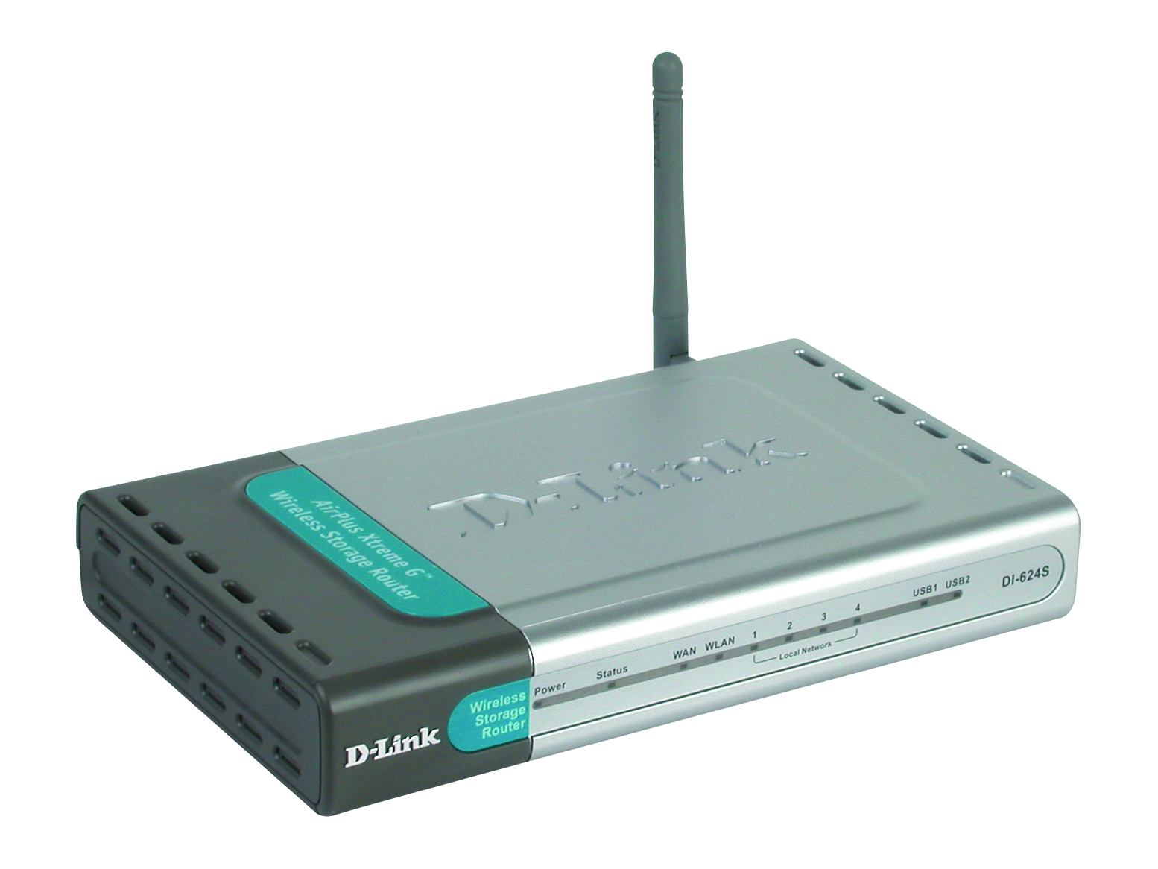
Why Sell This Product: | We’ve been successfully selling the DI-624 for some time. Buyers liked this wireless router for its 108Mbps Turbo speed and integrated firewall function, and the media has given it a lot of awards. Now, in order to move on with something even better, we’re adding a storage capability to this router, and name it the DI-624S wireless storage router. To be flexible, we’re not adding any hard disk, but just USB ports for users to plug in their external disks. We’re also adding many features, such as a personal web server for setup of amateur web sites, an FTP server and file server for home/office file sharing, a printer sharing capability, and UPnP AV multimedia sharing for home entertainment. Advanced functions are also added, including the new WPA2 security standard and the Wi-Fi Multimedia (WMM) QoS. So this should be a complete, comprehensive all-in-one box Wi-Fi solution for the demanding home and SOHO users, and should breathe new life to the current DI-624.  Selling Points  - Many functions in one device: wireless router, Internet sharing, network storage, built-in servers for DHCP, personal web, FTP, file/printer/multimedia sharing, 4-port Ethernet switch.  - External hard disk attachment provides flexibility for users and avoids need for distributors to stockpile storage devices.  - Can work with a variety of printers in different OS environments.  - High 108Mbps wireless speed.  - Strong wireless security & good firewall protection.  - Wireless router with QoS support based on protocol, MAC address, port and IP address: good for home (on-line games, multimedia, entertainment applications) and SOHO (VoIP, file transfer).
Key Features: | High Speed Wireless Connection  - 802.11g Wireless Speeds Up to 54Mbps  - D-Link 108G Wireless Speeds Up to 108Mbps  Multiple Device Interfaces  - 2 USB 2.0 Ports for Hard Disks/Printer Connection  - 4 10/100BASE-TX Ethernet Ports for Computer Connection  6-In-One Integrated Functions  - File Server to Share Files/Disk Space  - FTP Server to Share Files  - Personal Web Server to Share Photos  - Printer Sharing  - UPnP AV Server to Share Video/Music  - DHCP Server to Share Internet Connection  Advanced Security  - WEP, WPA/WPA2 Data Encryption/Security  - Stateful Firewall Protection With SPI  - URL Blocking/Parental Control  - System Logging  Simple Setup  - Setup Wizard for Step-by-Step Installation  - Intuitive Web-Based Management Utility  - Supports Windows Connect Now to Simplify Wireless Setup  - Built-in Cable Tester to Ensure Proper Cable Connection
Technical Details: | Hardware and Port Characteristics  Memory  - Flash: 4MB  - DRAM: 32MB  Device Interfaces  - 4 10/100BASE-TX Ethernet LAN Ports With Auto MDI/MDIX  - 1 10/100BASE-TX Ethernet WAN port With Auto MDI/MDIX  - 2 USB 2.0 Type A Ports  - 802.11g Wireless LAN  Diagnostic LEDs  - Power  - Status  - WAN  - WLAN  - LAN (Link/Activity) for Each LAN Port  - USB1, USB2  Software Functions  WAN Connection Types  - Static IP Address  - Dynamic IP Address (DHCP Client)  - PPP over Ethernet (PPPoE)  - PPTP  - L2TP  - Big Pond  Connection Schemes  - Connect-on-Demand/Auto-Disconnect  - Manually Connect/Disconnect  - Auto-Reconnect  NAT Functionality  - Virtual Server  - Special Application (Games)  - DMZ Host  Access Control  - MAC-level Access Control  - Inbound/Outbound IP Filter  - Domain Access Control  Firewall  - Stateful Firewall With SPI Mode  - DoS Detection  Event Logging  On-Web Logging  VPN Support  - IPSec Pass-Through  - PPTP Pass-Through  - LT2P Pass-Through  Routing  Static Route  Built-in Servers  - File Server  - FTP Server  - Printer Sharing  - UPnP AV Server  - Personal Web Server  QoS Support  - Protocol-Based  - MAC-Based  - Port-Based  - IP-Based  Installation/Setup Support  - DDNS (Dynamic Domain Name Server) Support  - UPnP Support  Configuration/Management  - Web-Based GUI  - Hardware Configuration Reset Button  Firmware Upgrade  - Web-Based  - Windows Application  Wireless Support  Standards  - IEEE 802.11g  - IEEE 802.11b  Data Rates  - D-Link 108G: 108Mbps  - 802.11g Mode: 1Mbps to 54Mbps  - 802.11b Mode: 1Mbps to 11Mbps  Security/Data Encryption  - WPA2 AES  - WPA TKIP  - 64/128-bit WEP  Quality of Service  Wi-Fi Multimedia (WMM)  Wireless Frequency Range  2.4GHz to 2.4835GHz  Antenna  2dBi Detachable Dipole Antenna (Reverse SMA Connector)  Input Power  - DC 5V3A  - Through External Power Adapter  Certification  - FCC Class B  - CE  - C-Tick  - Wi-Fi
EMI/EMC Report | ☑FCC No. ☑ CE No. ◻ VCCI No.  ◻ CTR-21 No. ☑ C-Tick No. ◻ A-Tick No.  ◻ FDA No. ◻ R&TTE No. ◻ BSMI No.  ◻ Others
Safety | ◻ TUV No. ◻ UL No. ☑ CSA No.  ◻ Others
Packaging Style | ◻ Clamshell ◻ Brown Box ☑ Gift Box ◻ Bulk ◻ Others
Packaging Contents: | DI-624S Wireless Storage Router x 1  CD-ROM with Manual x 1  - Quick Installation Guide x 1  - CAT5 Ethernet cable (1.8m) x 1  - 5V/3A External Power Adapter x 1
UPC Code:
  UPC code |  | Part Number
  790069 | 283642 | EI624SEEU.B1
  790069 | 283659 | EI624SBEU.B1
  790069 | 283666 | NI624SCEU.B1
  790069 | 283673 | TI624SANA.B1
  790069 | 283680 | II624SBEU.B1
  790069 | 283697 | II624SEEU.B1
  790069 | 283703 | II624SENA.B1
  790069 | 283710 | II624SANA.B1
  790069 | 283727 | II624SNEU.B1
Units Per Carton: | For USA | For EU | For WW
Units Per Carton: | 5 | 10 | 10
Cartons Per Pallet: | For USA | For EU | For WW
Cartons Per Pallet: | Air:52, Sea: 65 | Air:28, Sea: 28 | Air:21, Sea: 28
Dimensions and Weight: | Box:  ◻ 237x168x36mm (Type A) ◻ 225x150x75mm (Type B)  ◻ 269x162x65mm (Type C) ☑ 274x208x68mm (Type D)  ◻ 274x208x118mm (Type D1) ◻ 274x208x138mm (Type D2)  ◻ 288x245x66mm (Type E)  , Others __________, .91 kg  Carton: 360x230x310 mm, 5.00 kg  435x354x294 mm, 10.00 kg  Pallet: (by Air) 1220x1020x1370 mm, 275 kg (for USA)  1100x1200x1310 mm, 340 kg (for EU)  1200x1100x1300 mm, 255 kg (for WW)  (by Sea) 1220x1020x1990 mm, 405 kg (for USA)  1100x1200x2190 mm, 581 kg (for EU  1200x1100x2180 mm, 435 kg (for WW)  INTRASTAT weight: 1.17 kg (Box)  Packing material weight (Box):  - Paper: 0.512 kg  - Plastic: 0.012 kg  - Mixed: 0.01 kg

