DI-724P++

Date: October 27, 2003

Product name: | 2.4GHz Wireless Router with 4-Port Switch and Printer Server
Product Group & Type: | Wireless Router
Revision: | A1
Available:
Picture: | 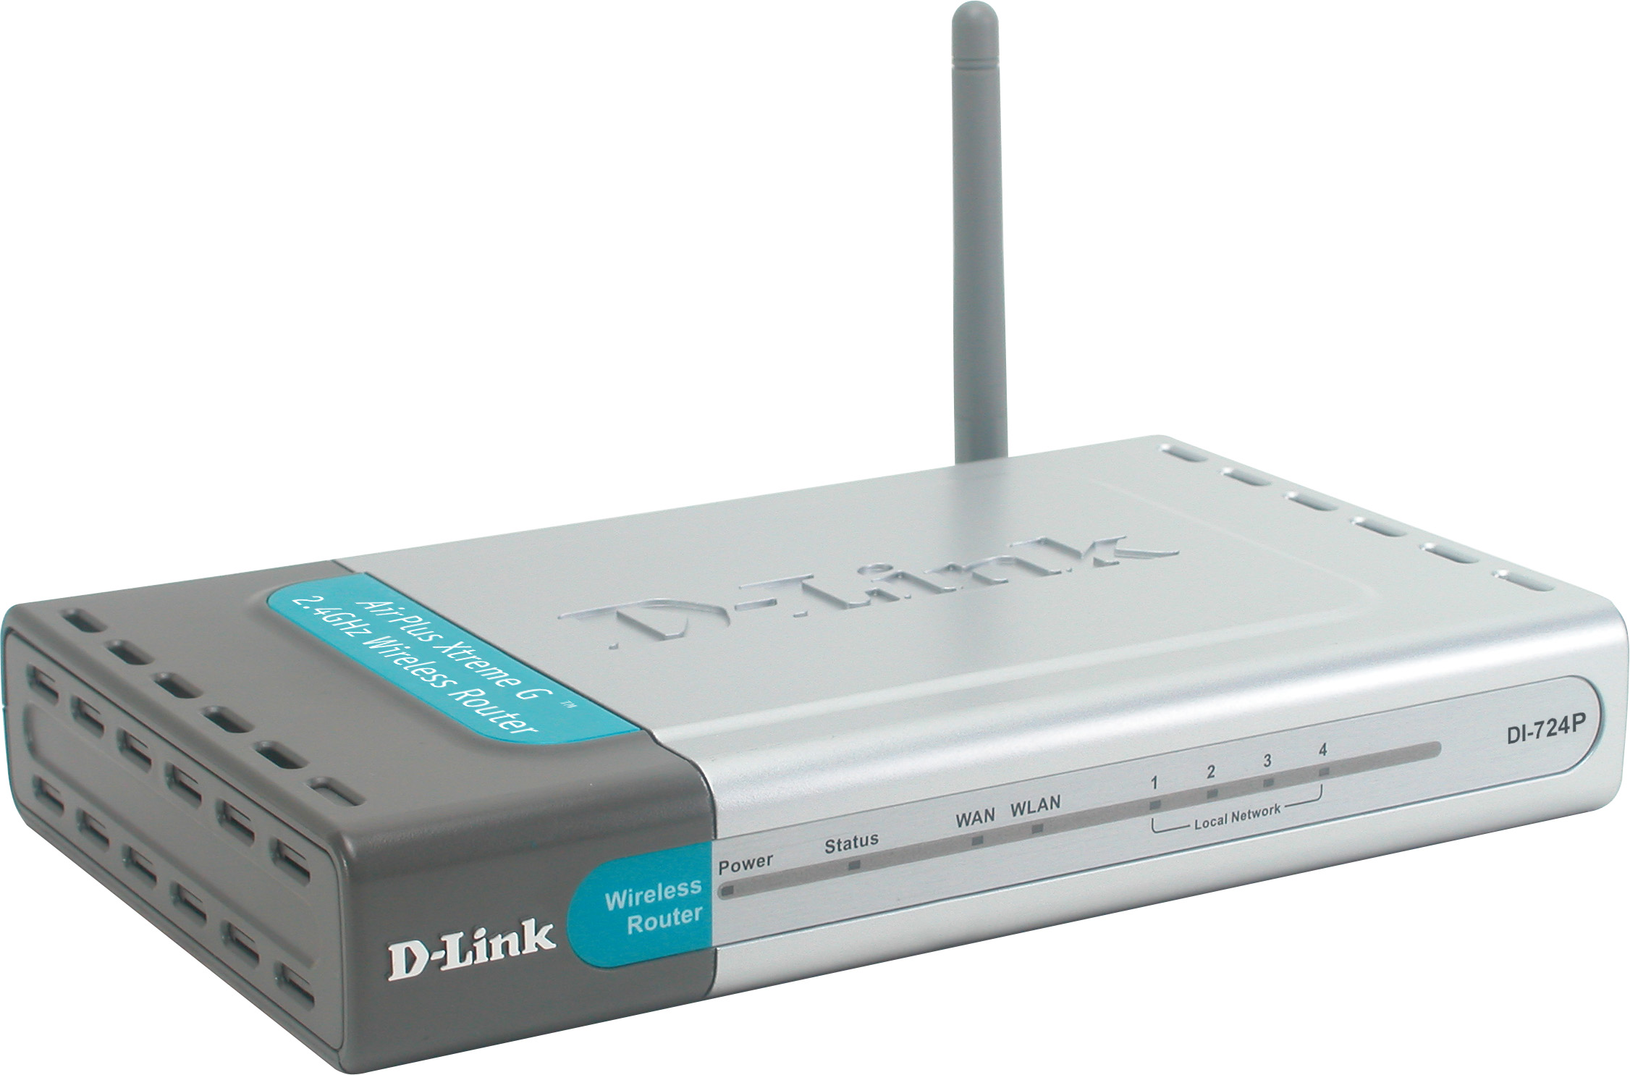
Why Sell This Product: | - Expand your G+ product line.  - Supplement your current series of routers with built-in print server, this time with additonal G+ (802.11g) WLAN.  - For SOHO, hotspots: This router can be distributed through your retail channels.  - Familiar technical support: This router uses the same software functions as DI-704P and DI-707P's upgraded versions, plus G+ WLAN.  Selling Points  - Higher WLAN speed.  - More firewall/security functions.
Keyfeatures: | - 54Mbps high-speed wireless broadband Internet access *  - 10/100BASE-TX port for DSL/cable modem connection  - WAN port supports PPPoE for DSL dial-up mode to save ISP connection fee  - Built-in 802.11g wireless LAN with real throughput 8 times faster than 802.11b devices **  - WLAN supports Dynamic Channel Selection (auto-selection of least utilized channel of operation)  - 4 built-in 10/100BASE-TX switch ports with auto MDI/MDIX support  - Built-in parallel printer port/print server supporting Windows, MacOS, Linux  - Multi-sessions with VPN pass-through  - User access control: 802.1x authentication, Access Control List, scheduling and user level control  - Parental control: URL blocking, domain filtering  - Firewall: Stateful Packet Inspection (SPI), Ping of Death prevention, Intrusion detection, security event log  - DMZ and Virtual Server Mapping support  - Network Time Protocol & UPnP support  - Web-based configuration, Windows-based utility & Setup  - Wizard for quick installation  *When used with other 802.11g devices  ** When used with other AirPlusXtremeG+ devices
Technical Details: | Hardware  WAN Port  - 10/100BASE-TX  - Supports "Always-on" (bridged) and PPPoE for DSL dial-up  LAN Ports  4 10/100BASE-TX ports with auto MDI/MDIX  Printer Port  DB-25 parallel port  LED indicators  - Power  - Status  - WAN  - WLAN  - Local (Ethernet) Network (4 LEDs)  Software  NAT  - IP Network Address Translation  - Traditional IP Network Translation  - Protocol Complications with IP Network Address Translation  - DHCP server and client support  - Subnet mask class A, B, and C  - DHCP server class C (1 to 254 clients)  NAT Application Level Gateway  - H.323 Protocol Suite  - File Transfer Protocol (FTP)  - Session Initiation Protocol (SIP)  - Session Description Protocol (SDP)  - Real-Time Transport Protocol (RTP)  - Internet Relay Chat (IRC)  - Multiple Gaming Protocol  Virtual DMZ Host  1 entry  Virtual Server Mapping  13 entries  VPN Support (Multi-Session)  - PPTP pass-through  - L2TP pass-through  - IPSec pass-through  Routing (Protocols & Functions)  - Static Route  - Dynamic Route  - RIP-1, RIP-2  - IP Alias  - IP Multicast  - UDP, TCP, ICMP, ARP  - IP spoofing  Firewall Functions  - Stateful Packet Inspection (SPI)  - Packet Filtering  - Ping of Death prevention  - IP spoofing  - Intrusion Detection  - Security event log  Firewall (Stateful Packet Inspection)  - IP Address and Port Number  - Packet Count and Byte Count  - Sequence and Acknowledgement Number  - Timestamps  - Payload Modification History  - Dynamic Association  Firewall (Comprehensive Logging)  - Filtering activity: logs rejected internal and external connection requests  - Session tracking activity: logs all session creation and termination information  - Intrusion detection activity: log information about outside attack  Access Control  - User access control: MAC filtering, Access Control List (ACL), 802.1x authentication, WPA (WLAN)  - WAN access control: domain filtering, URL filtering, WAN connection scheduling  Print Server OS Support  - Windows 95, 98, ME, 2000, XP, NT  - MacOS  - Linux  Configuration and Management  - Web-based Utilities  - PC Utility supporting Windows 98SE, ME, 2000, XP  - UPnP support  - Network Time Protocol (NTP) support  - Status log  Software Upgrade  TFTP  Built-in Wireless LAN  Wireless LAN Standards  - 802.11b  - 902.11b+  - 802.11g  Data Rates  - 802.11g: up to 54Mbps (6/9/12/18/24/36/48/54Mbps)  - 802.11b+: up to 22Mbps  - 802.11b: up to 11Mbps (1/2/5.5/11Mbps)  - Auto-switch to select 802.11g or 802.11b mode  - Data rate auto fall-back under noisy environment or longer range distance  Transmission Technology  DSSS  RF Frequency Range  2.4 to 2.4835GHz  Frequency Stability  Within +/- 25ppm  Operating Channels  - 1 to 11 channels (North America)  - 1 to 13 channels (General Europe)  Data Modulation Type  DBPSK, DQPSK, CCK, PBCC and OFDM (BPSK/QPSK/  16-QAM/ 64-QAM)  Antennas  - 1 detachable external dipole antenna, 2dBi Gain (reverse SMA connector)  - 1 internal antenna, 2dBi Gain  Transmit Output Power  - 802.11g: 14dBm (typical)  - 802.11b: 16dBm (typical)  Receive Sensitivity (for 802.11b)  (typically @PER < 8% packet size 1024 @ 25 °C +/- 5 °C)  - 22Mbps (PBCC): -80dBm  - 11Mbps (PBCC): -85dBm  - 11Mbps (CCK): -84 dBm  - 5.5Mbps (CCK): -87 dBm  - 2Mbps (QPSK): -90 dBm  - 1Mbps (BPSK): -92 dBm  Receive Sensitivity (for 802.11g)  (typically @PER < 8% packet size 1024 @ 25 °C +/- 5 °C)  - 54Mbps (OFDM): -71 dBm  - 48Mbps (OFDM): -72 dBm  - 36Mbps (OFDM): -77 dBm  - 24Mbps (OFDM): -80 dBm  - 12Mbps (OFDM): -86 dBm  - 9Mbps (OFDM): -87 dBm  - 6Mbps (OFDM): -89 dBm  Operating Range *  - Indoors: 100 meters (328 feet)  - Outdoors: 400 meters (1,312 feet)  * Environmental factors may adversely affect range  Wireless Data Security  - WEP 64/128/256-bit data encryption (user-selectable)  - 802.1x user authentication (MD5 and TLS) (in Windows XP only)  - Wi-Fi Protected Access  - SSID broadcast enable/disable  Built-in Fast Ethernet Switch  Standards  - IEEE 802.3 10BASE-T Ethernet  - IEEE 802.3u 100BASE-TX Fast Ethernet  - ANSI/IEEE 802.3 NWay auto-negotiation  Supported Functions  - Full/half duplex (per port)  - MDI/MDIX auto uplink (per port)  Transmission Method  Store-and-forward  MAC Address Learning  Automatic update  Physical & Environmental  DC input  - 5V/2A  - Through external power adapter  Dimensions  192 x 118 x 31 mm (device only)  Weight  300 grams (device only)  Operation Temperature  0 to 55 °C  Storage Temperature  -20 to 70 °C  Humidity  5% to 95% non-condensing  Emission (EMI) Certifications  - FCC Part 15 Class B, Sec. 15.247, 15.109  - ETS 300 328, ETS 301 489-1&17, CE mark  Wireless LAN Compatibility  Wi-Fi Compliant  Box Includes  - DI-724P+ router  - External power adapter  - Ethernet Cable  - Quick Installation Guide  - Manual on CD  - 4 rubber feet  - 1 set of screws
EMI/EMC Report | ☑FCC No. ☑ CE No. ◻ VCCI No.  ◻ CTR-21 No. ☑ C-Tick No. ◻ A-Tick No.  ◻ FDA No. ☑ R&TTE No. ◻ BSMI No.  ◻ Others
Safety | ◻ TUV No. ☑ UL No. ◻ CSA No.  ◻ Others
Packaging Style | ◻ Clamshell ☑ White Box ☑ Gift Box ◻ Bulk ◻ Others
Packaging Contents: | Device, CD, QIG, RJ45 cable, rubber feet, power adapter
UPC Code: | 790069-262562/TW, 790069-262487/ANA, 790069-262494/BEU,  790069-262500/EEU, 790069-262517/NEU, 790069-262524/CN,  790069-262531/ENA
Units Per Carton: | 5
Cartons Per Pallet: | Air: 40, Sea: 50
Dimensions and Weight: | Box: 275 x 206 x 65 mm, 1.0 kg  Carton: 370 x 265 x 308 mm, 5.5 kg  Pallet: (by Air) 1100 x 1200 x 1540 mm, 220 kg  (by Sea) 1100 x 1200 x 1800 mm, 275 kg  INTRASTAT weight: kg (Box)  Packing material weight (Box):  - Paper: kg  - Plastic: kg  - Mixed: kg

