DI-808HV

Date: October 7, 2003

Product name: | Ethernet Broadband Router with 8-Port Switch and USB Printer Server
Product Group & Type: | Broadband Router
Revision: | A1
Available:
Picture: | 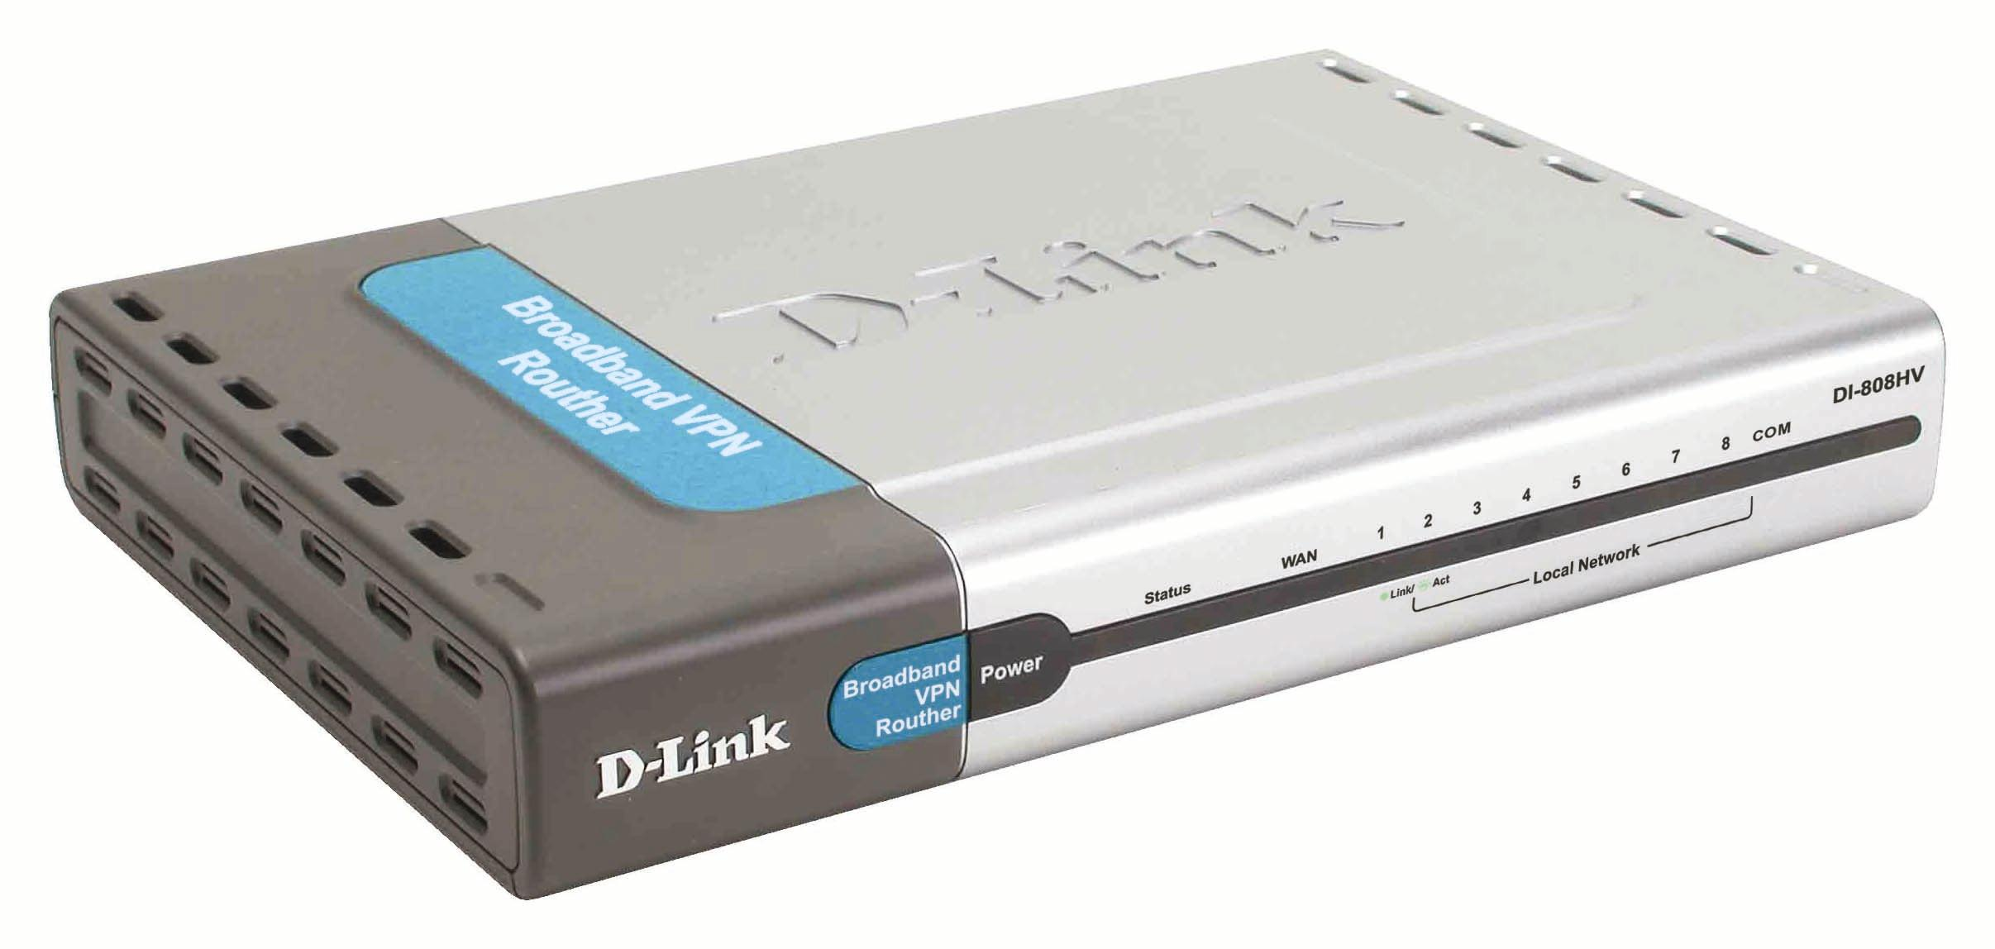
Why Sell This Product: | - Supplementing current product DI-804HV: the new DI-808HV is similar to the DI-804HV, but instead of having 4 integrated switch ports, the new DI-808HV has 8 built-in switch ports to meet the requirement of today's office environments.  Selling Points  - Good price/performance: routing, VPN IPSec and firewall functions performed by hardware, relieving the device's CPU a lot of overheads.  - Has additional advanced functions like enabled NetBIOS broadcast, Dynamic DNS support and SDI Service.  - Many other vendor routers don't have backup WAN port like this DI-808HV's RS-232 for ISDN/analog modem backup.
Keyfeatures: | - 168-bit 3DES IPSec advanced VPN security  - 3DES with SHA-1 advanced secure configuration  - Up to 40 VPN tunnels to 40 remote sites  - DoS, SPI, packet filtering firewall protection  - 10/100BASE-TX port for DSL/cable modem connection  - Additional RS-232 COM port for ISDN or 56Kbps analog modem backup supporting dial-on-demand & idle timer auto-disconnection  - 8 10/100BASE-TX switch ports for 8 workstation/server connections  - Aggressive/main client mold for VPN  - Web-based configuration setup  - Enabled NetBIOS broadcast  - Dynamic DNS support  - SDI Service (Home Internet Solution) port  - Universal Plug-n-Play (UPnP) enabled
Technical Details: | Hardware  WAN Ports  - 1 10/100BASE-TX port for DSL/cable modem connection  - 1 RS-232 port (460Kbps Baud) for ISDN TA/analog modem connection (for WAN backup)  LAN Ports  - 8 10/100BASE-TX switch ports with auto MDI/MDIX support  Broadband Support  - DSL modem  - Cable modem  - PPP over Ethernet (PPPoE)  Backup Link Support  - Dial-up ISDN TA  - Dial-up Analog modem  - PPP  - Dial-on-Demand with auto login to ISP  - Auto-disconnect with user-defined idle timer  - PAP/CHAP security  Diagnostic LEDs  - Power  - Status  - WAN Port (Link/Act)  - COM Port  - 8 LAN Ports (Link/Act)  Routing  Routed Packet Type  IP packets  Routing Protocols & Methods  - RIP-1, RIP-2  - Static Routing  - Dynamic Routing  VPN & IPSec  Application Support  - IPSec pass-through  - PPPTP pass-through  - L2TP pass-through  Data Encryption Methods  - IP ESP (Encapsulating Security Payload)  Confidentiality over IP payload  Optional authentication of IP payload and ESP header  - Null encryption  Encryption Transforms  - 56-bit DES (Data Encryption Standard)  - 168-bit 3DES  Authentication Transforms (for ESP and AH)  - MD5  - SHA-1  Security  - Pre-shared key  - Manual key  - IKE Security Association (SA) assignment  Connection Modes  - Site to Site  - Client to Site  Number of Tunnels  40 IPSec tunnels (max.)  Internet Gateway & Firewall  Supported Functions  - Network Address Translation (NAT)  - DHCP server automatic IP assignment  - Virtual server  Packet Inspection  Static Packet Inspection (SPI)  Number of DMZ Ports  1 port (user-assignable to any LAN port)  Firewall Security  - Stateful Packet Inspection (SPI) to prevent Denial of Service (DoS) attacks  (Syn flood, ICMP flood, UDP flood, "ping of death", IP spoofing, land attack,  tear drop attack, IP address sweep attack, Win Nuke attack)  - Intrusion Detection Logging  - LAN/WAN filtering  Management & Configuration  IP Number Self-identification  Through DHCP client  Local & Remote Management  Web-based utilities (via browser)  Firmware Upgrade  Web-based (via browser)  Physical & Environmental  Power Supply  - DC 5V 2A  - Through external power adapter  Dimensions  235 x 162 x 35 mm (device only)  (7.56 x 4.64 x 1.22 inches)  Weight  310 grams (0.68 lb.) (device only)  Operating Temperature  5 to 55 °C  Storage Temperature  -20 to 70 °C  Humidity  10% to 90% non-condensing  EMI Certification  - FCC Class B  - CE Class B  Safety  UL
EMI/EMC Report | ☑FCC No. ☑ CE No. ◻ VCCI No.  ◻ CTR-21 No. ☑ C-Tick No. ◻ A-Tick No.  ◻ FDA No. ◻ R&TTE No. ◻ BSMI No.  ◻ Others
Safety | ◻ TUV No. ◻ UL No. ◻ CSA No.  ◻ Others
Packaging Style | ◻ Clamshell ☑ White Box ☑ Gift Box ◻ Bulk ◻ Others
Packaging Contents: | Device, CD, QIG, RJ45 cable, rubber feet, power adapter
UPC Code: | 790069-262272/USA, 790069-262227/A, 790069-262234/B,  790069-262241/E, 790069-262258/N
Units Per Carton: | 5
Cartons Per Pallet: | Air: 30, Sea: 40
Dimensions and Weight: | Box: 275 x 206 x 118 mm, 1.48 kg  Carton: 640 x 300 x 240 mm, 8.0 kg  Pallet: (by Air) 1100 x 1200 x 1560 mm, 270 kg  (by Sea)1100 x 1200 x 1960 mm, 360 kg  INTRASTAT weight: kg (Box)  Packing material weight (Box):  - Paper: kg  - Plastic: kg  - Mixed: kg

