MAC OS setting on Broadband Router
Open Finder

Click Install MAC OS X HDD
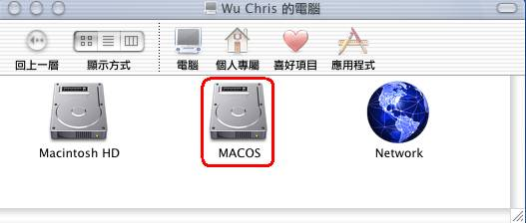

Click Applications
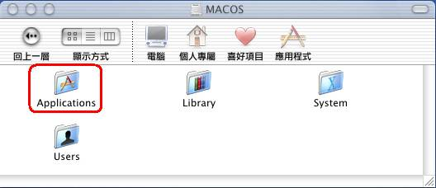

Click Utilities
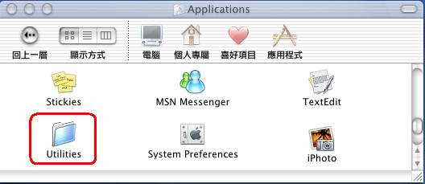

Click Print Center
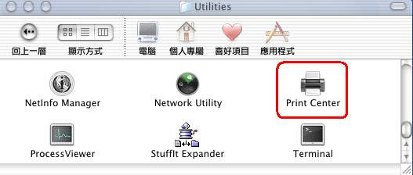

After open Print Center, Click "add a print"
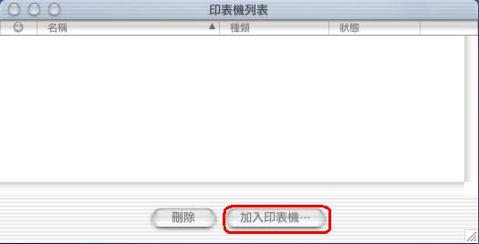

Please refer to below 1-5 step.
1. Choose "using IP’s LPR print"
2. IP address insert "192.168.0.1"(DI-724P+ default IP address), Please using DI-724P+ LAN Port IP address
3. "Don’t choose" using default Queue on server
4. Queue name is "lp" (Must be small letters!)
5. Choose your printer server model
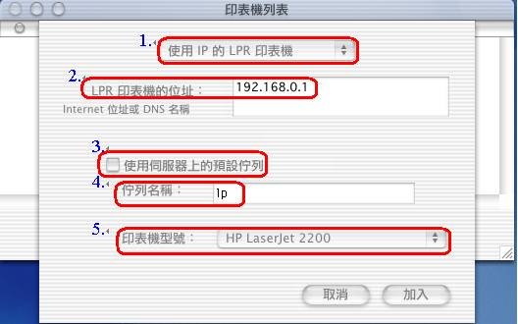
And click "add" to finish the setting
Then you can try to print your file through DI-724P+ on MAC OS.

Please forgive us that we don’t have English version of MAC OS to do the test.

