Install Guide D-Link TR-069

Alpha version

28.09.2011
D-Link Corporation

Table of Content
1. Technical Design 3
1.1. Structural Description 3
1.2. Minimum Requirements 3
2. Installation 3
2.1. Install jdk 3
2.2. Install libmysqlclient 4
2.3. Install MYSQL server 4
2.4. Install Apache tomcat 5
2.5. Install ACS server 5
2.6. Locate project into tomcat 7
3. Start web application 7

Technical Design

Structural Description

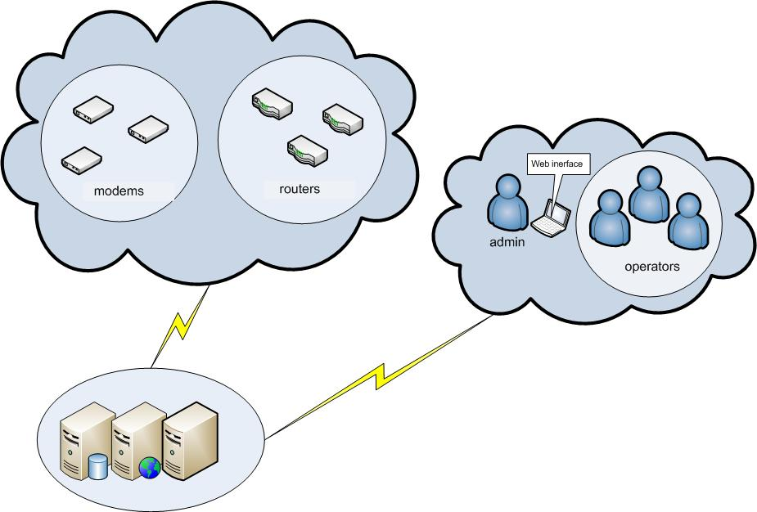

Minimum Requirements

1 | Operation System | Ubuntu 10.10
2 | Database | MYSQL 5.0 ++
3 | Database Tools | MYSQL Administrator , libmysql client 12
4 | Java Environment | jdk 1.6++
5 | Web Server | Apache tomcat 6
6. | ACS server | libmysqlclient-dev  libmysql++3

Installation

Install jdk

Install java JDK and JRE with apt-get install
sudo add-apt-repository ppa:ferramroberto/java
sudo apt-get update
sudo apt-get install sun-java6-jdk

- After installation done, jdk and jre will be installed at /usr/lib/jvm/java-6

Install libmysqlclient
Open a terminal window, and use the following command:
sudo apt-get install libmysqlclient-devllibmysql++3

Install MYSQL server
Open a terminal window, and use the following command:
sudo apt-get install mysql-admin mysql-server

Then you need to enter your password twice:
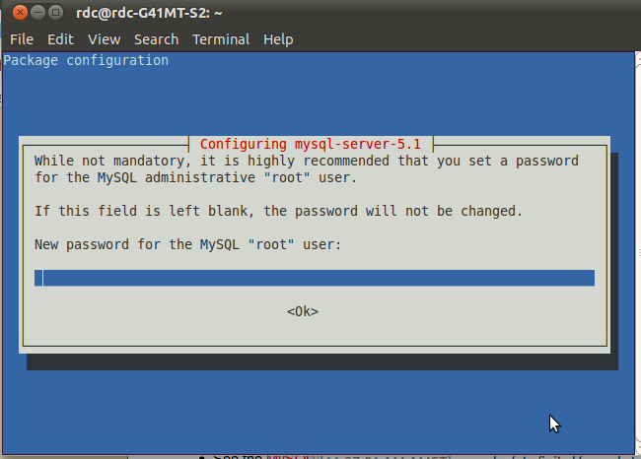
The username will be “root”.
After installing server you can configure the password by using following command if you have not been asked for password during installation:
sudodpkg-reconfigure mysql-server-5.1

After that you need to create a new database by using following command:

mysqladmin -u root -p create d_acs

After creating database you will need to import the database. To import the database use following command:

mysql -u root -h localhost –P3306 –p d_acs<d_acs.sql

The mentioned command is correct for Ubuntu 10.10. For Ubuntu 11.04 you need to use following command:

mysql -u root -h localhost –p d_acs<d_acs.sql

Install Apache tomcat

Change current directory to /home, after that get tomcat by running:

wgethttp://mirror.cc.columbia.edu/pub/software/apache/tomcat/tomcat-6/v6.0.35/bin/apache-tomcat-6.0.35.tar.gz

Extract and rename the downloaded file:

tar xvfz apache-tomcat-6.0.35.tar.gz
mv apache-tomcat-6.0.35 apache-tomcat

Tomcat needs to set JAVA_HOME or JRE_HOME to execute. Open the follow document and edit the lines
sudogedit ~/.bashrc
then place the following lines in
export JAVA_HOME=/usr/lib/jvm/java-6
export PATH=$PATH:$JAVA_HOME/bin

Open /home/tomcat/conf/tomcat-users.xml file and add the following row:

<user username="tomcat" password="tomcat" roles="admin,manager"/>

Start tomcat:

sudoapache-tomcat/bin/startup.sh run

To stop tomcat you should use following command

sudoapache-tomcat/bin/shutdown.sh run

Change permission by running:
chmod -R 777 apache-tomcat/*

Install ACS server
Open thedistribution file – find the ACS_Server folder.
Run the following commands:

mv ACS_Serverstart.sh stop.sh check.sh stopcheck authipAddress.sh/home/rdc-4
mv config/home/rdc-4
mv server-log /home/rdc-4
cd
chmod 777 start.sh stop.sh check.sh ipAddress.sh check stop authACS_Serverserver-log

(rdc-4 is the current user home)
Server can be startedfrom the web. Onlyuser with administration rights can run the server.
To configure the server you need to open the configuration files in /config/ folder.
Insert the necessary parameters:
In db configuration file (dbase.config)
localhost // Host where located Database
root // Database username
rdc2010 // password for Database
d_acs // Database name

In log configuration file (log_trace.config)
//Log level: INFO=0,DEBAG=1,WORNING=2,ERROR=3,FATAL=4
level = 0
path=/home/rdc-4/server-log/
//trace on=1,off=0
trace=0
// xxx@yyy.ru, zzz@yyy.com,kkk@lll.am
mailto= "administrator@dlink.am"
// log file format and repetition - DD.MM.YY:HH:MM
// new file every hour
repeat ="DD.MM.YY:HH"

Locate project into tomcat
The project folder “ACSProject” must be located into /apache-tomcat/webapps folder

Change permission by running:

chmod 777 ACSProject
cd ACSProject
chmod –R 777 *

Then you need to open the configuration files in /apache-tomcat/webapps/ACSProject/WEB-INF/classes/resource folder.
Insert the necessary parameters:
In db configuration file (database-config.properties)
db-driver=com.mysql.jdbc.Driver
db-url=jdbc:mysql://localhost:3306/d_acs
db-username=root
db-password=
In server configuration file (server-config.properties)
home-path=/home/rdc-4
start=/home/rdc-4/start.sh
stop=/home/rdc-4/stop.sh
check=/home/rdc-4/check.sh
connect_req=/home/rdc-4/auth
serverIp=/home/rdc-4/ipAddress.sh

Start web application

Open the browser and enter the following URL:
http://localhost:8080/ACSProject/
Username: admin
Password: admin

