User Guide D-link TR-069

9/28/2011
D-Link Corporation

Table of Content
1. Administrator 2
1.1. The horizontal menu 3
1.1.1. Configuration 3
1.1.1.1. View 3
1.1.1.1.1. Users 3
1.1.1.1.2. Networks 5
1.1.1.2. Settings 8
1.1.1.3. Set Default Parameters 9
1.1.1.4. Server Security 9
1.1.2. View 10
1.1.2.1. Unknown user 10
1.1.2.2. Unknown hardware 10
1.1.2.3. Not in glossary 10
1.1.3. Glossary 11
1.1.3.1. Manufacturer 11
1.1.3.2. CPE type 11
1.1.3.3. Model 11
1.1.4. FW Upgrade 12
1.1.4.1. Upload file 13
1.1.4.2. Upgrade device 13
1.1.5. Topology 14
1.1.6. Profile 14
1.1.6.1. View 14
1.1.6.2. Edit 15
1.1.6.3. Logout 16
1.2. Checking database and server 16
1.3. Actions with ACS server 16
2. Operator 17
2.1. Menu 17
2.2. Networks 18
3. General 18
4. Device Configurations 20

- Administrator
Entering the URL of the web you will see the login page.
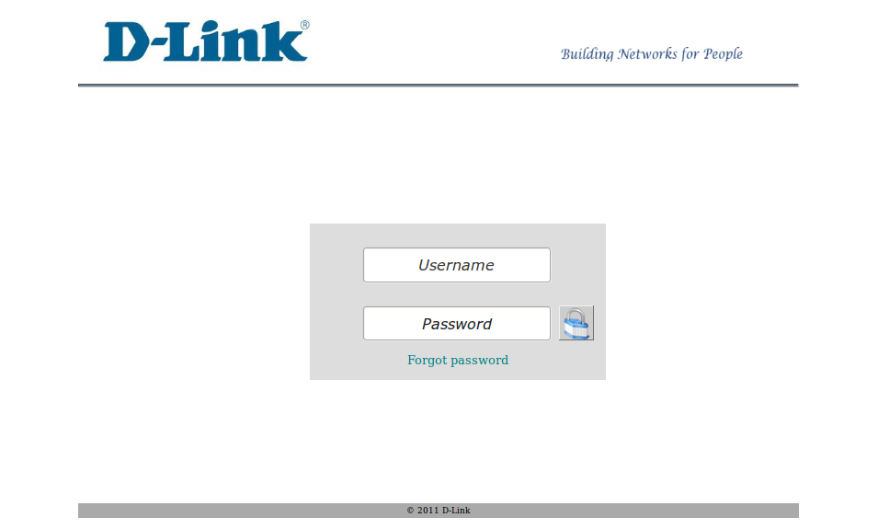
Entering correct username andpassword, you will see the page which has been created for Administrator.
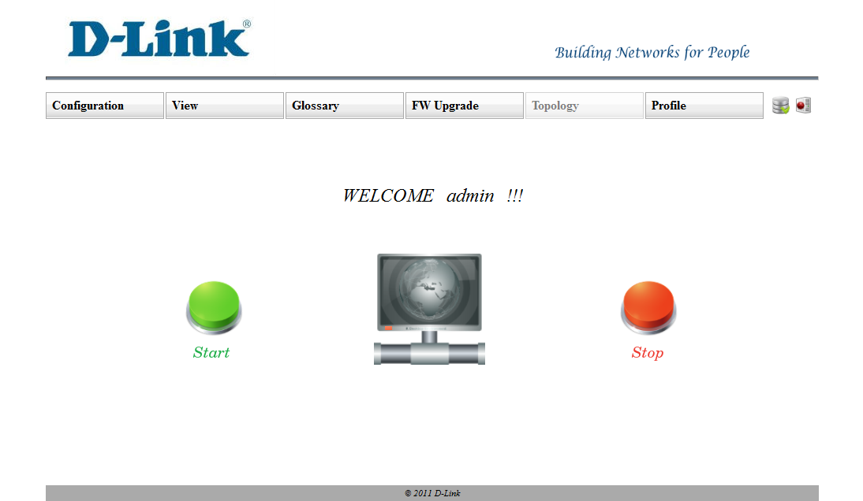

In the Admin page you will see the horizontal menu, the Icon which shows the database connection status and buttons which allows starting and stopping ACS server.
  - The horizontal menu
Itincludesthe following parts:
- Configuration
- View
- Glossary
- FW Upgrade
- Graphic
- Profile

    - Configuration
This menu has the following submenus:
- View
- Settings
- Set Default Parameters

      - View
This submenu has 2 submenus:
- Users
- Networks

        - Users
By clicking “Users” submenu you will see the following page:
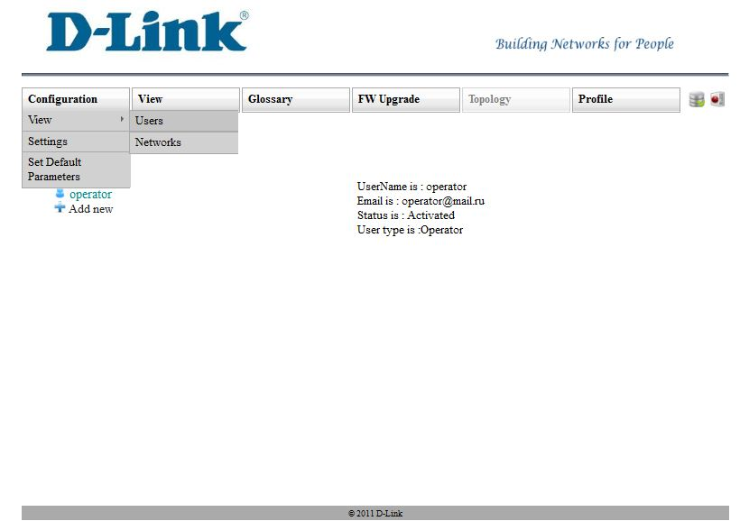

At the left of the page you will see all operators. By clicking on each user’s username on the right part you will see all information about appropriate user.
On hover of each user’s username you will see the red cross. By clicking that you can delete the appropriate user (the user will be deleted if you submit the “Ok” button on the confirmation dialog). By clicking “Add new ”link a dialog will be appeared .
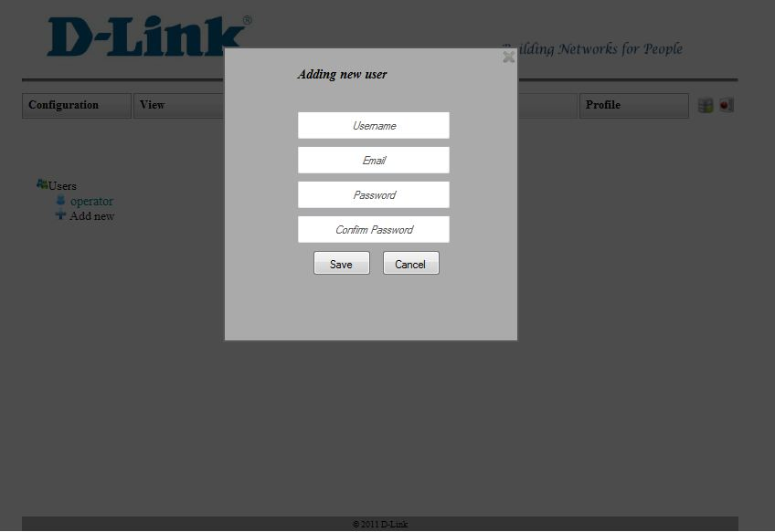
To add new user you need to enter all fields on the dialog correctly. By clicking “Save” button on the dialog, if everything will be ok, a new user will be added and the email will be sent to the entered email. The status of that user will be “Pending” until the appropriate user doesn’t activate his/her account via his/her email. Via that email the username and password will be sent.
        - Networks
By clicking “Networks” submenu you will see the following page:
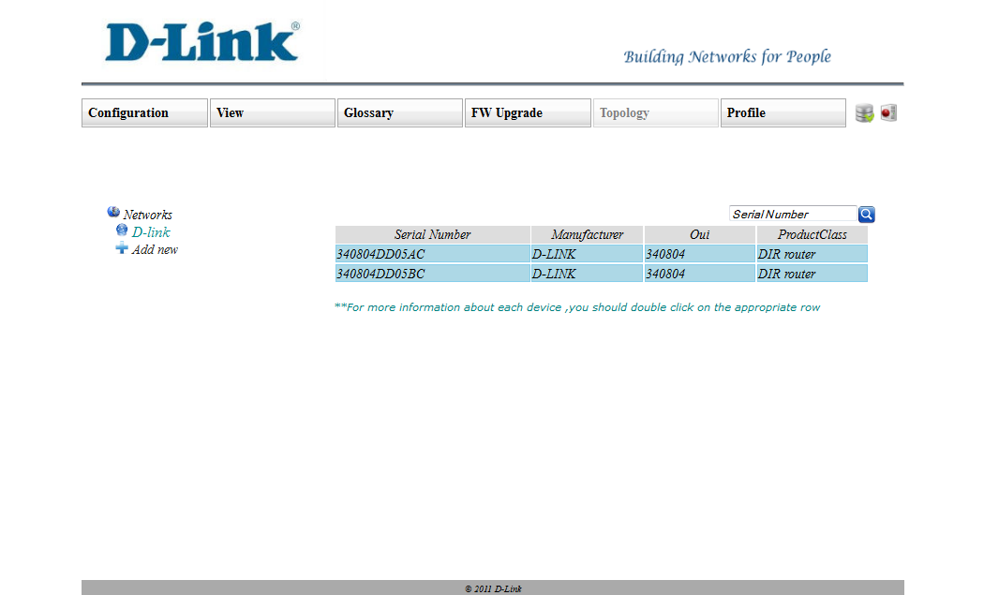
At the left of the page you will see all networks. By clicking on each network’s name on the right part you will see the table. This table includes all devices which are in the appropriate network. There you can search devices by their serial number.
To view more information about each device you will need to double click on each row. Double-clicking you will see the following page: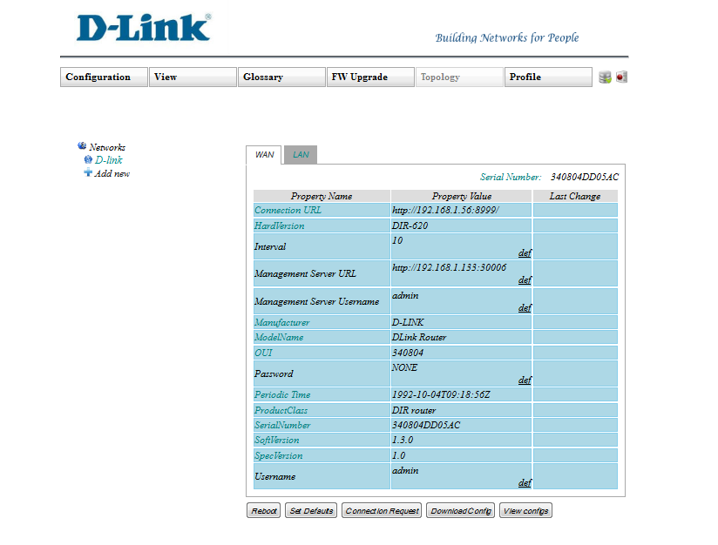
There are all device parameters which are visible for administrator. The first column shows the parameter’s visual name.The second column shows the parameter’s real value. Thethird column shows the status of the last change (waiting, ok, error). If status is waiting you can’t change value of that parameter. To change value of each parameter you need to double-click on the “value” field of the appropriate row. If the parameter is writable the text field will be appeared with green button. If you enter some value in that field and submit the button the request for changing parameters will be sent, and the status of that parameter will become waiting. After receiving the answer from ACS server the status can be changed. On the second field you can see the deflink .By clicking that you will replace the parameter’s current value with its default value.
You can set default values for all WAN or LAN parameters by submitting “Set Defaults” button.
By submitting “Reboot” button you can reboot the device.
By submitting “Connection Request” button the window will be appeared, where
you need to enter the Connection Request Password and submit the “Send” button.
After that our server will connect to the device.
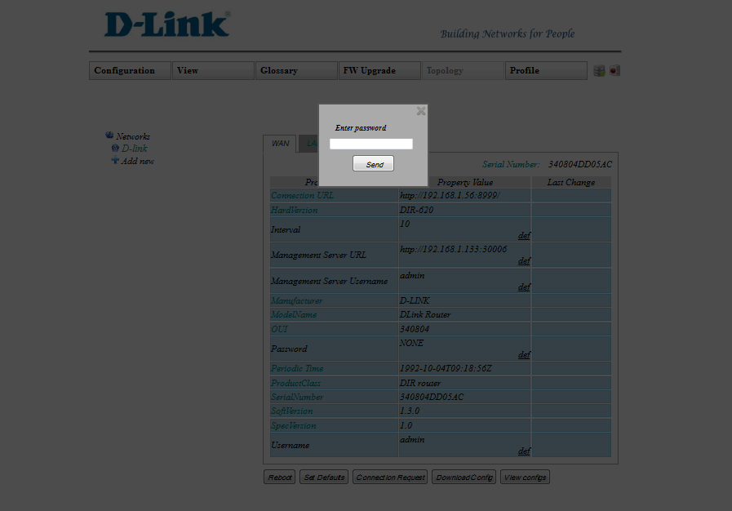
Configuration files
By submitting “Download Config” button you will downloadthe configuration files.
By submitting “View Configs” button you will see the following page:
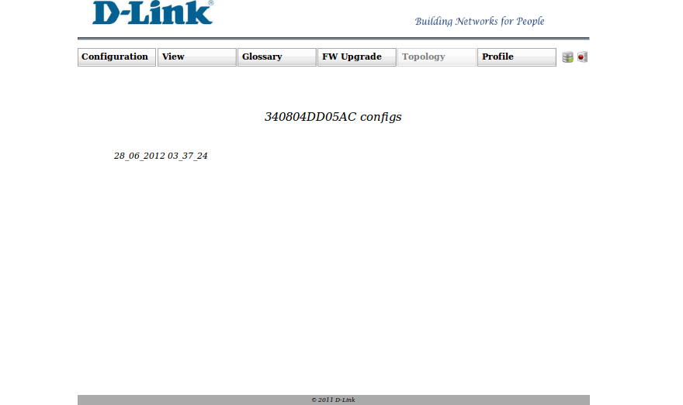
In this page you can see the all downloaded configuration files.
By clicking on each folder’s nameyou will see the files content, which you can
change.
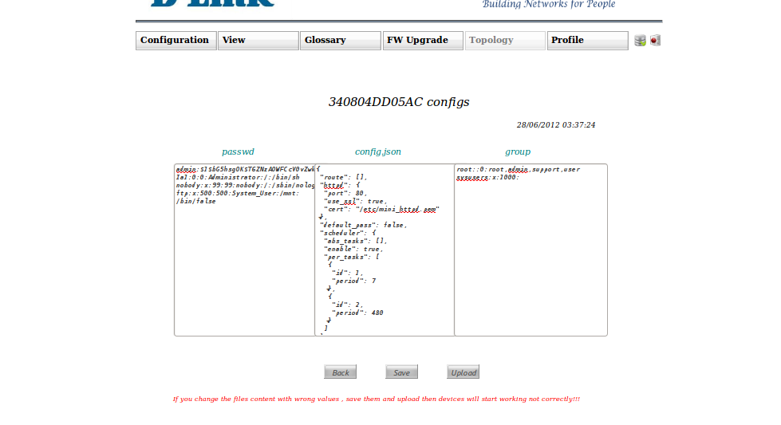

By submitting “Save” button you will save the changes.
By submitting “Upload”button you will upload the files on the device.
By submitting “Back” button you will see the previous page.
Restrictions
If you change the files content with wrong values, save them and upload then
devices will start working not correctly.

Similar to the users you can add and delete networks. But you can’t delete
networks, which are having devices.

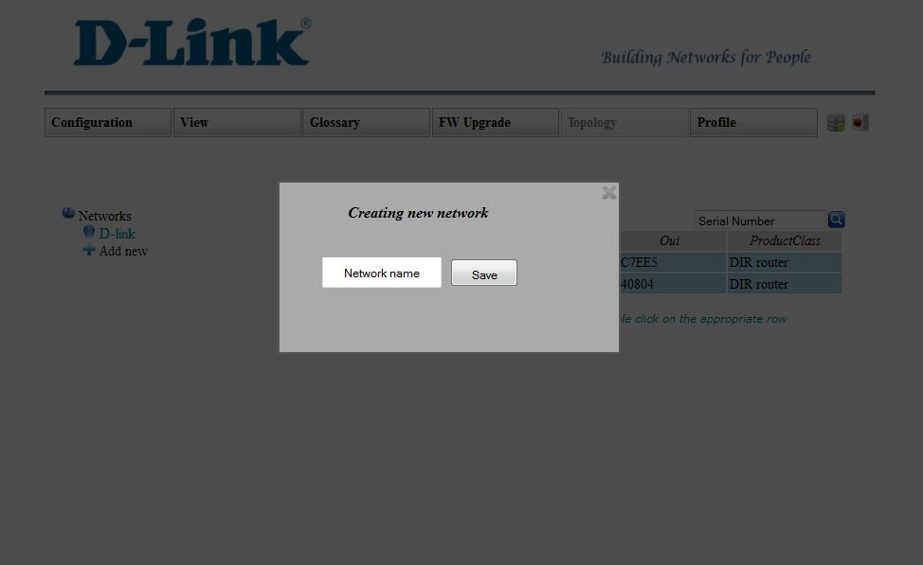

      - Settings
By clicking “Settings” submenu you will see the following page:

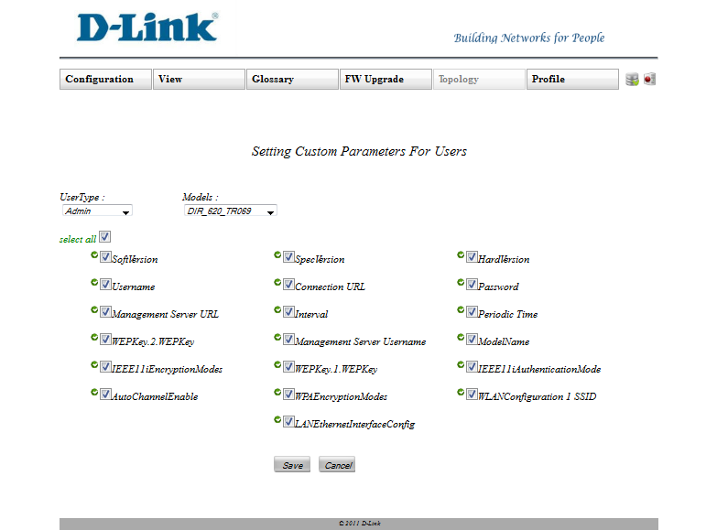
In this page you can configure the visibility of parameters of each models for each type of users. To configure you need to select type of user; select model and then parameters will be appeared. The default parameters will be checked by some symbols. You can allow the selected type of user to see some parameters. The selected type of user can see only default parameters if you don’t select any parameter. The selected type of user can see all parameters if you select all.The selected type of user can see custom parameters if you select only some parameters. By clicking “Save” button configuration process will be completed.

      - Set Default Parameters
By clicking “Set Default Parameters” submenu you will see the following page:
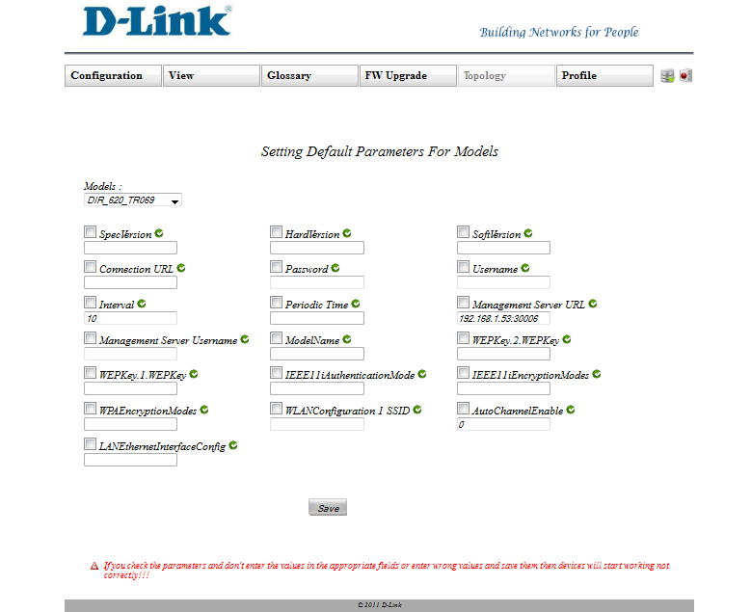

In this page you can set default parametersfor each model and their default values. For that youneed to select model and then the parameters of that model will be appeared. Some parameters, which are also default for that model, will be checkedby some symbols.In the fields will be shown the default values of each parameter. You can change those values. By clicking “Save” button process will be completed.
Restrictions
If you check the parameters and don't enter the values in the appropriate fields or enter wrong values and save them then devices will start working not correctly!!!

      - Server Security
By clicking “Server Security” submenu you will see the following page:
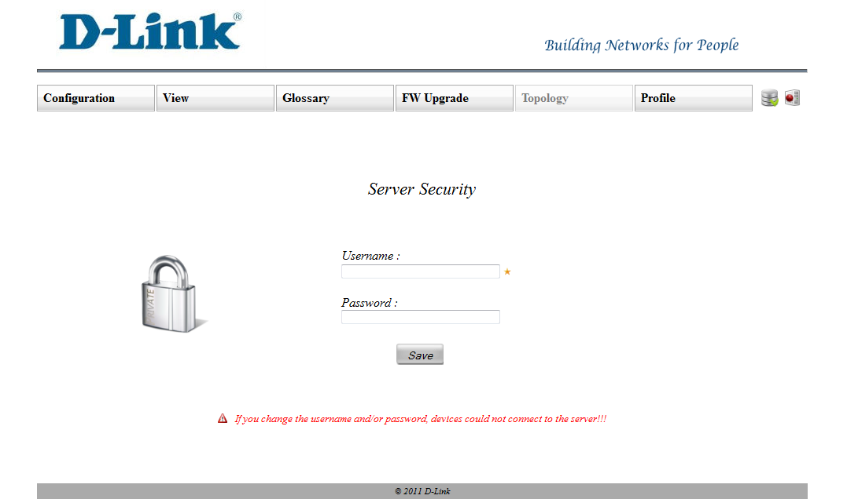

In this page you can see and change the username and the password of the server.
If you enter the values in theappropriate fields and submit “Change” button, the
parameterswouldbe changed.

    - View
On hover of “View” menu, you can see 3 submenus:
- Unknown user
- Unknown hardware
- Not in glossary

      - Unknown user
This submenu disabled yet.
      - Unknown hardware
This submenu disabled yet.
      - Not in glossary
By clicking “Not in glossary” submenu you will see the following page:
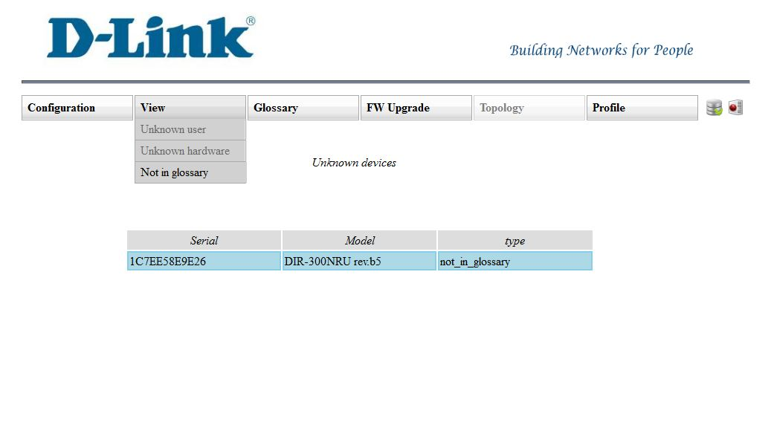There are all devices which was tried to connect to ACS server, but theirs model is not in our database.
    - Glossary
On hover of “Glossary” menu, you can see 3 submenus:
- Manufacturer
- CPE type
- Model
      - Manufacturer
On the “Manufacturer” submenu you will see all manufacturers’ names which are registered in our database.
Clicking each of these submenus you will see all models which are included in the appropriate manufacturer.
      - CPE type
On “CPE type” submenu you will see all device types which are registered in our database.
By clicking each of these submenus you will see all models which are included in the appropriate device type.
      - Model
By clicking “Model” submenu you will see all models which are in our database.
In each case (1.3.1, 1.3.2, 1.3.3) you will see following page:

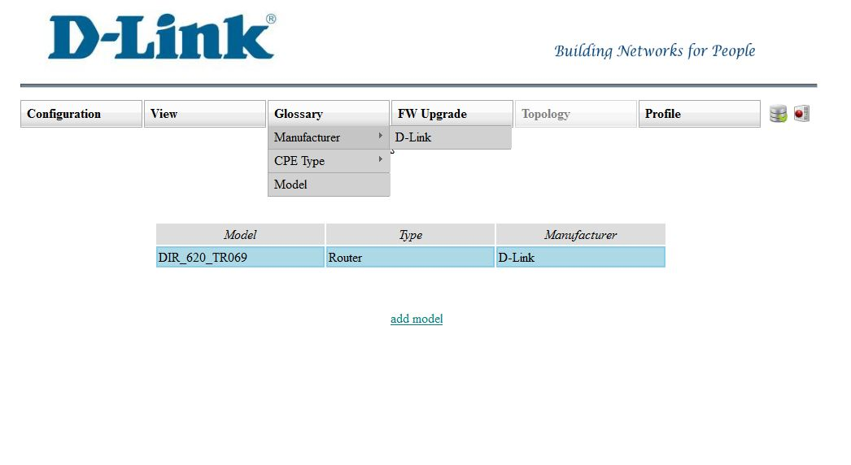
By clicking “add model” link you can see the following page:
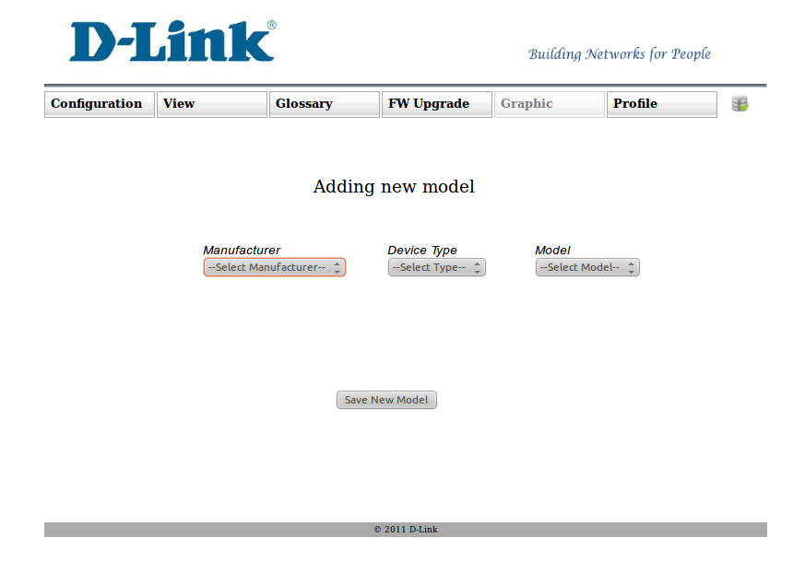
There you need to select the manufacturer, the type and the name for that model and submit the “Save new model” button.
    - FW Upgrade
On hover of “FW Upgrade” menu, you can see 2 submenus:
- Upload file
- Upgrade device
      - Upload file
Clicking “Upload file” submenu you will see the following page:
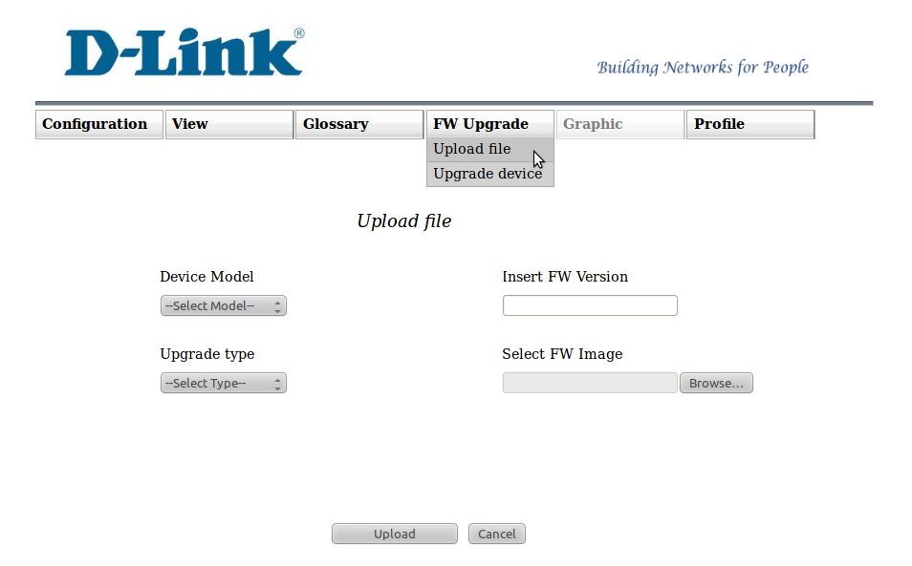
There you need to select the model, the upgrade type, insert the upgrade version and upload a file.By selecting the model you give the opportunity for all devices which belong to that model to be upgraded with this uploaded file.
To complete the process you need to submit the “Upload” button. To cancel the process you need to submit the “Cancel” button.
Restrictions
For each model you can’t upload more than one file of the same version.
The uploaded file must have only “.bin” extension.
      - Upgrade device
Clicking “Upgrade device” submenu you will see the following page:
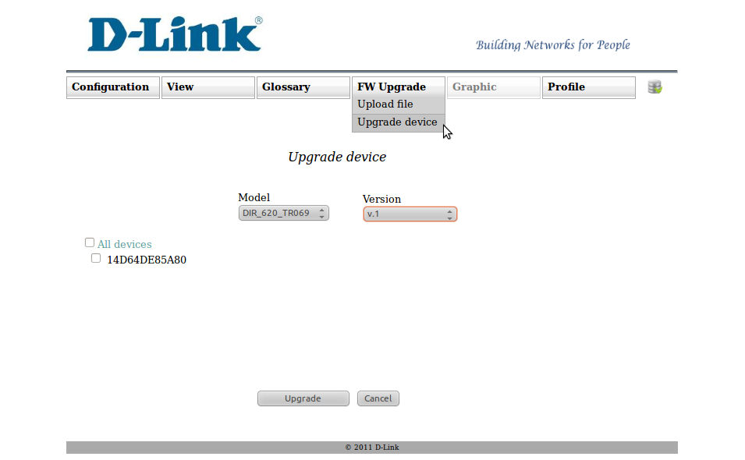
There you need to select the model. By selecting the model you will see all devices which are having the selected model.
Then you need to select some devices, which are needed to be upgraded. If you select “All devices”, all devices in that page will be selected to be upgraded. To complete the process you need to submit the “Upgrade” button. To cancel the process you need to submit “Cancel” button.
Restrictions
You can’t select the devices, which are already started to be upgraded.
    - Topology
This menu disabled yet.
    - Profile
This menu has following submenus:
- View
- Edit
- Logout
      - View
Clicking “View” submenu you will see the following page:
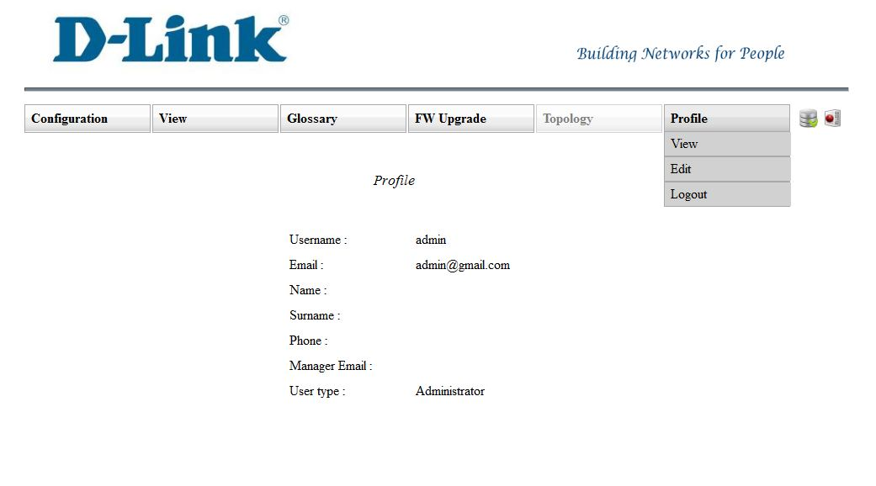

There isall your account information from the database,except password.
      - Edit
Clicking “Edit” submenu you will see following page:
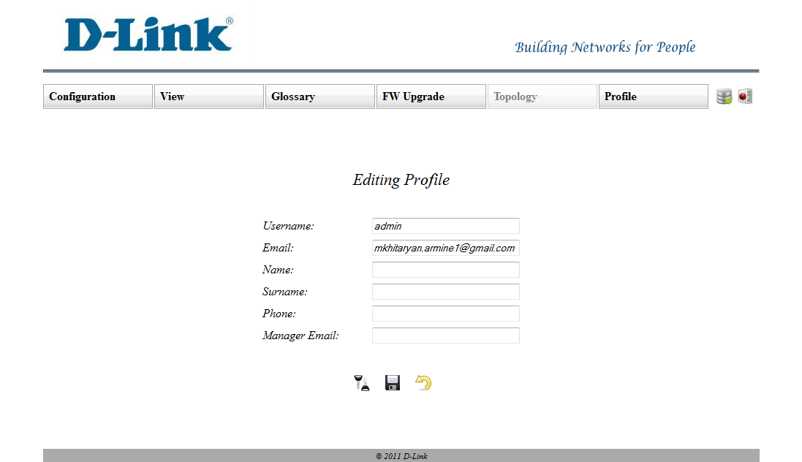
There is all your account information from the database, except password.
There you can edit each of that. To edit you need to enter new data in the appropriate field and submit “Save” button. To change password you need to click the “Change password” link.
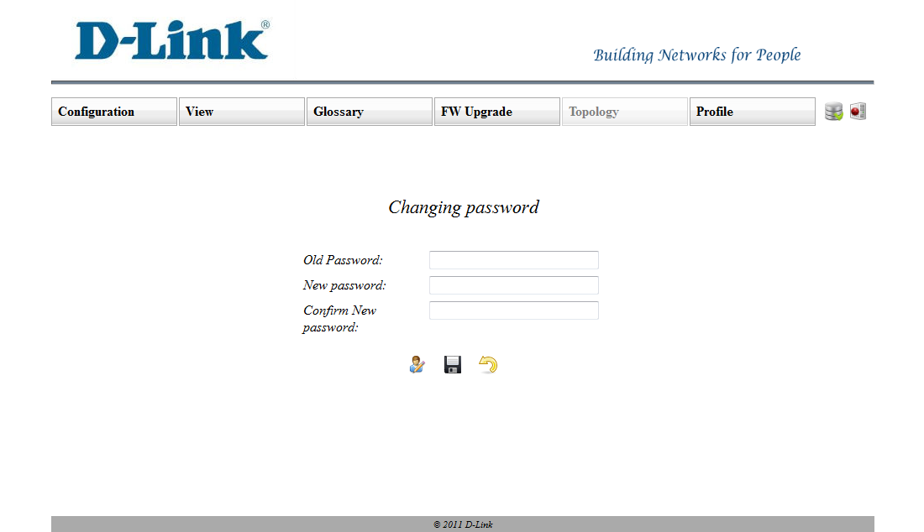

Then you will see fields where you need to enter your old password, new password and confirm the new password. Clicking “Save” button, if everything is ok, your password will be changed.
      - Logout
Clicking “Logout” submenu your page will be closed.

  - Checking database and server
From time to time we are checking the database connection and the server status.
Database:
If everything is ok you will see thisicon:
If database connection failed the first 3 times you will see:.The fourth time of connection failure you will see:

Server:
If server is running you will see thisicon:
If server is not running you will see thisicon:

  - Actions with ACS server

In this page you will see this picture and two buttons: “Start” and “Stop”.
Clicking “Start” button you will run the ACS server. Clicking “Stop” button you will stop the ACS server.
- Operator
If you are operator, you can enter your username, password in the login page and you will see the page which has been created for operators.
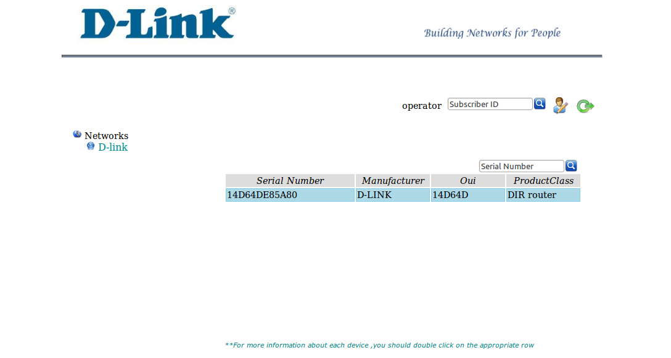

If it’s first time you have been logged in you couldn’t do anything until you didn’t changeyour password. In the appeared dialog you need to enter your current password, new password and to confirm the new password in the appropriate fields. After clicking the “Save” button, if everything is ok, your password will be changed. You will receive email which confirms that your password has been changed successfully.

In this page you will see the menu with 3 icons and the information about networks and its devices.

  - Menu
There you will see your username, the button which allows searching devices by subscriber id, the “Profile” icon which allows you to view and edit your profile and the “Logout” icon which allows logging out from your page.

Clicking “Profile” icon you will see following page:
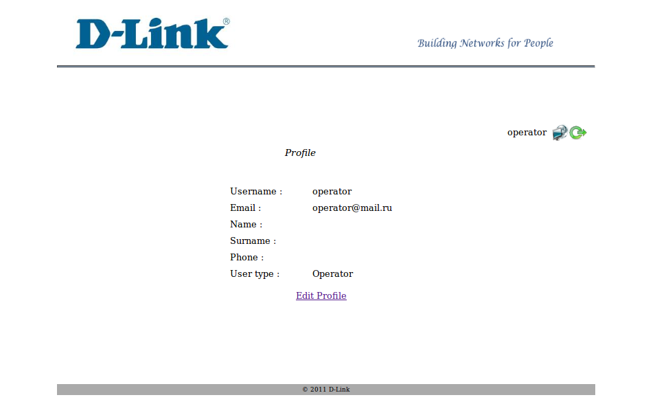
This page already has been introduced in the 1.1.6.1point. There is only one difference. In this page you will see the “Edit Profile” link.
By clicking “Edit profile” link you will see the page which already has been introduced in the 1.1.6.2 point.
By clicking “Logout” icon you will be logged out from your page.
  - Networks
In this part you will see the same view which has been introduced in 1.1.1.1.2 point.
But there are some differences. There you can’t add and delete networks. Besides it there you can search devices by serial number and subscriber id at the same time.Its means that if you enter fields for subscriber id and serial number and submit the search button for serial number, there will search the devices which are belong to that subscriber and serial number is similar to the entered serial number.If the subscriber’s id hasn’t been entered there will search all devices whose serial number is similar to the entered serial number. And in the end if you enter only subscriber id there will be search all devices which are belong to that subscriber.
- General
If you forgot your password or username you can click the “Forgot password” link. Then you will see the following page:
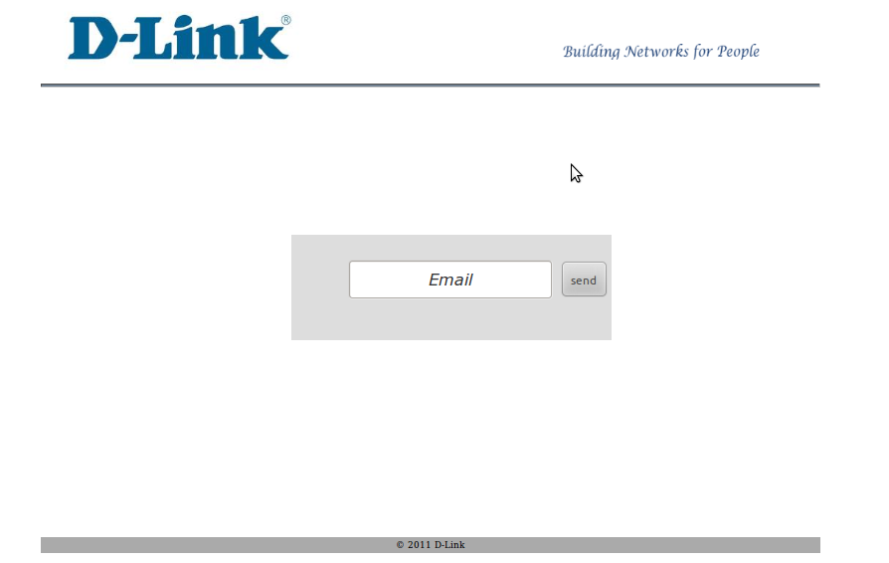
. There you need to enter your email and submit the “Send” button. After that you will receive the email. You need to follow the link you have received on your email. Then you will see following page

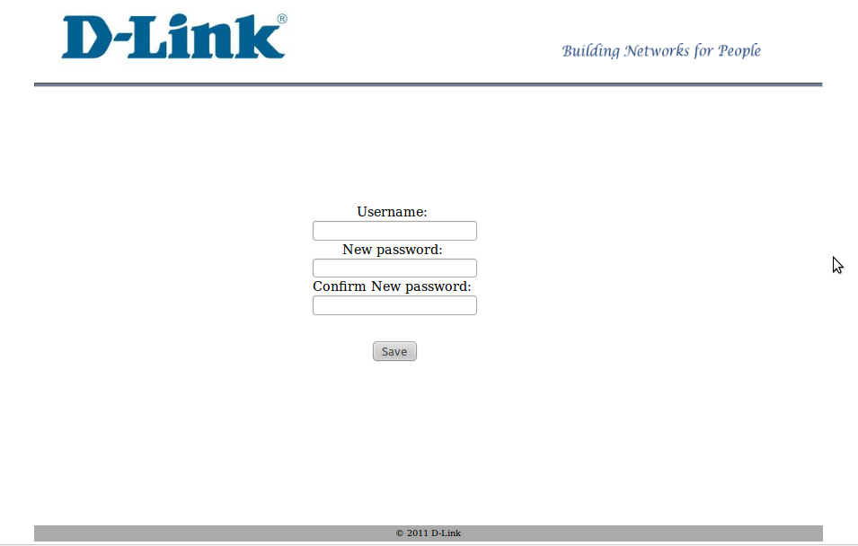. There you need to enter your new username, new password and confirm the new password. If everything is ok you willhave a new username and a new password and you page will be opened automatically.

- Device Configurations
To configure device you need to connect to device LAN port, then by entering the device IPyou will see the following page:

Step1
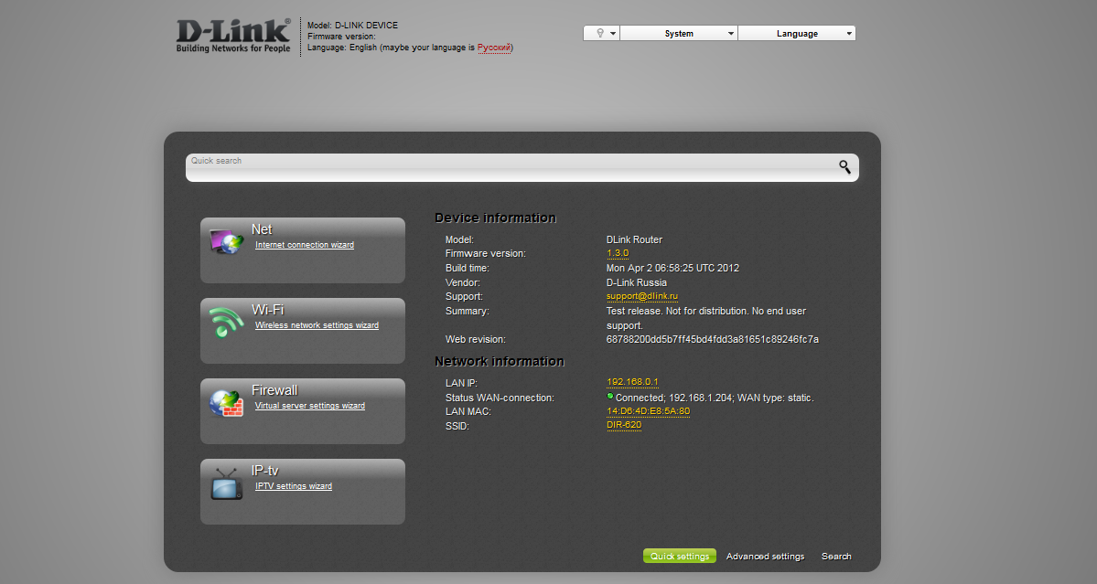

There you need to click on the “Advanced settings” button.

Step2
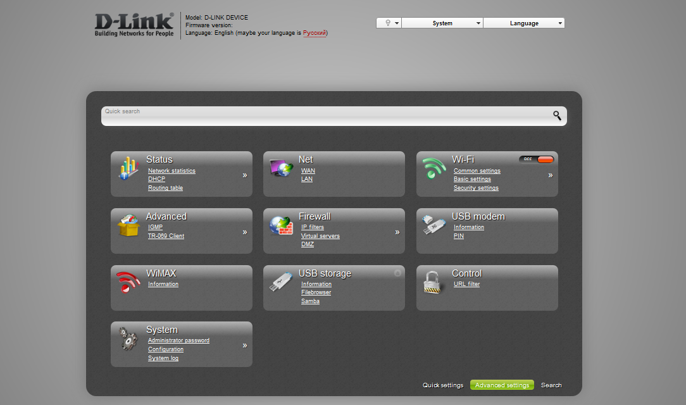

There you need to click on the “TR-069 Client”.

Step 3

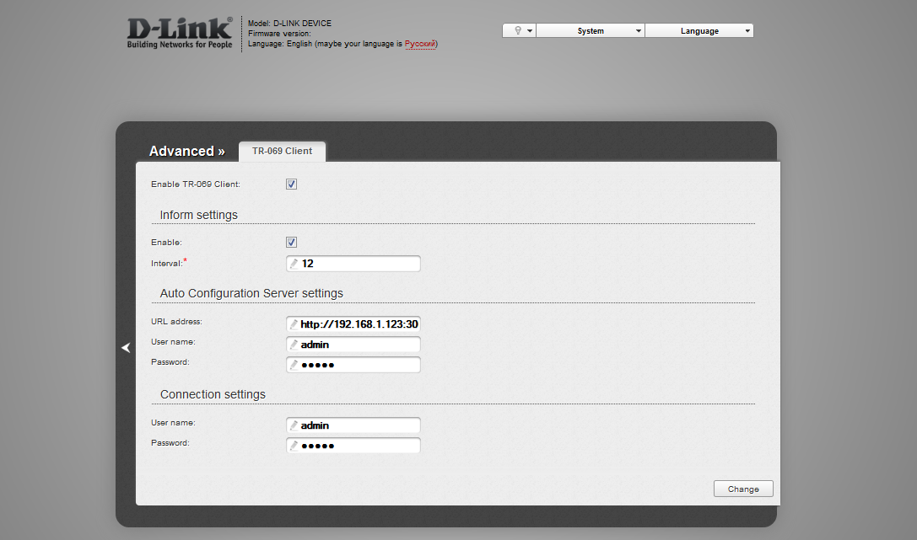

There you need to enter the url-address, the username and the password of the ACSserver in the appropriate fields, enable the “TR-069 Client“ and the inform settings.
One example of the url-address is http://192.168.1.53:30006 ,where192.168.1.53 is the server IP. To change the configurations you need to submit “Change”button. To complete the process you need to submit the “Save” button.

