DES-1316K

Date: September 14, 2004

Product name: | A PoE bundling kit of one 8 10/100Mpbs Ports + 8 10/100 PoE Ports Web Smart Switch and two DWL-P50
Product Group & Type:
Revision: | A1
Available:
Picture: | 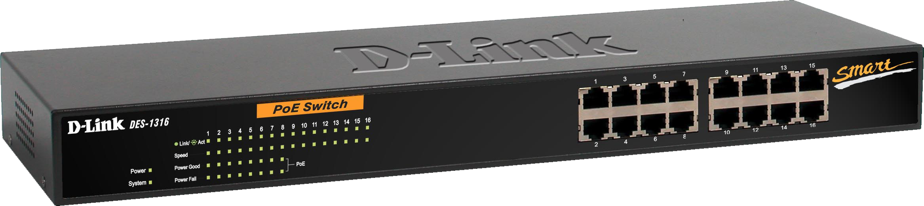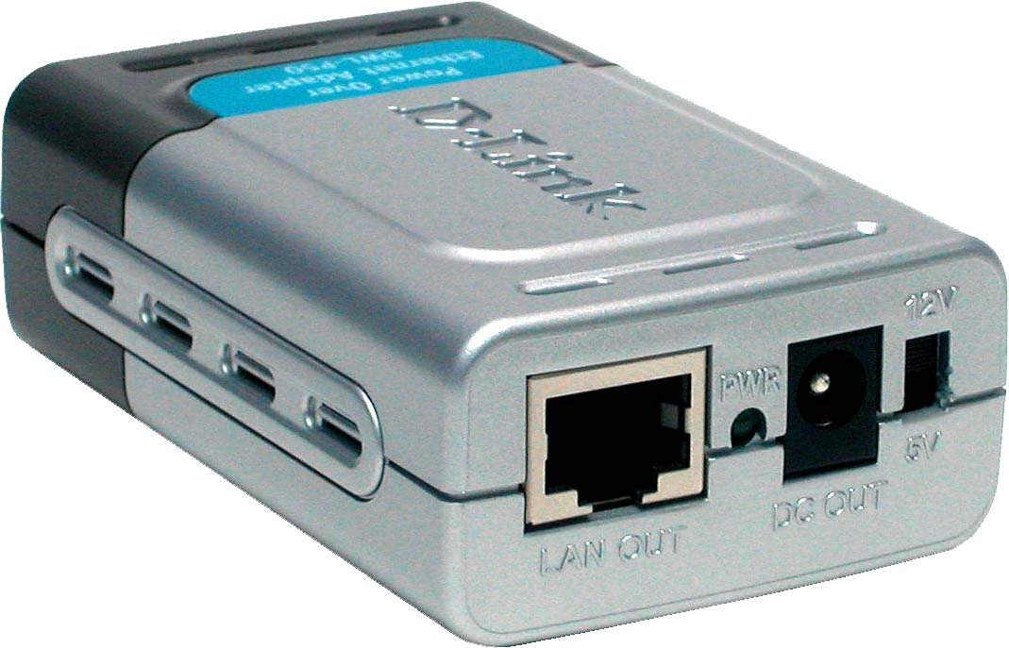
Why Sell This Product: | - Convenient kit consisting of a 802.3af standard PoE DES-1316 switch and 2 DWL-P50 PoE adapters. It’s a good way to introduce the DWL-P50 to your customers when you sell the DES-1316.  - Great for selling to installation sites with multiple (10 or above) wireless AP and Internet cameras.  Selling Points  - Convenient one-in-all PoE kit.  - Guaranteed operation with D-Link products.
Key Features: | DES-1316  - 16 10/100BASE-TX Ethernet ports (8 PoE ports, 8 non-PoE ports)  - Complies to 802.3af Power over Ethernet standard  - Supplies up to 15.4 watts per PoE port  - Auto-detection of network devices needing PoE  - Active circuit protection with auto-disable of PoE in case of over current  - PoE ports operate with all 802.3af compliant and non-compliant devices (DWL-P50 required for non-compliant devices)  - Auto MDI/MDIX cross over for all ports  - 802.3x Flow Control for protection against data loss  - Port mirroring for traffic monitoring  - Port trunk for server/network backbone attachment  - 802.1Q VLAN to enhance security/network performance  - 802.1p Priority Queues, port-based QoS  - Easy configuration through web-based management  - Standard rack-mount size  DWL-P50  - Provides DC power over existing Category 5 cable to wireless LAN device  - Cuts costs and provides convenience  - Transforms incoming AC power into low-voltage DC power  - Protects wireless LAN device from possible power-surges  - Supports both 5VDC and 12VDC power (selectable through a slide switch)  - Very compact size, lightweight  - Complete plug-and-play installation, no configuration setting or installation tool required  - No software required, O.S.-independent
Technical Details: | DES-1316  General  Port Standards & Functions  - IEEE 802.3af Power over Ethernet (PoE)  - IEEE 802.3 10BASE-T Ethernet (twisted-pair copper)  - IEEE 802.3u 100BASE-TX Fast Ethernet (twisted-pair copper)  - ANSI/IEEE 802.3 NWay auto-negotiation  - IEEE 802.3x Flow Control  - Port mirroring  Number of Ports  16 10BASE-T/100BASE-TX ports (8 PoE ports, 8 non-PoE ports)  Protocol  CSMA/CD  Data Transfer Rates  - Ethernet:  10Mbps (half duplex)  20Mbps (full duplex)  - Fast Ethernet:  100Mbps (half duplex)  200Mbps (full duplex)  Topology  Star  Network Cables  - UTP Cat. 5, Cat. 5e (100 m max.)  - EIA/TIA-568 100-ohm STP (100 m max.)  Media Interface Exchange  Auto MDI/MDIX adjustment for all ports  LED Indicators  - Power (per device)  - CPU (per device)  - Link/Act, Speed (per port)  - 100Mbps (per port)  - PoE (per PoE port)  PoE  PoE Ports  Port 1 to Port 8  Power Supplied  Up to 15.4 watts per port  Auto-Detection  Automatic recognition of connected Powered Device (PD) and sending power to PD  Auto-Disable  Automatically disables the port in case port current is over 350mA  Active Circuit Protection  Automatically disables the port in case of is a short  PoE Pinouts  Pins 1, 2, 3, and 6 of Cat. 5 cable  Software  VLAN  - Standard: IEEE 802.1Q  - Maximum number of VLAN: 16 per device  Quality of Service (QoS)  - Standard: IEEE 802.1p  - Maximum number of queues: 2  - Port-based  Port Trunks  - Standard: IEEE 802.3ad  - Max. 4 ports per trunk  - 1 port trunk per device  Configuration/Management Methods  - Web-based configuration  - Windows-based utility  - Configuration reset through software or hardware (reset button)  Configuration/Management Functions  - Port speed/full/half duplex setting  - Port power setting  - Switch auto-discovery  Performance  Switch Fabric  3.2Gbps  Transmission Method  Store-and-forward  MAC Address Table  4K entries per device  MAC Address Learning  Automatic update  Packet Filtering/Forwarding Rates (half duplex)  Maximum 1,488,095 pps per port  RAM Buffer  512KB per device  Physical & Environmental  AC Input  100 to 240 VAC 50/60Hz internal universal power supply  Power Consumption  - Maximum 9 watts per device (without any PoE devices connected)  - Maximum 130 watts per device (when all 8 PoE devices are connected)  Dimensions  440 (W) x 140 (D) x 44 (H) mm  19-inch standard rack mount width, 1 U height  Weight  2.15 kg  Operating Temperature  0 to 55 ℃  Storage Temperature  -10 to 70 ℃  Operating Humidity  10% to 90% RH  Storage Humidity  5% to 90% RH  Emission (EMI)  - FCC Class A  - CE Class A  - VCCI Class A  Safety  - UL  - CUL  - TUV  DWL-P50  Output Voltage  - Input: 48VDC, 400mA  - Output: 5VDC (11.5 watts) or 12VDC (12 watts) (slide switch selectable)  Ethernet Cable  - TIA/EIA 568 Cat. 5  - Connector: RJ-45  Diagnostic LED  Power  Dimensions  80.9 x 52 x 28 mm (adapter only)  Weight  80 grams (adapter only)  Operating Temperature  0 to 40 ℃ (32 to 104 ℃)  Storage Temperature  -40 to 70 ℃ (-40 to 158 ℃)  Operating Humidity  10% to 80% RH  Storage Humidity  5% to 90% RH  EMI  - FCC Part 15 Class B  - CE Class B  Safety  - UL  - TUV  Box Includes  - DWL-P50 PoE adapter  - Quick Installation Guide  - Ethernet cable  - DC power cable with female power connectors
EMI/EMC Report | DES-1316  ☑FCC No. NEI-FCCE-1-04E0539 ☑ CE No. NEI-EMC-1-04E0539 ☑ VCCI No. NEI-VC-1-04E0539  ◻ CTR-21 No. ◻ C-Tick No. ◻ A-Tick No.  ◻ FDA No. ◻ R&TTE No. ◻ BSMI No.  ◻ Others  DWL-P50  ☑FCC No. NEI-FCCE-1-04E0565 ☑ CE No. NEI-EMC-1-04E0565 ☑ VCCI No. NEI-VC-1-04E0565  ◻ CTR-21 No. ◻ C-Tick No. ◻ A-Tick No.  ◻ FDA No. ◻ R&TTE No. ◻ BSMI No.  ◻ Others
Safety | DES-1316  ◻ TUV No. ☑ CUL No. ◻ CSA No.  ◻ Others  DWL-P50  ◻ TUV No. ☑ CUL No. ◻ CSA No.  ◻ Others
Packaging Style | ◻ Clamshell ☑ White Box with D-Link logo ◻ Gift Box ◻ Bulk ◻ Others
Packaging Contents: | - One DES-1316 Device  - One set accessory including 2 Rack mount ear/4 Rubber feet and 8 Screws  - One AC power cord  - One CD Kit for DES-1316 Manual / QIG / Utility  - One hardcopy QIG for DES-1316 (BES1316KA.A1 doesn’t have)  - One hardcopy QIG for DWL-P50  - Two DWL-P50 PoE adapters  - Two Cat.5 Ethernet cable  - Two Female-to-Female power connector
UPC Code:
  BES1316KA.A1 | 790069 271717
  TES1316KA.A1 | 790069 271199
  NES1316KCNA1 | 790069 271182
  IES1316KN.A1 | 790069 271175
  IES1316KE.A1 | 790069 271168
  IES1316KA..A1 | 790069 271151
  EES1316KE.A1 | 790069 271144
  EES1316KB.A1 | 790069 271137
  EES1316KBEA1 | 790069 271120
Units Per Carton: | 6
Cartons Per Pallet: | Air: 16, Sea: 24
Dimensions and Weight: | Box: 545 x 210 x 94 mm, 3 .8 kg  Carton: 576 x 451 x 325 mm, 23.8 kg  Pallet: (by Air) 1200 x 1100 x 1460 mm, 395.8 kg (for WW)  1020 x 1220 x 1400 mm, 395.8 kg (forUSA)  (by Sea) 1200 x 1100 x 2110 mm, 586.2 kg (for WW)  1020 x 1220 x 1780 mm, 586.2 kg (for USA)  INTRASTAT weight: kg (Box)  Packing material weight (Box):  - Paper: 0.675 kg  - Plastic: 0.097 kg  - Mixed: 0.151 kg

