
Product Announcement

Date: 2005/1/20
To: USA, DI, PRC

Subject: 24-Port 10/100Mpbs + 2 Combo 1000BASE-T/SFP PoE Web Smart Switch

PART NO.: BES1526A..A1, IES1526A..A1, IES1526B..A1, IES1526E..A1, IES1526N..A1, NES1526CN.A1, TES1526A..A1

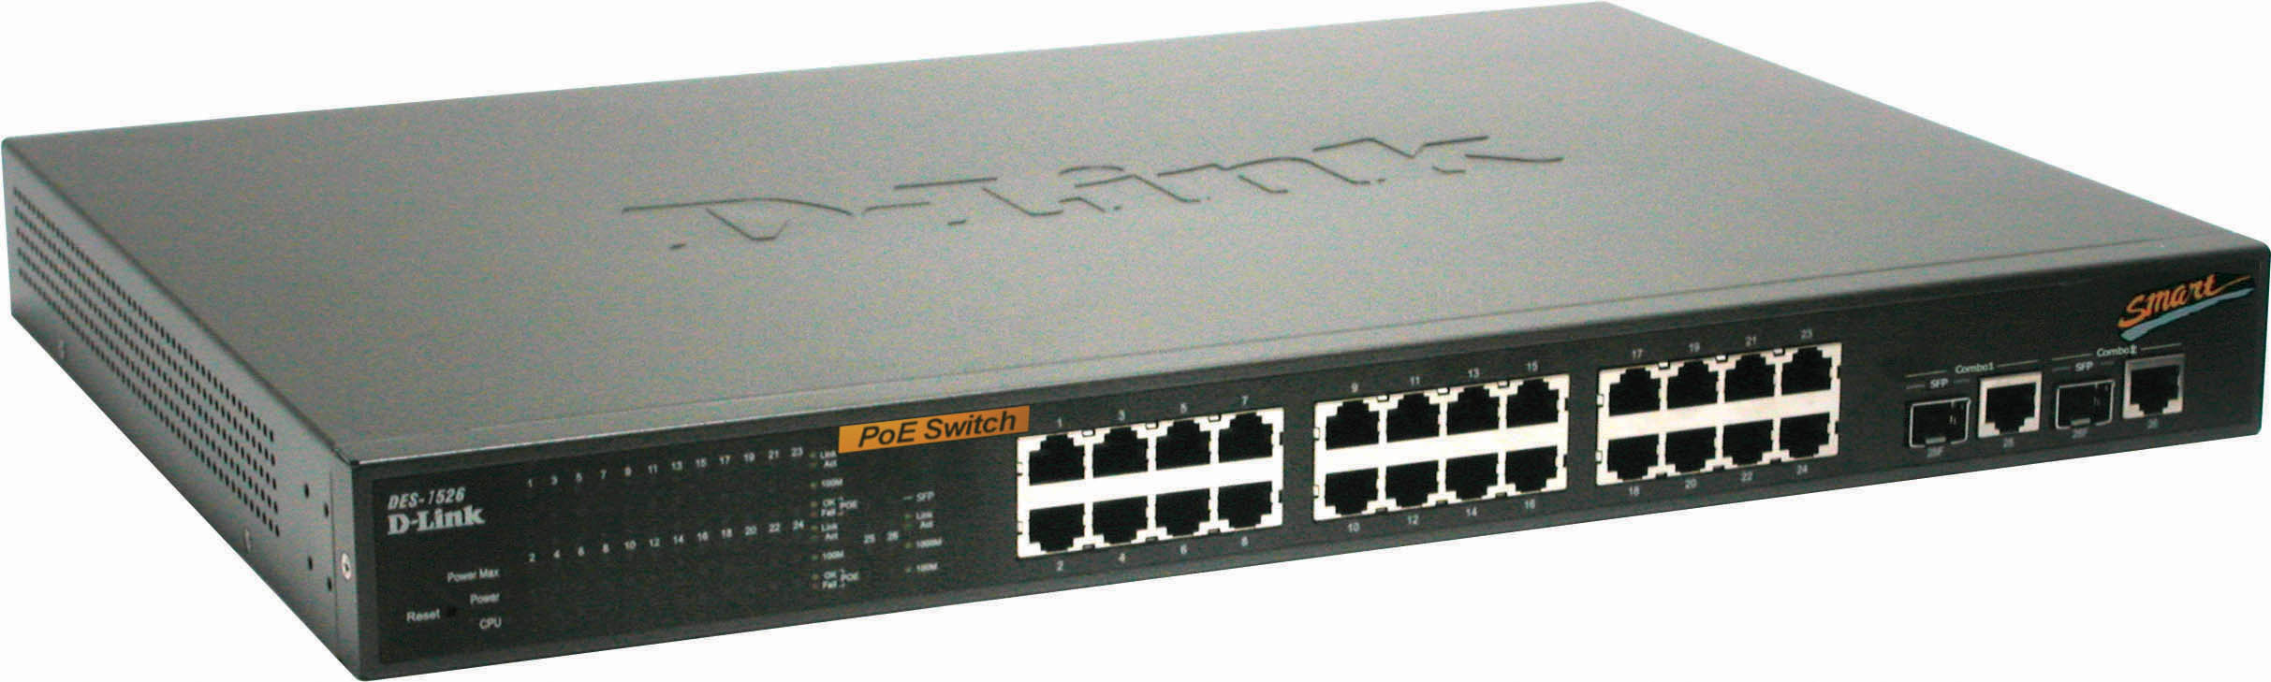

About DES-1526
DES-1526 is a 24-port 10/100M + 2 Combo 1000BASE-T/SFP Web Smart Switch, and all of its 10/100M port are with 802.3af PoE capability, which deliver power over CAT5 Ethernet cable for D-Link PoE capable wireless APs, IP Cams, IP phones or other 802.3af compliant powered devices. By working with DWL-P50 [PoE adapter], DES-1526 can include D-Link non-802.3af capable wireless APs, IP Cams and IP Phones into D-Link’s PoE solution. Also its Web GUI enable customers to perform easy and straight forward remote management.

Hardware Specifications

Key Components
Switching Capacity | 8.8Gbps
Max. Forwarding Rate | 6.55 million packets per second
Forwarding Mode | Store and Forward
SDRAM for CPU | 128Kbytes
Flash Memory | 1MB
LAN | 24 x 10/100BaseT ports  Compliant to following standards:  - IEEE 802.3 compliance  - IEEE 802.3u compliance  - Support Full-Duplex operations  - IEEE 802.3x Flow Control support for Full-Duplex mode
Combo ports | 2 combo 1000Base-T/SFP ports  1000Base-T ports compliant to following standards:  - IEEE 802.3 compliance  - IEEE 802.3u compliance  - IEEE 802.3ab compliance  - Support Full-Duplex operations  - IEEE 802.3x Flow Control support for Full-Duplex mode  SFP Transceivers Supported:  - DEM-310GT (1000BASE-LX)  - DEM-311GT (1000BASE-SX)  - DEM-314GT (1000BASE-LH)  - DEM-315GT (1000BASE-ZX)  Compliant to following standards:  - IEEE 802.3z compliance
MAC Address Table | 4K
Packet Buffer memory | 768Kbytes
PoE Features
PoE Capable Ports | Port 1-24
PoE Specification | - Supplies power to PD device up to 15.4W per port, meeting IEEE802.3af standards and more sufficiently is able to provide power to PD devices  - Power Budget: Full power for up to 12 ports, or up to 7W for 24 ports  - Auto discovery feature, automatically recognize the connection of PD device and immediately sends power to it  - Auto disable port if the port current is over 350mA while other ports remain active  - Active circuit protection, automatically disables the port if there is a short while other ports remain active  - Provide the power following the classification below  - DES-1526 follow the PSE pinout standard of Alternative A which is sending out power over number 1,2,3,6 pins of 8 wires of CAT5 UTP cable
  Class | Usage | Max power used by PD
  0 | Default | 15.4W
  1 | Optional | 4.0W
  2 | Optional | 7.0W
  3 | Optional | 15.4W
  4 | Reserved | 15.4W

Product Features

L2 Features
802.3ad Link Aggregation | Yes [Static Mode]  [Note: SFP ports can not be trunked]
Port mirroring | Yes
VLAN
802.1Q | Yes
VLAN Group | 64
Quality Of Service
Priority queues number | 2
Based on Port | Yes
802.1p support | Yes
Management
Web-GUI | Yes
CLI | Yes
Telnet | Yes
SNMP v1 | Yes
BooTP/DHCP client | Yes

Physical and Environmental

Physical and Environmental
AC inputs: | 100-240 VAC, 50/60Hz  Internal universal power supply
Operating Temperature: | 0 ~ 40°C
Storage Temperature: | -10~70°C
Humidity: | Operation: 10%-90% RH  Storage: 5% ~ 90% RH
Dimensions: | 441mm(Length) x 310mm(Width) x 44mm (Depth)
EMI: | FCC Class A, CE Class A, VCCI Class A
Safety: | CUL International

Box Includes

One DES-1526 Device

One set accessory including 2 Rack mount ears, 4 Rubber feet and 8 Screws

One AC power cord

One CD-ROM for Manual/QIG/Utility

One hard copy QIG(BES1526A..A1 doesn’t packed with QIG)

Ordering Information

BES1526A..A1 24-Port 10/100Mpbs + 2 Combo 1000BASE-T/SFP PoE Web Smart Switch, with USA power cord
IES1526A..A1 24-Port 10/100Mpbs + 2 Combo 1000BASE-T/SFP PoE Web Smart Switch, with DI QIG and USA power cord
IES1526B..A1 24-Port 10/100Mpbs + 2 Combo 1000BASE-T/SFP PoE Web Smart Switch, with DI QIG and UK power cord
IES1526E..A1 24-Port 10/100Mpbs + 2 Combo 1000BASE-T/SFP PoE Web Smart Switch, with DI QIG and European power cord
IES1526N..A1 24-Port 10/100Mpbs + 2 Combo 1000BASE-T/SFP PoE Web Smart Switch, with DI QIG and Australian power cord
NES1526CN.A1 24-Port 10/100Mpbs + 2 Combo 1000BASE-T/SFP PoE Web Smart Switch, with DI QIG and CN power cord
TES1526A..A1 24-Port 10/100Mpbs + 2 Combo 1000BASE-T/SFP PoE Web Smart Switch, with DI QIG and USA power cord

Ordering Price
Please refer to the Price Book

Lead Time:
4 ~ 5 weeks (with forecast)

