DES-3000 Series SNMP MIB User Guide for v3.00.036

This document provides example of how to use the SNMP MIB Spec as a reference to find out where the function locates in SNMP (DES-3000 Series MIB Tree Table_v3.00.036 .zip). Examples in the document include:
1. Save Configuration
2. Forwarding Table
3. CPU Utilization
4. Port Security
5. IP-MAC-Port Binding

For detailed software features with corresponding firmware version, users should also refer to the external specification.
Example 1. Save Configuration
(1) In the “DES-3000 Series MIB Tree Table_v3.00.036.xls” file, user can search “dlkAgent” label for “savecfg” and the result of the specific MIB will be shown below:

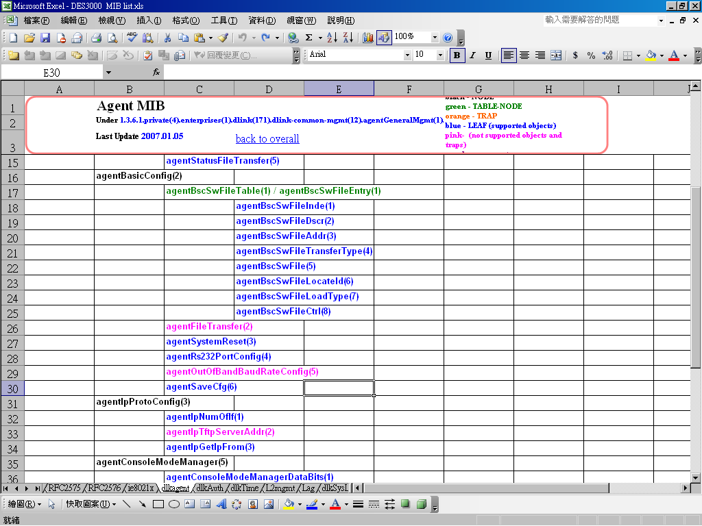

(2) In the “private” folder, using notepad or text editor to open “Agent.mib”, and search for “savecfg”. User can find out how to save the configuration:

agentStatusSaveCfg OBJECT-TYPE
SYNTAX INTEGER {
other(1),
proceeding(2),
completed(3),
changed-not-save(4),
failed(5)
}
MAX-ACCESS read-only
STATUS current
DESCRIPTION
"This indicates the status of the device configuration.

other(1) - this entry is currently in use but the conditions
under which it will remain so are different from each
of the following values.
proceeding(2) - the device configuration is being currently saved into the NV-RAM.
completed(3) – all of the device configuration parameters have been
saved into NV-RAM.
changed-not-save(4)– some of the device configuration parameters have
been changed but not saved into NV-RAM.
failed(5) - The process to save device configuration is failed."
::= { agentBasicInfo 4 }

Example 2. Forwarding Table
(1) In the “DES-3000 Series MIB Tree Table_v3.00.036.xls” file, user can search “RFC1493” label for “fdbtable” and the result of the specific MIB will be shown below:
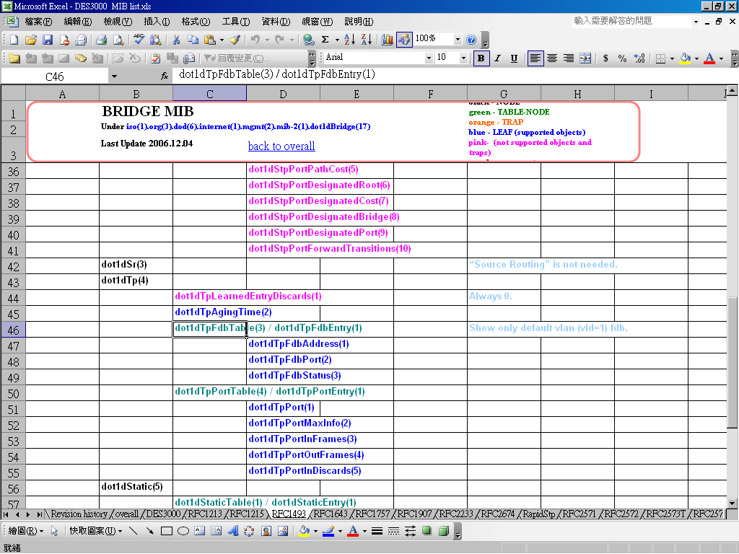

(2) In the “Public” folder, using notepad or text editor to open “RFC1493.MIB” and search for “fdbtable”. User can find the detail functions are described.

dot1dTpFdbTable OBJECT-TYPE
SYNTAX SEQUENCE OF Dot1dTpFdbEntry
ACCESS not-accessible
STATUS mandatory
DESCRIPTION
"A table that contains information about unicast
entries for which the bridge has forwarding and/or
filtering information. This information is used
by the transparent bridging function in
determining how to propagate a received frame."
::= { dot1dTp 3 }

dot1dTpFdbEntry OBJECT-TYPE
SYNTAX Dot1dTpFdbEntry
ACCESS not-accessible
STATUS mandatory
DESCRIPTION
"Information about a specific unicast MAC address
for which the bridge has some forwarding and/or
filtering information."
INDEX { dot1dTpFdbAddress }
::= { dot1dTpFdbTable 1 }

Dot1dTpFdbEntry ::=
SEQUENCE {
dot1dTpFdbAddress
MacAddress,
dot1dTpFdbPort
INTEGER,
dot1dTpFdbStatus
INTEGER
}

dot1dTpFdbAddress OBJECT-TYPE
SYNTAX MacAddress
ACCESS read-only
STATUS mandatory
DESCRIPTION
"A unicast MAC address for which the bridge has
forwarding and/or filtering information."
REFERENCE
"IEEE 802.1D-1990: Section 3.9.1, 3.9.2"
::= { dot1dTpFdbEntry 1 }
Example 3. CPU Utilization
(1) In the “DES-3000 Series MIB Tree Table_v3.00.036.xls” file, user can search “L2mgmt” label for “cpuutilizatoin” and the result of the specific MIB will be shown below:
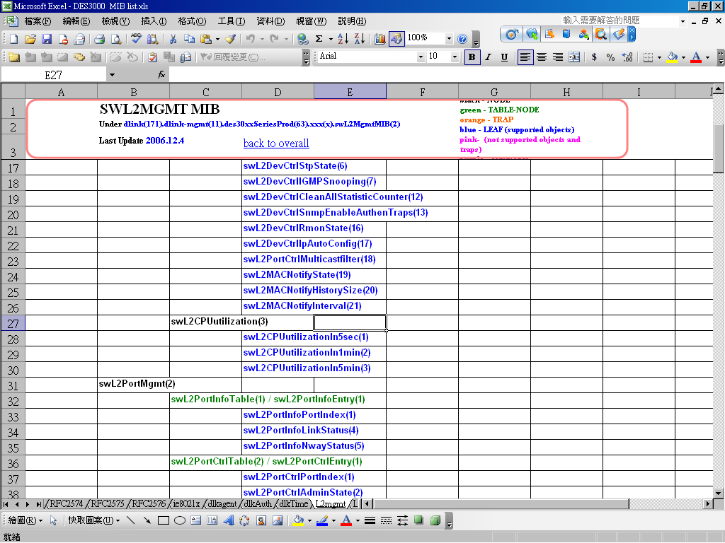

(2) If it is DES-3026, in the “private” folder. Using notepad or text editor to open “des3026-l2mgmt.mib”, and search for “cpuutilizatoin”user can find out how to display the 5 sec/1 min/5min CPU Utilization:

swL2CPUutilization OBJECT IDENTIFIER ::= { swL2DevMgmt 3 }
swL2CPUutilizationIn5sec OBJECT-TYPE
SYNTAX Integer32
MAX-ACCESS read-only
STATUS current
DESCRIPTION
"Time scale is 5 seconds.The value will be between 0%(idle) and 100%
(very busy)."
::= { swL2CPUutilization 1 }

swL2CPUutilizationIn1min OBJECT-TYPE
SYNTAX Integer32

MAX-ACCESS read-only
STATUS current
DESCRIPTION
"Time scale is 1 minute.The value will be between 0%(idle) and 100%
(very busy)."
::= { swL2CPUutilization 2 }

swL2CPUutilizationIn5min OBJECT-TYPE
SYNTAX Integer32
MAX-ACCESS read-only
STATUS current
DESCRIPTION
"Time scale is 5 minute.The value will be between 0%(idle) and 100%
(very busy)."
::= { swL2CPUutilization 3 } MAX-ACCESS read-only
STATUS current
DESCRIPTION
"Time scale is 5 minute.The value will be between 0%(idle) and 100%
(very busy)."
::= { agentCPUutilization 3 }

Example 4. Port Security
(1) In the “DES-3000 Series MIB Tree Table_v3.00.036.xls” file, user can search “L2mgmt” label for “portsecurity” and the result of the specific MIB will be shown below:
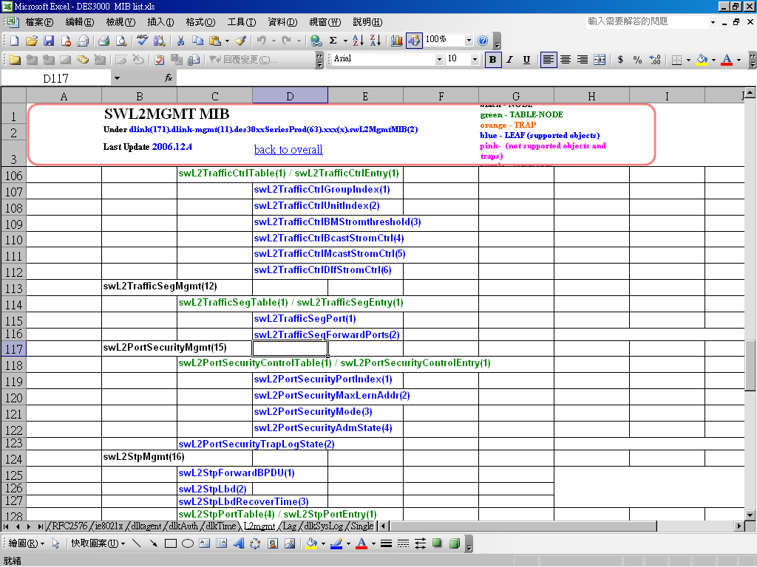

(2) Similarly, if it is DES-3026, in the “private” folder. Using notepad or text editor to open “des3026-l2mgmt.mib”, and search for “portsecurity”. User can check for how to use port security function.

swL2PortSecurityControlTable OBJECT-TYPE
SYNTAX SEQUENCE OF SwL2PortSecurityControlEntry
MAX-ACCESS not-accessible
STATUS current
DESCRIPTION
"port security feature which controls the address leaning capability and the
traffic forwarding decision. Each port can have this function enabled or disabled.
When it is enabled and a number is given said N, which allows N addresses to be
learned at this port, the first N learned addresses are locked at this port as
static entry. When the learned addresses number reach N, any coming packet with
not learned source addresses are discarded (e.g. dropped) and no more new addresses
can be learned at this port."
::= { swL2PortSecurityMgmt 1 }

swL2PortSecurityControlEntry OBJECT-TYPE
SYNTAX SwL2PortSecurityControlEntry
MAX-ACCESS not-accessible
STATUS current
DESCRIPTION
"A list of information contained in swL2PortSecurityControlTable."
INDEX { swL2PortSecurityPortIndex }
::= { swL2PortSecurityControlTable 1 }

SwL2PortSecurityControlEntry ::=
SEQUENCE {
swL2PortSecurityPortIndex
INTEGER,
swL2PortSecurityMaxLernAddr
INTEGER,
swL2PortSecurityMode
INTEGER,
swL2PortSecurityAdmState
INTEGER
}

swL2PortSecurityPortIndex OBJECT-TYPE
SYNTAX INTEGER (1..255)
MAX-ACCESS read-only
STATUS current
DESCRIPTION
"Indicates the secured port to lock address learning."
::= { swL2PortSecurityControlEntry 1 }

swL2PortSecurityMaxLernAddr OBJECT-TYPE
SYNTAX INTEGER (0..10)
MAX-ACCESS read-write
STATUS current
DESCRIPTION
"Indicates allowable number of addresses to be learned at this port."
::= { swL2PortSecurityControlEntry 2 }

swL2PortSecurityMode OBJECT-TYPE
SYNTAX INTEGER {
other(1),
permanent(2),
deleteOnTimeout(3),
deleteOnReset(4)
}
MAX-ACCESS read-write
STATUS current
DESCRIPTION
"Indicates the mode of locking address.
In deleteOnTimeout(3) mode - the locked addresses can be aged out after aging timer
expire. In this mode, when the locked address is aged
out, the number of address can be learned has to be
increased by one.
In deleteOnReset(4) mode - never age out the locked addresses unless restart
the system to prevent from port movement or intrusion."
::= { swL2PortSecurityControlEntry 3 }

swL2PortSecurityAdmState OBJECT-TYPE
SYNTAX INTEGER {
other(1),
enable(2),
disable(3)
}
MAX-ACCESS read-write
STATUS current
DESCRIPTION
"Indicates administration state of locking address."
::= { swL2PortSecurityControlEntry 4 }
Example 5. IP-MAC-Port Binding
(1) In the “DES-3000 Series MIB Tree Table_v3.00.036.xls” file, user can search “IPMacBind” label for “ipmacbind” and the result of the specific MIB will be shown below:
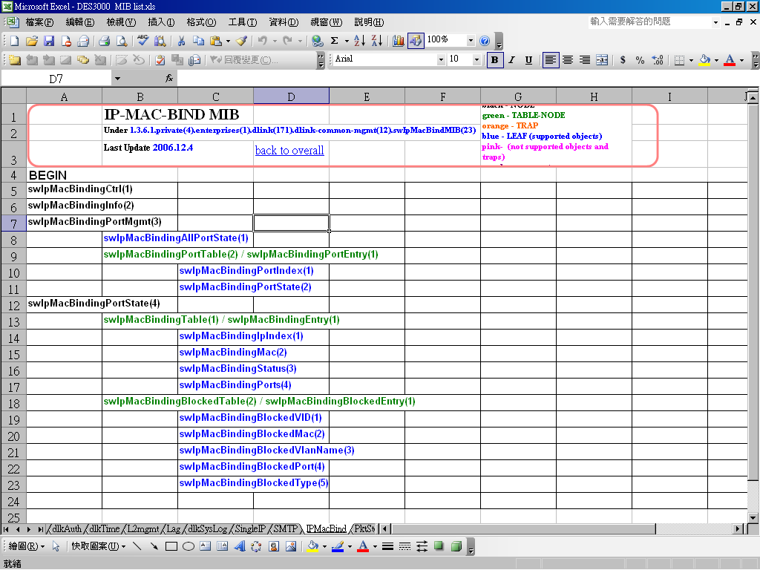

(2) In the “private” folder, using notepad or text editor to open “IPMacBind.mib”, and search for “ipmacbind”. User can find out detailed functions.

swIpMacBindingPortTable OBJECT-TYPE
SYNTAX SEQUENCE OF SwIpMacBindingPortEntry
MAX-ACCESS not-accessible
STATUS current
DESCRIPTION
"The table specifies port's ip-mac binding function."
::= { swIpMacBindingPortMgmt 2 }

swIpMacBindingPortEntry OBJECT-TYPE
SYNTAX SwIpMacBindingPortEntry
MAX-ACCESS not-accessible
STATUS current
DESCRIPTION
"A list of information about port's ip-mac binding function."
INDEX { swIpMacBindingPortIndex }
::= { swIpMacBindingPortTable 1 }

SwIpMacBindingPortEntry ::=
SEQUENCE {
swIpMacBindingPortIndex
INTEGER,
swIpMacBindingPortState
INTEGER
}

swIpMacBindingPortIndex OBJECT-TYPE
SYNTAX INTEGER(0..65535)
MAX-ACCESS read-only
STATUS current
DESCRIPTION
"This object indicates the module's port number.(1..Max port
number in the module)."
::= { swIpMacBindingPortEntry 1 }

swIpMacBindingPortState OBJECT-TYPE
SYNTAX INTEGER{
other(1),
enable(2),
disable(3)
}
MAX-ACCESS read-write
STATUS current
DESCRIPTION
"This object enable\disable the IP-MAC binding on the specified port."
::= { swIpMacBindingPortEntry 2 }

On the MIB browser, it shows like below:
The example above is to enable the IP-MAC-Port binding ACL mode for ip address “192.168.0.100” and MAC address “AABBCCDDEEFF” on port 1.

Each ports digit ”xxxxxxxx” (Hex) represents four ports, in this example, the first ”8” is ”1000” in binary.

１ ０ ０ ０
⇧   
p1 p2 p3 p4

=> 80000000 indicates Port 1

