
DES-3250TG

48-ми портовый 10/100Мбит/с коммутатор 2-го уровня 2 с 2-мя портами Gigabit Combo

- 48 портов 10/100Мбит/с и 2 порта Gigabit в одном корпусе 1U

- Class of Service
- До 255 групп VLAN
- Удобное управление
- Фильтр безопасности уровня 2
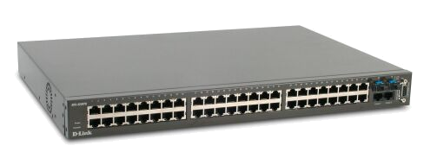

48 –ми портовый управляемый коммутатор

D-Link DES-3250TG – управляемый коммутатор с высокой плотностью портов. 48 портов 10/100M облегчают администратору подключение и обслуживание рабочих станций и серверов. Коммутатор позволяет вам подключать больше пользователей к одному устройству, обеспечивая экономичное и рентабельное решение.

DES-3250TG оснащен 4-мя комбинированными портами Gigabit, позволяя гибко расширять существующую сеть. На выбор предоставляется 3 варианта использования: 2 порта GBIC, 2 порта 1000Base-T или 1 порт GBIC и 1 порт 1000Base-T. Порты GBIC обеспечивают гибкое подключение к магистрали сети.

Коммутатор DES-3250TG обеспечивает возможность удаленного управления и настройки при помощи платформ сетевого управления, например D-View 5.1. D-View 5.1 имеет встроенный модуль управления для DES-3250TG.. Администратор может эффективно контролировать или управлять сетью через web-интерфейс, telnet, а также через консольный порт. Удаленное управление снижает стоимость технического обслуживания оборудования компании.

DES-3250TG поддерживает CoS (Class of Service). Коммутатор классифицирует пакеты на основе стандарта IEEE802.1p priority. Это позволяет администратору задавать уровень приоритета данных в зависимости от степени их важности.


Коммутатор DES-3250TG включает
DES-3250TG
Руководство пользователя на CD
Кабель RS232
Ножки
Набор для монтажа в стойку
Power Cord by Region

DES-3250TG
48-ми портовый управляемый коммутатор

Характеристики коммутатора

Chassis
- 48 10/100M RJ45 Ports
- Dimension: 440(W) × 277(D) × 44(H) mm
- Each switch will be equipped with female DCE RS-232 DB-9 console port for out-of-band configuration of the software features
- Each switch is equipped 2 1000BASE-T and 2 Mini-GBIC ports. Either 2 ports can be active at the same time.
- 64 bytes system packet forwarding rate: 10.1M packet per second
- Forwarding mode: Store and Forward
- LED status for port operations
- Per Device:
- Power,
- Off – Power Off
- Solid Green – Power On
- Console
- Off – not in use
- Solid Green –in use
- 10/100M Per ports:
- Link/ACT LED
- Off – No Link
- Solid Green – Link
- Blinking Green – Activity

Performance

- Gigabit ports:
- Link/ACT LED
- Off – No Link
- Solid Green – Link
- Blinking Green – Activity
- 4 Priority Queues per port
- Supports 8K MAC address
- Supports 32M Bytes buffer memory per device
- All ports are auto-negotiation and Full Duplex.

Physical & Environmental
- AC Input Power Supply: 100 – 120; 200 – 240 VAC, 50/60 Hz,
- Operating Temperature: 0 ~ 50°C
- Storage Temperature: -40 ~ 70°C
- Humidity: 5 ~ 95% non-condensing

EMC & Safety
- EMI Certification
- CE class A
- FCC Class A
- C-Tick
- BSMI class A
- Safety Certification
- CSA International

Software

Features

CoS
- Classification based on IEEE 802.1p priority
- Classification based on MAC SA/DA
- Support 4 priority queues
- Classification based on IEEE 802.1Q tag
- T.O.S priority
- DSCP

Spanning Tree Support
- IEEE 802.1D Spanning tree support

VLAN
- IEEE 802.1Q support
- GARP/GVRP
- 255 VLANs supported per device

IP Multicast
- IGMP v1/v2
- IGMP Snooping

RMON
- 4 Groups of RMON (Statistics, History, Alarms, Events)

IEEE 802.3ad
- IEEE 802.3ad compatible Link Aggregation

Port Trunking
- Ether Channel Interoperable
MIB Support
- RFC1213 MIB II
- RFC1493 Bridge
- RFC1757 RMON
- RFC 1643 Ether-like MIB
- Private MIB
- IEEE 802.1p RFC2674

Configuration
- Telnet Server
- TFTP Client
- BootP Client
- DHCP Client

Management
- Password enabled
- Web-based support
- SNMP v1/v3 support
- TFTP upgrade
- Command Line Interface

Security Layer 2 Filters
- VLAN based: Enable ingress checking
- Port based: Disable MAC address learning per port
- IEEE 802.1x access control

DES-3250TG
48-port Managed Switch
- 48 10/100M ports & 2 Gigabit ports in 1RU Footprint
The high port density, total 50 ports, is help the IT department of the corporation that facilitates to extend its nodes, so that the resources can be utilized in the most efficient way. Moreover, DES-3250TG only has 1RU (1.73” or 44mm) height. This thin appearance with high port density can conduce IT department to fully use the space.

- Class of Service
D-Link DES-3250TG supports CoS based on IEEE 802.1p, IEEE 802.1Q tag, and MAC SA/DA (Medium Access Control Source Address/ Destination Address). The administrator can set the priority of the traffic in terms of the importance. There are 4 priority queues can be classified.

- Up to 255 VLAN Groups
Virtual LAN is one of the most important and popular features for current networking application. The administrator can group the nodes upon their attributes by logical link, so that the traffic flow becomes more efficient. DES-3250TG supports 255 VLAN groups. Those large numbers of VLAN facilitate to control the packet flow.

- Multi-Accessible Management
DES-3250TG is a manageable switch. The administrator is able to configure the devices from a remote site via Internet. The administrator is able to choose the most convenient way to access the device through web page or Telnet. The updated firmware can be upgraded to the device through TFTP, so that the user can always have the most update device.

- Security Layer 2 Filter
To give consideration to both efficient and safe, DES-3250TG supports security function. The user is unable to catch the packet that is for the user who locates in another VLAN. The user will be requested to have the authorized ID and password once it would like to access to DES-3250TG. The administrator can set the device to allow the particular users to access the device upon MAC Address.




DES-3250TG
48-port Managed Switch

Key Features of the DES-3250TG

Feature | Advantage | Benefit
4810/100M ports & 2 Gigabit ports in 1U | High port density and gigabit ports facilitate the concentration and utilization of network | - To protect the investment and save the expense for future employee growth
Class of Service | Classifying the packets upon the importance | - To facilitate the traffic more efficient and deliver the critical data on time
Up to 255 VLAN Groups | Integrating nodes in similar characteristic | - To make the traffic easier
Multi-accessible Management | Configuring the device to the optimal condition and upgrading to the most update | - To save the money to buy a newer device and utilize the device in maximum
Security Layer 2 Filter | Protecting the nodes from improper packets | - To prevent the damage by inappropriate packets

DES-3250TG
48-port Managed Switch
Product Comparison Matrix

Company |  |  | D-Link | SMC | Cisco | 3COM
Model |  |  | DES-3250TG | SMC6750L2 | Catalyst 2948G | SS3 4250T
Structure |  |  | Standalone | Standalone | Standalone | Stackable Up to 4 units
Configuration |  |  | 48 10/100M+2G port | 48 10/100M+2G port | 48 10/100M+2 GBIC | 48 10/100M+2G port
Basic Port Configuration
Maximum 1000BASE-SX GBIC port per Switch |  |  | 2 (SFP) | 2 (SFP) | 2 | N
Maximum 1000BASE-LX GBIC port per Switch |  |  | 2 (SFP) | 2 (SFP) | 2 | N
Maximum 1000BASE-T port per Switch |  |  | 2 | 2 | N | 2
Layer 2 Switch Functions
MAC Address |  |  | 8K | 8K | 16K | 8K
Buffer Memory |  |  | 32M Bytes | 64M Bytes | 8M Bytes | N/A
10/100M Port Trunking / Trunk Group |  |  | Y | Y | Y | N
Dynamic VLAN (GVRP) Support |  |  | Y | Y | N | N
VLAN Group |  |  | 255 | 255 | 1024 | 60
Security Features | VLAN based (Enable ingress checking) |  | Y | Y | Y | N
Security Features | Port based (Disable MAC address learning per port |  | Y (Release II) | Y | N/A | N/A
Security Features | Disconnect unauthorized device |  | Y | N/A | N/A | Y
Security Features | 802.1x access control |  | Y (Release II) | N | N | N
Traffic Classification and Priority bits (CoS)
Support Priority Queues Numbers |  |  | 4 | 4 | 2 | 2
Based on MAC SA/DA |  |  | Y (Release II) | N/A | N/A | N
Base on T.O.S. Field |  |  | Y (Release II) | Y | N | N
Based on DiffServ |  |  | Y (Release II) | Y | N | Y

Management Function
RS-232 Port Support |  |  | Y | Y | N | Y
SNMP v3 Agent |  |  | Y (Release II) | N | N | N
MIB SUPPORT |  | Ethernet-Like MIB | Y (Release II) | Y | Y | N
 |  | RMON MIB II | N | N | Y | Y
 |  | 802.1P MIB | Y | N | N | N
 |  | Private MIB | Y (Release II) | Y | Y | N/A
RMON Support |  |  | Y (4 groups) | Y (4 groups) | Y (4 groups) | Y (4 groups)
Web Base Management Support |  |  | Y | Y | N | Y
DHCP Client Support |  |  | Y | Y | N | Y

Power/Mechanical
Redundant Power Supply Support |  |  | N | N | Y | Y
Case Size |  |  | 1RU | 1RU | 1.5RU | 1RU
Distribution Price
U.S. Dollar ($) |  |  | N/A | $1332.28 | $3989.00 | $1274.98
D-Link DES-3250TG Benefit Summary:
DES-3250TG
48-port Managed Switch

D-Link DES-3250TG, this SNMP managed switch provides 48 10/100Mbps Fast Ethernet ports, 2 copper Gigabit ports and 2 Mini GBIC ports, allowing up ot 48 workstations and servers to cost-effectively run on your existing twisted-pair network cable. The GBIC ports allow flexible connection to the fiber backbone. Advanced features like port trunking, VLANs and priority queues are provided, allowing a department to effectively deploy bottleneck-free switching network for easy integration with a larger enterprise or campus network.

DES-3250TG provides 48 10/100Mbps ports supporting auto-sensing and auto-negotiation of network speeds and full/half duplex. These ports can connect to workstations and print servers, giving each a dedicated bandwidth. 2 copper Gigabit ports provide an inexpensive alternative solution to fiber-optic. Using your existing low-cost Cat. 5 copper twisted-pair wires as the transmission media, these ports allow you to instantly upgrade your servers to Gigabit capability without requiring you to install new and expensive fiber cables. For flexible fiber connection, 2 Mini GBIC ports are provided for installation of 1000BASE-SX short/medium-distance and 1000BASE-LX long-distance fiber. An optional PHY module must be inserted in each of these ports.

DES-3250TG supports VLANs that improve security and bandwidth utilization by limiting the broadcast domains and confining intra-group traffic within their segments. To segment up the network, nodes supporting IEEE 802.1Q VLAN Tagging connected to the switch can be grouped into different Virtual LANs (VLANs). The switch also supports GVRP (GARP VLAN Registration Protocol) for automatic VLAN configuration distribution.

D-Link DES-3250TG is the perfect high-performance and cost-effective solution for enterprise and departmental business with high quality.

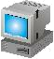
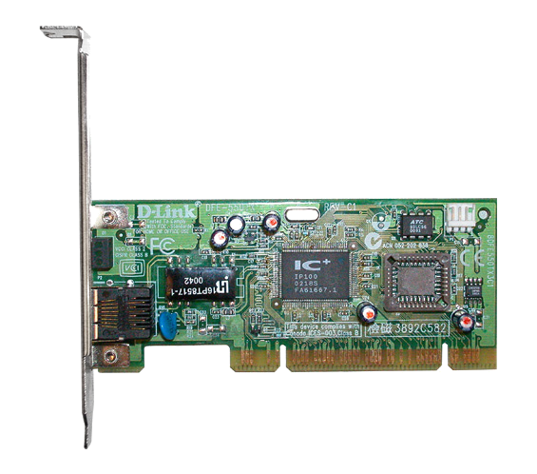
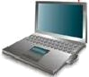
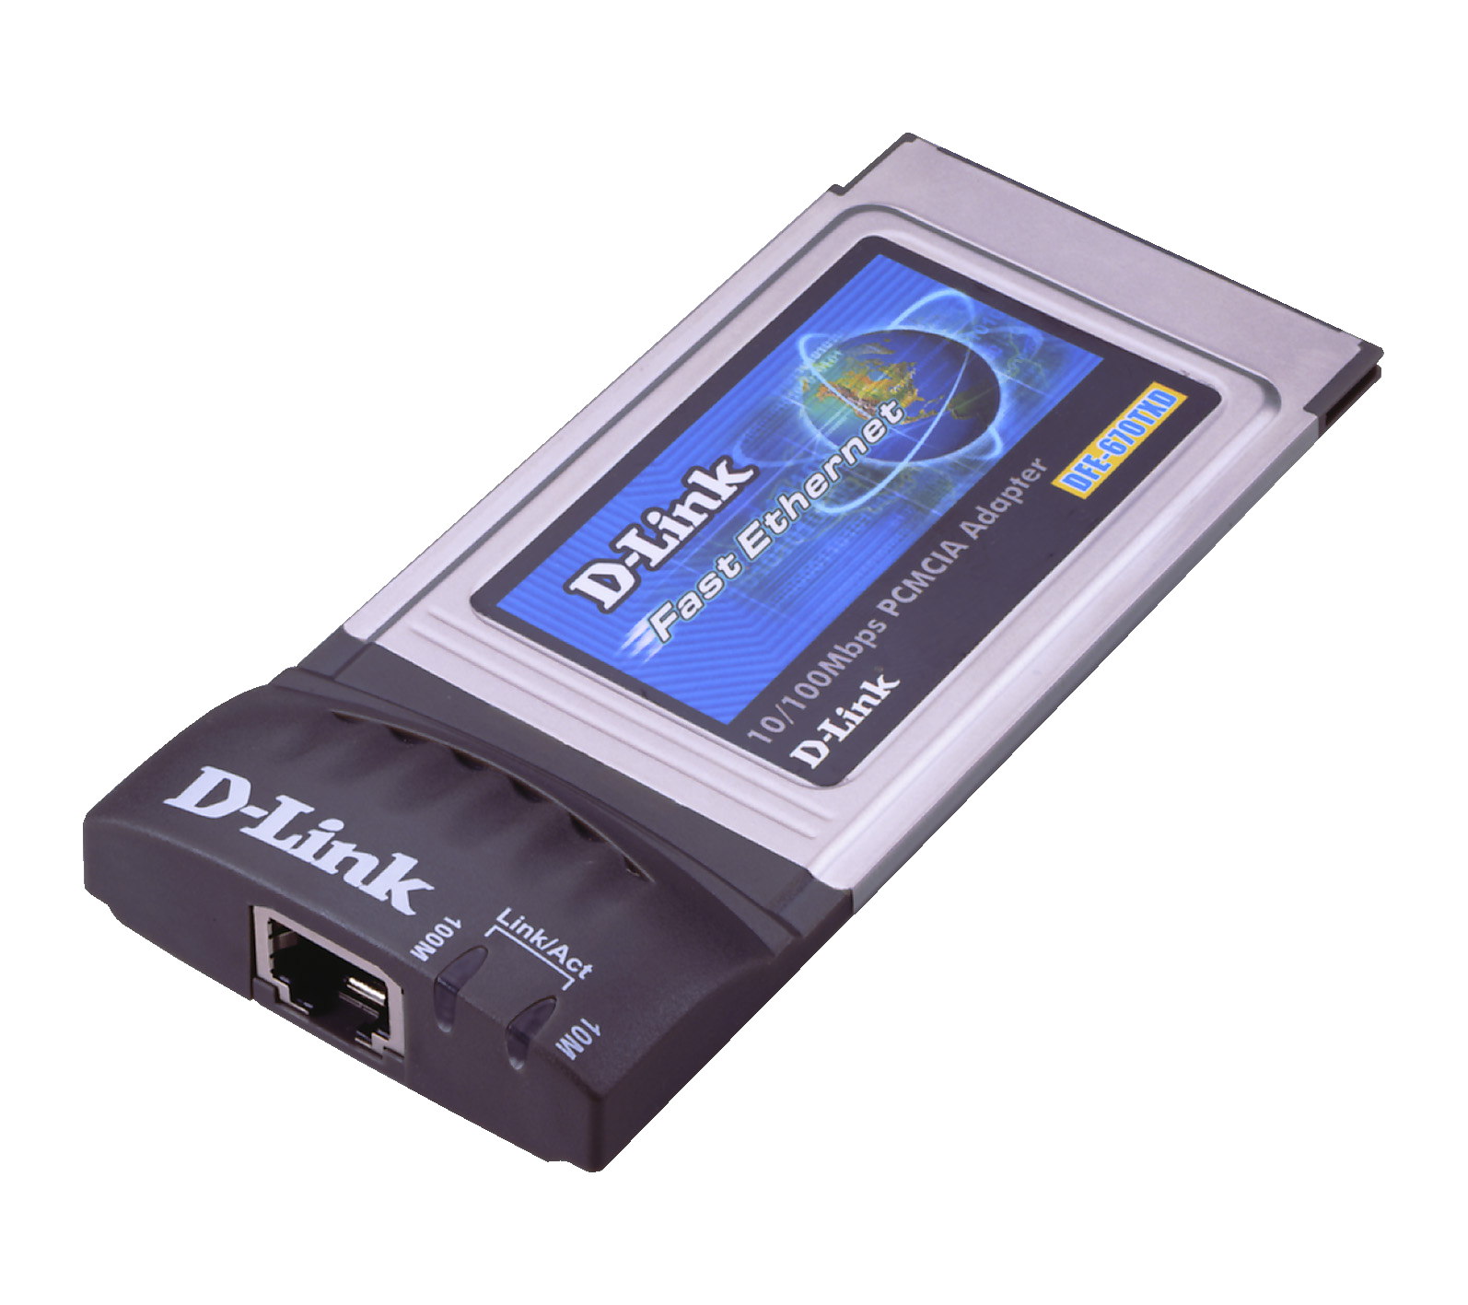
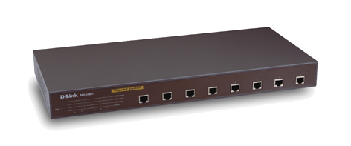
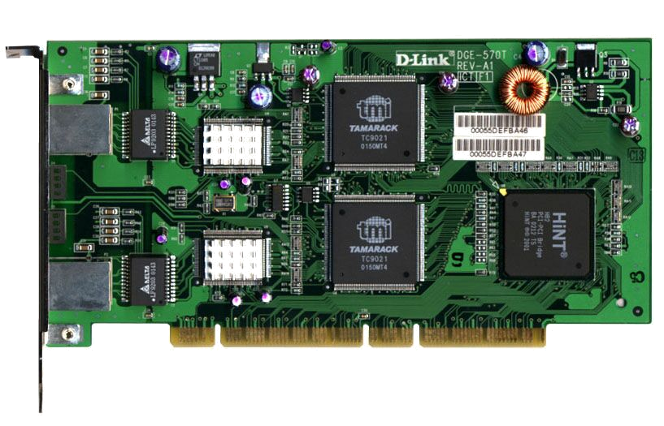
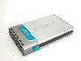
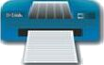
DES-3250TG
48-port Managed Switch
10/100M
1000M
PCI NIC
Workstation
PCI NIC
User
User
PCI NIC
User
PC Card
Smart Switch
Up to 48 Nodes
Server NIC
Server
Backbone
DES-3250TG
Print Server
Printer

