QUICK SETUP FOR DES-6300 WITH CONFIGMASTER 8.426

- Check version of the device upon booting up. Latest Version 3.135
- Upgrade device firmware version to the latest release
- To perform a factory reset to the switch. Follow the procedures are shown below :

- Using a pc, run a terminal emulation program, e.g Hyperterminal with settings
Bits per second – 115200
Data bits – 8
Parity – None
Stop bits -1
Flow Control – None
- Issue command -> debug, followed by password dlinkdebug once prompted

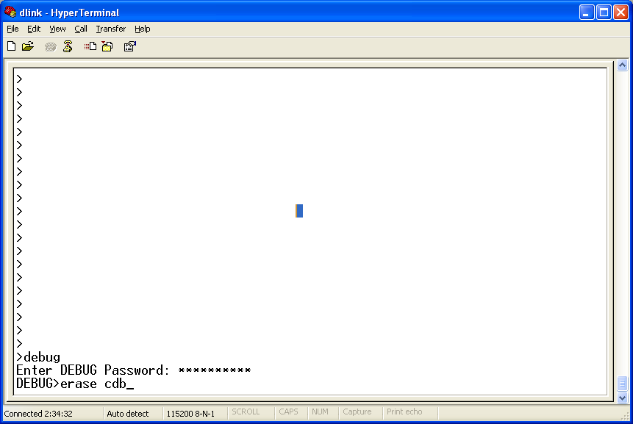

- Follow by command erase cdb, once entered the system will reset.
- Once rebooted, under the > prompt, enter initerm

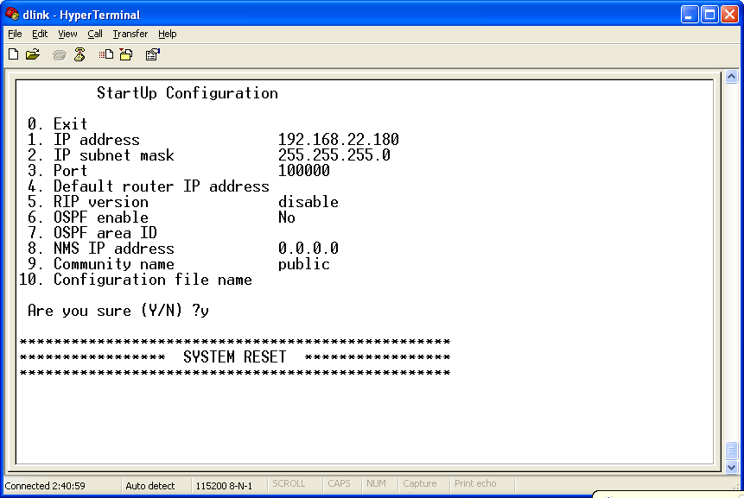

- As shown above, no settings are entered. Hence, configure IP address, subnet mask, port and the rest of the parameters accordingly. Note :- All ports belong to one VLAN (vid = 1) port setting 100000
- Switch reset automatically upon confirming configuration

Installation and Configuration of ConfigMaster (Version 8.426)

- Download latest release of ConfigMaster from www.dlink.com.tw
- Download EWS (Embedded Web Server) version 8.426 from www.dlink.com.tw . Unzip all files to directory C:/<Name of Directory>/Nms/Configuration/
- Download latest firmware version 3.135 from www.dlink.com.tw . and place firmware in C:/<Name of Directory>/Nms/Configuration/ . Do not unzip
- Upon downloading, click on the Des6300CM8426Sep152003.part1 to install ConfigMaster
- Upon installation of ConfigMaster, launch the application

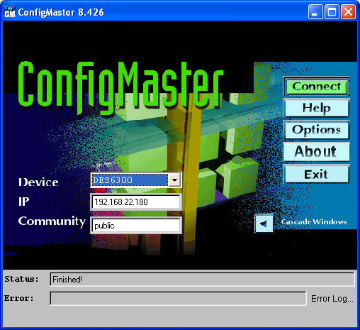

- Verify device settings as shown above and click connect to manage the switch

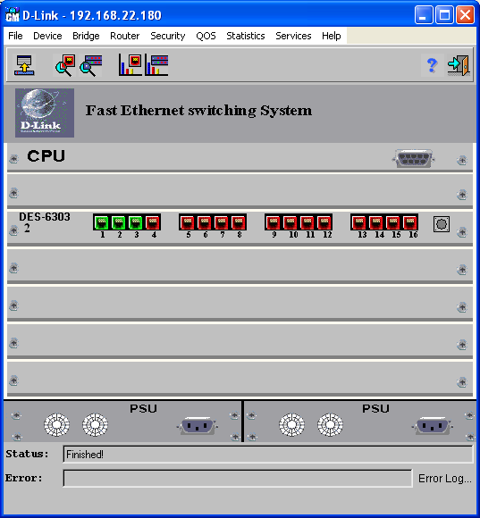

- Update firmware using ConfigMaster. Go to File -> Update Device software, click on the Green Tick to proceed

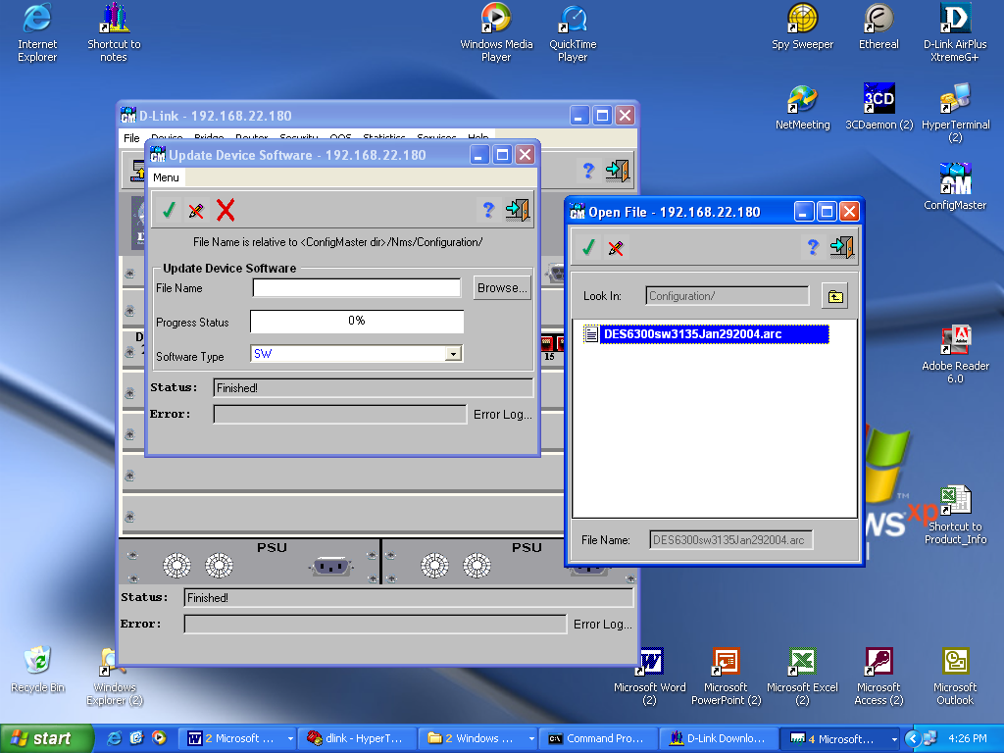

- Next, update Embedded Web Server files. File ->Update Embedded Web Server Files, click on the Green Tick to proceed

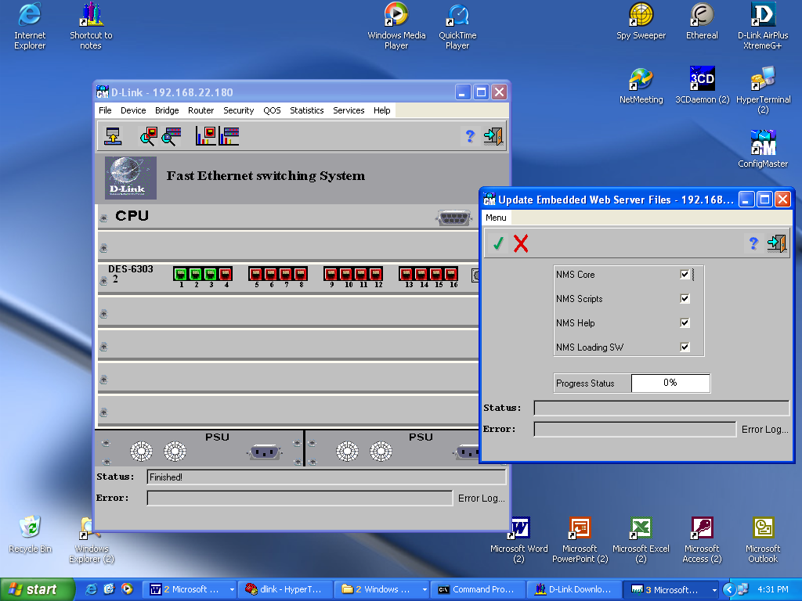

- Once the EWS Files are update, configuration of the DES6300 can be configured via HTTP. However, username and password access need to be created. Go to Security -> Web User Authorization Table to add users with various privileges. Example. User jason with Super Access Rights is created.

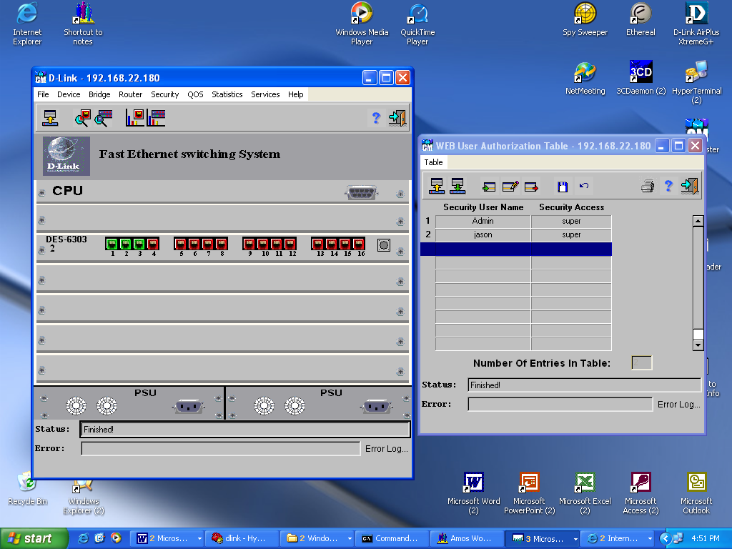

- Once users are created, configuration via HTTP is available.

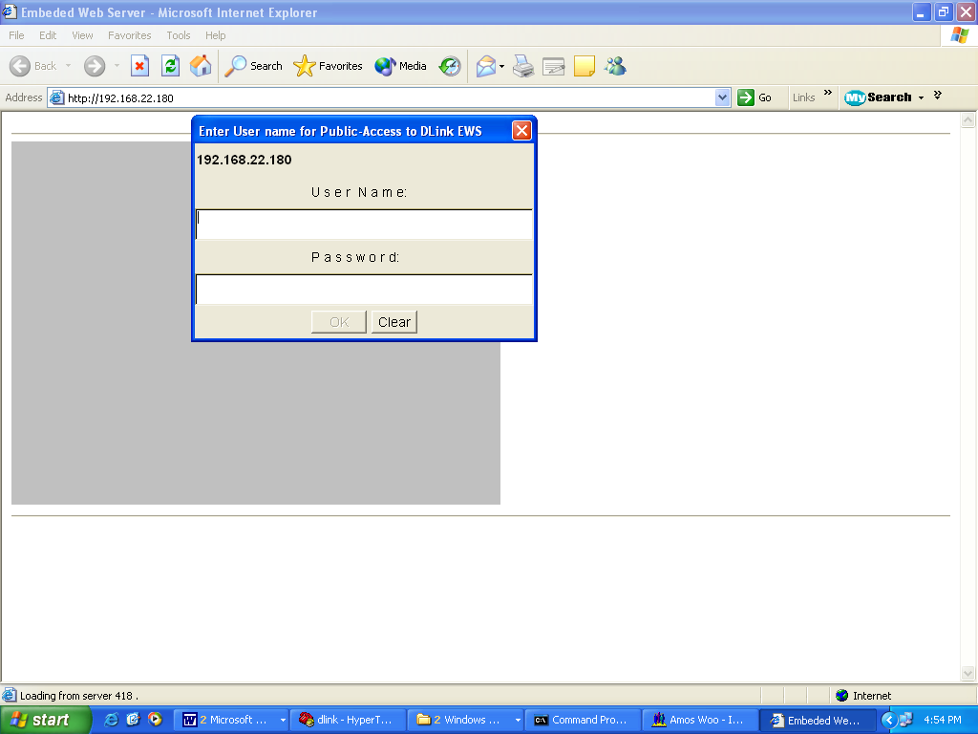

- Logging username and password. Next, will be prompted to enter community string. Enter ‘public’

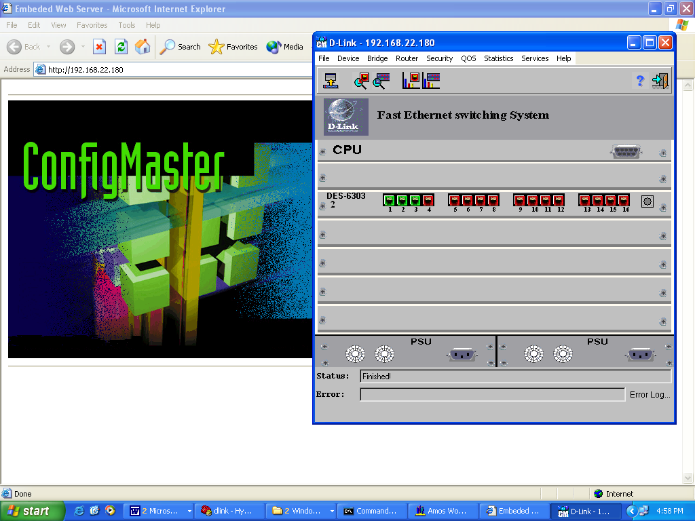

Note : To configure DES6300 switch via HTTP, do ensure that Java Runtime Environment is installed earlier.

