

Firmware Version: | 2.03.B015
Boot Code Version: | 1.00.007
MIB Version: | 2.01.B002
D-View Module Version: | 2.0.1.0
Published: | Jun. 11, 2014

These release notes include important information about D-Link switch firmware revisions. Please verify that these release notes are correct for your switch:
- If you are installing a new switch, please check the hardware version on the device label; make sure that your switch meets the system requirement of this firmware version. Please refer to Revision History and System Requirement for detailed firmware and hardware matrix.
- If the switch is powered on, you can check the hardware version by typing “show switch” command via Telnet or by checking the device information page on the web graphic user interface.
- If you plan to upgrade to the new firmware release, please refer to the Upgrade Instructions for the correct firmware upgrade procedure.
For more detailed information regarding our switch products, please refer to Related Documentation.
You can also download the switch firmware, D-View modules and technical documentation from http://tsd.dlink.com.tw.

Content:
Revision History and System Requirement: 2
Upgrade Instructions: 2
Upgrade using CLI (via Telnet) 2
Upgrade using Web-UI 3
New Features: 4
Changes in MIB & D-View Modules: 7
Changes in Command Line Interface: 10
Problem Fixed: 11
Known Issues: 12
Related Documentation: 13

Revision History and System Requirement:
Firmware Version | Date | Model | Hardware Version
Runtime: v2.03.B015  Boot: 1.00.007 | 11-Jun.-14 | DGS-1210-24 | A1
Runtime: v2.03.B014  Boot: 1.00.007 | 11-Feb.-14 | DGS-1210-24 | A1
Runtime: v2.03.B013  Boot: 1.00.007 | 25- Oct.-13 | DGS-1210-24 | A1
Runtime: v2.03.B012  Boot: 1.00.007 | 26- Aug.-13 | DGS-1210-24 | A1
Runtime: v2.03.B011  Boot: 1.00.007 | 22- Aug.-13 | DGS-1210-24 | A1
Runtime: v2.03.001  Boot: 1.00.007 | 12- Sep.-12 | DGS-1210-24 | A1
Runtime: v2.02.002  Boot: 1.00.007 | 12- Jan.-12 | DGS-1210-24 | A1
Runtime: v2.01.002  Boot: 1.00.003 | 22- Feb.-11 | DGS-1210-24 | A1
Runtime: v2.00.011  Boot: 1.00.003 | 30- Aug.-10 | DGS-1210-24 | A1
Runtime: v2.00.003  Boot: 1.00.003 | 13-July.-10 | DGS-1210-24 | A1
Runtime: v1.00.B017  Boot: 1.00.003 | 31-Mar.-10 | DGS-1210-24 | A1
Runtime: v1.00.B016  Boot: 1.00.003 | 22-Mar.-10 | DGS-1210-24 | A1
Runtime: v1.00.015  Boot: 1.00.003 | 22-Dec.-09 | DGS-1210-24 | A1

Upgrade Instructions:
D-Link Smart Switches support firmware upgrade via TFTP server. You can download the firmware from D-Link web site http://tsd.dlink.com.tw, and copy the downloaded firmware to the TFTP server folder. Please make sure that the TFTP server is accessible from the switch via networks.

Upgrade using CLI (via Telnet)
1. Make sure the network connection between the switch and PC is active.
2. Use software that supports telnet, for example, HyperTerminal or Telnet command in Microsoft Windows, to connect to the switch. If you are using Telnet command, type the command followed by the switch IP address, eg. telnet 10.90.90.90.
3. The logon prompt will appear.

The switch will prompt the user to enter his/her username and password. It should be noted that upon the initial connection, both the default user name and password are admin.
To upgrade the switch firmware, execute the following command:

Command | Function
download{firmware_fromTFTP tftp://ip-address/filename | cfg_fromTFTP tftp://ip-address/filename} | Download firmware file from the TFTP server to the switch.
When completing firmware upgrade, the following messages will pop up.
Device will reboot after firmware upgraded successfully
Image upgraded successfully

4. Execute the following command to check the firmware version and switch’s information.
Command | Function
show switch | Display the information of current firmware and boot version.

Example:

- DGS-1210-24:
Command: download firmware_fromTFTP tftp://10.90.90.91 DGS-1210-24 A1 1_00_015.hex
Device will reboot after firmware upgraded successfully
Image upgraded successfully

- DGS-1210-24:
Command: show switch
DGS-1210-24> show switch
System name :
System Contact :
System Location :
System up time : 0 days, 1 hrs, 8 min, 36 secs
System Time : 01/01/2009 01:58:42
System hardware version : A1
System firmware version : 1.00.015
System boot version : 1.00.003
System Protocol version : 2.001.004
System serial number : LABDGS1224008
MAC Address : 00-12-24-00-08-00

Upgrade using Web-UI
- Connect a workstation installed with java SE runtime environment to any switch port of the device.
- Open the web browser from the workstation and enter the IP address of the switch. The switch’s default IP address is 10.90.90.90.
- Enter administrator’s password when prompted. The password is admin by default.
- To update switch's firmware or configuration file, select Tools > Firmware Backup & Upgrade from the banner.
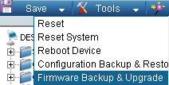v

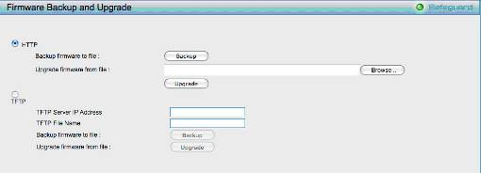
- Two methods can be selected : HTTP or TFTP

- Select HTTP to upgrade the firmware to or from your local drive of PC.
- Click Browse to browse your inventories for a saved firmware file
- Click Upgrade after selecting the firmware file you want to restore
- Click OK to continue with firmware upgrade
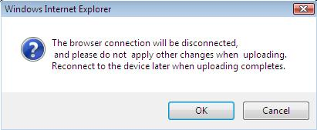

- Click OK to continue with firmware upgrade
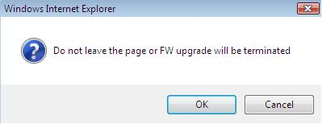

- Wait until the “Firmware Upgrade Successful” message pops up and login again after device boots up.

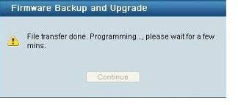

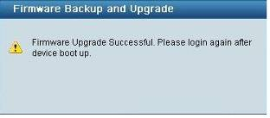

- Select TFTP to upgrade the firmware to or from a remote TFTP server.
- Enter the name of the firmware file located on the TFTP server
- Click Upgrade after selecting the firmware file you want to restore
- Click OK to continue with firmware upgrade

- Wait until the firmware upgrade ends and login again after device boots up.

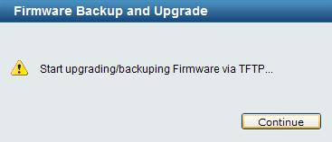

Upgrade using SmartConsole Utility
1. Connect a workstation installed with java SE runtime environment to any switch port of the device

2. Execute SmartConsole Utility
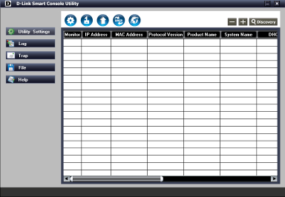

3. Click Discovery button to search target switch
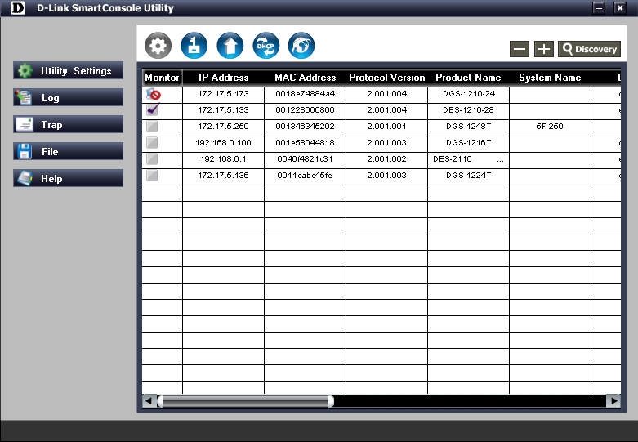

4. Single click the icon of Monitor column to choose the target switch

5. Click Firmware Upgrade button
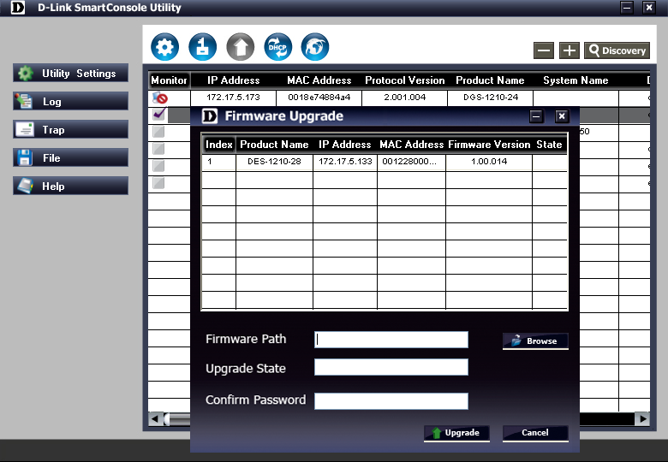

6. Click Browse button and select the firmware file (Model name_HW ver._FW ver. .hex) on your local hard drive.

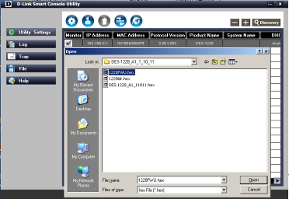

7. Enter password and click “Upgrade” button to start firmware upgrade. The default password is “admin”.

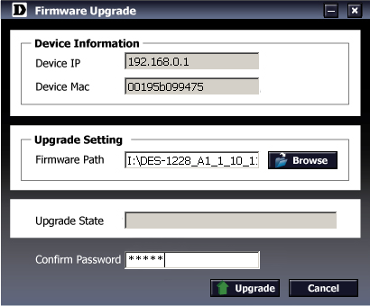

8. Once the message popped up, click “OK” button to complete the firmware upgrade
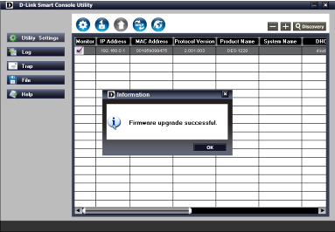

New Features:

Firmware Version | New Features
V2.03.B015 | N/A.
V2.03.B014 | N/A.
V2.03.B013 | N/A.
V2.03.B012 | N/A.
V2.03.B011 | DHCP relay and DHCP local relay.
V2.03.001 | N/A
V2.02.002 | N/A
V2.01.002 | Enhanced Auto Surveillance VLAN to V1.2  Add Portuguese to Multi-Language
V2.00.011 | Enhanced Auto Surveillance VLAN to V1.1
V2.00.003 | Multi-Language  SSL  SNMPV3  ARP Spoofing Prevention  DHCP Auto Configuration  DHCP Server Screening  Multicast Filtering  Auto Surveillance VLAN
V1.00.B017 | N/A
V1.00.B016 | N/A
V1.00.015 | First Release
.

Changes of MIB & D-View Module:
The new features of MIB file are also included in the corresponding D-View module. Please download the D-View module from http://tsd.dlink.com.tw. For detailed changes of MIB content, please refer to the modification history in each MIB file.
Firmware Version | MIB File | New Features
V2.03.B015 | DGS-1210-24_A1_2_01_B002.mib |  | N/A
V2.03.B014 | DGS-1210-24_A1_2_01_B002.mib |  | N/A
V2.03.B013 | DGS-1210-24_A1_2_01_B002.mib |  | N/A
V2.03.B012 | DGS-1210-24_A1_2_01_B002.mib |  | N/A
V2.03.B011 | DGS-1210-24_A1_2_01_B002.mib |  | Change object "stpPortPathCost" from read-write to read-only.
V2.03.001 | DGS-1210-24_AX_2_01_001.mib | N/A
V2.02.002 | DGS-1210-24_AX_2_01_001.mib | N/A
V2.01.002 | DGS-1210-24_AX_2_01_001.mib | Enhanced Auto Surveillance VLAN to V1.2
V2.00.011 | DGS-1210-24_AX_2_00_004.mib | Enhanced Auto Surveillance VLAN to V1.1
V2.00.003 | DGS-1210-24_AX_2_00_001.mib | SSL  SNMPV3  ARP Spoofing Prevention  DHCP Auto Configuration  DHCP Server Screening  Multicast Filtering  Auto Surveillance VLAN
V1.00.B017 | DGS-1210-24_A1_1_00_004.mib | N/A
V1.00.B016 | DGS-1210-24_A1_1_00_004.mib | N/A
V1.00.015 | DGS-1210-24_A1_1_00_004.mib | First Release

Firmware Version | D-View Module File | New Features
V2.03.B003 | DV_DGS-1210-24_V2.0.1.0_FW_v2.01.002.exe | None
V2.03.B002 | DV_DGS-1210-24_V2.0.1.0_FW_v2.01.002.exe | None
V2.03.B001 | DV_DGS-1210-24_V2.0.1.0_FW_v2.01.002.exe | None
V2.03.001 | DV_DGS-1210-24_V2.0.1.0_FW_v2.01.002.exe | None
V2.02.002 | DV_DGS-1210-24_V2.0.1.0_FW_v2.01.002.exe | NA
V2.01.002 | DV_DGS-1210-24_V2.0.1.0_FW_v2.01.002.exe | Enhanced Auto Surveillance VLAN to V1.2
V2.00.011 | DV_DGS-1210-24_V2.0.0.11_FW_v2.00.011.exe | NA
V2.00.003 | DV_DGS-1210-24_V2.0.0.2_FW_v2.00.003.exe | SSL  SNMPV3  ARP Spoofing Prevention  DHCP Auto Configuration  DHCP Server Screening  Multicast Filtering  Auto Surveillance VLAN
V1.00.B017 | DV_DGS-1210-24_V1.0.0.10_FW_v1.00.015.exe | N/A
V1.00.B016 | DV_DGS-1210-24_V1.0.0.10_FW_v1.00.015.exe | N/A
V1.00.015 | DV_DGS-1210-24_V1.0.0.10_FW_v1.00.015.exe | First Release

Changes of Command Line Interface:
The section below only shows command line changes that may bring backward compatibility issues with configuration settings for previous version of firmware.
Any new feature commands that do not have backward compatibility issues are not included in the below section.

Firmware Version | Changes
V2.03.B015 | NA
V2.03.B014 | NA
V2.03.B013 | NA
V2.03.B012 | NA
V2.03.B011 | NA
V2.03.001 | NA
V2.02.002 | NA
V2.01.002 | NA
V2.00.011 | NA
V2.00.003 | Add command “debug info”.
V1.00.B017 | N/A
V1.00.B016 | N/A
V1.00.015 | First Release

Problem Fixed:

Firmware Version | Problems Fixed
V2.03.B015 | 1. [DI20140530000002-Japan] Wrong Sys up time / same as DI20140205000006.  2. [DRU20140523000001-Russia] DGS-1210 snmp port speed issue.
V2.03.B014 | 1. [DI20140205000006-Japan]Fixed system up time issue.  2. [DRU20131101000002-Russia]Fix telnet issue that DUT with reboot during telnet session.
V2.03.B013 | 1. [ Support Request ] Fix Ping / Login Failure issue in SmartSW series.  Note: After confirm with D-LINK Shan, this issue can not find out the correct  D-track no. and will keep asking the result for the latest firmware.  2. [DEUR20131008000003-Central Europe] Fixed not able to set STP external cost on Port 9&10 in LAG  3. [DI20130913000003-Japan] Customer has a question about SNMP v1 trap about Enterprice OID and agent-Address.  4. [DI20131017000001-Japan] SNMP trap overlapping.
V2.03.B012 | 1. Fix D-track [DRU20130812000001-Russia]: Set more than one vlan. Static router port cannot update into multicast forwarding entry via static router port unplug and plug in again when one of the vlan status is disabled cause it cannot continue update static router port in next vlan’s multicast forwarding entry.
V2.03.B011 | 1. Change the behavior of DHCP server to client packet to be always forward.  2. Fix The DHCP relay packet format of Remote ID type is incorrect issue.  3. Fix D-tracking DGS-1210-10P TFTP operations via SNMP[DRU20130418000008-Russia]  4. 1. [HQ20130716000015 -D-track]  Fixed control packet forwarded by vlan under stp disable.
V2.03.001 | 1. Fix 802.1x server shared secret weak encryption issue and HTTP file system security issue.  (An European customer feedbacks issue).
V2.02.002 | 1. Added in additional MAC address range (28107B 000000 ~ 28107B 3FFFFF) for the ASV function
V2.01.002 | 1. Fixed password setting problem on some character combination.  2. Fixed the IP packet send from device can not pass through gateway.
V2.00.011 | 1. Fix the FW backup from IE in HTTPS mode error (FW.hex cheaksum fail)  2. Fix when we backup FW from IE in HTTPS then apply the download pop-up msg will cause white screen too long time.  3. Fix the OID Mask in the snmp view table must be input.  4. Fix the problem that web can't normally show the "delete VID" in 802.1Q VLAN page when we use the google browser and firefox browser.  5. Fix the display problem in smart wizard page when use the safari browser.  6. Fix that the MAC address learned by LA can not be deleted while STP is enabled.
V2.00.003 | First Release of R2 version.
V1.00.B017 | Fix web issue about the left menu does not show correctly via Firefox browser V3.6 for 1920*1080 Screen resolution.( HQ20100311000005 )
V1.00.B016 | Fix web issue about the left menu does not show correctly via Firefox browser V3.6.( HQ20100311000005 )
V1.00.015 | First Release

* D-Link tracking number is enclosed in ()

Known Issues:
Firmware Version | Issues | Workaround
V2.03.B015 | None |  | None
V2.03.B014 | None |  | None
V2.03.B013 | None |  | None
V2.03.B012 | None |  | None
V2.03.B011 | None |  | None
V2.03.001 | None |  | None
V2.02.002 | None |  | None
V2.01.002 | - We find the IGMP Settings page GUI display error via Google Brower v9.0.597.94 and and Safari 5.03  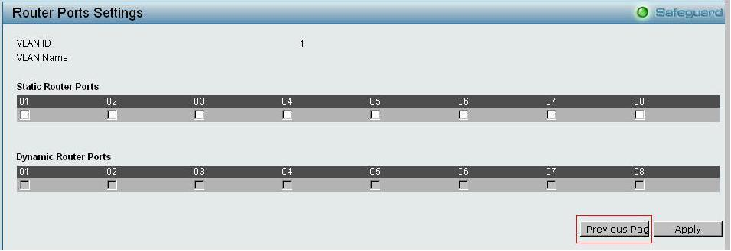  - When we transmit MAC address to DUT learning then we add this MAC address to ASV OUI list, We find the DUT Dynamic forwarding table display this meet OUI MAC type still keep in "dynamic".  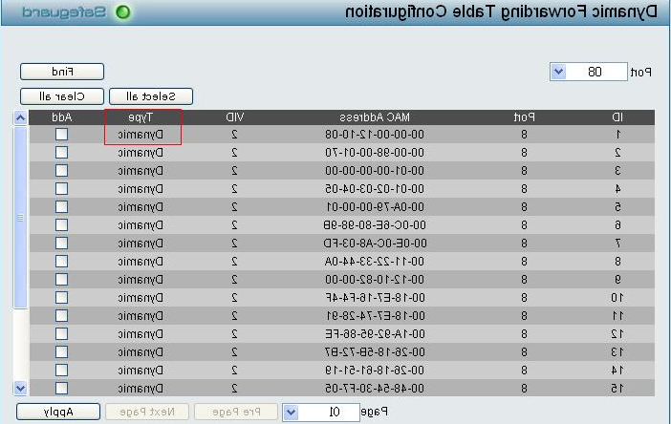  - We find the Dynamic Forward table display the same MAC address (meet OUI) in be removed VLAN interface by ASV, when we transmit meet OUI MAC to the DUT via unplug and plug interface.  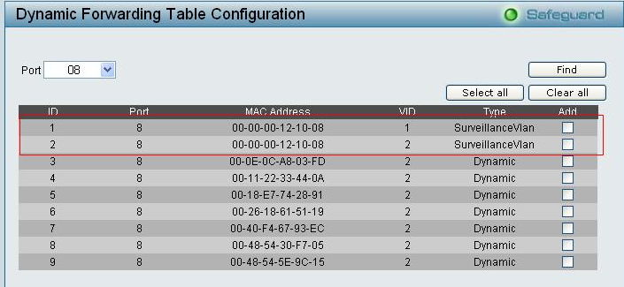  - We can not add OUI "00-00-00" to ASV user-defined MAC list.  - 1. Set port security MAX learning address to 1.  2. Use Smartbit transmit Unicast packets from port2 to port3 via 64 bytes. (Port2 SA MAC: 00-00-00-00-00-02/ Port3 SA MAC:00-00-00-00-00-03) (Please learning MAC address first)  3. Use Smartbit transmit 1000 broadcast packets to port3 of the DUT via 64 bytes. (Port3 SA MAC: 00-00-00-00-00-02)  We find Port2 or Port3 of the DUT in forwarding table doesn't exist. (Port2 SA MAC: 00-00-00-00-00-02 and Port3 SA MAC:00-00-00-00-00-03).
V2.00.011 | None |  | None
V2.00.003 | DGS-1210-24  - When two ports transmit packets to the same destination port with the same queue, the received rate is not stable.  * We find the VLAN settings page display error via Safari and Google Brower latest version.  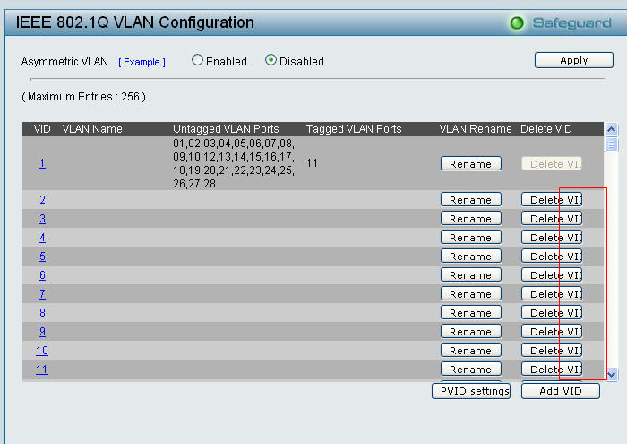  * We find the SmartWizard page display error via Safari latest version.  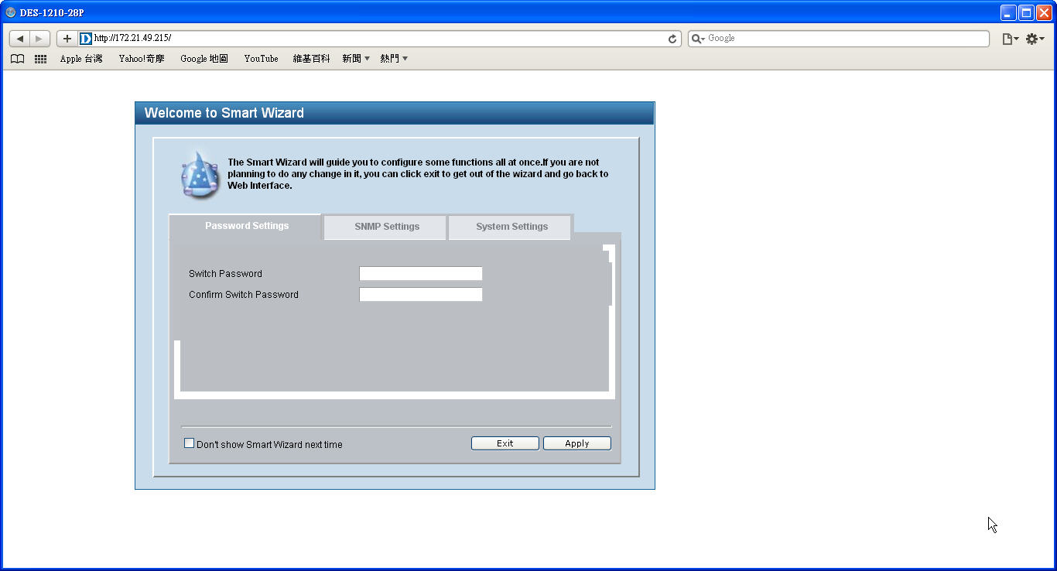  3.  *We find D-Link provide Multi-Language wording list does not include some Functional (Firmware and Configuration) warning message.  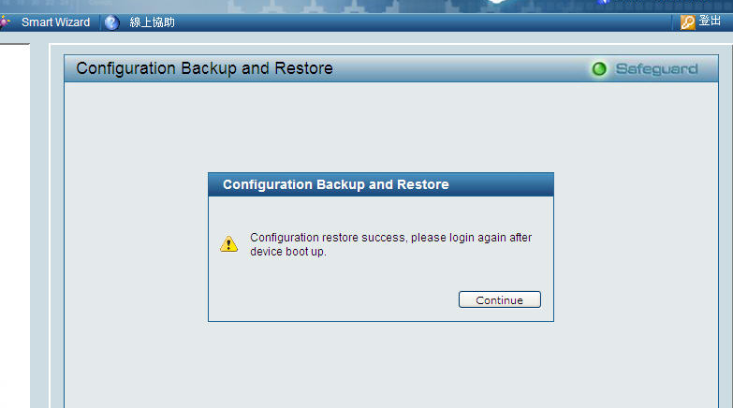  *We find some Multi-Language wording length too long that will cause GUI display abnormally.  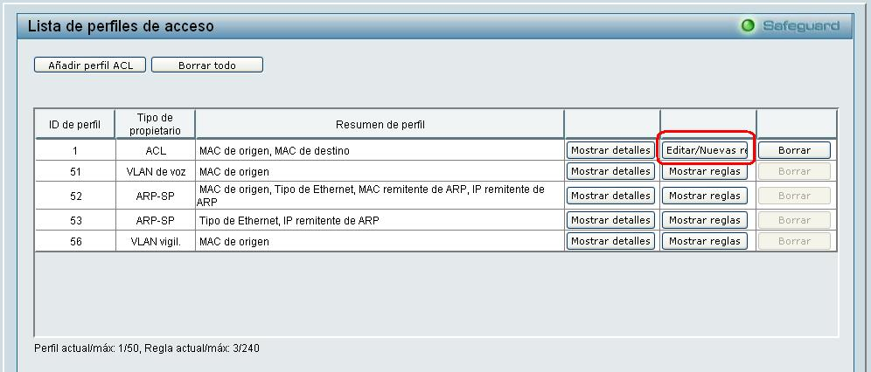 |  | None
V1.00.B017 | None |  | None
V1.00.B016 | None |  | None
V1.00.015 | DGS-1210-24  When two ports transmit packets to the same destination port with the same queue, the received rate is not stable. |  | None

Related Documentation:
- DGS-1210-24 Series User Manual
- DGS-1210-24 Series Getting Started Guide

