

Firmware Version: | 1.00.015
Boot Code Version: | 1.00.010
MIB Version: | 1.00.008
D-View Module Version: | 1.0.0.7
Published: | Aug. 25, 2011

These release notes include important information about D-Link switch firmware revisions. Please verify that these release notes are correct for your switch:
- If you are installing a new switch, please check the hardware version on the device label; make sure that your switch meets the system requirement of this firmware version. Please refer to Revision History and System Requirement for detailed firmware and hardware matrix.
- If the switch is powered on, you can check the hardware version by typing “show switch” command via Telnet or by checking the device information page on the web graphic user interface.
- If you plan to upgrade to the new firmware release, please refer to the Upgrade Instructions for the correct firmware upgrade procedure.
For more detailed information regarding our switch products, please refer to Related Documentation.
You can also download the switch firmware, D-View modules and technical documentation from http://tsd.dlink.com.tw.

Content:
Revision History and System Requirement: 2
Upgrade Instructions: 2
Upgrade using CLI (via Telnet) 2
Upgrade using Web-UI 3
New Features: 4
Changes in MIB & D-View Modules: 7
Changes in Command Line Interface: 10
Problem Fixed: 11
Known Issues: 12
Related Documentation: 13

Revision History and System Requirement:
Firmware Version | Date | Model | Hardware Version
Runtime: v1.00.015  Boot: 1.00.010 | 25-Aug.-11 | DGS-1500-20 | A1
Runtime: v1.00.013  Boot: 1.00.009 | 04-July.-11 | DGS-1500-20 | A1

Upgrade Instructions:
D-Link Smart Switches support firmware upgrade via TFTP server. You can download the firmware from D-Link web site http://tsd.dlink.com.tw, and copy the downloaded firmware to the TFTP server folder. Please make sure that the TFTP server is accessible from the switch via networks.

Upgrade using CLI (via Telnet)
1. Make sure the network connection between the switch and PC is active.
2. Use software that supports telnet, for example, HyperTerminal or Telnet command in Microsoft Windows, to connect to the switch. If you are using Telnet command, type the command followed by the switch IP address, eg. telnet 10.90.90.90.
3. The logon prompt will appear.

The switch will prompt the user to enter his/her username and password. It should be noted that upon the initial connection, both the default user name and password are admin.
To upgrade the switch firmware, execute the following command:

Command | Function
download{firmware_fromTFTP tftp://ip-address/filename | cfg_fromTFTP tftp://ip-address/filename} | Download firmware file from the TFTP server to the switch.
When completing firmware upgrade, the following messages will pop up.
Device will reboot after firmware upgraded successfully
Image upgraded successfully

4. Execute the following command to check the firmware version and switch’s information.
Command | Function
show switch | Display the information of current firmware and boot version.

Example:

- DGS-1500-20:
Command: download firmware_fromTFTP tftp://10.90.90.91 DGS-1500-20 A1 1_00_011.hex
Device will reboot after firmware upgraded successfully
Image upgraded successfully

- DGS-1500-20:
Command: show switch
DGS-1500-20> show switch
System name :
System Contact :
System Location :
System up time : 0 days, 1 hrs, 8 min, 36 secs
System Time : 04/07/2011 01:58:42
System hardware version : A1
System firmware version : 1.00.013
System boot version : 1.00.009
System Protocol version : 2.001.004
System serial number : 00SQA15002088
MAC Address : 00-15-00-20-08-88

Upgrade using Web-UI
- Connect a workstation installed with java SE runtime environment to any switch port of the device.
- Open the web browser from the workstation and enter the IP address of the switch. The switch’s default IP address is 10.90.90.90.
- Enter administrator’s password when prompted. The password is admin by default.
- To update switch's firmware or configuration file, select Tools > Firmware Backup & Upgrade from the banner.

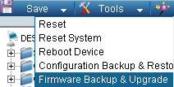v

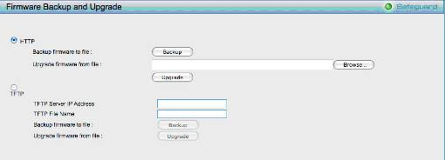
- Two methods can be selected : HTTP or TFTP

- Select HTTP to upgrade the firmware to or from your local drive of PC.
- Click Browse to browse your inventories for a saved firmware file
- Click Upgrade after selecting the firmware file you want to restore
- Click OK to continue with firmware upgrade
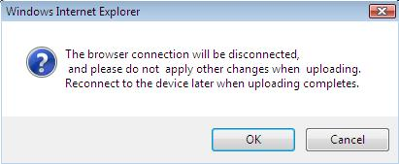

- Click OK to continue with firmware upgrade
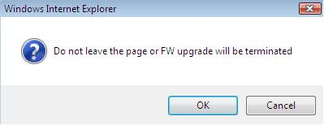

- Wait until the “Firmware Upgrade Successful” message pops up and login again after device boots up.
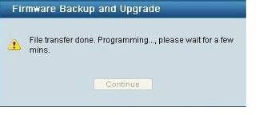

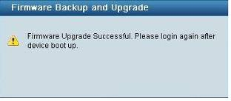

- Select TFTP to upgrade the firmware to or from a remote TFTP server.
- Enter the name of the firmware file located on the TFTP server
- Click Upgrade after selecting the firmware file you want to restore
- Click OK to continue with firmware upgrade

- Wait until the firmware upgrade ends and login again after device boots up.
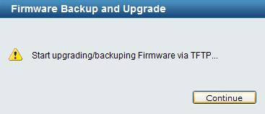

Upgrade using SmartConsole Utility
1. Connect a workstation installed with java SE runtime environment to any switch port of the device

2. Execute SmartConsole Utility

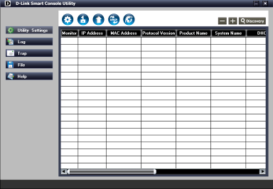

3. Click Discovery button to search target switch

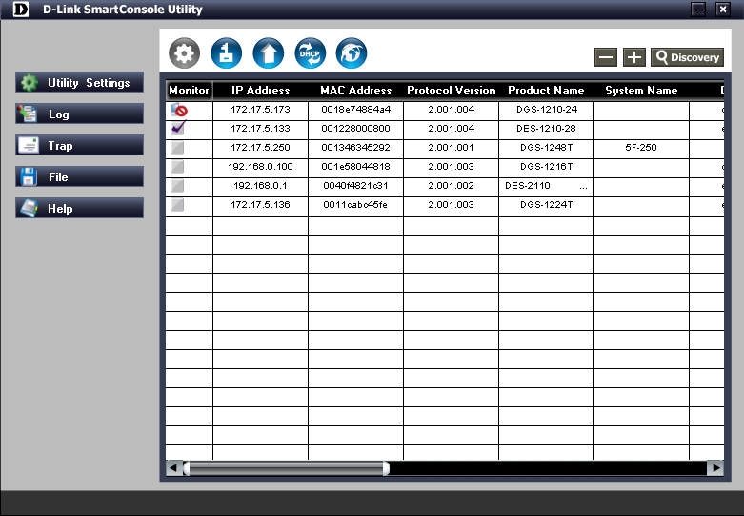

3. Single click the icon of Monitor column to choose the target switch

4. Click Firmware Upgrade button
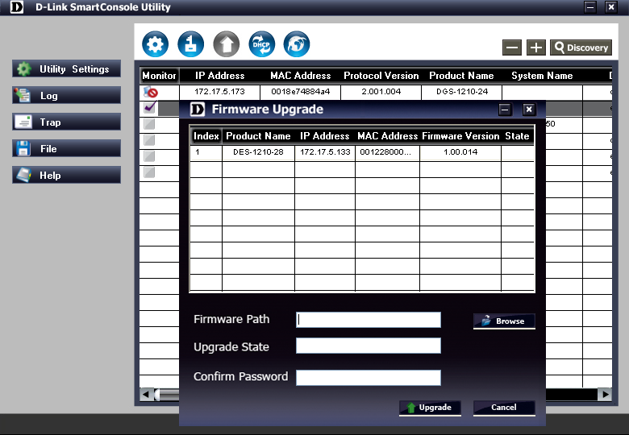

5. Click Browse button and select the firmware file (Model name_HW ver._FW ver. .hex) on your local hard drive.

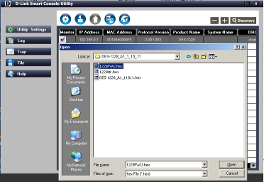

6. Enter password and click “Upgrade” button to start firmware upgrade. The default password is “admin”.
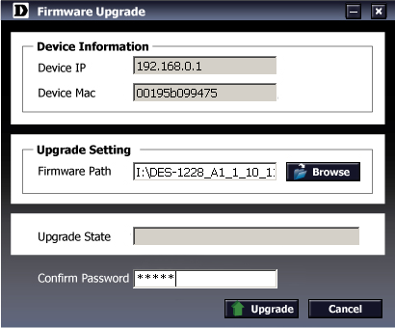

7. Once the message popped up, click “OK” button to complete the firmware upgrade
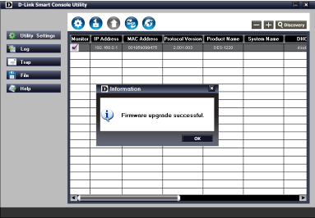

New Features:

Firmware Version | New Features
V1.00.015 | NA
V1.00.013 | First Release

Changes of MIB & D-View Module:
The new features of MIB file are also included in the corresponding D-View module. Please download the D-View module from http://tsd.dlink.com.tw. For detailed changes of MIB content, please refer to the modification history in each MIB file.
Firmware Version | MIB File | New Features
V1.00.015 | DGS-1500-20_AX_1_00_008.mib | NA
V1.00.013 | DGS-1500-20_AX_1_00_008.mib | First Release

Firmware Version | D-View Module File | New Features
V1.00.015 | DV_DGS-1500-20_V1.0.0.7_FW_V1.00.013.exe | NA
V1.00.013 | DV_DGS-1500-20_V1.0.0.7_FW_V1.00.013.exe | First Release

Changes of Command Line Interface:
The section below only shows command line changes that may bring backward compatibility issues with configuration settings for previous version of firmware.
Any new feature commands that do not have backward compatibility issues are not included in the below section.

Firmware Version | Changes
V1.00.015 | NA
V1.00.013 | First Release

Problem Fixed:
Firmware Version | Problems Fixed
V1.00.015 | - Fixed the problem for displaying the second interface IP.  - Fixed the problem for the system log of” 802.1x Authentication failure” cannot be forwarded when the authorization of 802.1 x clients failed.  - Fixed the problem for ping no response of switch CPU in certain situation. When the port status changed from "Port Stand-by" to “wake up by ingress packets” and then back to "Port Stand-by" status after 10 minutes idle time, the switch became no response for ping command.  - Fixed the problem that control PC occurred ping lost when users add in the MAC address of control PC in the ASV VLAN after three minutes.  - Fixed the issue that the SFP-enabled ports cannot work if users enabled port-based Loopback Detection then changing to VLAN-Based Loopback Detection on all ports.  - Fixed problems for link error of SIM and 802.1X on the quick configurations setting page for all languages except for English.  - Modified the pop-up message in Chinese Web GUI when users click “save configuration”.  - Modified default System Time to 01/01/2011.  - Fixed problem for displaying the time profile name over one character.  - Fixed the problem for display wrong message for “TX Hold Multiplier”.  - Improved the setting of LLDP Statistics table by adding one "clear" button.  - Fixed the problem for the error display of SIM topology when users remove device icon.  - Improved for the display problem in Firefox 5.0 under Fedora 9  - Fixed the problem for showing “Loop occurred log” in Loopback Detection VLAN-based mode on the System Log page.  - Fixed the problem that users cannot find the option of "Ignore the wizard next time" in the Smart Wizard configuration page.  - Fixed the bug that Web page will be redirected to incorrect warning page when users apply DUT's IP address as the gateway in Smart Wizard.  - Fixed the problem that the maximum entries of System Log cannot be up to 512.  - Made correction on the edge port behavior of RSTP. The edge port of RSTP should not be propagated TCN.  - Fixed the problem for the abnormal FDB entries behavior when switches receive TCN.  21. Fixed the problem that ASV dynamic port member will be changed to VLAN 1 after switches save and reboot.
V1.00.013 | First Release

Known Issues:
Firmware Version | Issues | Workaround
V1.00.015 | - When switch 1 uplinked to switch 2, the user connects to switch 1 cannot access switch 2. However, it’s workable for a scenario if the uplink port of switch 2 is in a default VLAN. | None
V1.00.013 | - If the speed of fiber port for DGS-1500 is set at auto mode and link partner is set at forced mode. The connection still works. Under normal situation, the connection should be failed.  - When power saving is enabled, the link status of uplink ports will be changed as linked up → linked down → linked up in very short time.  - The group interval is inaccurate if users set at 1225 sec.  - The link status of link partner will be changed if users enable or disable “LED Shut-off” of advanced power saving feature.  - It will take about 10 sec. waiting time to display total 2000 VLAN groups in Web GUI.  - The learned MAC address of fiber port could be taken out when a new fiber port linked up.  - When two ports transmit packets to the same destination port, the received rate could be inaccurate.  - The threshold of Storm Control has deviation. The maximum deviation happened on the 64Kbps threshold.  - When performing Cable Diagnostics, the port will be shut down and then linked up in very short time. | None

Related Documentation:
- DGS-1500-20 Series User Manual
- DGS-1500-20 Series Getting Started Guide

