DGS-3100 series firmware and boot code update SOP.
Warning: DGS-3100 series switch doesn’t support update boot-code from Web GUI.
Topology:
RJ-45
RS-232
(COM 1)
DGS-3100 Series
TFTP Server
Software Application:
1.TFTP server: 10.90.90.100.
TFTP server must be stay with firmware and boot-code at the same folder.
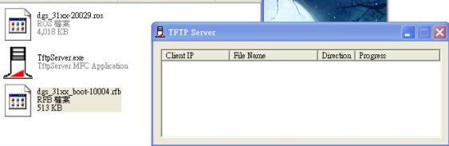

2. DGS-3100 series:
Default management IP address: 10.90.90.90
Common:
DGS3100# show switch
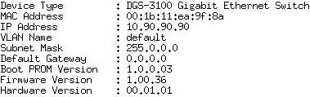
3. Update boot code and firmware from CLI.
- Download boot-code:
Common: download boot IPaddress (=TFTP server IP address) filename
DGS3100# download boot 10.90.90.100 dgs_31xx_boot-10004.rfb

- Download firmware:
Common: download firmware IPaddress (=TFTP server IP address) filename
DGS3100# download firmware 10.90.90.100 dgs_31xx-20029.ros
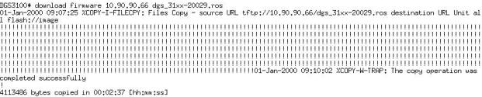
(P.S. In stacking mode, switch support update firmware for all units at the same time but it doesn’t support update boot code for all units at the same time)

