How to Test OSPF ABR function on D-Link Layer 3 Switches
Topology
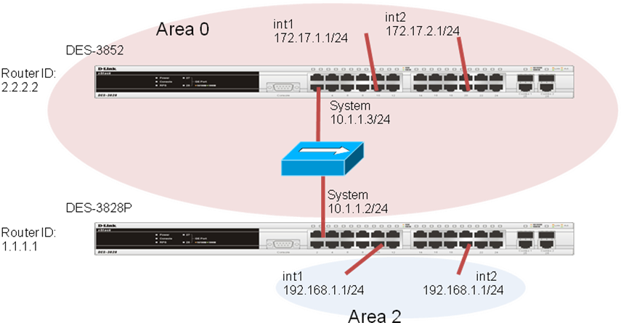
OSPF configuration On DES-3852
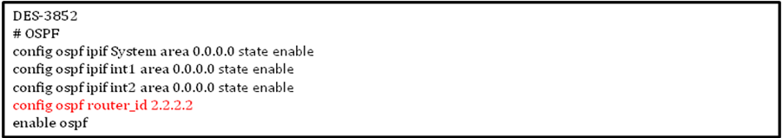
OSPF configuration On DES-3828P
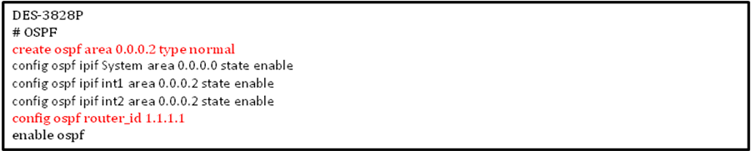
Setup a different ospf area in DES-3828P to assign two areas on two different interfaces.

On DES-3852, show ospf
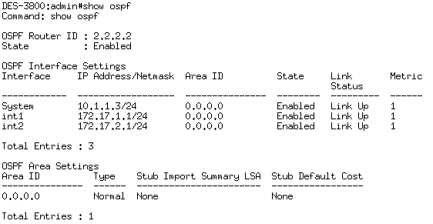
On DES-3828p, show ospf
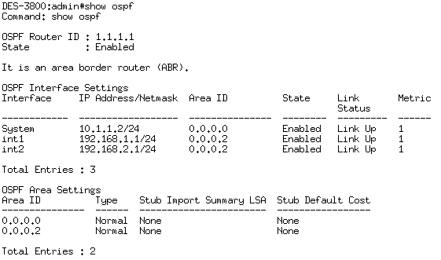

Now, you can see DES-3828P is an ABR when you show ospf information.

Routing Table on DES-3852
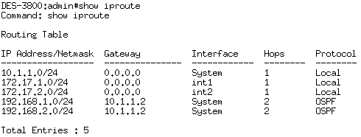
Routing Table on DES-3828P
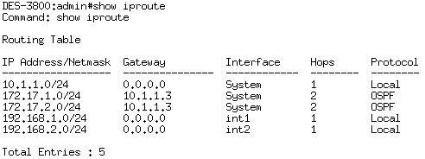

The route 192.168.1.0/24 and 192.168.2.0/24 on DES-3528 is called inter-area route, and would be marked as OIA in cisco routers/switches.

