How to config OSPF summary route on D-Link Switch
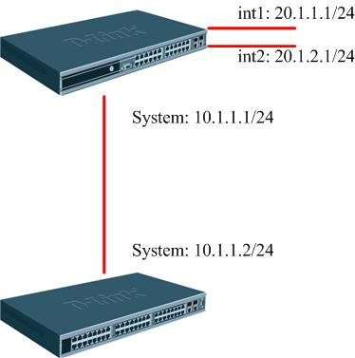
DES-3828
DGS-3650
Configure Procedure
Initial Config
DES-3828
# IP
config ipif System vlan default ipaddress 10.1.1.1/24 state enable proxy_arp disable
create ipif int1 20.1.1.1/24 2 state enable proxy_arp disable
create ipif int2 20.1.2.1/24 3 state enable proxy_arp disable
disable autoconfig
# OSPF
create ospf area 0.0.0.1 type normal
config ospf ipif System area 0.0.0.0 priority 1 hello_interval 10 dead_interval 40
config ospf ipif System authentication none metric 1 state enable active
config ospf ipif int1 area 0.0.0.0 priority 1 hello_interval 10 dead_interval 40
config ospf ipif int1 authentication none metric 1 state disable active
config ospf ipif int2 area 0.0.0.0 priority 1 hello_interval 10 dead_interval 40
config ospf ipif int2 authentication none metric 1 state disable active
config ospf router_id 0.0.0.0
enable ospf
DGS-3650
# IP
config ipif System ipaddress 10.1.1.2/24 vlan default
disable autoconfig
# OSPF
config ospf ipif System area 0.0.0.0 priority 1 hello_interval 10 dead_interval 40
config ospf ipif System authentication none metric 1 state enable passive disable
config ospf router_id 192.168.1.103
enable ospf

Redistribution Config
DES-3828
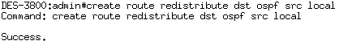
Result
On DGS-3650
