How to generate OSPF default route to D-link Switch

Topology
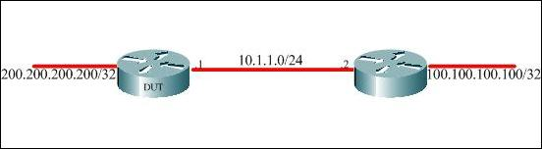
The Left one is D-Link switch and Right one is Cisco Router, sometimes we need to generate OSPF default route to D-Link switches to verify some function work.

Setup Procedure
D-Link Configuration
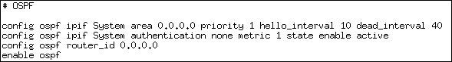
Cisco Configuration
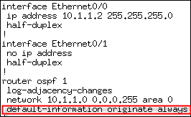

Result
