How to Test OSPF Virtual-Link function on D-Link Layer 3 Switches
Topology
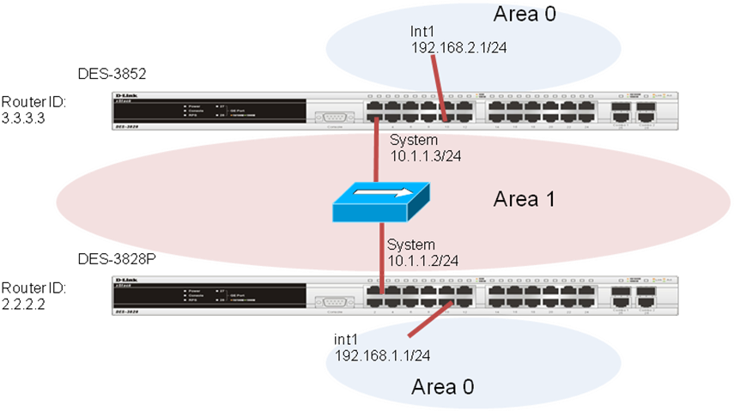
Virtual links are used to connect a discontinuous area to area 0
OSPF configuration On DES-3852
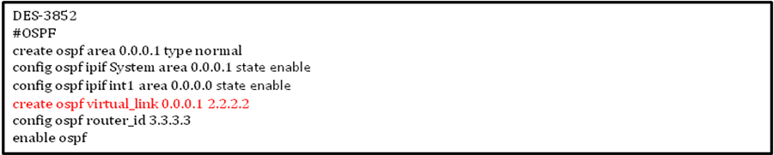
OSPF configuration On DES-3828P
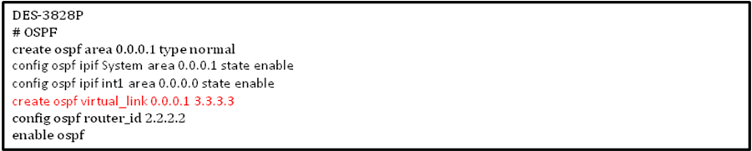

On DES-3852, show ospf virtual-link
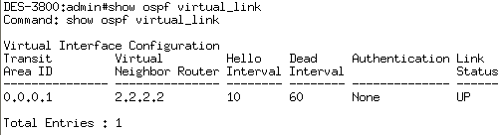
On DES-3828p, show ospf virtual-link
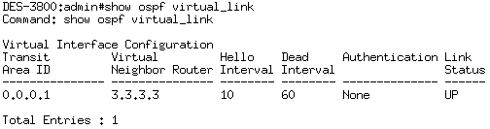
to verify ospf virtual-link informations

Routing Table on DES-3852
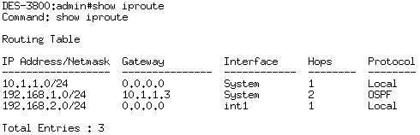
Routing Table on DES-3828P
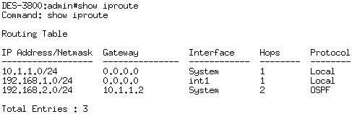
To check if the ospf virtual-link works properly

