xStack DGS-3600 Series SNMP MIB User Guide for v1.00B62

This document provides example of how to use the SNMP MIB Spec (the zip file contains one excel files:DGS-3600 MIB List.xls) as a reference to find out where the function locates in SNMP (DGS3600R1_1.00.B62.MIB.zip). Examples in the document include:
Save Configuration
SafeGuard Engine
CPU Utilization
IP-MAC-Port Binding

For detailed software features with corresponding firmware version, users should also refer to the external specification.

Example 1. Save Configuration
(1) In the “DGS-3600 MIB List.xls”, user can search for “savecfg” and the result of the specific mib will be shown below:

(2) Use notepad or text editor to open “dlkAgent.mib”, and user can find out how to save the configuration:
agentSaveCfg OBJECT-TYPE
SYNTAX INTEGER {
other(1),
idle(2),
set(3),
cfg-id1(4),
cfg-id2(5)
}
MAX-ACCESS read-write
STATUS current
DESCRIPTION
"As the object is set to
set(3) - save the current device configuration into NV-RAM bootup ID.
cfg-id1(4) - save configuration into NV-RAM ID1.
cfg-id2(5) - save configuration into NV-RAM ID2."
::= { agentBasicConfig 6 }
Example 2. SafeGuard Engine
(1) In the “DGS-3600 MIB List.xls”, user can search for “safeguard” and the result is shown below:
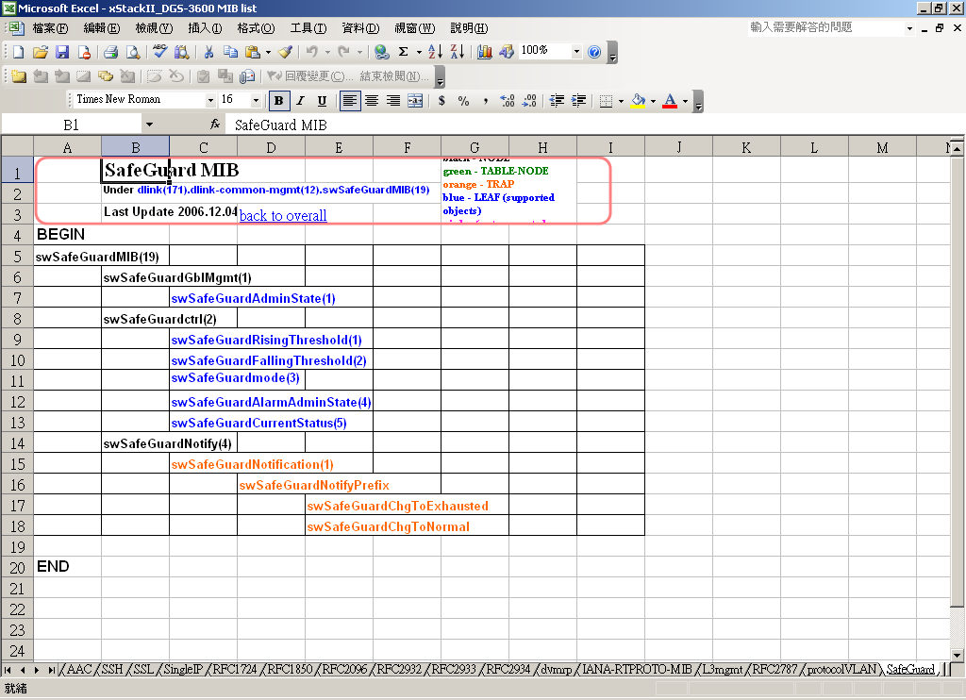

(2) Use notepad or text editor to open “SafeGuard.mib” and detailed functions are described. For instance, to enable the SafeGuard Engine is to set “swSafeGuardAdminState” to “3”.
swSafeGuardAdminState OBJECT-TYPE
SYNTAX INTEGER {
other(1),
disabled(2),
enabled(3)
}
MAX-ACCESS read-write
STATUS current
DESCRIPTION
"This object indicates the Safeguard engine state of the switch."
::= { swSafeGuardGblMgmt 1 }
Example 3. CPU Utilization
In the “DGS-3600 MIB List.xls”, user can search for “cpuutilization” and the result is shown below:
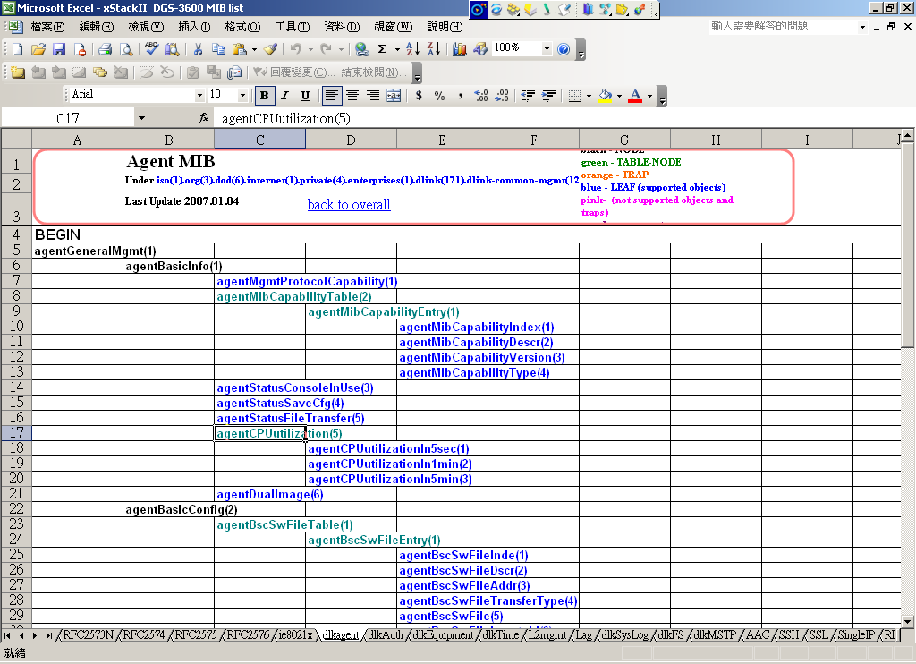

(2) In the “dlkAgent.mib”, user can find out how to display the 5 sec/1 min/5min CPU Utilization:
agentCPUutilizationIn5sec OBJECT-TYPE
SYNTAX Integer32
MAX-ACCESS read-only
STATUS current
DESCRIPTION
"Time scale is 5 seconds. The value will be between 0%(idle) and 100%
(very busy)."
::= { agentCPUutilization 1 }

agentCPUutilizationIn1min OBJECT-TYPE
SYNTAX Integer32

MAX-ACCESS read-only
STATUS current
DESCRIPTION
"Time scale is 1 minute. The value will be between 0%(idle) and 100%
(very busy)."
::= { agentCPUutilization 2 }

agentCPUutilizationIn5min OBJECT-TYPE
SYNTAX Integer32
MAX-ACCESS read-only
STATUS current
DESCRIPTION
"Time scale is 5 minutes. The value will be between 0%(idle) and 100%
(very busy)."
::= { agentCPUutilization 3 }

agentDualImageStatus OBJECT-TYPE
SYNTAX INTEGER {
not-supported(0) ,
supported(1)
}
MAX-ACCESS read-only
STATUS current
DESCRIPTION
"Status of dual image."
::= { agentBasicInfo 7 }

Example 4. IP-MAC-Port binding
(1) In the “DGS-3600 MIB List.xls”, user can search for “ipmacbind” and the result is shown below:
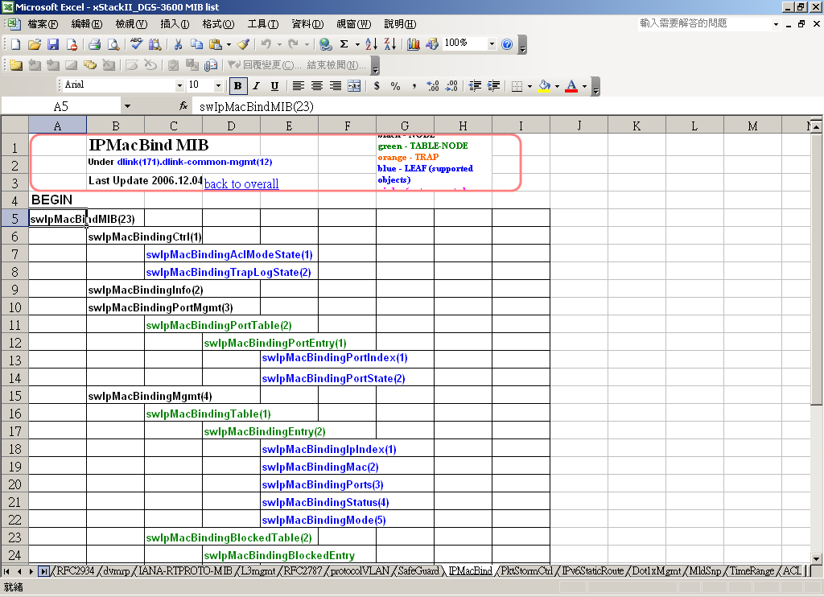

(2) In the “IPMacBind.mib”, user can find out detailed functions such as enable/disable the IP-MAC-Port binding ACL mode:
swIpMacBindingACLMode OBJECT-TYPE
SYNTAX INTEGER {
other(1),
enabled(2),
disabled(3)
}
MAX-ACCESS read-write
STATUS current
DESCRIPTION
"when enable(2), Ip Mac Binding will use acl mode"
::= { swIpMacBindingCtrl 2 }

And to setup an IP-MAC-Port entry:
swIpMacBindingEntry OBJECT-TYPE
SYNTAX SwIpMacBindingEntry
MAX-ACCESS not-accessible
STATUS current
DESCRIPTION
"IP-MAC binding entry used to add\delete\configure the address
pair to the switch's authorized user database."
INDEX { swIpMacBindingIpIndex }
::= { swIpMacBindingTable 1 }

SwIpMacBindingEntry ::=
SEQUENCE {
swIpMacBindingIpIndex
IpAddress,
swIpMacBindingMac
MacAddress,
swIpMacBindingStatus
RowStatus,
swIpMacBindingPorts
PortList,
swIpMacBindingAction
INTEGER,
swIpMacBindingMode
INTEGER
}

swIpMacBindingIpIndex OBJECT-TYPE
SYNTAX IpAddress
MAX-ACCESS read-only
STATUS current
DESCRIPTION
"The IP address of IP-MAC binding."
::= { swIpMacBindingEntry 1 }

swIpMacBindingMac OBJECT-TYPE
SYNTAX MacAddress
MAX-ACCESS read-create
STATUS current
DESCRIPTION
"The MAC address of IP-MAC binding."
::= { swIpMacBindingEntry 2 }

swIpMacBindingStatus OBJECT-TYPE
SYNTAX RowStatus
MAX-ACCESS read-create
STATUS current
DESCRIPTION
"The status of this entry."
::= { swIpMacBindingEntry 3 }

swIpMacBindingPorts OBJECT-TYPE
SYNTAX PortList
MAX-ACCESS read-create
STATUS current
DESCRIPTION
"The port members of this entry."
::= { swIpMacBindingEntry 4 }

swIpMacBindingAction OBJECT-TYPE
SYNTAX INTEGER{
inactive(1),
active(2)
}
MAX-ACCESS read-only
STATUS current
DESCRIPTION
"The action of this entry."
::= { swIpMacBindingEntry 5 }

swIpMacBindingMode OBJECT-TYPE
SYNTAX INTEGER{
arp(1),
acl(2)
}
MAX-ACCESS read-create
STATUS current
DESCRIPTION
"The mode of this entry."
::= { swIpMacBindingEntry 6 }

On the MIB browser, it shows like below:
The example above is to enable the IP-MAC-Port binding ACL mode for ip address “192.168.0.100” and MAC address “AABBCCDDEEFF” on port 1.

Each ports digit ”xxxxxxxx” (Hex) represents four ports, in this example, the first ”8” is ”1000” in binary.

１ ０ ０ ０
⇧   
p1 p2 p3 p4

=> 80000000 indicates Port 1

