DGS-3324SR
Date: Oct. 28, 2003

Product name: | 24-port 1000Base-T with 4 SFP Combo ports L3 Managed Stackable Switch
Product Group & Type: | D-Link redundant power supply system
Revision: | A1
Available: | 2003/11/14
Picture: | 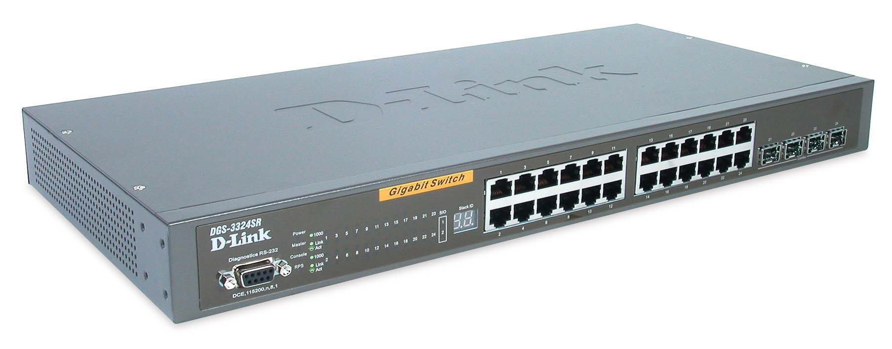
Why Buy This Product: | - More enterprise solutions: L3 switch supporting reliable star stacking architecture (used in conjunction with DGS-3324SRi), rich in functions with RPS support.  - Similarity in technical support: this switch uses the same firmware as many of our L2 and L3 switches, so it should be easier for you to support technically.  - Better altenative to DGS-3224SR L2 switch.  Selling Points  - Supports reliable star stacking architecture.  - Combo 1000BASE-T/SFP GBIC, it's the trend.  - High port density for low cost per port.  - RPS is as an option does not add RPS cost to the switch itself.  - An improved and much better software function set.
Keyfeatures: | - 24 10/100/1000BASE-T Gigabit ports  - 4 combo SFP (Mini GBIC) ports  - Up to 12 units per stack (ring architecture) or 6 units + 1 Stacking Master per stack (star architecture)  - Recoverable ring stacking or fail-safe star stacking  - Redundant power supply support  - 88Gbps switching fabric  - Auto MDI/MDIX uplink for all twisted-pair ports  - IP routing supporting RIP-1, RIP-2, OSPF routing protocols, DVMRP, PIM Dense mode  - 4K 802.1Q VLANs, IGMP snooping, eight 802.1p Priority Queues, port mirroring  - Multi-layer ACL and DiffServ QoS  - Administrator-definable port security  - 802.3ad Link Aggregation port trunks of up to 8 Gigabit ports  - Broadcast storm control  - 802.3x Flow Control  - Jumbo frame support  - 802.1D compatible and 802.1w Rapid Spanning Tree for redundant backup bridge paths  - Single IP address management per stack, SNMP v.1, v.2c,v.3 support, RMON monitoring, SYSlog, web-based management, Telnet, CLI through console port  - 802.1x port-based/MAC-based access control  - Per-port bandwidth control
Technical Details: | Hardware  Device Ports  - 24 auto-sensing 10/100/1000BASE-T ports (front panel)  - 4 combo SFP (Mini GBIC) ports (front panel)  - 2 10Gbps stacking ports (rear panel)  - 1 RS-232 console port (front panel)  Unit Stacking  - Ring architecture: 12 units per stack  - Star architecture: 6 units per stack + 1 DGS-3324SRi Stacking Master  Port Standard/Function Support  - IEEE 802.3 10BASE-T/802.3u 100BASE-TX/802.3ab 1000BASE-T  - ANSI/IEEE 802.3 NWay auto-negotiation  - IEEE 802.3x Flow Control  - Auto MDI/MDIX  - Port mirroring  SFP (Mini GBIC) Support  - IEEE 802.3z 1000BASE-LX (DEM-310GT transceiver)  - IEEE 802.3z 1000BASE-SX (DEM-311GT transceiver)  - IEEE 802.3z 1000BASE-LH (DEM-314GT transceiver)  - IEEE 802.3z 1000BASE-ZX (DEM-315GT transceiver)  Diagnostic LEDs  Per device:  - Power On/Off  - Master  - Console (login/POST status)  - RPS in use/not in use  Per 10/100/1000BASE-T port:  - 1000Mbps speed, 10/100Mbps speed  - Link/Activity  Per SFP port:  - Link/Activity  Per stacking port:  - Link/No Link  7-Segment Display  To display unit ID in the stack  Software  IP Routing  - IP v4 support  - IP Fragmentation support  - IP multi-netting  - Routing protocols supported:  Static routing  RIP-1, RIP-2  OSPF v.2  VLAN  - IEEE 802.1Q Tagged VLAN  - GARP/GVRP  - Asymmetric VLAN *  - Number of VLANs: 4K static VLANs (max.)  - Supports multiple IPs per VLAN *  * Feature available in next firmware upgrade  Priority Queues (CoS)  - Standard: IEEE 802.1p  - Number of queues: 8  Traffic Classification (CoS)  Can be based on user-definable application types:  - TOS  - Diffserv (DSCP)  - Port-based  - MAC address  - IP address  - TCP/UDP port number  Network Access Security  - Port security features  - 802.1x user authentication  Port-based access control  MAC-based access control *  - RADIUS client  - Multi-layer ACL based on:  VLAN  MAC address  IP address Protocol type  TCP/UDP port number  802.1p  Diffserv (DSCP)  - Other authentication protocols supported:  SSH2 *  TACACS *  TACACS+ *  SSL *  * Features available in future firmware release  Spanning Tree Protocol  - 802.1D Spanning Tree compatible  - 802.1w Rapid Spanning Tree *  * 802.1w available in next firmware release  IP Multicast  - IGMP Snooping  - IGMP v.2  - DVMRP  - PIM Dense mode  - PIM Sparse mode *  * Function supported in future firmware upgrade  MultiLink Trunking (MLT)  Enables grouping of links between the switch and another switch or a server to provide higher bandwidth of up to 8 Gigabit ports with active redundant links. A multi-link is defined as trunked ports spanning multiple units of the stack for fail-safe connectivity to mission-critical servers and the network center.  - Supports up to 32 trunking groups; up to 8 ports per group  - Operation mode: load sharing  - 802.3ad compatible Link Aggregation static mode  - 802.3ad compatible Link Aggregation (LACP) *  * Available in future firmware upgrade  Performance  Switch Fabric  88Gbps (32Mpps)  Transmission Method  Store-and-forward  MAC Address Table  16K entries per device  MAC Address Learning  - Dynamic entries: automatic update  - Static entries: user-defined  IP Address Learning  - Dynamic entries: automatic update  - Supports Delete of individual IP addresses by dynamic learning  Packet Filtering/Forwarding Rates (half duplex)  1,488,100 pps per port (max.)  RAM Buffer  2MB per device  Jumbo Frame  Up to 9,216 bytes  Configuration & Management  Management Support  - SNMP v.1, v.2c, v.3 *  - Web-based management  - Web GUI traffic monitoring  - Web-based MAC address browsing  - CLI (command line interface)  - RMON monitoring  - Telnet server  - SYSLOG  * SNMP v.3 available in next firmware release  MIBs  - MIB-II (RFC 1213)  - Bridge MIB (RFC 1493)  - RMON MIB (RFC 1757)  - 802.1p Priority Queues (RFC 2674)  - 802.1Q VLAN MIB (RFC 2674)  - IGMP MIB (RFC 2833)  - If MIB (RFC 2233)  - Ethernet-like MIB (RFC 1643)  - RIP MIB (RFC 1724)  - OSPF MIB (RFC 1850)  - CIDR MIB (RFC 2096)  - D-Link enterprise MIB  RMON Groups  1, 2, 3, 9 (Alarm, Statistics, History, Event)  IP Number Self-identification  Through DHCP client, Bootp client  Firmware Upgrade  TFTP  Console Port  DB-9 RS-232 DCE  Physical & Environmental  Power Input  100 to 240 VAC, 50~60 Hz  Internal power supply  Redundant Power Backup Support  Connector to connect to external redundant power supply  Power Consumption  90 watts (max.)  Ventilation  - 40 x 40 X10 mm DC fans x 2  - 60 x 60 X18 mm DC fans x 1  Dimensions  441 x 207 x 44 mm  19-inch rack-mount width, 1 U height  Weight  3.15kg  Operating Temperature  0 to 40 °C  Storage Temperature  -25 to 55 °C  Humidity  5% to 95% non-condensing  Emission (EMI)  - FCC Class A  - CE Class A  Safety  CSA International
EMI/EMC Report | ☑ FCC No. 039H048F ◻ CE No. _ _ ◻ VCCI No.  ◻ CTR-21 No. ◻ C-Tick No. ◻ A-Tick No.  ◻ FDA No. ◻ R&TTE No. ◻ BSMI No.  ◻ Others
Safety | ◻ TUV No. ◻ UL No. ☑ CSA No.( )  ◻ Others
Packaging Style | ◻ Clamshell ◻ White Box ☑ Gift Box ◻ Bulk ◻ Others
Packaging Contents: | Cable ass'y RS232, Power cord and Switch stacking cable.  1U 19 inch rack mount ear , Flat head screw M3*6 and Rubber foot.
UPC Code:
  DGS-3324SR/ A | 790069 | 262067
  DGS-3324SR/E | 790069 | 262074
  DGS-3324SR/N | 790069 | 262081
  DGS-3324SR/U | 790069 | 262098
  DGS-3324SR/BE | 790069 | 262104
  DGS-3324SR/CN | 790069 | 262111
Units Per Carton: | 5
Cartons Per Pallet: | 24 (Pallet C Shipping per Sea)
Dimensions and Weight: | Box: 550*310*92 mm, 4.5 kg  Carton: 573*333*500 mm, 23.5 kg  Pallet: __120*110*213____ cm, _580 kg  INTRASTAT weight: 4 kg (device + accessary + manual)  Packing material weight  - Paper: 100 g  - Plastic: g  - Mixed: 3900 g (device:3100g)

