DXS-3350SR

Date: July 13, 2004

Product name: | 48 10/100/1000Mbps Ports Layer 3 Stackable Switch with 4 SFP Combo ports and optional 2-port 10GE uplink module
Product Group & Type:
Revision: | A1
Available:
Picture: | 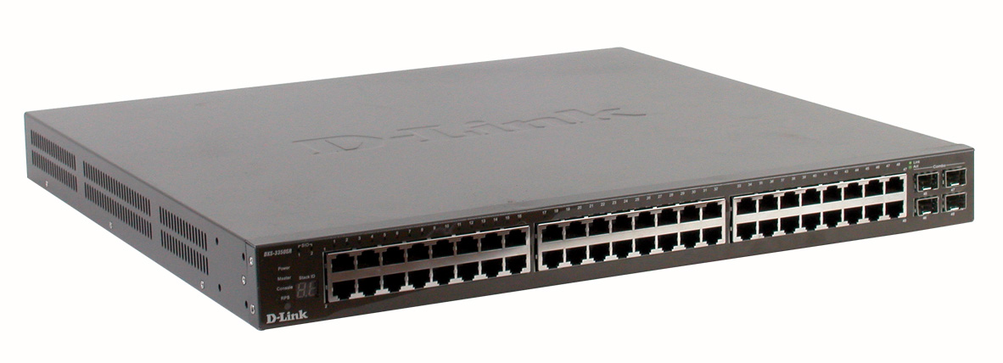
Why Sell This Product: | - High-end stackable Gigabit switch for enterprise solution.  - Part of the D-Link xStack, we give it a marketing slogan: "the Ultimate Stackable Alternative to Chassis."  - Meets the requirements of today's enterprise switches: Robust Availability, High Security Control, High Quality of Service.  - Features 10Giabit stacking and 10Gigabit uplink capability.  - Very high 48 Gigabit ports density, plus combo SFP for flexible copper/fiber Gigabit installation, plus L3 switching -- all ideal for core applications.  Selling Points  - Packs all 48 Gigabit ports plus 4 combo SFP in just 1-U low-profile housing.  - Performance: 10Gigabit high bandwidth stacking, 10Gigabit uplink option.  - Availability: reliable star stacking architecture, redundant power supply support.  - Security & industry approach: 802.3ad Link Aggregation, 802.1D STP, 802.1W RSTP, 802.1S MSTP, RIP, OSPF, VRRP, Port/MAC based 802.1x, MAC-IP binding, Multi-layer ACL, RADIUS, TACACS+, SSH, SSL, 802.1p, DSCP, Priority queuing, Multi-layer traffic classification- High port density, low cost SFP fiber Gigabit.  - Stackable price, chassis function & performance.  - Single IP Management available in firmware upgrade soon.  - Strong D-Link xStack technical support.
Keyfeatures: | - High port density per switch, with copper Gigabit, SFP fiber Gigabit support  - Very high-speed 10G uplink option 10 times faster than Gigabit  - Fault tolerant star stacking  - Up to 6 units per stack, maximum 312 Gigabit ports per stack (star stacking)  - Up to 7 units per stack, maximum 336 Gigabit ports per stack (ring stacking)  - High bandwidth 120Gbps star stacking, 40Gbps ring stacking  - Wire-speed packet routing supporting RIP v.1, v.2, OSPF, DVMRP, PIM Dense mode  - Per-port bandwidth control & multi-layer (L2, L3, L4) QoS/CoS  - Advanced Access Control Lists (ACL), enhanced TACACS/TACACS+ and RADIUS authentication  - 802.3ad Link Aggregation port trunks  - Jumbo frame support  - High availability with redundant power supply, Spanning Tree support  - Single IP Management, SNMP v.1, v.2c, v.3 support, RMON monitoring, Syslog, web-based management, Telnet, CLI through console port  * D-Link SIM (Single IP Management) support for xStack available in firmware upgrade in the near future.
Technical Details: | Hardware  Device Ports  - 48 10/100/1000BASE-T Gigabit ports  - 4 Combo SFP  - 2 10Gigabit stacking ports  - 1 open slot  - 1 console port  Port Standard/Function Support  - IEEE 802.3 10BASE-T/802.3u 100BASE-TX/802.3ab 1000BASE-T  - ANSI/IEEE 802.3 NWay auto-negotiation  - IEEE 802.3x Flow Control  - Auto MDI/MDIX  - Port mirroring  SFP Support  - IEEE 802.3z 1000BASE-LX (DEM-310GT transceiver)  - IEEE 802.3z 1000BASE-SX (DEM-311GT transceiver)  - IEEE 802.3z 1000BASE-LH (DEM-314GT transceiver)  - IEEE 802.3z 1000BASE-ZX (DEM-315GT transceiver)  XFP Support  IEEE 802.3ae compliant transceiver  Maximum Number of Units per Stack *  DXS-3350SR: star stacking 6 units, ring stacking 7 units  * In the ring stacking scheme, maximum 12 units per stack if only DGS-3324SR, DES-3352SR and DXS-3326GSR (any combination) are used. If DXS-3350SR is included in the stack, maximum number of units per stack will less than 12. Star stacking requires a DGS-3324SRi Stacking Master.  Stacking Port Speed  20,000Mbps full-duplex per port  Switch Fabric  176Gbps  Packet Forwarding Rate  131Mpps  Packet Buffer Memory  4MB  Maximum IP Address Table Entries  All models: 3K  Maximum MAC Address Table Entries  All models: 16K  Software  IP Routing  - IP v.4 support  - IP Fragmentation support  - Multiple IP interfaces per VLAN *  - Routing protocols supported:  Static routing  RIP v.1, RIP v.2  OSPF v.2 *  * Function available in future firmware upgrade  VLAN  - Port-based VLAN  - IEEE 802.1Q Tagged VLAN  - GARP/GVRP  - Maximum number of VLANs  Dynamic: 255  Static: 4K  Priority Queues (CoS)  - Standard: IEEE 802.1p  - Maximum number of queues: 8  Traffic Classification (CoS)  Can be based on user-definable application types:  - TOS  - Diffserv (DSCP)  - Port-based  - MAC address  - IP address  - TCP/UDP port number  Access Security  - 802.1x port-based access control  - 802.1x MAC-based access control  - Port security  - SSH *  - SSL *  * Functions available in future firmware upgrade  Access Control List  Multi-layer ACL based on:  - MAC address  - TOS  - Diffserv (DSCP)  - IP address  - Packet protocol type  - TCP/UDP port number (user-definable application types)  - TCP/UDP payload (user-definable packet content)  - Per port ACL definition  Spanning Tree Protocol  - 802.1D Spanning Tree compatible  - 802.1w Rapid Spanning Tree  - 802.1s Multiple Spanning Tree *  * Function available in future firmware upgrade  IP Multicast  - IGMP v.2  - DVMRP  - PIM Dense mode  - VRRP *  * Function supported in future firmware upgrade  Port Trunk  - Maximum number of ports per trunk: 8  - Maximum number of trunks per stack: 32  - Operation mode support: load sharing  - 802.3ad compatible Link Aggregation (LACP)  Transmission Method  Store-and-Forward  Jumbo Frame  9KB (max.)  Configuration & Management  Management Support  - D-Link SIM (Single IP Management) *  - SNMP v.1, v.2c, v.3  - Web-based management  - Web GUI traffic monitoring  - Web-based MAC address browsing  - CLI (command line interface)  - RMON monitoring  - Telnet server (up to 8 sessions)  - TACACS/TACACS+ authentication on switch admin access  - RADIUS authentication on switch admin access  - SYSLOG  - DHCP/Bootp relay  - DNS relay  - Dual Images  - Back-Door function  - Port description  - CPU utilization monitoring  MIBs  - MIB-II (RFC 1213)  - Bridge MIB (RFC 1493)  - RMON MIB (RFC 1757)  - 802.1p Priority Queues (RFC 2674)  - 802.1Q VLAN MIB (RFC 2674)  - IGMP MIB (RFC 2833)  - If MIB (RFC 2233)  - Ethernet-like MIB (RFC 1643)  - RIP MIB (RFC 1724)  - OSPF MIB (RFC 1850)  - CIDR MIB (RFC 2096)  - D-Link enterprise MIB  RMON Groups  1, 2, 3, 9 (Alarm, Statistics, History, Event)  IP Number Self-identification  Through DHCP client, Bootp client  Firmware Upgrade  TFTP  Power Supply  - 100 to 120VAC, 200 to 240VAC, 50/60Hz  - Internal universal power supply  - Optional external redundant power supply support  Emission (EMI)  - FCC Class A  - CE Class A  Safety  CSA International  Optional Redundant Power Supply  DPS-500 140-watt redundant power supply  DPS-800 2-slot redundant power supply chassis  DPS-900 8-slot redundant power supply chassis
EMI/EMC Report | ☑FCC No. ☑ CE No. ◻ VCCI No.  ◻ CTR-21 No. ☑ C-Tick No. ◻ A-Tick No.  ◻ FDA No. ◻ R&TTE No. ◻ BSMI No.  ◻ Others
Safety | ◻ TUV No. ◻ UL No. ☑ CSA No.  ◻ Others
Packaging Style | ◻ Clamshell ◻ White Box ◻ Gift Box ◻ Bulk ☑ Others white box
Packaging Contents: | - One DXS-3350SR Device  - One set accessory including 2 Rack mount ear/4 Rubber feet and 8 Screws  - One AC power cord  - One Cable Ass’y RS232(DB09)  - One Cable Infinband 4X50CM  - One CD Kit for User’s Guide/CLI/D-View module  - One CD Kit for D-View 5.1 Trial version.  - One Generic QIG  - One H/W hard copy User’s Guide
UPC Code:
  DXS3350SRAA1: 790069 267727
  DXS3350SRBA1: 790069 269431
  DXS3350SRCA1: 790069 267765
  DXS3350SREA1: 790069 267734
  DXS3350SRNA1: 790069 267741
  XS3350SRBEA1: 790069 267758
Units Per Carton: | 2
Cartons Per Pallet: | Air: 12, Sea: 18
Dimensions and Weight: | Box: 565 x 527 x 140 mm, 8 kg  Carton: 580 x 560 x 310 mm, 16.5 kg  Pallet: (by Air) 1220 x 1020 x 1250 mm(USA), 213 kg  1200 x 1100 x 1240 mm (WW), 213 kg  (by Sea)1220 x 1020 x 1810 mm(USA), 312 kg  1220 x 1020 x 1800 mm(USA), 312 kg  INTRASTAT weight: kg (Box)  Packing material weight (Box):  - Paper: kg  - Plastic: kg  - Mixed: kg

